Project 1 ReadMe file

A simpe MVC based Modern Interactive Website with JavaScript.

Theme: City of Mostar, its monuments, culture and history with a postcard selection form

NOTE:

If an error message like the one below is shown while using the website (does not render the selects because of CORS? policy) please use the link provided for the local website:

<http://127.0.0.1:3000/index.html>

Serenity link:

http://serenity.ist.rit.edu/~az4739/client/ZagorcicA_Project1/index.html

**Web Design and Programming Principles (CLO1)**

* Overall look and feel of the page is created using pure html and css. There is a navigation bar with all important parts of the website. The content is based on the city of Mostar, describing the way of life, its monuments, history and culture.
* All code is structured and implemented proffesionally to the website. MVC architecture was used.
* All code is indented, aligned and commented in the JSDoc format

**Conditional/Cascading Selects (CLO2)**

- the conditional selects are implemented at the end of the page with MEMORY header. Present in navigation bar. The selects are based on a postcard picker where the user can pick between 3 different selects. Shape of the postcard, color of it, and the motive.

-There are 2 choices on all 3 different selects of the postcard chooser.

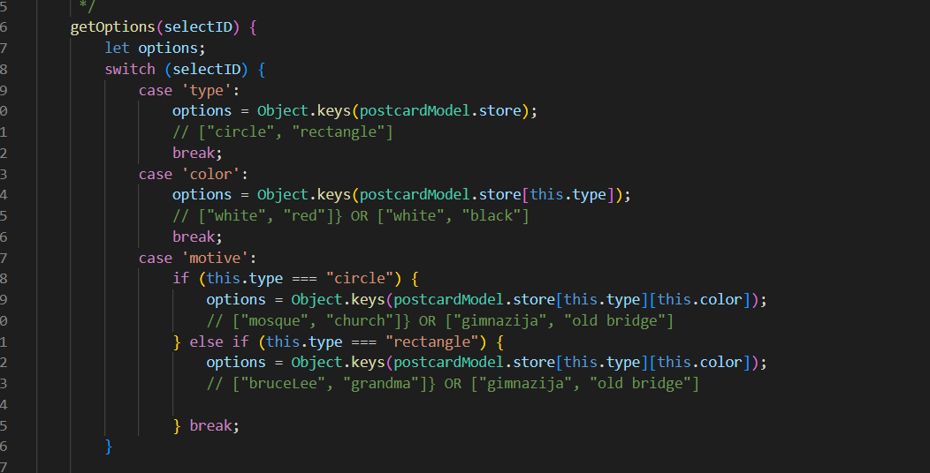

* Selects are dynamically created depending upon the user’s previous select option.

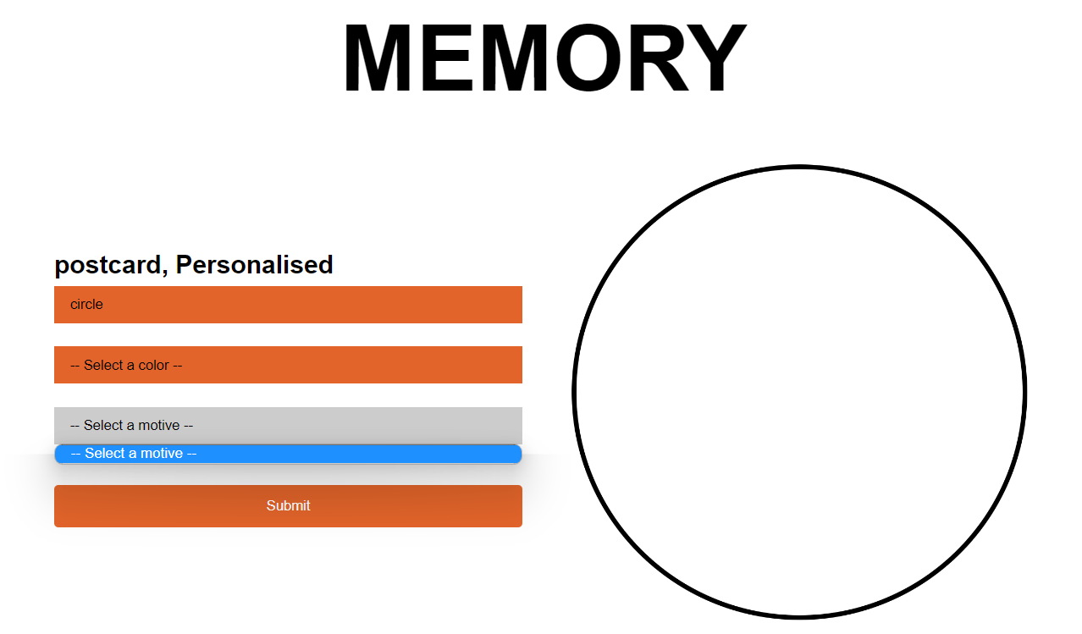

* The user can start over and the selects are re-drawn from the point of the user’s new selection

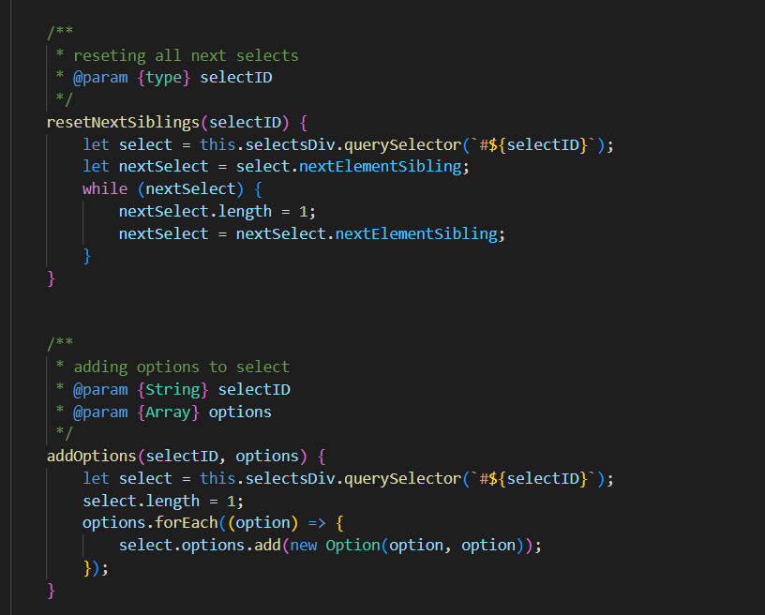

* he selection process includes a dynamically generated GUI element that changes in response to the user's selection

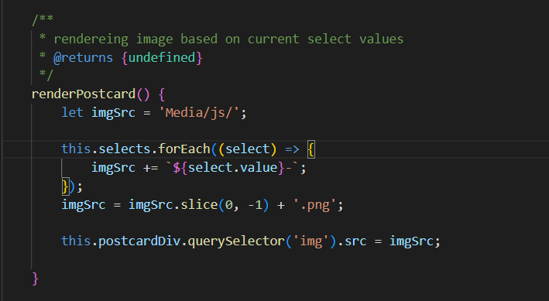

**Form Element (CLO2)**

* Once the user is done with the selection, a form is used to send the user selected options via the submit button (name, email, type, color and motive) are sent

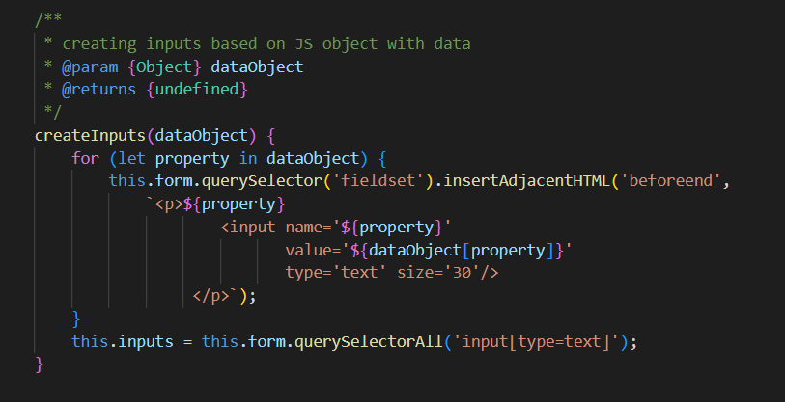

* Once the user is done with the selection, Local Storage is used to store the selected options

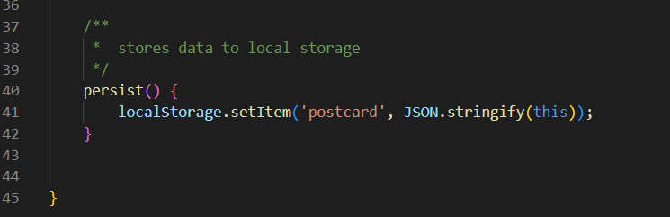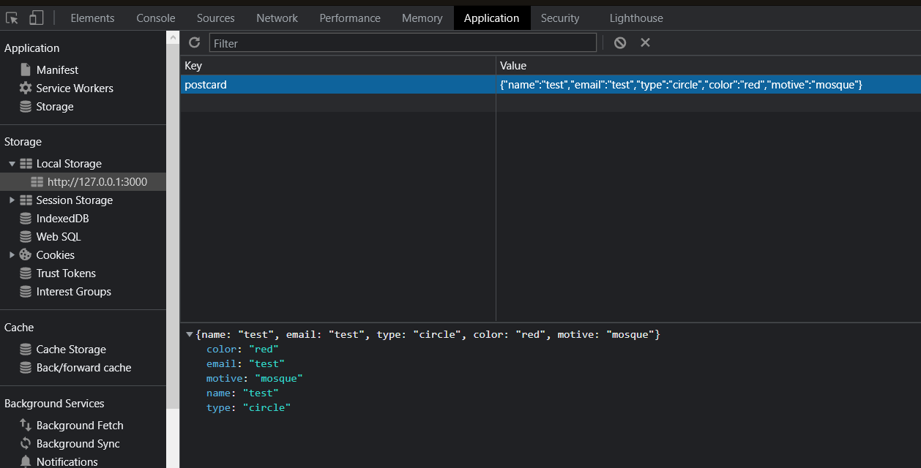

**Browser Support (CLO3)**

* The application checks how well the user’s browser supports the application’s features and lets the user what they need to do to have the application work as expected. There is a vendor folder that contains Modernizr file that is responsible for checking if features are supported on the brower that the site is being used in. „no-“ is added to the beggining of the class name (which is later used in css to present the user with the information) if there are features unsuported. Implemented in both form and index html files. Tested on old version of mozila firefox. The contents of the page is hidden and only the information div is provided

