“Curriculum Vitae”

Bhoopendra Singh
UGC NET, Ph.D. Pursuing, M.Phil., M.Lib&.Inf.Sc., M.A.(Public Administration)
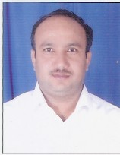MOB#: - 09460500344, 9352423669
E-mail- librarianjcdvmcoe@gmail.com
Flat No. 03 SMEC CAMPUS NEEMRANA ALWAR PIN-301706

CAREER OBJECTIVE:
To administer the smooth functioning of the Library -Updating the database with new arrivals of books and non-book materials -Maintaining the records related to the books and non-book materials.
EDUCATIONAL QUALIFICATION: Master of Arts in Public Administration in 2001-2002 University of Rajasthan.
- Bachelor of Arts in 1999-2000 from University of Rajasthan (Philosophy, Public Administration, English Literature)
PROFESSIONAL QUALIFICATION:
- Ph.D. Pursing from Department of Library and Information Science University of Rajasthan, Jaipur.
- RSCIT (Rajasthan State Certificate of Information Technology) Course from (VMOU) Vardhman Mahaveer Open University, Kota.
- UGC-CBSE NET November 2017 Qualified from University Grant Commission, New Delhi.
- M. Phil. Library and Information Science in 2005-2006 from Annamalai University.
- Master of Library and Information Science in 2003-2004 from University of Rajasthan, Jaipur.
- Bachelor of Library and Information Science in 2002-2003 from University of Rajasthan, Jaipur.
- Computer Course in 2004 from Mahatma Gandhi Institute in Bhartiya Vidya Bhavan, Jaipur.

ORGANISATIONAL EXPERIENCE:- (Total Year of Experience -15^{th +} Yr. Approx)
- Presently working as Senior Librarian in School of Aeronautics Neemrana Alwar (April 16, 2018 to till date)
- Worked as Librarian in Jan Nayak Choudhary Devi Lal Vidyapeeth Sirsa (December 2015 to April 14, 2018)
- Worked as Librarian St. Margaret Engineering College Neemrana Alwar (April 2009 to December 2015)
- Worked as Librarian in Vedant College of Engineering & Technology Bundi (August 2008 to April 2009)
- Worked as Librarian in NIMS UNIVERSITY (National Institute of Medical Science), Shobha Nagar, Jaipur (09th September 2007 to June 2008)
- Worked as Librarian at Jaipur Dental College, Dhand Jaipur. (9th December2005 to 18th September 2007)
- Worked as Assistant Librarian in Global Institute of Technology, Jaipur. (1st July 2004 to 8th December 2005)

CAREER HIGHLIGHTS:-

- 17 Year + Approx Total Experience in Library and Automation Library field.
- Basic knowledge of computer so as to process computer data as fast as possible.
- Excellent in co-ordination with team member to give better output.
- Ability to communicate in any age group.
- Self starter with ability to adapt new techniques as per recruitments.

SEMINAR CONFERENCE / WORKSHOP /SHORT TERM COURSES:
- One Week TEQIP –III Sponsored Faculty Development Program me on Stress and Anger Management Organised by RTU and JECRC Jaipur.
- Short term course in Communication Skills through ICT from January 11, 2016 to January 15, 2016 at JCDM College of Engineering Sirsa (Haryana).
- Short term course on Classification by DDC and Cataloguing by AACR2 from May 13, 2013 to May 24, 2013 at NITTTR, Chandigarh.
- Short term course on Research Methodology from February 06, 2012 to February 10, 2012 at NITTTR, Chandigarh.
- Short term course on Digital Library Management from March 07, 2011 to March 09, 2011 at NITTTR, Chandigarh.
- Short term course on Internet Collaborative Tools for Librarian from August 09 to 11, 2010 at NITTTR, Chandigarh.
- Workshop on DELNET at IILM Academy of Higher Learning, Sanganer, Jaipur and JALIS on Saturday, February 26, 2011 at IILM Jaipur.
- All India Seminar on Information Resource Sharing and Web based services for Engineers: Recent Trends and Technologies, Organized by The Institution of Engineers (IEI) Jaipur, Rajasthan State Centre and JALIS, Jaipur on February 12-13, 2011.
- Seminar on Recent Trends & Technologies in LIS Profession Organized by Jaipur Library and Information Society (JALIS), Jaipur on November14, 2010.
- Seminar on Job Opportunities and Career Development in LIS Profession Organized by Indian Institute of Craft and Design, Jaipur and Jaipur Library and Information Society (JALIS), Jaipur.
- Seminar on E- Resources & Resource Sharing in Libraries Organized by Jaipur Library and Information Society (JALIS), Jaipur on July 27,2008.
- Training Program for Library Automation Software- TLSS Total Library Software Systems on 24 to 26 January, 2006 (Three Days) at Jaipur Dental College, Jaipur.
- National Workshop on Building Digital Libraries Using GSDL and D Space Open Source Software, at Institute of Health Management Research (IHMR), Jaipur, Rajasthan. (March 14 and 15, 2008) Organized by Society for the Advancement of Library and Information Science (SALIS), New Delhi and IIHMR, Jaipur.
- Seminar on IT Application & Resource Sharing in Libraries-2006 Organized by Kautilya Institute of Technology and Engineering, Jaipur on 20th August 2006

PERSONAL VITAE:-

Father’s name: Shri Ram Lal
Date of Birth: 26th September 1976.
Gender: Male
Marital Status: Married.
Blood Group: B (+ve)
Languages Known: English & Hindi.
Nationality: Indian
Category: General
Salary Expected: As per the norms
PERMANENT ADDRESS:-

Bhoopendra Singh S/O Shri Ram Lal Head Master (Retired)
House No. -69,
Village and Post –Awar , Tehsil – Kumher
District – Bharatpur Rajasthan
PIN - 321202

DECLARATION:-

I solemnly declare that the statements given above are true to the best of my knowledge.
Place: Neemrana 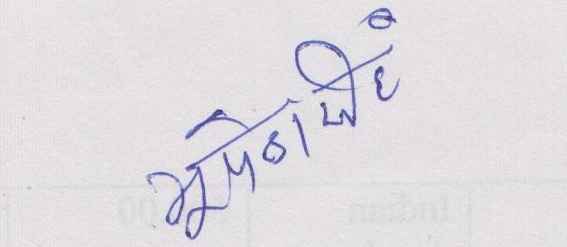
Date: 18/08/2021 Bhoopendra Singh

