ARUN KUMAR SINGH 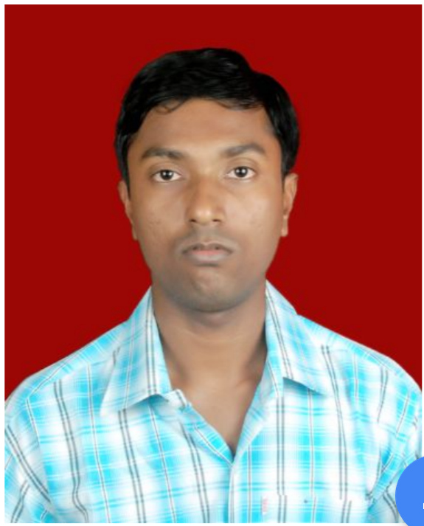
Mobile: 7870627056
E-Mail: arun2fight@gmail.com

CAREER OBJECTIVE

To work in a globally competitive on challenging assignments that shall yield twin benefits of job satisfaction and steady paced professional growth.

EDUCATION QUALIFICATION
- B.Tech in Computer Science from Institute Of Advanced Computer and Research, Rayagada, Biju Patnaik University of Technology, Rourkela, Odisha in 2010. Scored 7.19 (CGPA).
- 12th from Rajkamal Saraswati Vidya Mandir, Dhanbad, C.B.S.E Board in 2005. Scored 72.4%.
- 10th from Lakshmi Narayan Vidya Mandir, Dhanbad, J.B.S.E Board in 2003. Scored 63.2%.

PROFESSIONAL EXPERIENCE

- Company : TCS ION DIGITAL ZONE (Through RTNS Kolkata) - Dhanbad
Duration : MARCH 2017 – AUGUST 2018
Designation : INVIGILATOR

PROFESSIONAL EXPERIENCE

- Company : CAPGEMINI INDIA PVT LTD - Kolkata
Duration : AUGUST 2013 – NOVEMBER 2013
Designation : CONSULTANT (HR Department)

PROFESSIONAL EXPERIENCE

- Company : WIPRO INFOTECH LTD (Retainer) - Gurgaon
Duration : JUNE 2013 – AUGUST 2013
Designation : HR - EXECUTIVE OPERATION – RMG (Resource Management Group)

JOB DESCRIPTION
- Rookie’s Infusion
- Bench Management.
- SAP Tagging.
- Indent Pushing.
- Handling Transfer Case.
- TCAC Evaluation.
- MIS Report
PROFESSIONAL EXPERIENCE

- Company : WIPRO INFOTECH LTD (Through Alp Consulting Pvt Ltd) - Bangalore
Duration : May 2012 – May 2013
Designation : ASSOCIATE TALENT ACQUISITION - Recruitment

JOB DESCRIPTION

- As a Recruiter, experience include recruiting through job portals combined with utilizing existing candidate relationships and referrals, along with various other sourcing techniques.
- My other responsibilities include:
- Handling the complete Recruitment Life Cycle – Sourcing/Screening, Short-listing Profiles, Candidates Tracking and Follow-up, processing CV’s, Updating/maintaining Internal Database etc.
- Analyze requirement according to the specification mentioned by the client.
- Profiles sourcing according to client requirements.
- Identifying the potential candidates through various sources like Internal databank, LinkedIn, job portals, Mass Mailing, Referencing etc to fill the vacancies and stimulating them to apply for the jobs.
- Conduct first level interview (Telephonic) to check communication skills, domain skills, interest level, availability, salary etc.
- Responsible in handling all senior level requirements.
- Gathering pre-close information (candidate’s present/ expected compensation, relocation issues etc.) Following up with the candidates till he/she is on board.
- Maintaining Good Pipeline for the open positions.
- Follow-up with the candidates as well as with the clients till the candidates join the organization.
- Generating invoice through “Wipro Synergy Portal“ in built software which co-ordinates with internal employees and service employees as well.
- Following up with the candidates on the feedback from the company side and solving all the query between the candidate and the company to meet the mutual satisfaction.
- Maintaining a systematic and comprehensive database of all the candidates.
- Preparing weekly and monthly reports on End to End recruitment process.

Major Clients:
Wipro Technology, Wipro BPO, HDFC, JCB, JP Morgan, Ericsson, Alcatel Lucent, Google, Oil India, BPCL, Railtel etc.
Achievement:
- Close first position with our new client, got appreciation from Manager and Senior Management.
- Got 3 offers in a week from different client.

PROFESSIONAL EXPERIENCE

- Company : ADECCO INDIA PVT LTD (for Cisco Client) - Bangalore
Duration : July 2011 – April 2012
Designation : RECRUITMENT CONSULTANT

COMPUTER SKILLS

- Excellent in MS Excel, MS Word & MS PowerPoint.

TRAINING

- One month training in BSNL (OCB 283 EXCHANGE) at Dhanbad, Jharkhand.

STRENGTH

- Confident and hardworking to achieve the set goals.
- Keen to learn new things.
- Interpersonal Skills & Team player.
- Multi-tasking ability & Solution oriented attitude towards work.

PERSONAL PROFILE

- Name : Arun Kumar Singh
- Father’s Name : Rajdeo Singh
- DOB : 15/12/1988
- Sex : Male
- Marital Status : Single/Unmarried
- Languages Known : English, Hindi
- Hobbies : Browsing Internet
- Permanent Address : Near Rajkiya Ambedkar High School, Hirak Road, Bhelatand,
Dhanbad – 826004 (Jharkhand)
DECLARATION

I hereby declare that all the data and information provided above are true and correct to the best of my knowledge and I hold responsible myself for any irregularities if found.

Date: Signature
Place: Arun Kumar Singh

