Curriculum Vitae
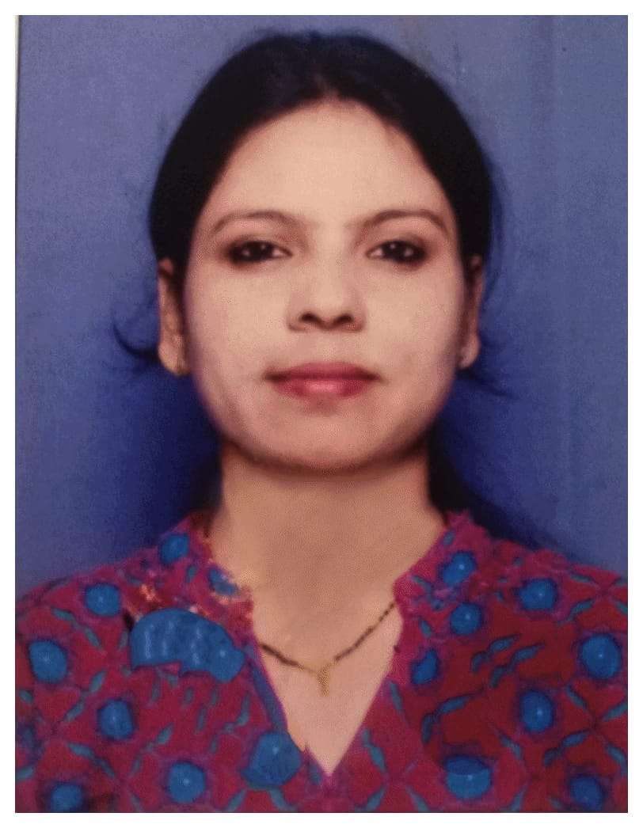
MEGHA YOGESH VANMALI
+91 – 9172530465
mags.vanmali@gmail.com

CAREER OBJECTIVE
Professional with teaching experience in the Primary and secondary section.
Common sense decision maker with emphasis on planning, organization & optimization of the given conditions to derive the best from the students.
Strong communication and interpersonal skills serve as the foundation to effectively understand student's academic requirements and help them achieve their goals.

Total Work Experience – 8 Years

PREVIOUS JOB DESCRIPTION

Organization: Children’s Academy Group of Schools (ICSE)
Designation: Assistant Teacher
Subject: Marathi
Section: Primary
Time Duration: JUNE 2012 – APRIL 2019

Organization: Union High School
Designation: Assistant Teacher
Subject: Marathi
Section: Primary & Secondary
Time Duration: JUNE 2011 – APRIL 2012

Core Responsibilities:
- Head of the Department in Marathi for 2 years.
- Assessing student’s progress and performance.
- Monthly planning and preparing lesson plans.
- Question paper setting and preparation.
- Providing guidance to students.
- Maintaining discipline.

Education Qualification:
- Qualified NET in Education (2021)
- M.A. in Education from Mumbai University (2017)
- B.Ed. in Marathi & Economics from Ncrd sterlling College Mumbai ( 2007)
- B.A. from Mumbai University (2004)
Other Qualification:

- Certificate course of MSCIT
- Certificate course of Computer Education

PERSONAL PROFILE
Name : Megha Yogesh Vanmali
Date of Birth : 16th Jan 1983
Nationality : Indian
Marital Status : Married
Languages known : English, Hindi, Marathi.

