DR. Vithoba C. Sawant

Flat No. 1A/104, Rameshwar Complex,
Gholai Nagar, Kalwa (E),
Thane- 400605.
Contact No.: 9870208619
Email: sawantvithoba80@gmail.com
Date: 02/05/2022

To,
The Principal,
Chatrapati Shivaji Maharaj University,
Panvel, Navi Mumbai.
410206.
Sub: Application for the post of Assistant Professor- Economics.

Respected Sir/Madam,

I undersigned here by applying for the above mentioned post. It is known that there is vacancy for the above post in your institution.

I have done my Ph.D. from University of Mumbai. I have done M.A.,
(History, Economics), B.Ed.,M.Ed., M.Phil.,PGDME from University of Mumbai.

If I am selected, it will be my sincere endeavor to satisfy you with my sincere and diligent work. I shall be thankful if you give me the opportunity to teach in your institution. Along with the application I am attaching my curriculum vitae for your perusal.

Yours Sincerely,

(DR.Vithoba Sawant)

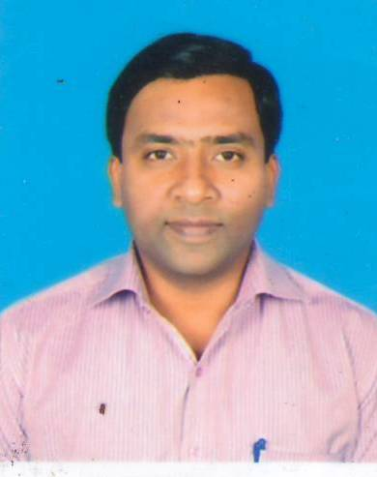
Resume

Dr. sawant vithoba chandrakant
Flat No. 1A/104, Rameshwar Complex,
Gholai Nagar, Parsik Nagar, Kalwa (E), Mob.: 9870208619/9892415578
Dist-Thane – 400 605. E-Mail: sawantvithoba80@gmail.com

Academic Qualification:
Name of Course | Subject | University | Institute | Passed Year | Class
Ph.D. | Education | Mumbai | University of Mumbai | Feb 2021 | Awarded
M.A. | Economics | SPPU | Savitribai Phule Pune University | May 2017 | First
PGDME | Education | Mumbai | K.J.Somaiya College | May 2012 | First
M.Phil. | Education | Mumbai | Department of Education | Nov 2009 | Awarded
D.S.M | Education | YCMOU | Shahapur College | May 2010 | First
M.Ed. | Education | Mumbai | K.J. Somaiya College | May 2008 | First
B.Ed. | Marathi &  History | Mumbai | Pillai’s College of Education Research | May 2005 | First
M.A. | History | Mumbai | University of Mumbai | May 2004 | Second
B.A. | History & Economics | Mumbai | S.K. Somaiya College of Arts, Commerce, | May 2002 | First

additional Qualification:
- MS-CIT, MS Office, Internet
- English Typing (30-40 w.p.m.)

Work Experience: Total 16 years in the field of Education
- Worked as Asst. Professor in Pillai HOC College of Education & Research from 2011
- Worked as visiting faculty (Economics) Pillai HOC Arts, Commerce and Science from 2017
- Worked as Lecturer in Gurukrupa College of Education & Research, Kalyan, from 2008 to 2011.
- Worked as Lecturer in Pillai’s College of Education & Research, Chembur from 2006 to 2008.
- Worked as Asst. Teacher in J.J. Academy English Medium Secondary High School for 2 years.
Award:
- Merit Holder in B.A. (History & Economics) from S.K. Somaiya College, Year 2002.
- Merit Holder in M.Ed. from K.J. Somaiya Comprehensive College of Education & Research, Year-2007-08.
- Best Teacher Award from Rotary Club of Bombay, Mulund (E), Year 2006.
- B.Ed. College Sports Championship, Year 2004-05.
- M.Ed. College Sports Championship, Year 2007-08.

Extra Curricular Activity:
- Participated and presented a paper at the 2 day Interdisciplinary International conference on ‘Nurturing the Whole being for the 21st century – exploring Indian Psychology’ 5-6 February, 2015.
- Participated and presented a paper at the National Seminar on ‘Inclusive education: A system reculturation’ 7 April, 2016.
- Participated in the workshop on ‘Creating a Mindset Towards Inclusive Classrooms’ 28 February 2017.
- Participated and presented paper at the National Conference on ‘Social Transformation In Higher Education’ 8 & 9 March 2018.
- Participated and Presented paper in the International Multi-Disciplinary Conference on ‘Quality Enhancement of Higher Education in India, tends and Challenges: Vision 2025’ March 2019
- Invited as the chairperson for interdisciplinary Nation Seminar and presented paper in
“Gandhian Values and Challenges. 4th October, 2019.
- Many more paper presented in State Level, National Level and International Level.

hobbies:

- Kabaddi, Volleyball, Travelling, Listening Music etc.

Personal details:

father’s name : Shri. Chandrakant Dattaram Sawant
Date of Birth : 4th December 1980
Gender : Male
Nationality : Indian
Religion : Hindu-Maratha
Marital Status : Married
Languages Known : English, Marathi & Hindi

Date : 02/05/2022
Place : Mumbai (Dr. Vithoba C. Sawant)

