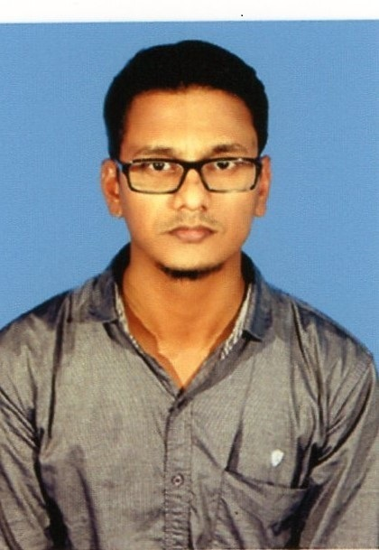
Dr.H.SHEIK JAHABAR ALI
S/o,S.Hameed sultan,
No:5-17,Maraikayar street,
Manjakkollai,& (Po)
Nagapattinam Tk,
Nagapattinam Dist,
Tamil Nadu.
Pin :611106
 Mobile: +919791560574

E–mail: royalherbalist.h42@gmail.com

O b j e c t i v e
To Build a successful career in the challenging environment of an organization that could utilize my inherent skills to contribute towards the growth of the organization.
E d u c a t i o n
DEGREE/COURSE | INSTITUTE | YEAR OF PASSING | Aggregate %
Ph.D in Herbal Science  Equallent to Botany  GO.(MS) NO: 266 - 2019 | Faculty of science,Department of Botany,Annamalai University | 2017 | Highly Recommended
M.Sc in Herbal science  (Integrated)  Equallent to Botany  GO.(MS) NO: 266 - 2019 | Faculty of science,Department of Botany,Annamalai University | 2005 – 2010 | 8.08 OGPA
H.S.C.C. | St.Antony’s HSS,Velippalayam,Nagapattinam. | Mar 2005 | 58%
S.S.L.C | Kumaran HS,Manjakkollai,Nagapattinam. | Mar-2003 | 70%
HDCA | CSC Education, Nagapattinam. | July 2003 | ‘A’(OAG)

P e r s o n a l S k i l l s & A b i l i t i e s
- Highly Organized and dedicated, with positive attitude
- Excellent verbal and written communication skills, with an eye on detail proficient
C o m p u t e r S k i l l s
Software exposure
Operating Systems : WINDOWS’98/XP/2007/8/10
Strength
Innovative Thinking, Willing to Learn, perfect Working
P e r s o n a l D e t a i l s

Date of Birth : 15.06.1985
Father’s Name : S.Hameed Sultan
Sex : Male
Marital Status : Married
Spouse Name : S.Habeeb Nachiyar
Qualification : HSLC
Employment status : Home maker
Languages Known : English & Tamil.
Hobbies : Reading Books and playing chess, caram,Drawing.
No of Children : One (Female baby)
Name of the child & age : S.Ameerah Tamil Gani, 9 year old

AREAS OF INTEREST

Plant Morpholpgy
Plant Diversity
Taxonomy of Angiosperms
Plants and Human welfare
Plant Anotomy
Plant Physiology
Plant Metobolism
Ethano Botany
Biological techniques and Instrumentation

Principle of Pharmacology
Phytochemistry
Herbal Formulation
Phytopharmacy
Quality assurance of Herbal drugs
Herbal Toxicology and Screening Methods

Taxonomy of Medicinal and Aromatic Plants
Breeding of Medicinal and Aromatic Plants
Cell biology and Genetics
Plant Molecular Biology
Tissue Culture Techniques

Work Experience :
- Presently working as Assistant professor in Department of Biotechnology & Botany, Sir Issac Newton College of Arts & Science, Nagapattinam, Tamilnadu.
- 6 Years Experienced in Assistant professor in Department of Biotechnology & Botany, Edayathangudy G. S. Pillay Arts & Science College,
( Accrediated with “A” Grade by NAAC) Nagapattinam, Tamil Nadu
- 13 Years Experience in Research work (Life Science)
- 3 Years Experience in teaching class 6, 7, 8, 9, 10 std School Students.

Training for 20 Days :

Rumi Herbal PVT.LTD ,Chennai.for hands on Training on “Quality Control Standards and developing new Herbal formulation”.

PROJECT WORK DETAILS
Ph.D Thesis work: Phytochemical diversity and larvicidal activities of leaves of
Hyptis suaveolens, (L) Poit on Yellow fever mosquito (Aedes aegypti L) and Avian malarial mosquito (Culex quinquefasciatus Say)

UNDER THE GUIDANCE OF Dr. K.ANNAMALAI, M.Sc., Ph.D., Associate Professor
Botany wing (DDE), Annamalai University, Annamalai Nagar.

NUMBER OF STUDENTS GUIDED:

M.Sc Biotechnology - 10

Papers Publication :’ 15’, (International Journals) & UGC Apporoved Journals

Workshop : ‘09’.

National Seminar : ‘07’

International Seminar : ‘01’

National Conference : ‘10’

International Conference : ‘06’

Symposium : ‘01’

Training Programmes : ‘03’

Awards:

1.Best Poster presentation award for National Conference on “RECENT TRENDS IN BIOPROSPECTING OF PLANTS” 28th &29th March- 2014, Organized by Department of Plant Science, Bharathidasan University, Tiruchirappalli-24.

2. Best Poster presentation award for National Conference on 14th IAAM national conference on 9th to 10th September 2016. Presentation 3rd prize, organized by Department of Microbiology, Dr. NGP Arts and Science college, coimbatour, Tamil Nadu.

3. Best poster presentation award for National level Technical Symposium , held on 25th September 2017 . 2nd prize, at Sri Venkateshwara college of Engineering( Autonomous), Pennalur, Sriperumbutur, Chennai.
4. Best Oral Presentation award for National Level seminar on Approaches and future aspects for Cancer Therapy, ONCO-T20, 7th Feb 2020, Organized by the school of Life Sciences, Maruthupandiyar College, Thanjavur.

Membership:
Membership in “BIOLOGIST FORUM OF INDIA”

I hereby declare that all the information and facts stated above are true and correct to the best of my knowledge and belief.

Place : Nagapattinam
Date : 06.05.2022

( H.SHEIK JAHABAR ALI )

