Resume
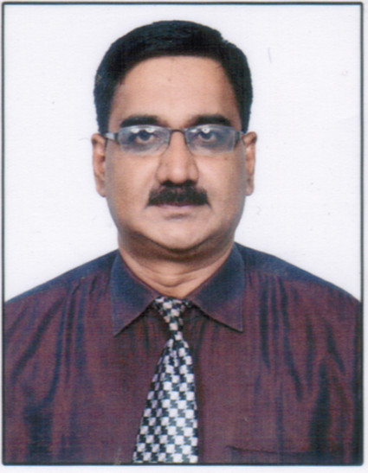
Mr. Vishwasrao Shinde
Email :Vishwasrao21@rediffmail.com
Mobile No. 9820235546

- Educational Qualification: M.Sc.B.Ed. NET( UGC),PET.Ph.D [Pursuing ]

Employment Status:

- Total Teaching Experience – 23 years.
---------------------------------------------------------------------------------------------------------------------
- Professional Experience:

- Taught in Junior college and senior college
- Subjects Taught : Geography and Environmental Science
---------------------------------------------------------------------------------------------------------------------
Teaching Experience
          - Worked as a Assistant Professor in Bhonsala Military college , Nashik.
          - Worked as a Assistant Professor at National Defence Academy (NDA)
Khadakwasala, Pune.
- Worked as a senior school Teacher in Podar International school Santacruz West, Mumbai
          - Worked as a Post Graduate Teacher in Geography and HOD Social Science at B.K. Birla Center for Education ,Pune

- Educational Profile:

Examination | Year | Class / Grade | University / Board | Subject
Secondary School Level | 1987 | First Class | Pune | --
B.Sc. | 1992 | First Class with Distinction | Pune | Geography
M.Sc. | 1994 | First Class | Pune | Geography
B.Ed. | 1999 | First Class with Distinction | Pune | Geography & Science Methods
Qualified  National Eligibility Test  (NET )  For Lectureship |  |  | University Grants Commission  ( UGC),  New Delhi | Geography
Qualified P.E.T.  (Ph.D. Entrance Test ) | 2012 |  | Mumbai | Geography
Ph.D.[ Perusing] | 2018 |  | Savitribai Phule Pune University,Pune | Geography

ACHIVEMENTS: Received Guru Dronacharya Awards from Yuvak Pratishthan Mumbai for valuable contribution in the field of education.

- Conferences/Seminar / Workshop :

- Participated in workshop on “Effective Teaching Skills”, conducted by Global Institute of Interaction Training, Pune.
- Participated in International conference on ‘Challenges in Human Geography’ at Shirpur,
- Participated in National Seminar on New Thrust areas in Research in Geography at Department of Geography, Savitribai Phule Pune University,Pune..
- Participated in National Conference on Contemporary Issues in Environment and Geography, organized by N.G. Acharya College, Chembur,Mumbai.
- Attended workshop on “Enrich Teacher Personality”.
- Attended workshop on “Learner Centric Teaching” conducted by Global Research & Training Foundation, Pune
- Attended Orientation Programme in Disaster Management, conducted by C.B.S.E.
- Attended workshop on how to integrated Computer in class room teaching conducted by Intel India and JIL
- Completed online workshop for IB Teachers conducted by INTERNATIONAL BACCALAUREATE ORGANISATION [IB],GENEVA SWITZERLAND
- Completed IGCSE online workshop conducted by Cambridge University.
- Presented Research Paper on Air Quality at International Conference on Climate Change and Biodiversity at Rahuri .

- Personal Profile :

Date of Birth : 01.12.1970
Gender : Male
Marital Status : Married
Nationality : Indian
Language known : English, Hindi & Marathi
Hobbies : Making Geographical Models, Research, Travelling, Trekking, Social Work etc.
Sports : Cricket, Football, Swimming
Mobile No. : 9820235546

Email : vishwasrao21@rediffmail.com

Address for Correspondence:
Mr.Vishwasrao Shinde,
28/04 ,Tower -13,
Runwal Eirene,
Near Narayana School,
Balkum Thane West ,
Mumbai 400608

