RESUME

M. VINOTH KUMAR

Applying for the position of ADMIN DEPARTMENT
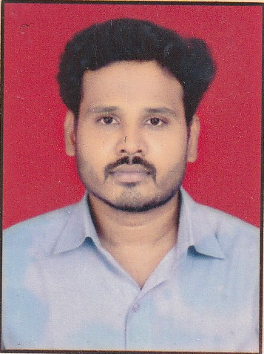
Objective:
A challenging job with opportunity to rise and grow where I can make the use of professional skills and qualifications for the better of the organization and seeking a suitable position to utilize my skill and abilities.

Permanent Address:

THE LANDMARK BUILDING, A WING 401
SECTOR: 12, KAMOTHE
NAV MUMBAI: 410209

Mobile: +918879695391

E- mail: vino0264@gmail.com

PERSONAL DATA:

D.O.B: 02nd April.1985

Sex: Male.

Father’s Name:
Mr. K.P MANI

Nationality: Indian.

Hobbies: Playing Cricket, travelling and reading.

Pen Picture:

In my personal life, perhaps I am an easy going personality. As far as my professional front is concerned, I am full of energy and get motivated by new challenges. I am good teacher as well as Lerner and usually meet the deadlines on time. I am a team player and learn very quickly.

philosopy :

- Believe in God, your diligence & yourself.
- Life is simple, it’s just not easy.

achivements :
- Awarded best conduct in my college.
Skills:
Languages: Hindi, English Tamil

Computers:

Effective user of all Windows based computer applications. MS Office, Power point, Excel

academic dossier:
2000-2001 SSC PASSED FROM STATE BOARD OF TAMIL NADU BOARD.
2002-2003 H.S.C PASSED FROM STATE BOARD OF TAMIL NADU BOARD.
2003-2006 Diploma Hotel Management & catering tech
INSITUTE OF HOTEL MANAGEMENT CATERING TECHNOLOGY
Panvel, Maharashtra, India

2007-2010 B.B.A. COMPLETED FROM ANNAMALAI UNIVERSITY

2010-2012 MBA HR COMPLETED FROM SHIVAJI UNIVERSITY KHOLAPUR

Experience:

Worked with Fariyas Hotel Lonavala Maharashtra for 1 yr. as Senior Steward.
6 month industrial training completed in all departments from Fariyas Hotel Lonavala, MAHARASHTRA
3 Years work experience as Training & Placement Officer in IHMCT PANVEL NAVI MUMBAI. (2007-2010)
In present working with PREMIER COLLEGE, PANVEL as a IN-CHARGE CUM HR MANAGER
From 2012 -2022

Declaration:
I solemnly declare that the above information is true and correct to the best of my knowledge. I understand that if any information given above is found false/incorrect, my candidature is liable to be rejected.

DATED: _____________ M.VINOTH KUMAR

(SIGNATURE)

