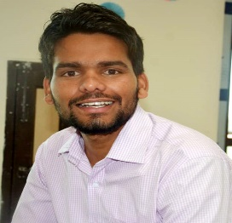**RESUME**

**Shri Ram Saini**

**Add:** Dhani Jatala, Post Maonda Kalan, Sikar Rajasthan

**Mobile No.:** 8279042262

**Email ID:** [kammaniyashriram@gmail.com](mailto:kammaniyashriram@gmail.com)

**CARRIER OBJECTIVES:-**

To seek a dynamic and challenging career an organization strives for excellence with my knowledge and team effort while making positive contribution to promote the individual opportunity and professional growth.

**ACADEMIC QUALIFICATION:-**

|  |  |  |  |  |
| --- | --- | --- | --- | --- |
| **Sr. No.** | **Class/ Degree** | **Board/University** | **Year** | **Division /Percentage** |
| 1. | High School | Rajasthan Board Ajmer | 2013 | 76.50% |
| 2. | Intermediate | Rajasthan Board Ajmer | 2015 | 84.60% |
| 3. | Graduation | PDUSU Sikar Rajasthan | 2018 | 62.27% |
| 4. | Post-Graduation | University of Hyderabad | 2021 | 80% |

* Qualified UGC/NET with JRF Examination in History.

**WORK EXPERIENCE: -**

**PERSONAL DETAILS: -**

**Father Name: -** : Sh. Sugan Chand Saini

**Mother Name: -** : Smt. Sarvan Devi

**Date of Birth: -** : 05/07/1998

**Gender: -** : Male

**Marital Status: -** : Unmarried

**Nationality: -** : Indian

**Religion: -** : Hindu

**Language Knowledge: -** : Hindi & English

**DECLARATION: -**

I hereby declare that the above information is true and correct to the best of my knowledge.

**Date: -**

**Place: - (**Shri Ram Saini)