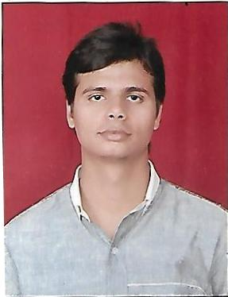 **CURRICULUM VITA**

**Pushpendra**

H. No. 72, Naveen Kunj, Ward No. 28, Loni, Ghaziabad

Pin Code:- 201102, U.P.

Contact: 8949047290

Email : pushpendrasingh3661@gmail.com

**CAREER OBJECTIVE**

My career objective is to work sincerely and to get more knowledge about work assigned to me. My passion is to become a potential professor by utilizing my skills and abilities.

**SUMMARY**

I am a history scholar pursuing PhD in Ancient Indian History, so as to prepare myself for the career I have chosen for myself, that is of being a professor. I want to gain knowledge of various aspects of Ancient India as well as Ancient World to that I can fulfill my dream of teaching students about the various magnificent eras of the past.

**EDUCATIONAL QUALIFICATION**

* High School passed from U.P. Board in 2009.
* Intermediate passed from CBSE Board in 2011.
* Graduated from University of Delhi with Bachelor of Arts (History Hons.) in 2016.
* Completed Post-graduation in Ancient History (Hons.) from Noida International University with Gold Medal.
* Pursuing PhD in Ancient Indian History from Amity University, Rajasthan.

**Research Works**

* Dissertation on the Architectural Techniques of The Great Pyramid of Giza.
* Working on Aeronautical Techniques in Ancient India: A Study Through Vedic Literature.
* Two Research Papers on Ancient Indian Aeronautics and Vimana Technology are under publishing in IJSRMT.
* Library member as Research Scholar at Nehru Memorial Museum & Library, New Delhi.

**EXPERIENCE**

* Bijendra Singh Memorial Public School (1 year teaching experience)
* New Adarsh Public School (2 year teaching experience)

**STRENGTHS**

* Positive Attitude
* Honesty
* Punctuality
* Self-Motivation

**PERSONAL DETAILS**

Date of Birth : 10th February 1994

Father’s Name : Sh. Hoshiyar Singh

Marital Status : Unmarried

Nationality : Indian

Hobbies : Reading and travelling

Declaration:

I hereby certify that all particular stated above to best of my knowledge and believe true and fair.

Date: 28th April 2022

Place: Deeg