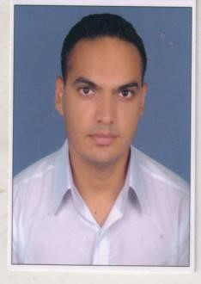**Curriculum Vitae**

**Kulbir singh**

H. No. 223, Azad Nagar,

Sultanwind Road, Amritsar (Punjab) **(M)** 09915695115, 09463966014

# Career Objectives

To become a part of Growth Oriented Organization and achieve great heights with my hard work and dedication.

# Qualification

• B.A from GNDU

• M.A from GNDU

# Technical Qualification

* Security Management Diploma for the post of Security Manager from Police Training Centre at Jahan Khelan, Hoshiarpur
* NCC ‘C' Certificate
* IELTS
* ISLPR

# Computer Proficiency

* MS-Word
* MS-Excel
* MS-PowerPoint

# Experience

* Presently, Sr. Hostel Warden at Chandigarh University in Mohali from 1 Oct 2021 to till date.
* Hostel Warden at Icici Academy for Skills in Mohali from 17 July 2017 to 17 July 2021
* Hostel Warden at DAV University in Jalandhar from 3 Aug 2016 to 8 July 2017
* Assistant Administrative Officer cum Asst. Hostel Warden from 6June 2011 to 19July 2014 at Lovely Professional University in Jalandhar.

# Hobbies

* Reading Magazines
* Blood Donation (Donated 11 time till today)

# Strengths

* Grasping Power and Innovative Mind
* Confidence and Dynamic
* Good Planning and Execution
* Leadership
* Govt. Liaison

# Personal Detail

|  |  |  |
| --- | --- | --- |
| Father's Name : | | S. Sukhwinder Singh (Army Officer) |
| Date of Birth | : | 26 July, 1982 |
| Language Known | : | English, Punjabi and Hindi |
| Nationality | : | Indian |
| Marital Status | : | Married |
| Email ID    **Declaration** | : | kulbirsingh49@yahoo.com |

*I hereby declare that the information given above is true to the best of my knowledge.*

Kulbir singh

Date : Signature