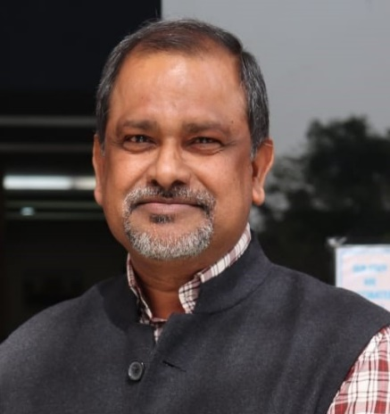Curriculum Vitae

**Mr. Prasanta Swarnakar**

**(MA, B. Com, Executive Diploma, DCA)**

**PRESENT POSITION** Deputy Registrar

JK Lakshmipat University

Jaipur

**DATE OF BIRTH** January 21, 1970

**MOBILE NO:** 08094683124

**E-MAIL:**  prosad1970@gmail.com

# AWARDED “Excellent Performer of the Year 2000-2001” Awarded by Nirma Institute of Management, Ahmedabad, Gujarat. India

# ACADEMIC QUALIFICATION

|  |  |  |  |  |
| --- | --- | --- | --- | --- |
| **Examination Passed** | Board/University | **Year** | **% of Marks** | Subjects Taken |
| MA  (Economics) | Eastern Institute of Integrated Learning in Management (EIILM) University, Sikkam | 2011 | 66% Passed | Advanced Micro Economics, Agriculture Economics, Research Methodology,  Development Economics, International Economics, Advanced Macro Economics  Monetary Economics, Fiscal Economics,  Economics of Growth and Development,  Environmental Economics |
| B. Com | The University of Burdwan, West Bengal | 1991 | 38% Passed | Accountancy, Economics, Business Organization. |
| Higher  Secondary | West Bengal Council of Higher Secondary Education, West Bengal | 1989 | 40% Passed | Accountancy, Business Organization, Economics, English & Bengali. |
| Madhyamik  Examination (Secondary) | West Bengal Board of Secondary Education,  West Bengal | 1986 | 45% Passed | Bengali, English, Mathematics, History, Physical Science, Life Science, Geography, Work Education & Physical Education. |

# PROFESSIONAL QUALIFICATION

1. **Diploma in Computer Application (DCA)** from **Hi-Tech Computer Academy**, Vastrapur, Ahmedabad, Gujarat, during September 1996 - February 1997.
2. **Executive Diploma Programme (EDP) in Information Technology** from **Nirma Institute of Management**, Ahmedabad, Gujarat, during October 2000 - May 2001.
3. **Course Certificate** in **Introduction to Data Analysis Using Excel** an online non-credit course authorized by **Rice University, Houston, United States** and offered through Coursera, six weeks completed on October 07, 2020.

###### COMPUTER PROFICIENCY

### Having Good Knowledge of Computer & Office Equipment’s:

Windows, Microsoft Office (Word, Excel, and Power Point) and Familiar with Internet Operations

**DETAILS OF TRAINING/WORKSHOP ATTENDED**

1. **Staff Development Programme** from **Institute of Management, Nirma University of Science and Technology, Ahmedabad**, during February 09-10, 2008.
2. **Management Development Programme (Managerial Skills for Technical Professionals)** from **Institute of Management, Nirma University, Ahmedabad**, during July 22-23, 2010.
3. **Technical Workshop** on **“**Modification Assured Career Progression Scheme & Pay Fixation under the New Rules on Implementation VIth CPC Report**”** from **Centre for Training & Social Research**, New Delhi, during September 05 – 07, 2013.
4. **E-Conclave** on **“Higher Education & Building Successful Career Post Covid-19”** Organized by **JK Lakshmipat University, Jaipur** in association with NHRD Network on July 03, 2020.
5. **Workshop** on the 4-day **“Enhance Your Professional Effectiveness”** Workshop from **Confederation of Indian Industry, New Delhi** during January 14th – 17th, 2021.
6. **23rd NHRD National Conference** **“Transforming HR: Agility. Resilience. Digital,** hosted in virtual mode by the Delhi & NCR Chapter during February 26 – 27, 2021

WORK EXPERIENCE 30 YEARS

**May 2017 onwards** Presently, I am working with **JK Lakshmipat University,**

**(Duration: 05 Years) Jaipur, Rajasthan** as **Deputy Registrar - HR & Operations.**

**April 2013 - April 2017 JK Lakshmipat University, Jaipur** as **Assistant Registrar**

**(Duration: 4 Years 01 Months)**

**September 2010 - March 2013 JK Lakshmipat University, Jaipur** as **Section** **Officer**

**(Duration: 2 Years 07 Months)**

**March 1998 - August 2010:** **Institute of Management, Nirma University**, Ahmedabad,

**(Duration: 12 Years 06 Months)** Gujaratas Senior Clerk in the Admissions Division.

# 

**December 1997 - March 1998:****Royal Castor India Limited, Royal Group,** Ahmedabad

**(Duration: 04 Months)** as **Computer Operator cum Assistant**.

**February 1993 - December 1997:****Indian Institute of Management,** Ahmedabad, Gujarat as

**(Duration: 4 Years 11 Months) Research Assistant**.

**January 1991 - February 1992:** **M/s. Mondal Black Stone,** Phatarchal, Po: Harinsingha, Birbhum

**(Duration: 1 Year 2 Months)** West Bengal as **Accountant.**

**REFERENCES Dr. Devi Singh**

Former Director, Indian Institute of Management Lucknow

Mobile: 08698967711/9818623000, E-mail: devisingh@hotmail.com

**Dr. Upinder Dhar**

Vice Chancellor

Shri Vaishnav Vidyapeeth Vishwavidyalaya, Indore

Mobile: 09829089526/09425900020, Email: [upinderdhar@gmail.com](mailto:upinderdhar@gmail.com)

**Mr. Prakash Choudhary**

Principal

Prestige Public School, Indore

Phone: 9630091365, Email: pchoudhary06@yahoo.co.in