*RESUME*

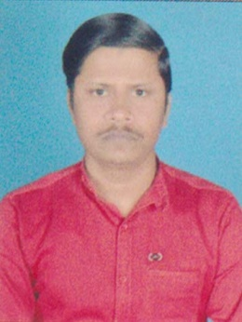

**GANGANAND KUNWAR**

S/O **:-** Shashi bhushan prasad

AT **:-**  At – Sadpura Near Durga mandir

Ramna

Muzaffarpur

Pin -842002 (Bihar)

**Mobile:- 9431814946**

**Whatsapp No- 9431827443**

**Email-ganganand7864@gmail.com**

##### OBJECTIVE

I am looking forward to a challenging position, where I could garner skills and leverage my strengths through hard work.

##### EDUCATIONAL QUALIFICATIONS

1. 10th  passed from CBSE in 2013 with 85% .
2. Intermediate (I.Sc) from B.S.E.B. Patna with 65%.
3. B.Sc (Agriculture) Appearing. (7th Semester)

**Computer Knowledge**

* **DCA**

**PERSONAL PROFILE**

**Father’s Name** **:**  Shashi bhushan prasad

**Marital Status :** Unmarried

**Date of Birth : 25/07/1998**

**Religion** **:** Hindu

**Languages proficiency :** Hindi, & English

**(Ganganand Kunwar**)