**ATANU BHATTACHARYA**

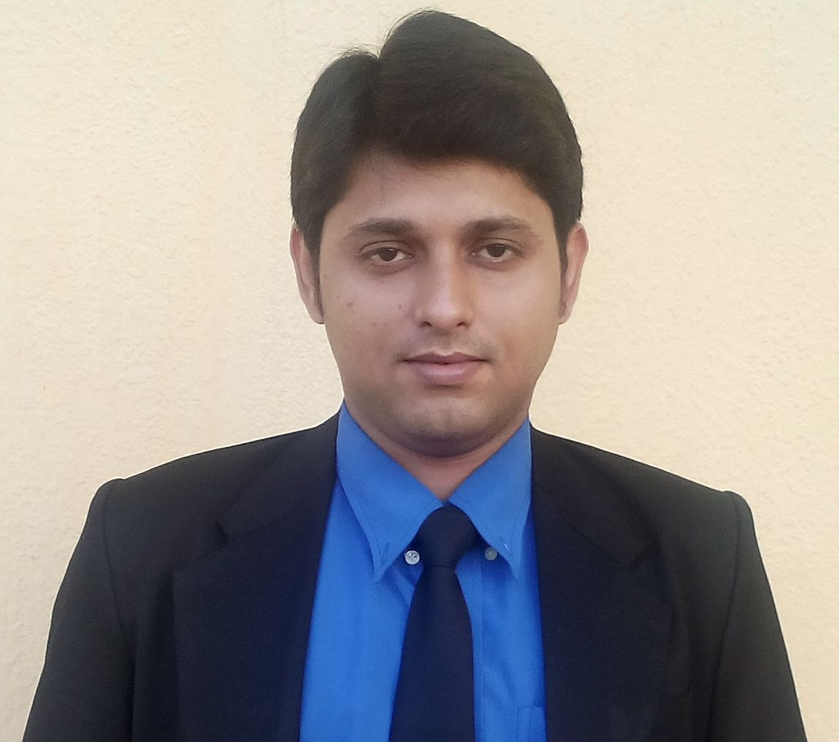

**+91-9512742934**

****[**atanubhattacharya230@gmail.com**](mailto:atanubhattacharya230@gmail.com)

**SKYPE : atanu.bhattacharya11**

**FRONT OFFICE PROFESSIONAL**

**OBJECTIVE:**

My aim is to learn and gain experience in a progressive organization.

I believe my sincerity and hard work combined with my academic qualifications should stand me in a good stead. Any challenging assignment, which will give me the opportunity to learn and grow, is what I earnestly seek. I aim to secure a position of responsibility in a short span of time.

**Personal Profile:**

A hotel management graduate from Institute of Hotel Management, Catering Technology & Applied Nutrition, Kolkata, West Bengal. **Presently working with IHM, Hisar as an Assistant Professor (H.O.D).** This job has enabled me to teach young aspiring students, the basic aspects of Front office, Rooms Division and has also given me a chance to serve the industry in a very noble manner.

**EDUCATIONAL SNIPPETS**

**MBA in Marketing Management - 2016**

Annamalai University, Tamil Nadu

**Bachelor Degree in Hospitality Management & Catering Technology - 2010**

Hotel Management, Catering Technology & Applied Nutrition, Kolkata, West Bengal

**10th +2 - 2005**

Indian School Certificate Examination

**10th 2003**

Indian Certificate of Secondary Education

## IT Skills

Windows Operating System, IDS, Opera, Fidelio, Prologic, Mini, MS Office, Internet surfing

**ACHIEVEMENTS OF LIFE**

* **Secured 1stposition in Essay Competition in “NATURE MATES” Kolkata**

**PUBLICATION**

* Article “The Effect of Covid-19 on Hospitality Sector”, published in **HUMANITARIAN CEREBRATIONS AND PANDEMIC IN INDIA** (ISBN: 978-93-92240-20-1)
* Indian Patent on “Artificial Intelligence Powered Hotel Revenue Management System”. Published in April, 2022. (Application No: 202231015260)

**PROFESSIONAL SNIPPETS**

**Institute of Hotel Management, Hisar, Haryana**

**Head of the Department (From Dec, 2020 to Till Date)**

* Setting up of IHM i.e taking approval of NCHMCT (Noida, Sec-62) to start IHM, Hisar. The process has ended and IHM, Hisar is now one amongst total 76 IHMs all over India.
* Allocation of the practical labs floor wise keeping in mind the weight-age of equipments & heavy machineries.
* Installation of Gas-stations as per the entire building plan for smooth running of the food-production practical classes.
* Linear arrangement of the chimneys and working-tables in the labs.
* Bakery Lab set-up in accordance to the mentioned parameters.
* Entire planning of the Training Restaurant including the linear set-up of the tables, chairs, dummy-waiters and also the interior designing, which also includes the Training Bar.
* Bar planning with all the equipments as per NCHMCT norms.
* Set-up of the Front Office Operation lab.
* Set-up of the House-Keeping Operation lab & installation of all the equipments and machineries as per the electricity connection availability.
* Responsible for maintaining the regular operations of academics.
* Responsible for maintaining performance level of students.
* Organizing Webinars for students and to help them in their career advancement in hospitality sector.
* Taking practical classes in Rooms Division Management.
* Preparation of Time-Tables and calculation of lecture loads as per various programs.
* Giving Power-Point presentations for a better understanding of the Hospitality Sector.
* Preparing Question papers of Theory & Practical Examination.
* Taking care of the Semester examinations.
* Continuous assessing of students’ performance standards and guiding them as required.
* Arrangement of Industry visits to Star category Hotels in Delhi, NCR or Chandigarh region.
* Setting up of Interviews of students for the Industrial Training for 6 months in Star category Hotels.

**Sunder Deep IHM, Ghaziabad**

**H.O.D (NCHMCT) cum TPO – Hotel Management (From July, 19 to Nov, 2020)**

* Responsible for taking routine classes.
* Responsible for maintaining standard grooming of students.
* Organizing guest lecturers for students and to help them in their career advancement in hospitality sector.
* Taking practical classes in Front Office.
* Handling the Front Office Department.
* Giving Power-Point presentations for better understanding of the Hospitality Sector.
* Preparing Question papers of Theory & Practical Examination.
* Setting up of University Question Papers.
* Heading the examinations section.
* Handling THIMS (NCHMCT specialized software for IHM Colleges).
* Conducting Practical examination for the National Council.
* Assisting in Career Counseling.
* Taking Specialization practical classes in Front Officefor the Final year students.
* Conducting Job Fair for the students.
* Arrangement of Events inside the Campus.
* Training & Placement of students.
* Continuous follow-up with the Hotels for feedback about the Trainees from the College.

**Regal College of Hotel Management & Tourism**

**(Chiplun, Maharashtra)**

**H.O.D – Hotel Management (From June, 18 to June 19)**

* Leadership & Management - Responsible and accountable for setting and advancing the academic strategy of the Department in line with Faculty and University strategic plans and direction.
* Responsibility of Research - Ensure the highest levels of quality, integrity and ethics in all research undertaken. Create a dynamic and forward looking research environment for both staff and students
* Knowledge Transfer - Create and exploit new opportunities for knowledge transfer activity in order to secure additional income streams and new areas of teaching and/or research
* People Management - Ensure that staff performance is managed appropriately and in a way that is consistent with the expectations of the Sheffield Academic, and that fair workload allocation processes are in place
* Financial Management - Manage income and expenditure in order to promote financial sustainability
* Quality Assurance -  Ensure all activities are carried out to the highest possible standards and put in place the necessary evaluation and monitoring procedures to ensure both compliance and improvement: such procedures will include teaching, research and management of all resources
* Development of Academic/ Research Understanding - Continue to develop one´s position as a leading academic researcher; including publication, securing of external funding and the pursuit of other relevant indicators of standing in the field. Give due consideration to ways of retaining connections with teaching at both undergraduate and postgraduate levels
* Person specification for different departments - Candidates will have a very strong academic record and standing and have a very good understanding of the academic disciplines within the department. Candidates will have the ability to engage constructively with people, have excellent communication skills, have excellent delegation skills,  be able to develop their skills and seek advice from a variety of sources and be flexible and adapt to changing circumstances
* Training & Placement - Placement is a crucial interface between the stages of completion of academic program of the students and their entry into the suitable employment. Our placement cell is performing the following activities

**OTHER ACTIVITIES**

1. Arranging in-plant training for students.
2. Inviting various organizations for recruitment
3. Training to suit various needs of industry.
4. Personality development.
5. Interview Techniques
6. Interpersonal and Communication Skills.
7. Career planning and career mapping.
8. Placement across the country.
9. International Internships & Jobs.

**AIMS Institute, Anand, Gujarat**

**Asst. Professor – Hotel Management (From July, 15 to June, 18)**

* Responsible for taking routine classes.
* Responsible for maintaining standard grooming of students.
* Organizing guest lecturers for students and to help them in their career advancement in hospitality sector.
* Taking **practical classes in Front Office**.
* Handling the Front Office Department.
* Giving Power-Point presentations for better understanding of the Hospitality Sector.
* Preparing Question papers of Theory & Practical Examination.
* Setting up of University Question Papers.
* Conducting Practical examination for the University.
* Assisting in Career Counseling.
* Taking **Specialization practical classes in Front Office** for the Final year students
* Preparing for probable On-Campus Questionnaires.
* Preparing of new brochures of the College for the new admission year.
* Assisting the Marketing department in every possible way.
* Approaching to different schools for **College presentation.**
* Preparing **Presentations for Marketing.**
* Assisting in the **Banners and Leaflets for College Advertisement.**
* Analysis of **Market Segmentation.**
* **Preparing Marketing Budget every year and presenting it to the Management.**
* Meeting the **Personal Enquiries**during admission for free-counseling.
* Meeting the guardians and updating them about the present academic position of the students.
* Taking Skill Development Classes.
* Performing the duties of Teacher and Head a Department for a particular subject or group of subjects.
* Actively assisting the Head of Institution in ensuring the good professional practice, standards, and quality of teaching and learning of subject/s through proper dialogue with the class teachers and promotes a healthy process of reciprocal informal observation of class teaching practices.
* Advising and contributing to curriculum development at College and system level under the direction and guidance.
* Coordinating the teaching and learning of the subject/s for which one is responsible.
* Setting examination papers, coordinating marking schemes and moderating examinations and assessment processes.
* Ensuring timely and adequate provision of textbooks, materials, and equipment required for the effective teaching of the subject across in the College.
* Ensuring that the maintenance and upkeep of equipment related to the subject at College is regularly carried out.
* Preparing specifications and budgets for the requirements of the subject specific teaching tools and equipment, including laboratory equipment.
* Mentoring other teachers in the subject/level of their specialty.
* Holding and leading regular departmental meetings and ensuring the keeping of minutes.
* Training & Placement - Placement is a crucial interface between the stages of completion of academic program of the students and their entry into the suitable employment. Our placement cell is performing the following activities

**Golden Regency Institute of Hospitality Management**

**Haldia, West Bengal**

**Lecturer – Front Office (From Dec, 14 to July, 15)**

* Responsible for taking routine classes.
* Responsible for maintaining standard grooming of students.
* Taking care of sports committee.
* Organizing guest lecturers for students and to help them in their career advancement in hospitality sector.
* Taking care of Library as Teacher-in-Charge Library.
* Taking **practical classes in Front Office**.
* Acting as Assistant Hostel Warden.
* Aesthetic & hygienic upkeep of the boys’ hostel.

**Radisson Blu, Noida**

**Lobby Manager – Front Office (From Apr, 14 to Nov, 14)**

* Greets the VIP guests of the hotel. As directed by the Front Office Manager, Performs special services for VIP Guest’s.
* Assists in VIP’s arrival departure in absence of guest relation officers.
* Checks cleanliness of lobby and public areas, lights and as well as front office staff in proper and orderly appearance and behavior.
* Checks on registration cards of arriving guests and ensures all information should be filled on each cards either by Guest Relation Officers or the guests.
* Assists in sending guest messages or faxes.
* Gives the instructions to the Night Reception, during the high occupancy periods, regarding: walk-in guests and release room blocked because of no- shows
* Assists in handling room lock problems.
* Prepares and checks for VIP’s arrival and escorts guests to rooms.
* Co-ordinates with all departments concerned in order to maintain Front Office functions properly.
* Operates the front office computer system in order to assist front office attendants.
* Checks group department, fit and ensure switchboard makes appropriate wake up calls.
* Handles guest complaints and other related problems and reports on the Assistant Manager’s log book.
* Assists reception, business centre, cashier, concierge and bell captain during they are busy.
* Answers guest inquires, handles complaints and attend to the needs of the guests.
* Approves and sign for allowances, rebates etc., as required by Front Office Cashier.
* Authorizes charges to be made for late departures and/or compliments on them.
* Promotes and maintains good public relations.
* Motivates and maintains good staff relations.
* Maintains and be guided of hotel policy on credit/lost and found hotel guests properties.
* Follows up in credit check report, liaise with credit manager.
* Responsible for front office operation during the absence of Front Office Manager (HOD).
* To discuss all matters that needed to follow up with the next shift Reception Manager.
* Approves the working schedule for the front office attendants and submits them to front office manager (HOD).
* Conducts and ensures the neat of appearance of front office attendant as well as correct attitude and behavior, discusses problems that encountered on this point with front office manager, assistant front office manager and their shift leaders.
* Assigns and Approves Duty roster for all Front desk staffs.

**Radisson Blu, Noida**

**Front Office Executive (From Jan, 13 to Mar, 14)**

* Great all Guests at all the time in a friendly and helpful manner, and attempt to learn and use Guest’s names at every opportunity.
* Upon Check in, ensure that the Guest completes his registration card completely and legibly, and that the guest is assigned a room of the Type and the rate indicated on the Reservation.
* Accommodate Guest’s special requests whenever possible assist in pre-registration and room blocking whenever necessary.
* Stay up to date on Room Rates, Special Packages, Discounts and how to handle each.
* In the case of Walk-in , making sure that the Guest should be sold a room with the highest possible room rate.
* To use the up-selling techniques in order to maximize the Rooms Revenue.
* Being knowledgeable of all the Credit cards and cashing policies, and how to handle cash properly and efficiently.
* Develop Detailed Knowledge of the Rooms’ Locations, Facilities and Types.
* Develop Detailed Knowledge of the Hotel’s Key Personnel, service, outlets, and hours of operation for each.
* Handle the Safe Deposit Boxes according to the Hotel procedures
* Prepare and report guests with High Balance to the attention of the Front Office Manager.
* Be thoroughly aware of the hotel reservation system, and cancellation policy.
* Communicate with all other departments through the proper channels, and through the Communication Forms.
* Promptly notify the Housekeeping of all check outs, early check in, special requests in the rooms.
* Action the Housekeeping reports immediately upon Receipt, record Discrepancies and report to the Shift Leader.
* Develop a working Knowledge of the Reservation Department, Take same day reservations, and be aware of the cancellation procedures.
* Use proper Telephone manners.
* Understand and use properly the Mail, Parcel, Message Delivery.
* Report any unusual occurrence or request to the Manager on Duty or the Front Office Manager.
* Read and initial pass on logbook and Front Office Bulletin Board to keep updated and current.

**Radisson Blu, Noida**

**Front Office Supervisor (From Jul, 11 to Dec, 12)**

* Supervise daily shift process ensuring all team members adhere to standard operating procedures.
* Uses suggestive selling techniques to sell room nights, increase occupancy and revenue.
* Ensure Outstanding customer care at all times.
* Courteously and accurately answers inquiries from potential guests and accepts hotel reservations.
* Responds to telephone and in-person inquiries regarding reservations, hotel information and guest concerns.
* Train, direct the work of, resolve issues/problems and coach and counsel the front desk team members to ensure a quality operation.
* Adhere to company credit limit / floor limit policies.
* Resolve customer issues, complaints, problems in a quick, efficient manner to maintain a high level of customer satisfaction and quality service.
* Build strong relationships and liaise with all other department's especially housekeeping, reservations etc.
* Allocate rooms to expected arrivals after checking the guests’ preferences and special requests.
* Operates the EPBX equipment, including, assisting incoming & outgoing calls, setting wake-up calls, enabling DND (Do Not Disturb) and paging for in-house guests.
* Cross Check all billing instructions are correctly updated
* Controls cash transactions at the front desk and maintains complete responsibility for personal bank as specified by hotel bank agreement policy.
* Performs other duties as assigned, requested or deemed necessary by management.
* Performs other duties as assigned, requested or deemed necessary by management.
* Ensure Front office log book and hotel log book is always updated and actioned upon.
* Ensures safety by following guest check in and security procedures and reporting suspicious activity to security, manager, or MOD.
* Participate in hotel committees and task force assignments
* Assist all departments in servicing the guests during high volume periods.

**Radisson Blu, Noida**

# Front Office Assistant (From Jul, 10 to Jun, 11)

* Welcoming the Guest.
* Serving welcome drink to the Guest.
* Preparing Guest Registration Card & educating the guest about it.
* Preparing Welcome Letters.
* Handling of Master key.
* Assigning & Allotting of Guest Rooms.
* Preparing Group Registration Cards when there is a group arrival.
* Cashiering & Cash Handling.
* Updating C-Forms.
* Handling Foreign Money Exchange Cashiering.
* Changing of Foreign Exchange Money Rates.
* Making Reservation, Cancelling Reservation, Amending Reservation & Re-Instating them if required.
* Preparing Complimentary Drinks Coupon.
* Batch Settlement of EDC machines.
* Handling Guest Mails & Message Slips.
* Updating RLM Register on a regular basis.
* Checking all Room Rates.
* Posting of Room Rates before Night Audit.
* Slotting of Food & Laundry Supporting along with Guest Registration Cards.
* Handling Travel Desk.
* Closing of Cash in respective shifts.
* Cashiering for Banquets.
* Preparing Night Reports.
* Checking of all Check Out Bills following Settlement Summary.

# The Park, Kolkata

# Industrial Trainee (From June, 08 – Nov, 08)

(All four major departments)

# 

# Personal Details

Father’s Name : Mr. Arun Bhattacharya

Date of Birth : 19th July 1987

Current Address : 2nd by lane, D.C Rakshit Road, Birinchi

Bagan, Bosepara, P.O. Chandannagar

Hooghly, West Bengal.

Pin - 712136

Marital status : Married

Language known : English, Hindi, Bengali, Gujarati, Marathi

Height : 5’ 10” Inches.

Hobbies : Singing, Playing chess, Watching

movies, Kite flying.

**Place : Hisar, Haryana**

**(Atanu Bhattacharya)**