**CURRICULUM VITAE**

Name of Applicant: **ALKA TIWARI** 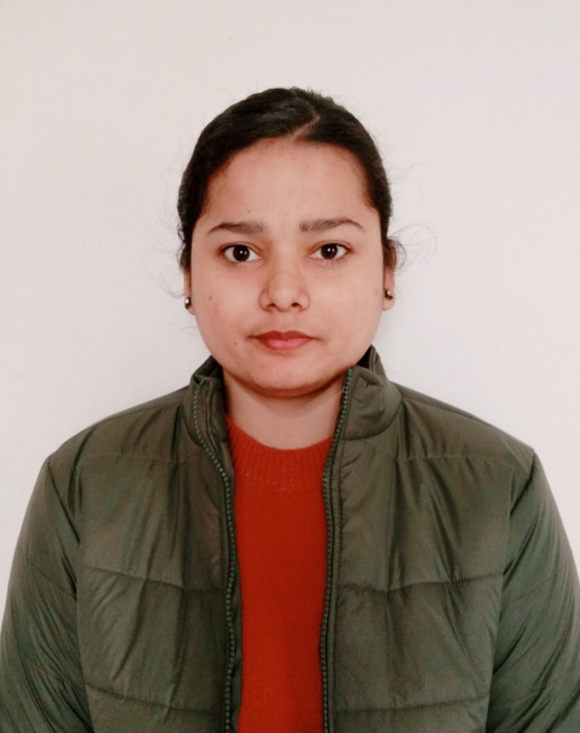

Date of Birth: 05.03.1996

Postal address: Flat C2, Janak Plaza Apartment

RK Puram, Danapur Cantt, Patna- 801503

Contact number: 8340538722, 7677510762

Email id: [aspirantalka@gmail.com](mailto:aspirantalka@gmail.com)

Educational Qualifications:

|  |  |  |  |  |  |
| --- | --- | --- | --- | --- | --- |
| Name of the Degree | Name of the University or examining body | Percentage of marks obtained | Division obtained | Year of Passing | Subject (s) (Major) |
| Matriculation | CBSE | 93.8% | 1 | 2012 | English, Hindi, Maths, Science, Social Sciences |
| Intermediate | CBSE | 80.8% | 1 | 2014 | Physics, Chemistry, Maths, Biology, English |
| Bachelor of Arts (Honours) | Patna Women’s College, Patna University | 67.12% | 1 | 2017 | Political Science (Honours), History and English (subsidiary) |
| Master of Arts | IGNOU | 67% | 1 | 2021 | Political Science |
| UGC NET | National Testing Agency(NTA) | 97.08 percentile | Qualified | 2022 | Political Science |

Extra Qualifications:

Certificate of Merit for being top 0.1% successful candidates in Biology in Intermediate in 2014.

Certificate course in Human Rights from Patna Women’s College

Certificate course in Computer Literacy from Patna Women’s College

Certificate course in Remedial English from Patna Women’s College

LibreOffice Suite Writer from Patna Women’s College

LibreOffice Suite Impress from Patna Women’s College

Declaration:

I hereby declare that all the data and information provided above are true and correct to the best of my knowledge and I hold myself responsible for any irregularities, if found.