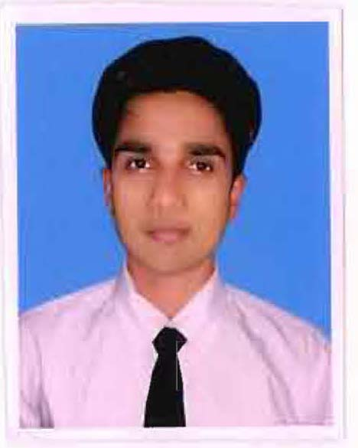**Curriculum Vitae**

**YOGENDRA PRASAD PADhy**

**career Objective**

**CAREER OBJECTIVE**

I want to be apartof an organization that would give me an opportunity to continuously enhance my knowledge and help me gain experience while effectively contribute to overall organizational goals. To work in a challenging, rewarding and fulltime career in “Tourism and Hospitality Industry” with an intent to develop a career in positive, progressive and high-tech corporate environment which will give me to realize my full potential.

**ACADEMIC QUALIFICATION**

* Passed **10th** from **BAPUJI HIGH SCHOOL KAMIRA** in the year 2009.
* Passed +**2** from **G.M. JUNIOR COLLEGE SAMBALPUR** in the year 2012.
* Completed **Bachelors in Tourism & Hospitality management** from **National Institute of Hotel Management and Tourism, Bhubaneswar** in the year 2016.

**PROFESSIONAL QUALIFICATION**

Pursuing **Ph. D.** in **6th** Semester (Theses pre-submission in August, 2022) at **Lovely Professional University, Punjab** in Tourism & Hospitality management (Hotel Management).

I have persuaded Masters in Tourism & Hospitality Management in **Bhadrak** **Autonomous College**, permanently affiliated to Fakir Mohan University, Odisha.

**WORK EXPERIENCES**

* Working presently as an Assistant Professor in Hotel Management department in **Front Office and Housekeeping department** at **Sant Baba Bhag Singh University, Jalandhar**.
* Worked as an Assistant Professor at **CT University, Ludhiana** in the core areas of both **Front Office and Food & Beverage Services.**
* I have an Industrial experience in the **Zuri** **White Sands Goa Resort & Casino** in all Core Departments.
* I have worked as a “**Front Office Faculty**” in Central Institute of Hotel Management & Catering, Bhubaneswar, Odisha.
* Worked as a Trainer in **HOUSEKEEPING** utility trade under Odisha Skill Development Authority with SIHM, Balangir.
* Worked as a “**Food & Beverage Service Trainer**” in HDFC Bank Parivartan, Bhubaneswar under NSDC based on a CSR Project.

**MY KEY SKILLS**

* Very much comfortable in Team work & ability to work under pressure.
* Self-motivation & ability to take initiative.
* Quick learner, keen to learn & improve skill with self-confidence.
* Hard working & Dedication.

**HOBBIES**

* Playing cricket & solving puzzles
* Listening Music & Dancing
* Reading Books, Articles and Newspapers
* Travelling to different Tourist Destination Places.

**ACHIEVEMENTS**

* Working as a NAAC member of two criteria.
* Selected as Cricket Commentator in Sonepur District Cricket Association.
* Working in Training & Placement department.
* Certified as a Mr. Fresher Ph.D. Scholar of the term 2019.

**PERSONAL PROFILE**

**Name : Mr. YOGENDRA PRASAD PADHY**

**Father’s Name : Mr. DHARANIDHAR PADHY**

**Father’s Occupation : FARMER**

**Date of Birth : 28th November 1993**

**Gender : Male**

**Marital Status : Unmarried**

**Nationality : Indian**

**Religion : Hindu**

**Height : 5‘8’’**

**Weight : 66 kg**

**Blood Group : O +**

**Vision : 6/6**

**Email :** [**padhyyogendra@gmail.com**](mailto:padhyyogendra@gmail.com)

**Contact No. : +91- 7978780490**

**Languages Known : Hindi, English & Odia.**

**DECLARATION**

I do hereby declare that all the above-mentioned information is correct to the best of my knowledge & belief. I bear the responsibility for the correctness of these particulars.

**Date:**

**Place**: ***Signature of the Candidate***