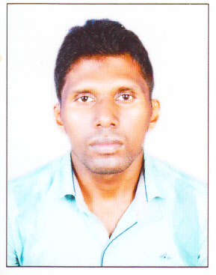**RESUME**

Name: SUNIL BARI

C/O- Jenaram Bari

Address: At-Pahadpur

Post- Aharbandha

Ps-Badampahad

Dist- Mayurbhanj, Odisha

Pin-757050

Contact No- 7735915004,8118032635

E-Mail- ID- [sunilbari902@gmail.com](mailto:sunilbari902@gmail.com)

**Career Objective:-**

* I am a self motivating & quality conscious person and my key attributes are firm determination, innovative ideas, positive attitude never dying confidence to work in the most challenging position with an organization that provides ample opportunities to learn & to contribute.

**Educational Qualification:**

|  |  |  |  |  |
| --- | --- | --- | --- | --- |
| **Qualification** | **Institute** | **Board University** | **Year Of Passing** | **Percentage/**  **CGPA** |
| 10th | Aharbandha High School | BSE,  Odisha | 2008 | 35.00% |
| +2 ( Arts) | Badam Pahad Junior College, Badma Pahad | CHSE,  Odisha | 2011 | 43.33% |
| +3 (Arts) | North University | Badam Phaad Degree College | 2014 | 41.33% |
| PG MSW | Utkal University Culture | Utkal University Culture | 2018 | 55.67% |
| PH.D | Opjs University Churu | Rajesthan | Reg Nu-15320016 |  |

**Computer Proficiency:**

* PGDCA

**Personal skills:**

* Self confidence
* Attractive personality

**Family Details:**

|  |  |
| --- | --- |
| Name | Occupation |
| Jenaram Bari | Farmer |
| Doli Bari | House Wife |

**Personal Details:**

Date of Birth : 5th Oct 1990

Gender : Male

Marital Status : Signal

Category : ST

Nationality : Indian

Hobbies : Playing Football

Languages Known : Hindi, English & Odia

**Declaration:**

* The information provided by me above is true to the best of my knowledge and belief.

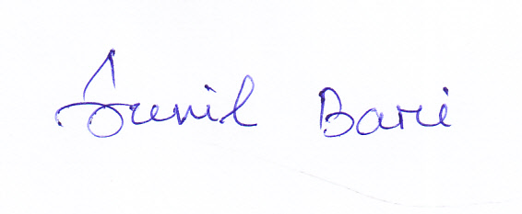

**Date :26/04/2022**

**Place: Pahadpur Signature**