# **CURRICULUM VITAE**

**AVINASH DONGARE**

**M.Sc.(Mathematics),CSIR NET (AIR- 73), SET, GATE.**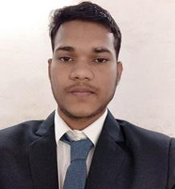

Asst. Professor, Bharat College of Arts & Commerce,Badlapur.

Email.ID [sangramdongare1994@gmail.com](mailto:sangramdongare@gmail.com)

Mobile No. 8424946978

303, B-Wing,Farheen Apartment,Near Matoshree Vidyamandir,

Ajade Gaon,Dombivli (East)

Pin Code:421201

**ACADEMIC ACHIEVEMENTS**

|  |  |  |  |
| --- | --- | --- | --- |
| EXAMINATION | INSTITUTE | PERCENTAGE | PASSING YEAR |
| M.Sc.(Mathematics) | Mumbai University | 57.80% | May 2018 |
| B.Sc.(Mathematics) | Mumbai University | 79.31% | April 2015 |
| HSC | Maharashtra Board | 71.33% | February 2012 |
| SSC | Maharashtra Board | 87.64% | March 2010 |

* Qualified CSIR NET (AIR-73) Exam in 2022.
* Qualified Maharashtra SET Exam in 2022.
* Qualified GATE Exam in the year 2022.

**EXPERIENCE**

* Lecturer in Mathematics at Bharat College of Arts & Commerce, Badlapur ( From 2018 to Till date)
* Worked as lecturer for CS & IT Students.
* Subjects Taught :

Discrete Mathematics,Linear Algebra,Calculus,

Statistical Methods & Testing of Hypothesis

Statistics & Introduction to Probability,COST

Applied Mathematics,Operation Research

Numerical & Statistical Methods,CGT

* Worked as Exam Coordinator,Cluster College Coordinator,Chairperson of Competitive exam Study centre committee
* Lecturer in Mathematics at JSSP College Khardi, Shahapur ( From 2017 to 2018)
* Worked as lecturer for B.Sc. Mathematics Students.
* Subjects Taught : Real Analysis, Linear Algebra,

Abstract Algebra,Graph Theory,

Numerical Analysis,Calculus,

Commerce Mathematics

**TECHNICAL SKILLS**

Programming languages : Basics of 1) R software 2) Scilab

**ACHIEVEMENTS**

1. Published Article “Why linear Algebra …?” in Episteme Journal of Bharat College , Badlapur in 2018
2. Published Research paper “Developing India: Opportunities and Challenges of Agricultural Growth in India” in Episteme Journal of Bharat College , Badlapur in 2019.
3. Published Research paper “A study on impact of Air Pollution on Human Health” in UGC Care Journal in 2020.

ISSN: 2394-3114 Vol-40-Issue-51-March-2020

1. Published Article “ REVIEW ON IMAGE COMPRESSION TECHNIQUES” in Episteme Journal of Bharat College,Badlapur in2021

**BASIC DETAILS**

Languages : English, Hindi, Marathi

Date of birth: 16th March, 1994

Permanent Address : At Nadgaon, Post Sogaon, Tal Shahapur, Dist-Thane Pin Code 421601

Date : 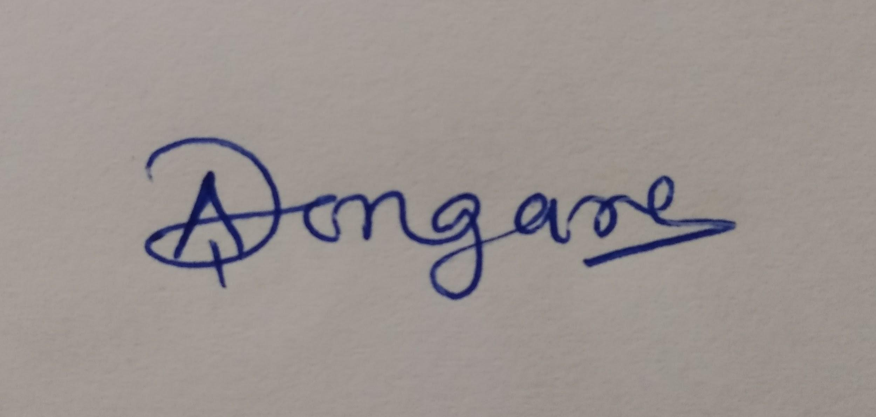

Place: (Avinash Dongare )