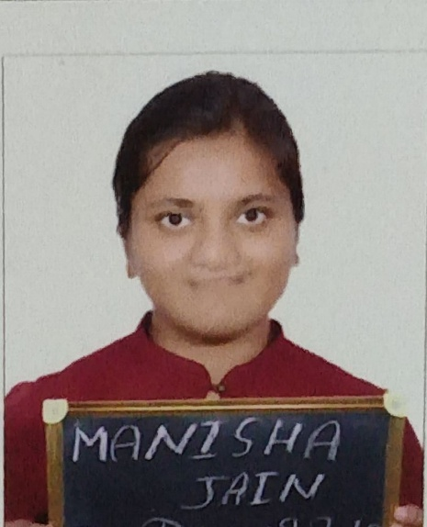**Manisha Jain**

**Contact No. -** +91-9664067887, 9530214405

**Email-** [manishajain7866@gmail.com](mailto:manishajain7866@gmail.com)

**Home Address**- 9,Bhajan Nagar, Ajmer Road, Beawar, District Ajmer,Rajasthan

**Objective-** To pursue a challenging position by utilizing my best potentials , educational qualifications, skills and attitude with persistence towards growth of organization while being resourceful and flexible.

***Educational Qualifucations***

**S.No. Name of Course Name of Board/University CGPA/% Year**

1 M.Sc(Chemistry) Department of Chemistry, 5.77/6.0 2018-20

University of Rajasthan , Jaipur or 88.50%

2 B.Sc. Hons. Mody University of Science 9.83/10 2015-18

(Chemistry) and Technology, Laxmangarh

3 Diploma in German Mody University of Science 8.5/10 2018

and Technology, Laxmangarh

4 12th CBSE (Mangal Newton School) 87.3% 2015

5 10th  CBSE( St. Paul Sr. Sec. School) 10/10 2013

***Academic Achievement-***

* Cleared **CSIR NET JRF** December 2019 with **AIR 72**.
* Qualified Graduate Aptitude Test in Engineering (**GATE**) in Chemistry 2020 with **AIR 250**.
* B.Sc. Chemistry **Gold Medalist** (2018).
* Active member of Academic Society ‘Sangalap’ (2015-18)

***Projects-***

* Transient Techniques in Electrochemistry

Summer Internship (Graduation)

Institue- Delhi University

Project Supervisor-Dr. Rama Kant

* Interaction of Magnetite Nanoparticle with DNA of Plant Virus

Academic Project (Graduation)

Institute- Mody University

Project Supervisor-Dr. Amlan Kumar Das

* Green Synthesis of ZnO Nanoparticles and their biological activity

Academic Project( Post Graduation)

Institute- University of Rajasthan

Project Supervisor-Dr. Harshita Sachdeva

***Personal Qualities-***

* Highly inquisitive,creative and resourceful.
* Excited by the challenges and have the ability to give fruitful results.
* Good Communication Skills.
* Diligent and Cooperative.

***References-***

* Dr. Harshita Sachdeva

Associate Professor, Department of Chemistry,University of Rajasthan,Jaipur.

Email- drhmsachdevaster@gmail.com

* Dr. Amlan Kumar Das

Professor, Department of Chemistry, Mody University of Science and Technology.

Email- amlan.snigdha72@gmail.com