**CURRICULUM VITAE**

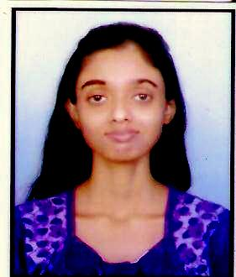

**BAISHALI CHAKRABORTY**

Shyam Sundar Apartment

First Floor, Flat no: D/1/1

Madhu Sudan mukherjee road

P.O. B.D. Sopan( Khardah)

Dist: North 24 Parganas

Kolkata—700116

Contact No. – **9123833407**

Email: **baishali24chakraborty@gmail.com**

**PERSONAL INFORMATION:**

Date of Birth : 23.09.1995

Language Proficiency: Bengali, English & Hindi

**ACADEMIC QUALIFICATION:**

|  |  |  |  |  |  |
| --- | --- | --- | --- | --- | --- |
| ***Examination Passed*** | ***Name of the***  ***Institution*** | ***Name of***  ***Board/University*** | ***Year*** | ***Subjects Taken*** | ***% Obtained*** |
| Madhyamik Examination | Barrackpore Girls’ High School | West Bengal  Board of Secondary  Education | 2011 | All compulsory subjects with Physical science, Life science, | 77% |
| Higher Secondary Examination | Barrackpore Girls’ High School | West Bengal  Council Of  Higher Secondary  Examination | 2013 | All compulsory subjects and physics, Chemistry, Mathematics, Biological Science. | 59% |
| B.Sc.  (Graduation) | Dum Dum Motijheel College | West Bengal State University | 2018 | B.sc Hons. In Microbiology with Physics and Chemistry. | 44.13% |
| M.Sc  (Post Graduation) | West Bengal State University | West Bengal State University | 2021 | M.sc in BioChemistry. | 71.34% |

**OTHER RELEVANT INFORMATION:**

Father’s Name Amar Nath Chakraborty

Cast General

Religion Hinduism

Nationality Indian

**ADDITIONAL SKILLS**:

Basic computer knowledge with good communication and writing skill.

----------------