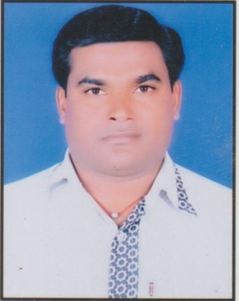

**RESUME**

PERSONAL INFORMATION

**Application :- Hindi Education**

# NAME :- Mori Vajesinh FATHER NAME-: Balubhai

**AADHAR NO :- 777914668925 DATE OF BIRTH-: 01/06/1978 GENDER-: Male**

# MARITAL STATUS-: Married

**LANGUAGE KNOWN-: GUJRATI,HINDI,ENGLISH NATIONALITY-: INDIAN**

**Email id :-** [**vajumori995@gmail.com**](mailto:vajumori995@gmail.com)

# CONTECT NO. :- 7698405052

ADDRESS -: AT:- VADODARA (ZALA)

Ta:- SUTRAPAD Dist:- GIR SOMNATH

State :- gujrat

Pin:- 362275

## EDUCATION QUALIFICATION

|  |  |  |  |  |  |  |
| --- | --- | --- | --- | --- | --- | --- |
| SR NO | EXAM | BOARD | Passing year | PERCENTAGE | SUBJECT | CLASS |
| 1 | SSC | GSSB | MARCH  1998 | 48.15 % |  |  |
| 2 | HSC | GHSEB | MARCH  2000 | 59.17 % |  |  |
| 3 | COLLEGE  ALL SEM | Sau.uni | Jun 2003 | 57.14 % | Hindi | secound |
| 4 | MA.edu | Himalayan  garhwal | Sub 2020 | 67.60% | Hindi | fust |
| 05 | Bed | Sau.uni | May2007 | 73.02 % | Hindi | distiction |
| 06 | M.ed Edu | Baraktullah vi.vidhyalay  bhopal | Feb2009 | 64.14 % | Hindi Edu | Fust |
| 07 | Phd.edu | Sunrise uni. | Aug 2017 | ----- | Hindi  Education |  |

## Experience

I have been worked with 2 Years B.ed college **ASSISTANT PROFESSOR** Sutrapada

* **Declaration**

Sir , I Hopeful That You Would Consider This Application Favorably And Give Me Chance To Face Interview If I Am Selected, I Will Do Work Hard And Sincerely

## YOUR FAITHFULL

**Place:- Sutrapada VAJESIHN B MORI**