**ABHISHEK CHRIS**

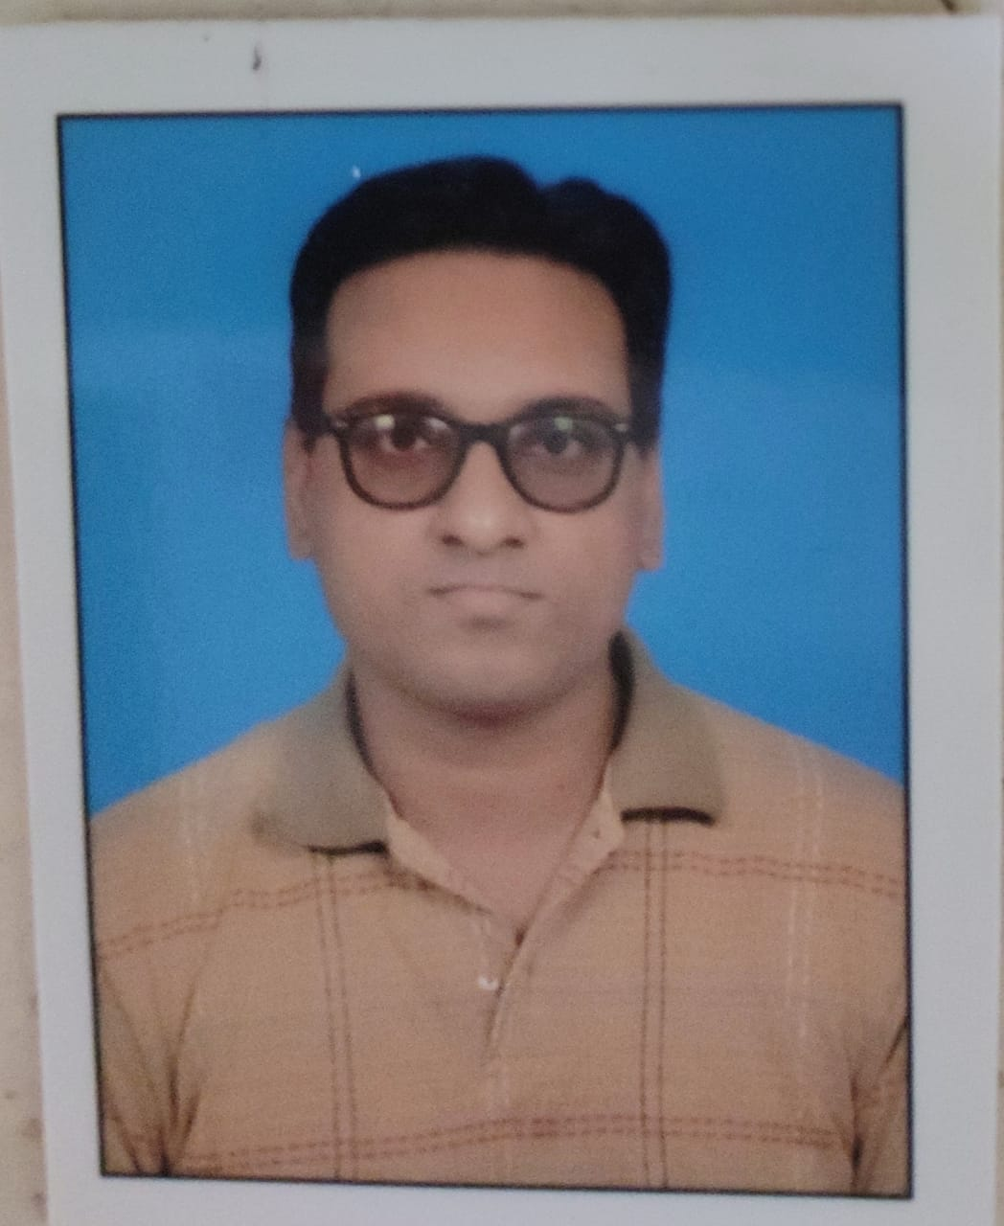

**Plot no. 32, H No. 101**

**U.G. Floor Shiv Park**

**Kakrola Dwarka**

**New Delhi 110078**

**Mob No. 9868928612**

**Email:** [**abhishekchris11@yahoo.com**](mailto:abhishekchris11@yahoo.com)

**___________________________________________________________________________**

**CAREER OBJECTIVE**

*To secure a challenging position in a reputable organization to expand my learning’s, knowledge, and skills*

**ACADMIC QUALIFICATION**

* Graduate (BBA) from GJU Hissar 2007- 10
* One year diploma in Office Management from New Delhi YMCA in 2011
* 12th from Central Academy School, Delhi (C.B.S.E) 2007
* 10th from Central Academy School, Delhi (CBSE) 2005

**PROFFESIONAL QUALIFICATION**

Graduate (BBA) 2007-10

**Course Contents**

* Business Accountancy
* Financial Managements
* Human Resource Managements
* Production Management
* Foundation Management & Organizational Behaviour
* Business Law

**WORK EXPERIENCE**

* Worked as Computer Operator in University of Petroleum and Energy Study (UPES) PHD House New Delhi for 3 Months

**Work Profile**

* Computer Operator
* Sending Courier to other Educational Organization
* Filing Important Papers
* Internet Browsing
* Worked as Assistant at Modern Times Helpline Pharma for 1 year 3 months

**Work Profile**

* Making Export Import Invoices
* Online Marketing
* Filing Important Papers
* Taking Care of all the Websites of the Firm
* Banking
* Worked as Purchase Assistant at Jullundur Motor Agency for 5 years and 6 months

**Work Profile**

* Placing Purchase Orders
* Knows Working on COMIS Software
* Knows Working on ERP Software
* Creating Weekly and Monthly Reports on Excel
* Making Pivot Tables
* Making Reports using V lookup and H Lookup
* Currently Working as Academic Assistant at JIMS Kalkaji

**Work Profile**

* Making Notice & Circular for Students and Faculties
* Formatting Documents
* Looking after the Files and Files Movement Register
* Making Drives & Sheets in Google Drive
* Updating notice in Activity Calendar on Google Drive
* Submitting project reports of students
* Updating notice in JIMS ERP
* Updating students marks in ERP
* Making and updating time table in ERP
* Switching on and off Google classroom
* Switching on Classrooms for the day

**ADDITIONAL QUALIFICATION**

Certificate course in Automation and Desktop Designing (CADD)

**STRENGTHS**

* Honesty
* Learning ability
* Punctuality

**INTERESTS**

* Sports Soccer
* Reading

**EXTRA CURRICULAR ACTICITIES**

Participated as a Volunteer in Commonwealth Games 2010

**PERSONAL PROFILE**

Date of Birth : MAY 11, 1988

Fathers Name : Mr Julias John

Marital Status : Married

Language Known : English, Hindi

**DATE: May 06, 2022 (Abhishek Chris John)**