CURRICULUM VITAE

**Vinod Kumar Vishwakarma**

**M.T**ech.(**C**onstruction **T**echnology and **M**anagement) **N**ational **I**nstitute of **T**echnical **T**eacher’s **T**raining and **R**esearch, (NITTTR) **C**handigarh, India

**Cell Phone Number-**

(+91) 8851377190

**E-mail-**

vinodvis.bit@gmail.com

**Father’s Name**

Mr. Somendra Kumar Vishwakarma

**Mother’s Name**

Mrs. Parvati Devi

**Permanent Address**

C/o Ramu Vishwakarma

Vill- Mahimapur (Samahat Nagar)

Post- Jalalpur (222136)

Dist- Jaunpur

U.P. India

**Personal Data**

Date of Birth: 7th Feb, 1994

Nationality: Indian

**Area of interest**

* Open Channel Flow.
* Advanced Concrete design.
* Design of Concrete.
* Geotechnical Engineering
* Transportation Engg.
* Structural Analysis- 2

**Hobbies**

* Playing Cricket
* Travelling
* Teaching

**Languages known**

* English
* Hindi

|  |
| --- |
| **Career Objective** |

To pursue a challenging career and be part of a progressive organization that gives scope to enhance my knowledge, skills and to reach the pinnacle in the computing and research field with sheer determination, dedication and hard work.

|  |
| --- |
| **Branch of Study** |

* Civil Engineering

|  |
| --- |
| **Academic Qualification** |

|  |  |  |  |  |
| --- | --- | --- | --- | --- |
| **Qualification** | **Year of Passing** | **Institute** | **Board/University** | **Percentage** |
| M.Tech. (Construction Technology & Management) | 2021 | National Institute of Technical Teacher’s Training and Research,(NITTTR) Chandigarh | Punjab University | 3nd sem. 7.90 (SGPA) |
| B. Tech.  (Civil Engineering) | 2017 | Bharat Institute of Technology, Meerut | Dr A.P.J. Abdul  Kalam Technical  University,  Lucknow | 73.80 |
| Senior Secondary | 2012 | Raj English School, Shivpur | CBSE | 54.00 |
| Higher Secondary | 2010 | S.S. Public School, Babatpur | CBSE | 53.20 |

|  |
| --- |
| **Seminar/Presentations/Workshops attended** |

* Current project on Effect of Anti-Stripping Agent and Cement on Indirect Tensile Strength of Bituminous Concrete
* Attained Technical Quiz on IS456:2000 2020 organised by Indian Association of structural Engineers (IAStructE) Student Chapter CEPT University, Ahmedabad on 08th August 2020
* Attained Webinar on Concrete options - White Topping 2020, Organised by Indian Concrete Institute – Chandigarh Centre and Ultra Tech Cement Ltd. On 15th Oct 2020, in NITTTR Chandigarh
* Attained seminar on “India’s Biggest Civil Championship 2015” organised by IIT Madras on 18th September, 2015 to 19th September, 2015 in Bharat Institute of Technology, Meerut

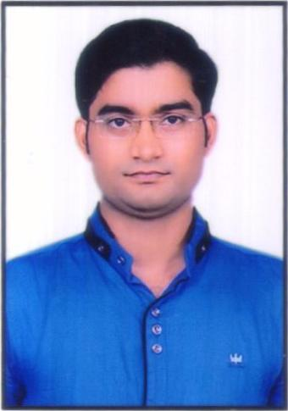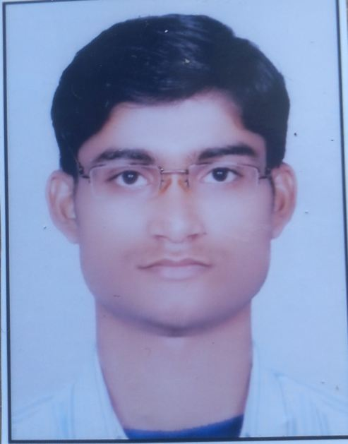

Scanned photograph

Image

|  |
| --- |
| **Achievements** |

* Two years Teaching experience in Engineering College, Ghaziabad
* Attained overall 73.80% in B.Tech.
* Attained 79.15% in B.Tech. 4th  year
* Attained 82.80% in B.Tech. 8th Semester
* Attained 74% Marks in Open Channel Flow in B. Tech. 7th semester
* Attained 70% Marks in Water Resources Engineering in B. Tech. 7th semester
* Attained 73 % Marks in Structure Analysis- II in B. Tech. 5th semester

|  |
| --- |
| Key Skills Proficiency |

* Can work effectively in team, as well as individually
* Have good inter-personal skills as well as leadership qualities
* Punctual
* Hard worker and good grasping power
* Self-motivated
* Problem solving & organizational skills

|  |
| --- |
| Extra Curricular Activities |

* Participated in March Parade in BIT, Meerut 2016
* Participated in bridge making competition in Bharat Institute of Technology, Meerut 2015
* Participated in “Khoj” event during Technotsav 2015

|  |
| --- |
| Position of Responsibilities |

* 3rd International conference Innovation Technologies for Clean and Sustainable Development “Acted as Member of Organising Committee” 19th -21st February 2020 at National Institute of Technical Teachers Training and Research (NITTTR),Chandigarh
* Member of Organizing Committee of “Decoration and Management” team during “India’s Biggest Civil Championship 2015” at Bharat Institute of Technology, Meerut

|  |
| --- |
| Declaration |

I hereby declare that the above information is correct to the best of my knowledge and belief

Date :…10/03/2022...........................

Place :...Chandigarh...........................

(VINOD KR. VISHWAKARMA)