TRISHARAN P. KAMBLE 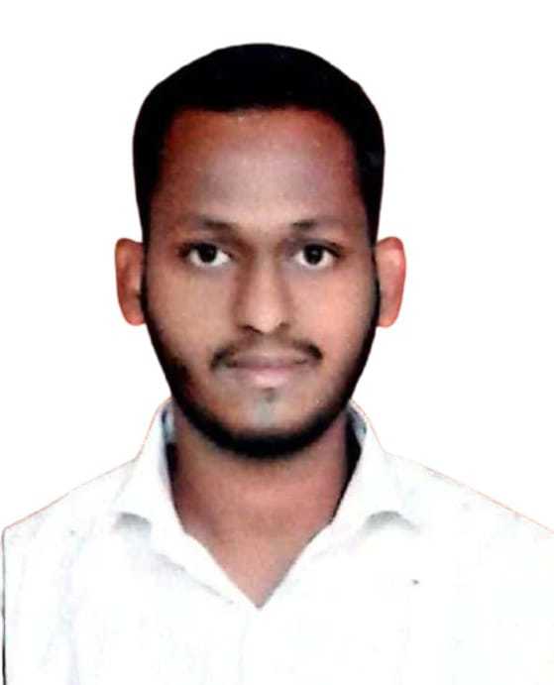

*Contents*

***Personal Information 2***

***Qualification & Other Actives3***

***Work Experience & Other4***

### 

**CURRICULAM VITAE**

**2**

***Career Objectives***

**To be part of a growing & dynamic organization that provides Ample opportunity for analytical decision making, continuous learning & skill enhancement, which improves upon my efficiency and knowledge so that, I remain competitive adding value to my employment wherein my skills & talent can be improvised and utilized to the maximum for my personal development as well as for the best interest of the organization.**

***Personal Details***

* **Name Trisharan Popat Kamble**
* **Address PL-5 B, 7/3, Sector No.9, Tirtharaj Society**

**Khanda Colony New Panvel West,**

**Raigad - 410206.**

* **Mobile Number 9757185601/9082118217**
* **Email Address** [**trisharankamble.tk@gmail.Com**](mailto:trisharankamble.tk@gmail.Com)
* **Gender Male**
* **Date of Birth 30, August 1993**
* **Marital Status Single**
* **Nationality Indian**
* **Religion Buddhist**

***Hobbies & languages known***

* **Playing Cricket, Reading Books, Swimming & Listening Music**
* **Marathi, Hindi & English**

**3**

***Educational qualification***

|  |  |  |  |  |
| --- | --- | --- | --- | --- |
| **EXAMINATION** | **INSTITUTION** | **BOARD / UNIVERSITY** | **YAER** | **PERCENTAGE** |
| **S.S.C** | **Mahatma School Of Academics & Sports** | **Mumbai Board** | **2008-09** | **64%** |
| **H.S.C** | **Mahatma Phule Arts, Science & Com** | **Mumbai Board** | **2011-12** | **35%** |
| **T.Y.B.A.** | **Siddharth College Arts, Science & Com** | **Mumbai University** | **2014-15** | **62%** |

***Co-Curricular Activities***

* **MS-CIT**
* **Marathi Typing 30wpm / English Typing 40wpm**
* **CIVIL DEFENCE Basic Course & First Aid**

**3**

**2**

**2**

**4**

**4**

***Work Experience***

* **2 Years’ Experience in Disasters Control In Mumbai -M ward**
* **2 years’ experience in Pritart Printing press at front desk - Navi Mumbai (2016-2018)**
* **1 year worked at Arham Electricals as an Assistant, Kalbadevi Mumbai (2018-2019)**
* **since February 2020 working at Fanora Ice-cream manufacturing Unit**

***Major Strengths***

* **Ability to work hard & thrive under pressure**
  + **Quick learner, confidence, patience and pro-active**
* **Willing to accept challenges**
* **Positive Attitude**
* **Willing to learn**

***Declaration***

**I consider myself familiar with accounting aspects. I am also confident of my ability to work in a team. I hereby declare that the information furnished above is true to the best of knowledge.**

**HEREBY, I AM ATTACHING ALL THE EDUCATIONAL AND SUPPORTED DOCUMENTS.**

**PLEASE FIND THE ATTACHMENT WITH RESUME.**

**Yours Faithfully**

**Trisharan Popat Kamble**