**SARITA K .VIRULKAR**

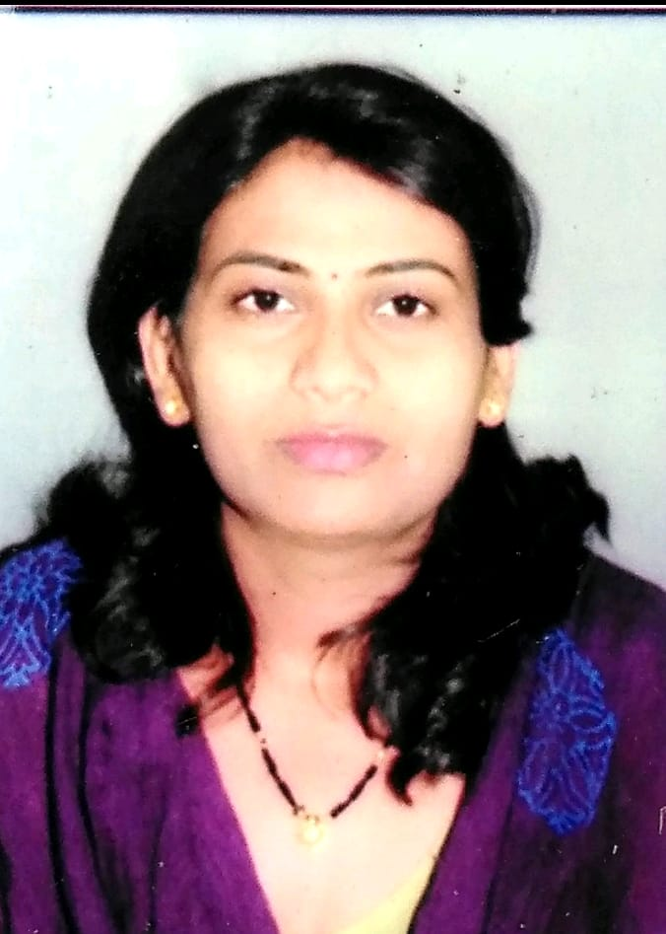

[saritavirulkar6@gmail.com](mailto:saritavirulkar6@gmail.com)

Mb.NO.8262829047

**CAREER OBJECTIVE:**

Want to learn in organization where I can learn more and can put my instant and knowledge for achieving a role of organization where my professional growth and satisfaction.

**EDUCATION QUALIFICATIONS:**

|  |  |  |  |  |
| --- | --- | --- | --- | --- |
| **SR.NO.** | **EXAMINATION** | **SCHOOL/COLLEGE** | **YEAR OF PASSING** | **Class/%** |
| 1 | SSC | Lokmanya school , Warora ,Dist-Chandrapur. | 2000 | Second |
| 2 | HSSC | Lokmanya Jr college , Warora, Dist-Chandrapur. | 2002 | Second |
| 3 | BA | Lokmanya Jr college , Warora, Dist-Chandrapur. | 2005 | Second |

**WORK EXPERIENCE:**

|  |  |  |
| --- | --- | --- |
| **YEAR** | **ORGANIZATION** | **JOB PROFILE** |
| 2006-2010 | Jagdamba Typing Institute,Nagpur | Tutor |
| 2016-2020 | Private Tutor | Yoga Teacher |
| 2016-2018 | Vasantrao Naik Group of Institute, Nagpur | Jr. cleark |
| 2018-2020 | Sapna Girls hostel .Shiv Nagar , Nandanvan –Nagpur. | Hostel warden |
| 2021- | Tirumalla Hair Oil India PVT LTD. | Product Promoter |

**ACHIEVMENTS & AWARDS:**

* Certified YOGA Teacher-Patanjali–HARIDWAR
* Volleyball-National/University Player.

**COMPUTOR SKILL:**

MS-CIT(2002),MS-OFFICE,TALLY+GST(JULLY 2018)

TYPING-W.40 (English Marathi)

**Personal Information:**

Date of Birth: 8th April 1985

Permanent Address : Azad ward , Warora, Dist: chandrapur

Residential Address: As above

**HOBBIES:** Music.

**DECLARATION:**

I hereby declared that information given above is true and correct to the best of my knowledge and belief.

Date:

Place: **( Sarita Virulkar)**