Міністерство освіти і науки України

Національний університет «Львівська політехніка»

Кафедра ЕОМ



Звіт

до лабораторної роботи № 3

з дисципліни «Моделювання комп’ютерних систем»

на тему:

«Поведінковий опис цифрового автомата Перевірка роботи автомата за допомогою стенда Elbert V2 – Spartan 3A FPGA»

Варіант №1

Виконав:

ст. гр. КІ-201

Захарко О. С.

Прийняв:

ст. викладач   
каф. ЕОМ  
Козак Н. Б.

Львів 2024

**Мета роботи**: На базі стенда реалізувати цифровий автомат для обчислення значення виразів.

**Виконання роботи:**

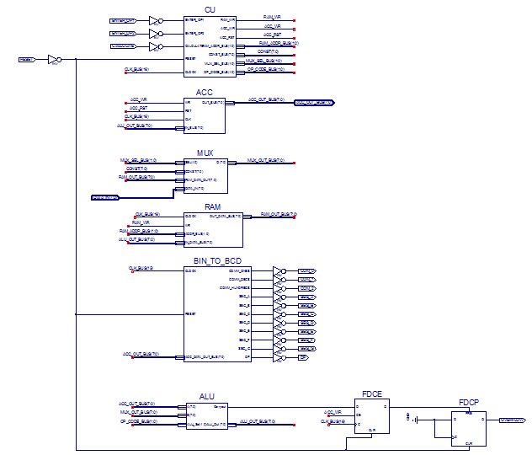

*Рис. 1 – Top Level*

|  |
| --- |
| Файл ACC.vhd  *library IEEE;*  *use IEEE.STD_LOGIC_1164.ALL;*  *use IEEE.STD_LOGIC_ARITH.ALL;*  *use IEEE.STD_LOGIC_UNSIGNED.ALL;*  *entity ACC is*  *Port ( WR : in STD_LOGIC;*  *RST : in STD_LOGIC;*  *CLK : in STD_LOGIC;*  *IN_BUS : in STD_LOGIC_VECTOR (7 downto 0);*  *OUT_BUS : out STD_LOGIC_VECTOR (7 downto 0));*  *end ACC;*  *architecture ACC_arch of ACC is*  *signal DATA : STD_LOGIC_VECTOR (7 downto 0);*  *begin*  *process (CLK)*  *begin*  *if rising_edge(CLK) then*  *if RST = '1' then*  *DATA <= (others => '0');*  *elsif WR = '1' then*  *DATA <= IN_BUS;*  *end if;*  *end if;*  *end process;*    *OUT_BUS <= DATA;*  *end ACC_arch;* |

|  |
| --- |
| Файл ALU.vhd  library IEEE;  use IEEE.STD_LOGIC_1164.ALL;  use IEEE.STD_LOGIC_UNSIGNED.ALL;  use ieee.NUMERIC_STD.all;  entity ALU is  Port (  A, B : in STD_LOGIC_VECTOR(7 downto 0);  ALU_Sel : in STD_LOGIC_VECTOR(1 downto 0);  ALU_Out : out STD_LOGIC_VECTOR(7 downto 0);  Carryout : out std_logic  );  end ALU;  architecture Behavioral of ALU is  signal ALU_Result : std_logic_vector (8 downto 0);  begin  process(A,B,ALU_Sel)  begin  case(ALU_Sel) is  when "01" =>  ALU_Result <= ('0' & A) + ('0' & B);  when "10" =>  ALU_Result <= ('0' & A) and ('0' & B);  when "11" =>  case(B) is  when x"00" => ALU_Result <= std_logic_vector(unsigned(('0' & A)) sll 0);  when x"01" => ALU_Result <= std_logic_vector(unsigned(('0' & A)) sll 1);  when x"02" => ALU_Result <= std_logic_vector(unsigned(('0' & A)) sll 2);  when x"03" => ALU_Result <= std_logic_vector(unsigned(('0' & A)) sll 3);  when x"04" => ALU_Result <= std_logic_vector(unsigned(('0' & A)) sll 4);  when x"05" => ALU_Result <= std_logic_vector(unsigned(('0' & A)) sll 5);  when x"06" => ALU_Result <= std_logic_vector(unsigned(('0' & A)) sll 6);  when x"07" => ALU_Result <= std_logic_vector(unsigned(('0' & A)) sll 7);  when others => ALU_Result <= std_logic_vector(unsigned(('0' & A)) sll 0);  end case;  ALU_Result(8) <= '0';  when others => ALU_Result <= ('0' & B);  end case;  end process;  ALU_Out <= ALU_Result(7 downto 0);  Carryout <= ALU_Result(8);  end Behavioral; |

|  |
| --- |
| Файл CPU.vhd  library IEEE;  use IEEE.STD_LOGIC_1164.ALL;  entity CU is  port( ENTER_OP1 : IN STD_LOGIC;  ENTER_OP2 : IN STD_LOGIC;  CALCULATE : IN STD_LOGIC;  RESET : IN STD_LOGIC;  CLOCK : IN STD_LOGIC;  RAM_WR : OUT STD_LOGIC;  RAM_ADDR_BUS : OUT STD_LOGIC_VECTOR(1 DOWNTO 0);  CONST_BUS : OUT STD_LOGIC_VECTOR(7 DOWNTO 0);  ACC_WR : OUT STD_LOGIC;  ACC_RST : OUT STD_LOGIC;  MUX_SEL_BUS : OUT STD_LOGIC_VECTOR(1 DOWNTO 0);  OP_CODE_BUS : OUT STD_LOGIC_VECTOR(1 DOWNTO 0));  end CU;    architecture CU_arch of CU is  type STATE_TYPE is (RST, IDLE, LOAD_OP1, LOAD_OP2, RUN_CALC0, RUN_CALC1, RUN_CALC2, RUN_CALC3, RUN_CALC4, FINISH);  signal CUR_STATE : STATE_TYPE;  signal NEXT_STATE : STATE_TYPE;  begin  CONST_BUS <= "00001010";      SYNC_PROC: process (CLOCK)  begin  if (rising_edge(CLOCK)) then  if (RESET = '1') then  CUR_STATE <= RST;  else  CUR_STATE <= NEXT_STATE;  end if;  end if;  end process;      NEXT_STATE_DECODE: process (CUR_STATE, ENTER_OP1, ENTER_OP2, CALCULATE)  begin  --declare default state for next_state to avoid latches  NEXT_STATE <= CUR_STATE; --default is to stay in current state  --insert statements to decode next_state  --below is a simple example  case(CUR_STATE) is  when RST =>  NEXT_STATE <= IDLE;  when IDLE =>  if (ENTER_OP1 = '1') then  NEXT_STATE <= LOAD_OP1;  elsif (ENTER_OP2 = '1') then  NEXT_STATE <= LOAD_OP2;  elsif (CALCULATE = '1') then  NEXT_STATE <= RUN_CALC0;  else  NEXT_STATE <= IDLE;  end if;  when LOAD_OP1 =>  NEXT_STATE <= IDLE;  when LOAD_OP2 =>  NEXT_STATE <= IDLE;  when RUN_CALC0 =>  NEXT_STATE <= RUN_CALC1;  when RUN_CALC1 =>  NEXT_STATE <= RUN_CALC2;  when RUN_CALC2 =>  NEXT_STATE <= RUN_CALC3;  when RUN_CALC3 =>  NEXT_STATE <= RUN_CALC4;  when RUN_CALC4 =>  NEXT_STATE <= FINISH;  when FINISH =>  NEXT_STATE <= FINISH;  when others =>  NEXT_STATE <= IDLE;  end case;  end process;  OUTPUT_DECODE: process (CUR_STATE)  begin  case(CUR_STATE) is  when RST =>  MUX_SEL_BUS <= "00";  OP_CODE_BUS <= "00";  RAM_ADDR_BUS <= "00";  RAM_WR <= '0';  ACC_RST <= '1';  ACC_WR <= '0';  when IDLE =>  MUX_SEL_BUS <= "00";  OP_CODE_BUS <= "00";  RAM_ADDR_BUS <= "00";  RAM_WR <= '0';  ACC_RST <= '0';  ACC_WR <= '0';  when LOAD_OP1 =>  MUX_SEL_BUS <= "00";  OP_CODE_BUS <= "00";  RAM_ADDR_BUS <= "00";  RAM_WR <= '1';  ACC_RST <= '0';  ACC_WR <= '1';  when LOAD_OP2 =>  MUX_SEL_BUS <= "00";  OP_CODE_BUS <= "00";  RAM_ADDR_BUS <= "01";  RAM_WR <= '1';  ACC_RST <= '0';  ACC_WR <= '1';  when RUN_CALC0 =>  MUX_SEL_BUS <= "01";  OP_CODE_BUS <= "00";  RAM_ADDR_BUS <= "00";  RAM_WR <= '0';  ACC_RST <= '0';  ACC_WR <= '1';  when RUN_CALC1 =>  MUX_SEL_BUS <= "01";  OP_CODE_BUS <= "01";  RAM_ADDR_BUS <= "01";  RAM_WR <= '0';  ACC_RST <= '0';  ACC_WR <= '1';  when RUN_CALC2 =>  MUX_SEL_BUS <= "11";  OP_CODE_BUS <= "01";  RAM_ADDR_BUS <= "00";  RAM_WR <= '0';  ACC_RST <= '0';  ACC_WR <= '1';  when RUN_CALC3 =>  MUX_SEL_BUS <= "01";  OP_CODE_BUS <= "10";  RAM_ADDR_BUS <= "01";  RAM_WR <= '0';  ACC_RST <= '0';  ACC_WR <= '1';  when RUN_CALC4 =>  MUX_SEL_BUS <= "01";  OP_CODE_BUS <= "11";  RAM_ADDR_BUS <= "00";  RAM_WR <= '0';  ACC_RST <= '0';  ACC_WR <= '1';  when FINISH =>  MUX_SEL_BUS <= "00";  OP_CODE_BUS <= "00";  RAM_ADDR_BUS <= "00";  RAM_WR <= '0';  ACC_RST <= '0';  ACC_WR <= '0';  when others =>  MUX_SEL_BUS <= "00";  OP_CODE_BUS <= "00";  RAM_ADDR_BUS <= "00";  RAM_WR <= '0';  ACC_RST <= '0';  ACC_WR <= '0';  end case;  end process;  end CU_arch; |

|  |
| --- |
| Файл MUX.vhd  library IEEE;  use IEEE.STD_LOGIC_1164.ALL;  entity MUX is  Port ( SEL : in STD_LOGIC_VECTOR (1 downto 0);  CONST : in STD_LOGIC_VECTOR (7 downto 0);  RAM_DATA_OUT : in STD_LOGIC_VECTOR (7 downto 0);  DATA_IN : in STD_LOGIC_VECTOR (7 downto 0);  O : out STD_LOGIC_VECTOR (7 downto 0));  end MUX;  architecture MUX_arch of MUX is  begin    PROCESS (SEL, CONST, RAM_DATA_OUT, DATA_IN)  BEGIN  IF (SEL = "00") THEN  O <= DATA_IN;  ELSIF (SEL = "01") THEN  O <= RAM_DATA_OUT;  ELSE  O <= CONST;  END IF;  END PROCESS;  end MUX_arch; |

|  |
| --- |
| Файл RAM.vhd  library IEEE;  use IEEE.STD_LOGIC_1164.ALL;  use IEEE.NUMERIC_STD.ALL;  use IEEE.STD_LOGIC_UNSIGNED.ALL;  entity RAM is  port( CLOCK : STD_LOGIC;  WR : IN STD_LOGIC;  ADDR_BUS : IN STD_LOGIC_VECTOR(1 DOWNTO 0);  IN_DATA_BUS : IN STD_LOGIC_VECTOR(7 DOWNTO 0);  OUT_DATA_BUS : OUT STD_LOGIC_VECTOR(7 DOWNTO 0));  end RAM;  architecture RAM_arch of RAM is  type ram_type is array (3 downto 0) of STD_LOGIC_VECTOR(7 downto 0);  signal UNIT : ram_type;  begin  process(CLOCK, ADDR_BUS, UNIT)  begin  if (rising_edge(CLOCK)) then  if (WR = '1') then  UNIT(conv_integer(ADDR_BUS)) <= IN_DATA_BUS;  end if;  end if;  OUT_DATA_BUS <= UNIT(conv_integer(ADDR_BUS));  end process;  end RAM_arch; |

|  |
| --- |
| Файл SEG_DECODER.vhd  library IEEE;  use IEEE.STD_LOGIC_1164.ALL;  use IEEE.STD_LOGIC_ARITH.ALL;  use IEEE.STD_LOGIC_UNSIGNED.ALL;  entity BIN_TO_BCD is  port( CLOCK : IN STD_LOGIC;  RESET : IN STD_LOGIC;  ACC_DATA_OUT_BUS : IN STD_LOGIC_VECTOR(7 DOWNTO 0);  COMM_ONES : OUT STD_LOGIC;  COMM_DECS : OUT STD_LOGIC;  COMM_HUNDREDS : OUT STD_LOGIC;  SEG_A : OUT STD_LOGIC;  SEG_B : OUT STD_LOGIC;  SEG_C : OUT STD_LOGIC;  SEG_D : OUT STD_LOGIC;  SEG_E : OUT STD_LOGIC;  SEG_F : OUT STD_LOGIC;  SEG_G : OUT STD_LOGIC;  DP : OUT STD_LOGIC);  end BIN_TO_BCD;  architecture Behavioral of BIN_TO_BCD is  signal ONES_BUS : STD_LOGIC_VECTOR(3 downto 0) := "0000";  signal DECS_BUS : STD_LOGIC_VECTOR(3 downto 0) := "0001";  signal HONDREDS_BUS : STD_LOGIC_VECTOR(3 downto 0) := "0000";  begin  BIN_TO_BCD : process (ACC_DATA_OUT_BUS)  variable hex_src : STD_LOGIC_VECTOR(7 downto 0) ;  variable bcd : STD_LOGIC_VECTOR(11 downto 0) ;  begin  bcd := (others => '0') ;  hex_src := ACC_DATA_OUT_BUS;  for i in hex_src'range loop  if bcd(3 downto 0) > "0100" then  bcd(3 downto 0) := bcd(3 downto 0) + "0011" ;  end if ;  if bcd(7 downto 4) > "0100" then  bcd(7 downto 4) := bcd(7 downto 4) + "0011" ;  end if ;  if bcd(11 downto 8) > "0100" then  bcd(11 downto 8) := bcd(11 downto 8) + "0011" ;  end if ;    bcd := bcd(10 downto 0) & hex_src(hex_src'left) ; -- shift bcd + 1 new entry  hex_src := hex_src(hex_src'left - 1 downto hex_src'right) & '0' ; -- shift src + pad with 0  end loop ;  HONDREDS_BUS <= bcd (11 downto 8);  DECS_BUS <= bcd (7 downto 4);  ONES_BUS <= bcd (3 downto 0);    end process BIN_TO_BCD;    INDICATE : process(CLOCK)  type DIGIT_TYPE is (ONES, DECS, HUNDREDS);    variable CUR_DIGIT : DIGIT_TYPE := ONES;  variable DIGIT_VAL : STD_LOGIC_VECTOR(3 downto 0) := "0000";  variable DIGIT_CTRL : STD_LOGIC_VECTOR(6 downto 0) := "0000000";  variable COMMONS_CTRL : STD_LOGIC_VECTOR(2 downto 0) := "000";    begin  if (rising_edge(CLOCK)) then  if(RESET = '0') then  case CUR_DIGIT is  when ONES =>  DIGIT_VAL := ONES_BUS;  CUR_DIGIT := DECS;  COMMONS_CTRL := "001";  when DECS =>  DIGIT_VAL := DECS_BUS;  CUR_DIGIT := HUNDREDS;  COMMONS_CTRL := "010";  when HUNDREDS =>  DIGIT_VAL := HONDREDS_BUS;  CUR_DIGIT := ONES;  COMMONS_CTRL := "100";  when others =>  DIGIT_VAL := ONES_BUS;  CUR_DIGIT := ONES;  COMMONS_CTRL := "000";  end case;    case DIGIT_VAL is --abcdefg  when "0000" => DIGIT_CTRL := "1111110";  when "0001" => DIGIT_CTRL := "0110000";  when "0010" => DIGIT_CTRL := "1101101";  when "0011" => DIGIT_CTRL := "1111001";  when "0100" => DIGIT_CTRL := "0110011";  when "0101" => DIGIT_CTRL := "1011011";  when "0110" => DIGIT_CTRL := "1011111";  when "0111" => DIGIT_CTRL := "1110000";  when "1000" => DIGIT_CTRL := "1111111";  when "1001" => DIGIT_CTRL := "1111011";  when others => DIGIT_CTRL := "0000000";  end case;  else  DIGIT_VAL := ONES_BUS;  CUR_DIGIT := ONES;  COMMONS_CTRL := "000";  end if;    COMM_ONES <= COMMONS_CTRL(0);  COMM_DECS <= COMMONS_CTRL(1);  COMM_HUNDREDS <= COMMONS_CTRL(2);    SEG_A <= DIGIT_CTRL(6);  SEG_B <= DIGIT_CTRL(5);  SEG_C <= DIGIT_CTRL(4);  SEG_D <= DIGIT_CTRL(3);  SEG_E <= DIGIT_CTRL(2);  SEG_F <= DIGIT_CTRL(1);  SEG_G <= DIGIT_CTRL(0);  DP <= '0';    end if;  end process INDICATE;  end Behavioral; |

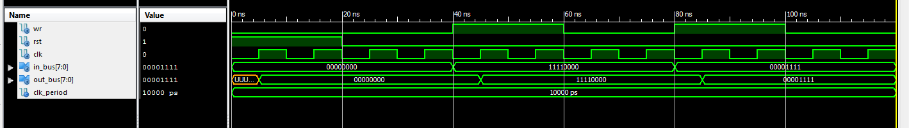

*Рис. 2 – Часова діаграма ACC*

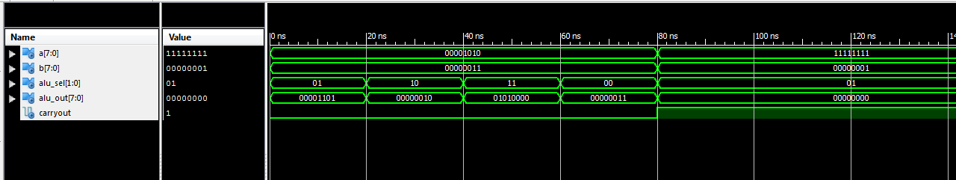

*Рис. 3 – Часова діаграма ALU*

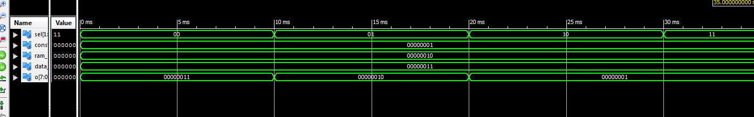

*Рис. 4 – Часова діаграма MUX*

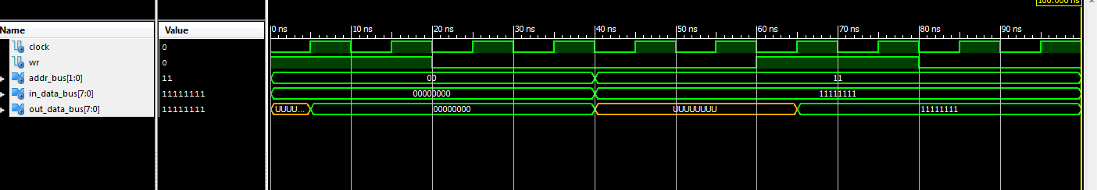

*Рис. 5 – Часова діаграма RAM*

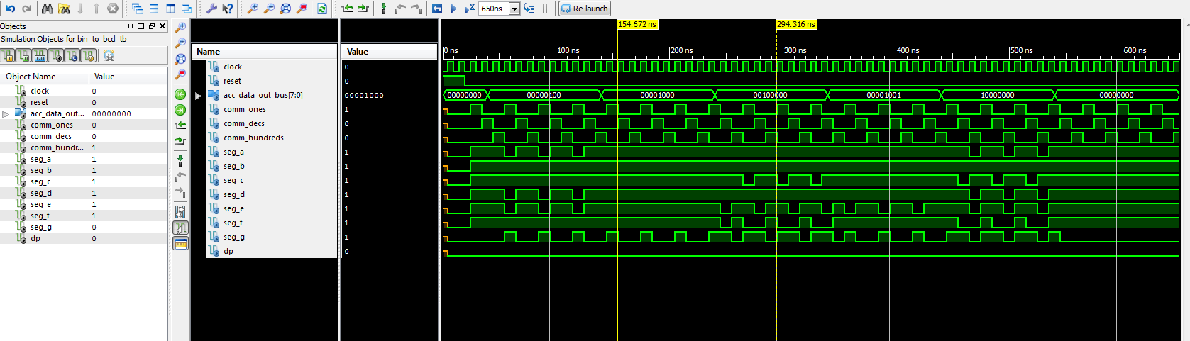

*Рис 6. – Часова діграма SEG_DECODER*

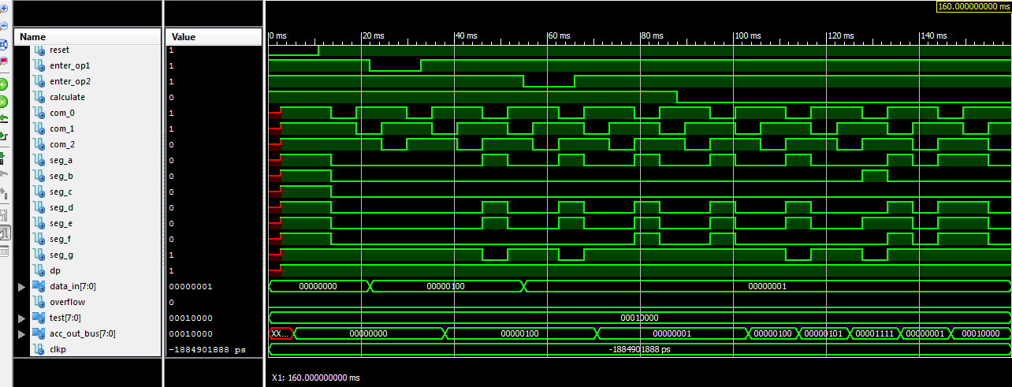

*Рис 7. – Часова діграма TopLevel*

|  |
| --- |
| *Файл TopLevelTest.vhd*  *-- * Test Bench - User Defined Section \**  *tb : PROCESS*  *BEGIN*    *lp1: for i in 4 to 4 loop*  *lp2: for j in 1 to 1 loop*  *ENTER_OP1 <= '1';*  *ENTER_OP2 <= '1';*  *CALCULATE <= '1';*  *case(std_logic_vector(to_unsigned(i, 8))) is*  *when x"00" =>*  *TEST <= std_logic_vector(signed(std_logic_vector(unsigned(std_logic_vector(to_unsigned(to_integer(unsigned(std_logic_vector(to_unsigned(i, 8)))) + to_integer(unsigned(std_logic_vector(to_unsigned(j, 8)))) + 10, 8)))) AND std_logic_vector(to_unsigned(j, 8))) SLL 0);*  *when x"01" =>*  *TEST <= std_logic_vector(signed(std_logic_vector(unsigned(std_logic_vector(to_unsigned(to_integer(unsigned(std_logic_vector(to_unsigned(i, 8)))) + to_integer(unsigned(std_logic_vector(to_unsigned(j, 8)))) + 10, 8)))) AND std_logic_vector(to_unsigned(j, 8))) SLL 1);*  *when x"02" =>*  *TEST <= std_logic_vector(signed(std_logic_vector(unsigned(std_logic_vector(to_unsigned(to_integer(unsigned(std_logic_vector(to_unsigned(i, 8)))) + to_integer(unsigned(std_logic_vector(to_unsigned(j, 8)))) + 10, 8)))) AND std_logic_vector(to_unsigned(j, 8))) SLL 2);*  *when x"03" =>*  *TEST <= std_logic_vector(signed(std_logic_vector(unsigned(std_logic_vector(to_unsigned(to_integer(unsigned(std_logic_vector(to_unsigned(i, 8)))) + to_integer(unsigned(std_logic_vector(to_unsigned(j, 8)))) + 10, 8)))) AND std_logic_vector(to_unsigned(j, 8))) SLL 3);*  *when x"04" =>*  *TEST <= std_logic_vector(signed(std_logic_vector(unsigned(std_logic_vector(to_unsigned(to_integer(unsigned(std_logic_vector(to_unsigned(i, 8)))) + to_integer(unsigned(std_logic_vector(to_unsigned(j, 8)))) + 10, 8)))) AND std_logic_vector(to_unsigned(j, 8))) SLL 4);*  *when x"05" =>*  *TEST <= std_logic_vector(signed(std_logic_vector(unsigned(std_logic_vector(to_unsigned(to_integer(unsigned(std_logic_vector(to_unsigned(i, 8)))) + to_integer(unsigned(std_logic_vector(to_unsigned(j, 8)))) + 10, 8)))) AND std_logic_vector(to_unsigned(j, 8))) SLL 5);*  *when x"06" =>*  *TEST <= std_logic_vector(signed(std_logic_vector(unsigned(std_logic_vector(to_unsigned(to_integer(unsigned(std_logic_vector(to_unsigned(i, 8)))) + to_integer(unsigned(std_logic_vector(to_unsigned(j, 8)))) + 10, 8)))) AND std_logic_vector(to_unsigned(j, 8))) SLL 6);*  *when x"07" =>*  *TEST <= std_logic_vector(signed(std_logic_vector(unsigned(std_logic_vector(to_unsigned(to_integer(unsigned(std_logic_vector(to_unsigned(i, 8)))) + to_integer(unsigned(std_logic_vector(to_unsigned(j, 8)))) + 10, 8)))) AND std_logic_vector(to_unsigned(j, 8))) SLL 7);*  *when others =>*  *TEST <= std_logic_vector(signed(std_logic_vector(unsigned(std_logic_vector(to_unsigned(to_integer(unsigned(std_logic_vector(to_unsigned(i, 8)))) + to_integer(unsigned(std_logic_vector(to_unsigned(j, 8)))) + 10, 8)))) AND std_logic_vector(to_unsigned(j, 8))) SLL 0);*  *end case;*  *DATA_IN <= (others => '0');*  *RESET <= '0';*  *wait for CLKP;*  *RESET <= '1';*  *wait for CLKP;*  *DATA_IN <= (std_logic_vector(to_unsigned(i, 8))); -- A*  *ENTER_OP1 <= '0';*  *wait for CLKP;*  *ENTER_OP1 <= '1';*  *wait for CLKP * 2;*  *DATA_IN <= (std_logic_vector(to_unsigned(j, 8))); -- B*  *ENTER_OP2 <= '0';*  *wait for CLKP;*  *ENTER_OP2 <= '1';*  *wait for CLKP * 2;*  *CALCULATE <= '0'; -- START CALCULATION*  *REPORT "OP1 = (" & integer'image(i) & ") and OP2 = (" & integer'image(j) & ") calculation started" SEVERITY NOTE;*  *wait for CLKP * 7;*  *assert ACC_OUT_BUS = TEST severity FAILURE;*  *REPORT "OP1 = (" & integer'image(i) & ") and OP2 = (" & integer'image(j) & ") calculation finished" SEVERITY NOTE;*  *wait for CLKP;*  *end loop;*  *end loop;*  *WAIT; -- will wait forever*  *END PROCESS;*  *-- *** End Test Bench - User Defined Section \*\*\**  *END;* |

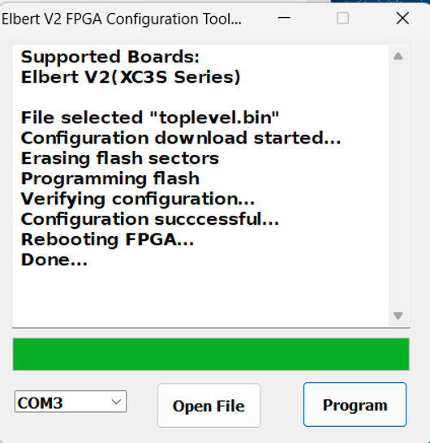

*Рис.9 – Успішна прошивка*

**Висновок:** Виконуючи дану лабораторну роботу я навчився реалізовувати цифровий автомат для обчислення значення виразів використовуючи засоби VHDL.