**<<INTERIOR CONSTRUCTION QUOTATION SYSTEM>>**

– HoChiMinh, January2024 –

**I. Introduction**

**1. Product Background**

Before there was an interior construction quote system, interior construction units often quoted prices based on their emotions, based on their own experience and evaluation. This leads to inconsistent and non-transparent interior construction prices, making it difficult for customers to choose a suitable interior construction unit. Today, the interior construction quote system will help customers easily understand the interior construction costs of each item, each type of material, each model, design, etc. This helps Customers can easily compare and choose an interior construction unit that suits their needs and budget. It helps interior construction units to strictly control construction costs, avoiding unexpected costs.

**2. Existing Systems**

**2.1  Interior construction quote system**

* Brief description:   
   An interior construction quote system is a specialized software solution designed to streamline and enhance the process of providing cost estimates for interior construction projects. This system automates the offering features that facilitate efficient and accurate pricing for materials. It aims to improve the overall efficiency of customers and construction professionals by automating calculations, ensuring consistency, and expediting the generation of detailed and precise quotes. This type of system is tailored to the specific needs of interior construction projects, providing a centralized platform for creating, managing, and retrieving project quotes.
* Links and Agents:
* Feature:  
  +) Friendly user interface: Easily refer to available drafts and also select furniture items.  
  +)Transparent pricing: Get detailed information about prices so they can allocate funds and spend appropriately.  
  +) Easy Customization: Customize according to customer needs and project specific needs  
  +) History and Tracking: Keep track of past quotes and projects, providing a comprehensive overview of your construction history for future planning.
* Advantage:  
  +) Efficiency and Accuracy: interior quoting improves efficiency and reduces the likelihood of errors in interior construction cost estimates  
  +) Customization: Allows for customization based on specific project requirements, accommodating various factors such as materials, labor costs, and project complexity.  
  +)  **Documentation and Record Keeping:** Provides a centralized location for storing quotes, facilitating easy retrieval, and creating a record for future reference and analysis.  
  +) **Competitive Advantage:** Enables contractors to respond promptly to client inquiries and submit accurate quotes, contributing to a positive impression and a competitive edge in the market.
* Defect:  
  +) **Human Touch:** Some clients may prefer a more personalized approach in the quoting process, and an entirely automated system might lack the human touch that can be valuable in building relationships.  
  +)  **Dependency on Technology:** Any technical glitches or system downtimes could disrupt the quoting process, potentially causing delays in project timelines.

**The system actors:**

* Guest
* Customer
* Staff
* Admin

**3. Business Opportunity**

**3.1** Media: Develop and operate an application or website that allows customers to search, compare, and request quotes from interior contractors. The system will automatically collect information from contractors and display corresponding quotes for customers.

**3.2** Provide benefits to contractors by giving them opportunities to access potential customers and enhance marketing effectiveness.

**3.3** Consultation and advertising help customers gain a better understanding of the construction process and increase trust and brand recognition, creating a lasting impression for customers to seek and utilize your services.

**4. Software Product Vision**

* The interior construction quotation system will provide customers with a method to search for reputable interior contractors and compare corresponding quotes. Customers will be able to view detailed quotes for each aspect such as construction, materials, dimensions, etc., enabling them to make intelligent and appropriate choices.

* The product's vision is to become a leading interior construction quotation system, offering customers transparency, security, and safety, while optimizing the quotation and bidding process to improve efficiency in their work.

**5. Major Features**

FE-01: See standard quotes for interior construction.

FE-02: Allows customers to calculate the estimated preliminary construction price    according to selected parameters.

FE-03: Create, view, modify and unsubscribe interior construction quotation

FE-04: Manage the process from the moment the customer requests a quote until the quote is confirmed to sign the contract

FE-05: Dashboard & report customer statistics, quotes

**6. Limitations and Exclusions**

LI-01: The software depends on accurate and complete input data on materials, prices, and interior specifications. If the data is inaccurate or missing, the quote may not be accurate.

**II.**

* 1. **Business Process:**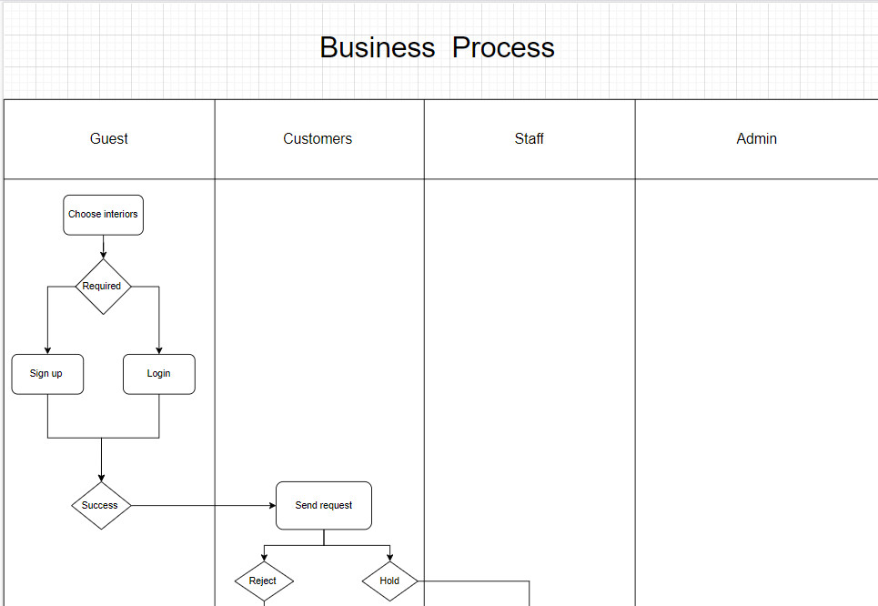

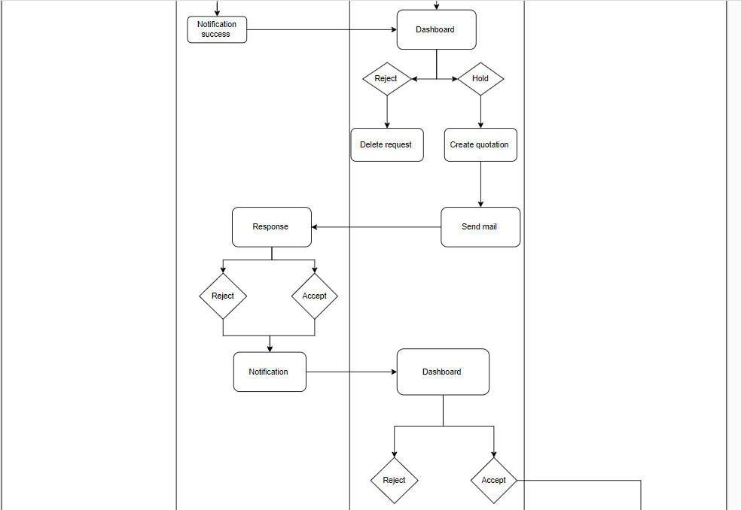

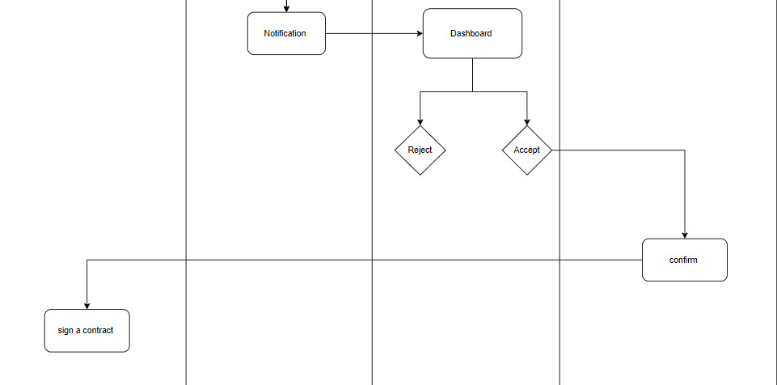

customer: send request → system:validate & store→ staff: check->create proposal→ system : receive->send proposal to customer→customer:check proposal->take decision(accep&reject)-> accept->sign a contract

**2. Diagram**

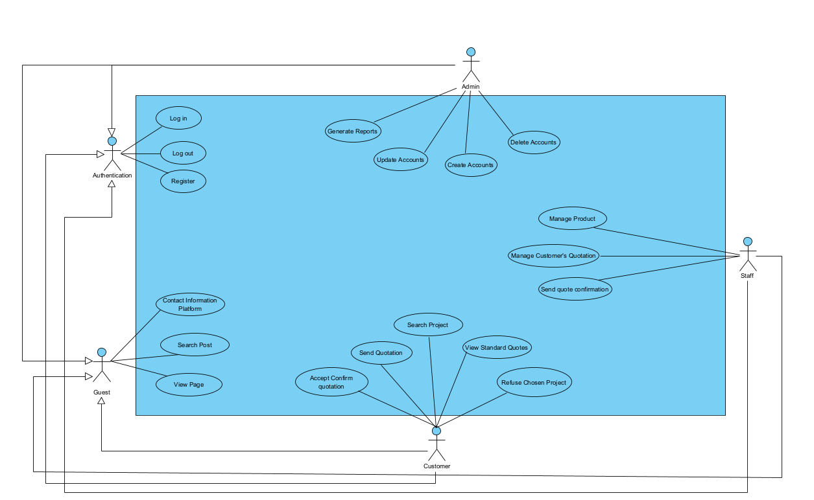

**4. ERD:**

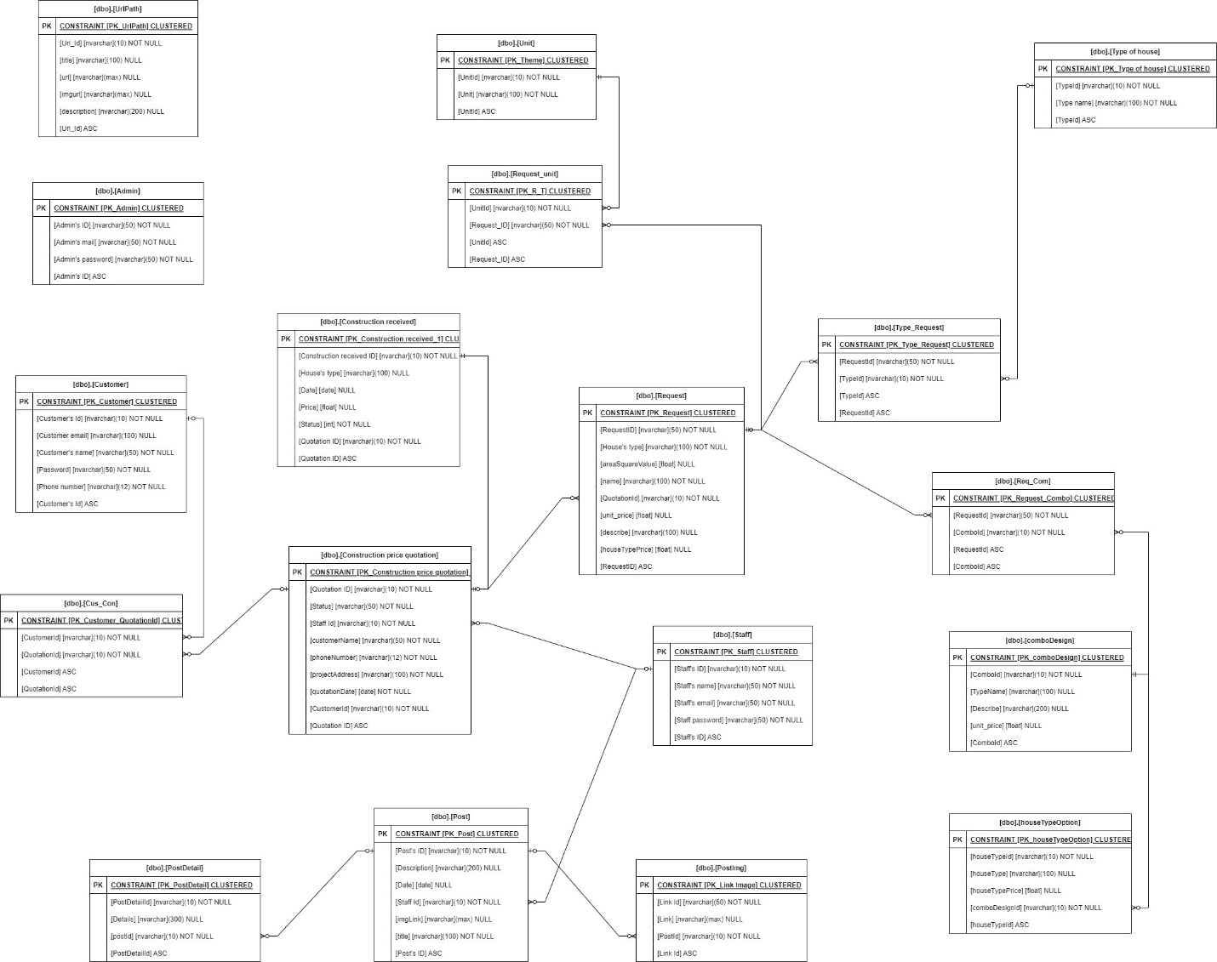

**5. Context Diagram:**

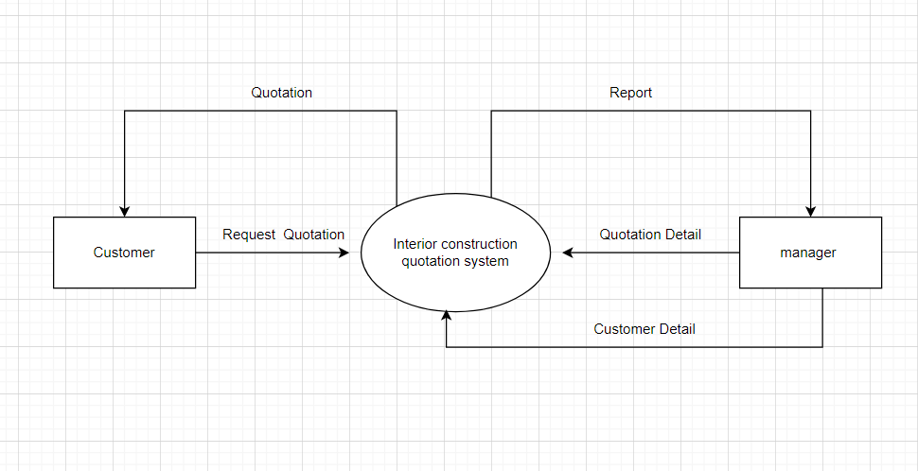

# **III. User Requirements**

## **1. Actors**

|  |  |  |
| --- | --- | --- |
| **#** | **Actor** | **Description** |
| 1 | Guest | Guests are visitors who access the website without creating an account or logging in. They have limited access to certain features and functionalities compared to registered customers. |
| 2 | Customer | Customers are individuals or entities interested in acquiring interior construction services for their unit. They seek information, quotes, and assistance in selecting the appropriate services for their needs. |
| 3 | Staff | The staff members are individuals involved in the management and operation of the interior construction quotation system. They may include project managers, interior designers, sales representatives, and administrative personnel. |
| 4 | Admin | The admin is a privileged user responsible for overseeing and managing the overall operation and performance of the interior construction quotation system. They have access to advanced features and administrative tools for efficient system management |

## **2. Use Cases**

### **2.1 Diagram**



### **2.2 Descriptions**

|  |  |  |  |
| --- | --- | --- | --- |
| **ID** | **Use Case** | **Actors** | **Use Case Description** |
| UC-01 | Send Request from Customer to System | Customer  Quotation System | This use case describes the process of a customer sending a request for a quotation from the interior construction quotation system. |
| UC-02 | Accept Request Sent in Email | Customer  Quotation System | This use case describes the process of a customer accepting a request for a quotation sent via email. |
| UC-03 | Refuses the Request | Customer  Quotation System | This use case describes the process of a customer refusing a quotation received from the interior construction quotation system. |
| UC-04 | Search and Choose Project | Customer  Quotation System | This use case describes the process of a customer searching for and selecting interior construction projects within the system. |
| UC-05 | Delete Chosen Project Before Sending | Customer  Quotation System | This use case describes the process of a customer deleting a chosen project before submitting a request for a quotation in the interior construction quotation system. |
| UC-06 | Login to System | Customer  Quotation System | This use case describes the process of a customer logging into the interior construction quotation system to access personalized features and services. |
| UC-07 | Signup to System | Customer  Quotation System | This use case describes the process of a customer signing up to the interior construction quotation system. |
| UC-08 | Receives Lost Password | Customer  Quotation System | This use case describes the process of a customer receiving a lost password for their account on the interior construction quotation system. |
| UC-09 | Receives Lost Email | Customer  Quotation System | This use case describes the process when a customer receives a lost email containing important information related to interior construction quotations. |
| UC-10 | Guest Search Project | Guest  Quotation System | This use case describes the process of a guest searching for interior construction projects on the system. |
| UC-11 | Create User Accounts | Admin | The admin can create user accounts for members.  They can assign roles and permissions to each user account based on their responsibilities within the system. |
| UC-12 | Delete User Accounts | Admin | The admin can delete user accounts for members.  They can assign roles and permissions to each user account based on their responsibilities within the system. |
| UC-13 | Update User Accounts | Admin | The admin can edit user accounts for members.  They can assign roles and permissions to each user account based on their responsibilities within the system. |
| UC-14 | Add new User Accounts | Admin | The admin can create user accounts for members.  They can assign roles and permissions to each user account based on their responsibilities within the system. |
| UC-15 | Search post | Guest, Staff, Customer, admin | The article search function on the home page provides users with a convenient way to explore and discover relevant articles related to interior construction projects, news updates, and shared experiences. Positioned prominently, the search feature invites users to input their queries, offering an intuitive pathway to access the wealth of information available on the website. |
| UC-16 | view standard quotes for interior construction | Customer | The function enabling customers to view standard quotes for interior construction embodies a pivotal aspect of our website, offering users an invaluable resource to explore and evaluate various construction options tailored to their needs. Seamlessly integrated into our user interface, this function serves as a gateway to a comprehensive repository of standardized pricing information, facilitating informed decision-making and fostering transparency in the interior construction process. |
| UC-17 | Search account | Admin | The feature allows admins to quickly search for accounts by searching the account names |
| UC-18 | Contact information platform | Customer, guest | Our contractor contact feature serves as a dynamic bridge between customers seeking interior construction services and a diverse network of skilled contractors. Designed to empower customers with comprehensive information about contractors across various platforms, including Facebook, TikTok, YouTube, and more, this feature facilitates seamless communication and collaboration between parties, fostering transparency, trust, and mutual understanding. |
| UC-19 | Link through related pages | Customer | The function allows customers to link through pages displaying related quotes |
| UC-20 | Generate Reports | Admin | The admin can generate various reports to analyze system performance and customer interactions.  Reports may include customer statistics, quote generation metrics, and trends in service preferences to inform business strategies. |
| UC-21 | Manage Product | Staff | - Employees can add, edit or delete products from the database.  - They can also view detailed information about each product, including description, images, price and availability. |
| UC-22 | Manage Customer | Staff | - Employees can add, update or delete customer information from the system.  - They can also view each customer's purchase history and contact information. |
| UC-23 | Create quote | Staff | - Employees can create quotes for customers based on their specific requirements.  - They can also view the status of created quotes and update them when there are changes. |
| UC-24 | Order confirmation | Staff | - When the customer accepts the quote, the employee can confirm receipt of the order and begin the order processing process. |
| UC-25 | Order management | Staff | - Employees can view a list of pending, active or completed orders.  - They can update the status of the order and convert information when necessary. |
| UC-26 | Send notifications to customers | Staff | - Employees can send notifications via email or text messages in the system to customers about order status or other necessary information. |
| UC-27 | Manage and respond to customer feedback | Staff | - When there is a request to return goods from a customer, staff can process and create returns in the system. |
| UC-28 | View reports and statistics | Staff | - Employees can view profit reports on sales revenue, royalties and survival to reflect the current business situation. |
| UC-29 | Product category management | Staff | - They can add, edit or delete product categories, helping to organize and manage products effectively. |
| UC-30 | Authentication and access | Staff | - Employees need to have access to the right features and data appropriate to their role. This includes login authentication and access management. |

|  |  |  |  |
| --- | --- | --- | --- |
| ID and Name: | **UC-01 Order a Meal** | | |
| Created By: | Prithvi Raj | Date Created: | 10/4/13 |
| Primary Actor: | Patron | Secondary Actors: | Cafeteria Inventory System |
| Description: | A Patron accesses the Cafeteria Ordering System from the corporate intranet or from home, views the menu for a specific date if desired, selects food items, and places an order for a meal to be delivered to a specified location within a specified 15-minute time window. | | |
| Trigger: | A Patron indicates that he wants to order a meal | | |
| Preconditions: | PRE-1. Patron is logged into COS.  PRE-2. Patron is registered for meal payments by payroll deduction. | | |
| Postconditions: | POST-1. Meal order is stored in COS with a status of “Accepted”.  POST-2. Inventory of available food items is updated to reflect items in this order.  POST-3. Remaining delivery capacity for the requested time window is updated. | | |
| Normal Flow: | **1.0 Order a Single Meal**  1. Patron asks to view menu for a specific date. (see 1.0.E1, 1.0.E2)  2. COS displays menu of available food items and the daily special.  3. Patron selects one or more food items from menu. (see 1.1)  4. Patron indicates that meal order is complete. (see 1.2)  5. COS displays ordered menu items, individual prices, and total price, including taxes and delivery charge.  6. Patron either confirms meal order (continue normal flow) or requests to modify meal order (return to step 2).  7. COS displays available delivery times for the delivery date.  8. Patron selects a delivery time and specifies the delivery location.  9. Patron specifies payment method.  10. COS confirms acceptance of the order.  11. COS sends Patron an email message confirming order details, price, and delivery instructions.  12. COS stores order, sends food item information to Cafeteria Inventory System, and updates available delivery times. | | |
| Alternative Flows: | **1.1 Order multiple identical meals**  1. Patron requests a specified number of identical meals. (see 1.1.E1)  2. Return to step 4 of normal flow.  **1.2 Order multiple meals**  1. Patron asks to order another meal.  2. Return to step 1 of normal flow. | | |
| Exceptions: | **1.0.E1 Requested date is today and current time is after today’s order cutoff time**  1. COS informs Patron that it’s too late to place an order for today.  2a. If Patron cancels the meal ordering process, then COS terminates use case.  2b. Else if Patron requests another date, then COS restarts use case.  **1.0.E2 No delivery times left**  1. COS informs Patron that no delivery times are available for the meal date.  2a. If Patron cancels the meal ordering process, then COS terminates use case.  2b. Else if Patron requests to pick the order up at the cafeteria, then continue with normal flow, but skip steps 7 and 8.  **1.1.E1 Insufficient inventory to fulfill multiple meal order**  1. COS informs Patron of the maximum number of identical meals he can order, based on current available inventory.  2a. If Patron modifies number of meals ordered, then Return to step 4 of normal flow.  2b. Else if Patron cancels the meal ordering process, then COS terminates use case. | | |
| Priority: | High | | |
| Frequency of Use: | Approximately 300 users, average of one usage per day. Peak usage load for this use case is between 9:00 A.M. and 10:00 A.M. local time. | | |
| Business Rules: | **BR-1, BR-2, BR-3, BR-4, BR-11, BR-12, BR-33** | | |
| Other Information: | 1. Patron shall be able to cancel the meal ordering process at any time prior to confirming it.  2. Patron shall be able to view all meals he ordered within the previous six months and repeat one of those meals as the new order, provided that all food items are available on the menu for the requested delivery date. (Priority = M)  3. The default date is the current date if the Patron is using the system before today’s order cutoff time. Otherwise, the default date is the next day that the cafeteria is open. | | |
| Assumptions: | Assume that 15 percent of Patrons will order the daily special (source: previous 6 months of cafeteria data). | | |

|  |  |  |  |
| --- | --- | --- | --- |
| ID and Name: | **UC-02 Register for Payroll Deduction** | | |
| Created By: | Nancy Anderson | Date Created: | 9/15/13 |
| Primary Actor: | Patron | Secondary Actors: | Payroll System |
| Description: | Cafeteria patrons who use the COS and have meals delivered must be registered for payroll deduction. For noncash purchases made through the COS, the cafeteria will issue a payment request to the Payroll System, which will deduct the meal costs from the next scheduled employee payday direct deposit. | | |
| Trigger: | Patron requests to register for payroll deduction, or Patron says yes when COS asks if he wants to register | | |
| Preconditions: | PRE-1. Patron is logged into COS. | | |
| Postconditions: | POST-2. Patron is registered for payroll deduction. | | |
| Normal Flow: | **5.0 Register for Payroll Deduction**  1. COS asks Payroll System if Patron is eligible to register for payroll deduction.  2. Payroll System confirms that Patron is eligible to register for payroll deduction.  3. COS asks Patron to confirm his desire to register for payroll deduction.  4. If so, COS asks Payroll System to establish payroll deduction for Patron.  5. Payroll System confirms that payroll deduction is established.  6. COS informs Patron that payroll deduction is established. | | |
| Alternative Flows: | None | | |
| Exceptions: | 5.0.E1 Patron is not eligible for payroll deduction  5.0.E2 Patron is already enrolled for payroll deduction | | |
| Priority: | High | | |
| Business Rules: | BR-86 and BR-88 govern an employee’s eligibility to enroll for payroll deduction. | | |
| Other Information: | Expect high frequency of executing this use case within first 2 weeks after system is released. | | |

>>

|  |  |  |  |
| --- | --- | --- | --- |
|  |  | | |
|  |  |  |  |
|  |  |  |  |
|  |  | | |
|  |  | | |
|  |  | | |
|  |  | | |
|  |  | | |
|  |  | | |
|  |  | | |
|  |  | | |
|  |  | | |
|  |  | | |

|  |  |  |  |
| --- | --- | --- | --- |
| ID and Name: | **UC-01**  Send Request from Customer to System | | |
| Created By: | Le Pham Khang | Date Created: | 3/21/2024 |
| Primary Actor: | Customer | Secondary Actors: | Quotation System |
| Description: | This use case describes the process of a customer sending a request for a quotation from the interior construction quotation system. | | |
| Trigger: | The customerrequest a quotation for interior construction services. | | |
| Preconditions: | PRE-1. The customer has access to the interior construction quotation system.  PRE-2. The customer is logged into their account (if applicable). | | |
| Postconditions: | POST-1. The request for a quotation is successfully sent to the system.  POST-2. The system acknowledges receipt of the request. | | |
| Normal Flow: | 1. The customer accesses the interior construction quotation system.  2. The customer navigates to the request quotation section.  3. The customer selects the desired parameters for the interior construction project (e.g., type of service, style, materials, dimensions).  4. customer fills out any required information fields, such as contact details or project specifications..  5. customer reviews the request to ensure accuracy.  6. The customer submits the request to the system.  7. The system receives the request and acknowledges successful submission. | | |
| Alternative Flows: | **Step 2a:** If the customer is not logged into their account, they may be prompted to log in or proceed as a guest.  **Step 4a:** If the customer encounters any issues or errors while filling out the request form, they may correct them before submission.  **Step 6a:** If the system is experiencing technical difficulties, it may display an error message prompting the patron to try again later. | | |
| Exceptions: | If the system fails to receive the request due to technical issues, it notifies the patron and advises them to try again later. | | |
| Priority: | High | | |
| Frequency of Use: | High, as customers frequently request quotations for interior construction projects. | | |
| Business Rules: | BR-01,BR-03,BR-04 | | |
| Other Information: | This use case assumes that the customer has basic knowledge of using the interior construction quotation system.  The system should provide clear instructions and guidance to assist customer s in submitting their requests. | | |
| Assumptions: | The system is functioning normally without any major disruptions.  The customer has a stable internet connection to access the system. | | |

|  |  |  |  |
| --- | --- | --- | --- |
| ID and Name: | **UC-02**  Customer Accept Request Sent in Email | | |
| Created By: | Le Pham Khang | Date Created: | 3/21/2024 |
| Primary Actor: | Customer | Secondary Actors: | Quotation System |
| Description: | This use case describes the process of a customer accepting a request for a quotation sent via email. | | |
| Trigger: | The customer receives an email containing a quotation request from the interior construction quotation system. | | |
| Preconditions: | PRE-1. The customer has access to their email account.  PRE-2. The customer has received an email from the interior construction quotation system containing a quotation request. | | |
| Postconditions: | POST-1. The customer successfully accepts the quotation request.  POST-2. The system records the patron's acceptance. | | |
| Normal Flow: | 1. Customer checks their email and finds a message from the interior construction quotation system regarding a quotation request.  2. The email contains details of the quotation request, including project specifications, contact information, and a call-to-action to accept the request.  3. The customer clicks on the provided link or button to accept the request.  4. System receives the acceptance confirmation from the customer . | | |
| Alternative Flows: | **Step 3a:** If the email does not contain sufficient information or the customer requires clarification, they may contact the system administrator for assistance.  **Step 4a:** If the customer encounters any issues while attempting to accept the request (e.g., broken link), they may notify the system administrator for resolution. | | |
| Exceptions: | If the email containing the quotation request is not delivered to the customer's inbox or is marked as spam, the customer may need to check their spam/junk folder or contact the system administrator for assistance. | | |
| Priority: | Medium | | |
| Frequency of Use: | High, as customers frequently receive and respond to quotation requests via email. | | |
| Business Rules: | BR-05,BR-11,BR-17,BR-20 | | |
| Other Information: | This use case assumes that the email sent by the system contains clear instructions and a user-friendly interface for accepting the quotation request.  The system should provide a seamless and intuitive process for patrons to accept requests via email. | | |
| Assumptions: | The customer has a basic understanding of using email and navigating email interfaces.  The email containing the quotation request is delivered successfully to the customer's inbox. | | |

|  |  |  |  |
| --- | --- | --- | --- |
| ID and Name: | **UC-03:**  Customer Refuses the Request | | |
| Created By: | Le Pham Khang | Date Created: | 3/21/2024 |
| Primary Actor: | Customer | Secondary Actors: | Quotation System |
| Description: | This use case describes the process of a customer refusing a quotation received from the interior construction quotation system. | | |
| Trigger: | The customer receives a quotation from the interior construction quotation system and decides to refuse it. | | |
| Preconditions: | PRE-1. The customer has submitted a request for a quotation.  PRE-2. The system has generated and sent the quotation to the customer . | | |
| Postconditions: | POST-1. The system acknowledges the customer's refusal of the quotation.  POST-2. The customer's request status is updated in the system. | | |
| Normal Flow: | 1. The customer receives the quotation from the interior construction quotation system.  2. The customer reviews the quotation and decides not to proceed with it.  3. The customer clicks on the provided link or button to accept the request.  4. The customer selects the option to refuse the quotation.  5. The customer submits the refusal request to the system.  6. The system receives the refusal request and updates the status accordingly.  7. The system acknowledges successful receipt of the refusal request to the customer . | | |
| Alternative Flows: | **Step 2a:** If the customer wishes to negotiate or discuss the quotation further instead of refusing it outright, they may contact customer support or request a revision through the system.  **Step 5a:** If the customer encounters any issues or errors while submitting the refusal request, they may try again or contact customer support for assistance. | | |
| Exceptions: | If the system fails to receive the refusal request due to technical issues, it notifies the customer and advises them to try again later. | | |
| Priority: | Medium | | |
| Frequency of Use: | Variable, depending on the customer's decision regarding the received quotation. | | |
| Business Rules: | BR-01,BR-07,BR-20 | | |
| Other Information: | This use case assumes that the customer has basic knowledge of using the interior construction quotation system.  The system should provide clear instructions and guidance to assist customers in submitting their refusal requests. | | |
| Assumptions: | The system is functioning normally without any major disruptions.  The customer has a stable internet connection to access the system. | | |

|  |  |  |  |
| --- | --- | --- | --- |
| ID and Name: | **UC-04:**  Customer Search and Choose Project | | |
| Created By: | Le Pham Khang | Date Created: | 3/21/2024 |
| Primary Actor: | Customer | Secondary Actors: | Quotation System |
| Description: | This use case describes the process of a customer searching for and selecting interior construction projects within the system. | | |
| Trigger: | The customer intends to explore interior construction projects within the system. | | |
| Preconditions: | PRE-1. The customer has access to the interior construction quotation system.  PRE-2. The customer is logged into their account (if applicable). | | |
| Postconditions: | POST-1. The patron successfully selects an interior construction project of interest.  POST-2. The system displays detailed information about the selected project. | | |
| Normal Flow: | 1. The customer accesses the interior construction quotation system. 2. The customer navigates to the project search section. 3. The customer enters search criteria such as project type, style, location, etc. 4. The system retrieves a list of matching interior construction projects based on the search criteria. 5. The customer browses through the list of projects and selects one of interest. 6. The system displays detailed information about the selected project, including project scope, images, client testimonials, etc. 7. The customer reviews the information and decides whether to proceed further with the selected project. | | |
| Alternative Flows: | **Step 3a:** If the customer is not logged into their account, they may be prompted to log in or proceed as a guest.  **Step 5a:** If the search does not yield any matching projects, the system may display a message indicating no results found and suggest refining the search criteria.  **Step 7a:** If the customer wishes to explore additional projects, they may go back to the list of search results and select another project. | | |
| Exceptions: | If the system fails to receive the refusal request due to technical issues, it notifies the customer and advises them to try again later. | | |
| Priority: | Medium | | |
| Frequency of Use: | High, as customers frequently search for interior construction projects for inspiration or reference. | | |
| Business Rules: | BR-02, BR-03 | | |
| Other Information: | This use case assumes that the customer has basic knowledge of using the interior construction quotation system.  The system should provide clear navigation and search functionalities to assist customers in finding projects of interest. | | |
| Assumptions: | The system contains a sufficient database of interior construction projects for customers to search through.  The search functionality is efficient and accurately retrieves relevant projects based on the customer's criteria. | | |

|  |  |  |  |
| --- | --- | --- | --- |
| ID and Name: | **UC-05:**  Customer Delete Chosen Project Before Sending | | |
| Created By: | Le Pham Khang | Date Created: | 3/21/2024 |
| Primary Actor: | Customer | Secondary Actors: | Quotation System |
| Description: | This use case describes the process of a customer deleting a chosen project before submitting a request for a quotation in the interior construction quotation system. | | |
| Trigger: | The customer decides to remove a project they have selected before finalizing their quotation request. | | |
| Preconditions: | PRE-1. The customer is logged into their account on the interior construction quotation system.  PRE-2. The customer has previously selected one or more projects for a quotation request. | | |
| Postconditions: | POST-1. The chosen project is successfully removed from the customer's quotation request.  POST-2. The customer's quotation request is updated accordingly. | | |
| Normal Flow: | 1. The customer accesses their account on the interior construction quotation system. 2. The customer navigates to the section where they can manage their quotation requests. 3. The customer locates the quotation request containing the project they wish to delete. 4. The customer selects the option to edit or manage the quotation request. 5. The customer identifies the chosen project they want to remove from the request. 6. The customer selects the option to delete the chosen project. 7. The system prompts the customer to confirm the deletion of the chosen project. 8. The customer confirms the deletion. 9. The system removes the chosen project from the quotation request and updates the request accordingly. 10. The system notifies the customer that the chosen project has been successfully removed. | | |
| Alternative Flows: | **Step 5a:** If the customer has multiple projects within the quotation request, they may need to specify which project they want to delete.  **Step 7a:** If the customer decides not to delete the chosen project, they can cancel the deletion process and return to the quotation request management screen. | | |
| Exceptions: | If the system encounters errors during the deletion process, it notifies the customer and advises them to try again later. | | |
| Priority: | Medium | | |
| Frequency of Use: | Low to Medium, as customers may occasionally need to delete projects before finalizing their quotation requests. | | |
| Business Rules: | BR-01 | | |
| Other Information: | This use case assumes that the customer is familiar with the process of managing their quotation requests within the system.  The system should provide clear instructions and guidance to assist customers in deleting chosen projects. | | |
| Assumptions: | The system is functioning normally without any major disruptions.  The customer has a stable internet connection to access the system. | | |

|  |  |  |  |
| --- | --- | --- | --- |
| ID and Name: | **UC-06:**  Customer Login to System | | |
| Created By: | Le Pham Khang | Date Created: | 3/21/2024 |
| Primary Actor: | Customer | Secondary Actors: | Quotation System |
| Description: | This use case describes the process of a customer logging into the interior construction quotation system to access personalized features and services. | | |
| Trigger: | The customer intends to access their account or use personalized features on the interior construction quotation system. | | |
| Preconditions: | PRE-1. The customer has registered for an account on the interior construction quotation system.  PRE-2. The customer has a valid username and password. | | |
| Postconditions: | POST-1. The customer successfully logs into the system.  POST-2. Personalized features and services are accessible to the customer. | | |
| Normal Flow: | 1. The customer navigates to the login page of the interior construction quotation system. 2. The customer enters their username and password. 3. The system verifies the entered credentials against the database. 4. If the credentials are valid, the system grants access to the customer's account and personalized features. 5. The customer gains access to their account dashboard or personalized features. | | |
| Alternative Flows: | **Step 3a:** If the customer forgets their password, they can request a password reset link via email.  **Step 3b:** If the customer enters invalid credentials, the system prompts them to re-enter their username and password.  **Step 4a:** If the customer's account is temporarily locked due to multiple failed login attempts, the system may display a message instructing the customer to contact support for assistance. | | |
| Exceptions: | If the system experiences technical issues preventing login functionality, it notifies the customer and advises them to try again later. | | |
| Priority: | Medium | | |
| Frequency of Use: | High, as customers frequently access the system to view quotations and manage their projects. | | |
| Business Rules: | BR-010, BR-11 | | |
| Other Information: | This use case assumes that the interior construction quotation system has a secure and user-friendly login interface.  The system should provide clear instructions and guidance to assist customers in logging in. | | |
| Assumptions: | The system is functioning normally without any major disruptions.  Customers have registered accounts and are familiar with the login process. | | |

|  |  |  |  |
| --- | --- | --- | --- |
| ID and Name: | **UC-07:**  Customer Signup to System | | |
| Created By: | Le Pham Khang | Date Created: | 3/21/2024 |
| Primary Actor: | Customer | Secondary Actors: | Quotation System |
| Description: | This use case describes the process of a customer signing up to the interior construction quotation system. | | |
| Trigger: | The customer decides to sign up for an account on the interior construction quotation system. | | |
| Preconditions: | PRE-1. The customer's account is successfully created in the system.  PRE-2. The system acknowledges successful account creation. | | |
| Postconditions: | POST-1. The customer's account is successfully created in the system.  POST-2. The system acknowledges successful account creation. | | |
| Normal Flow: | 1. The customer accesses the interior construction quotation system's signup page. 2. The customer fills out the signup form, providing required information such as name, email address, and password. 3. The customer reviews the provided information to ensure accuracy. 4. The customer submits the signup form to the system. 5. The system receives the signup request and validates the provided information. 6. The system creates a new account for the customer. 7. The system sends a verification email to the customer's provided email address. 8. The customer verifies their email address by clicking on the verification link in the email. 9. The system confirms successful verification and activates the customer's account. | | |
| Alternative Flows: | **Step 3a:** If the customer encounters any errors while filling out the signup form, they may correct them before submission.  **Step 7a:** If the system fails to send the verification email, it notifies the customer and provides instructions for manual verification.  **Step 8a:** If the customer does not receive the verification email, they may request a resend option or check their spam folder. | | |
| Exceptions: | If the provided information does not meet the system's requirements, the system prompts the customer to correct the errors.  If the system experiences technical difficulties during account creation, it notifies the customer and advises them to try again later. | | |
| Priority: | Medium | | |
| Frequency of Use: | Moderate, as customers may sign up to the system as needed. | | |
| Business Rules: | BR-010, BR-11 | | |
| Other Information: | This use case assumes that the signup process is straightforward and user-friendly.  The system should provide clear instructions and guidance to assist customers during the signup process. | | |
| Assumptions: | The system is functioning normally without any major disruptions.  The customer has a valid email address to complete the verification process. | | |

|  |  |  |  |
| --- | --- | --- | --- |
| ID and Name: | **UC-08:**  Customer Receives Lost Password | | |
| Created By: | Le Pham Khang | Date Created: | 3/21/2024 |
| Primary Actor: | Customer | Secondary Actors: | Quotation System |
| Description: | This use case describes the process of a customer receiving a lost password for their account on the interior construction quotation system. | | |
| Trigger: | The customer realizes they have forgotten their password and initiates the process to reset it. | | |
| Preconditions: | PRE-1. The customer has previously registered an account on the interior construction quotation system.  PRE-2. The customer has access to their registered email address. | | |
| Postconditions: | POST-1. The customer successfully receives a new password for their account.  POST-2. The customer can log in to the system using the new password. | | |
| Normal Flow: | 1. The customer navigates to the login page of the interior construction quotation system. 2. The customer clicks on the "Forgot Password" link. 3. The system prompts the customer to enter their registered email address. 4. The customer enters their email address and submits the form. 5. The system verifies the email address and sends a password reset link to the customer's email. 6. The customer checks their email and clicks on the password reset link. 7. The system prompts the customer to enter a new password. 8. The customer enters a new password and confirms it. 9. The system updates the customer's password and notifies them of the successful reset. | | |
| Alternative Flows: | **Step 6a:** If the customer does not receive the password reset email within a reasonable time frame, they may request to resend the email.  **Step 8a:** If the password entered by the customer does not meet the system's password requirements (e.g., length, complexity), the system prompts the customer to enter a valid password. | | |
| Exceptions: | If the email address provided by the customer is not found in the system, the system notifies the customer that no account is associated with the provided email address.  If the system encounters technical issues while sending the password reset email, it notifies the customer and advises them to try again later. | | |
| Priority: | Medium | | |
| Frequency of Use: | Low to Medium, depending on how frequently customers forget their passwords. | | |
| Business Rules: | BR-10, BR-11 | | |
| Other Information: | This use case assumes that the customer has basic knowledge of using email and navigating web interfaces.  The system should provide clear instructions and guidance to assist customers in resetting their passwords. | | |
| Assumptions: | The system has a mechanism in place to securely store and manage customer account information, including passwords.  The system's password reset functionality is properly implemented and tested for reliability and security. | | |

|  |  |  |  |
| --- | --- | --- | --- |
| ID and Name: | **UC-09:**  Customer Receives Lost Email | | |
| Created By: | Le Pham Khang | Date Created: | 3/21/2024 |
| Primary Actor: | Customer | Secondary Actors: | Quotation System |
| Description: | This use case describes the process when a customer receives a lost email containing important information related to interior construction quotations. | | |
| Trigger: | The customer realizes they have not received an expected email related to their interior construction quotation request. | | |
| Preconditions: | PRE-1. The customer successfully receives the lost email containing the required information.  PRE-2. The system is configured to send confirmation and update emails to customers. | | |
| Postconditions: | POST-1. The customer successfully receives the lost email containing the required information.  POST-2. The customer is informed and satisfied with the resolution.. | | |
| Normal Flow: | 1. The customer notices the absence of an expected email in their inbox related to their interior construction quotation request. 2. The customer contacts the system support team or customer service to report the issue. 3. The customer provides relevant details such as their email address and the expected content of the missing email. 4. The system support team investigates the issue to identify the cause of the missing email. 5. The system support team confirms that the email was sent from the system but was not successfully delivered to the customer's inbox. 6. The system support team re-sends the lost email to the customer's email address. 7. The customer receives the re-sent email containing the required information. 8. The system support team confirms with the customer that they have received the email and addresses any further concerns or questions. | | |
| Alternative Flows: | **Step 4a:** If the customer initially contacts customer service through a different channel (e.g., phone call), the system support team may request additional information to identify the missing email.  **Step 6a:** If the system support team identifies a technical issue preventing email delivery, they may implement a solution to resolve the issue before re-sending the email. | | |
| Exceptions: | If the system support team cannot identify the cause of the missing email or encounters technical difficulties in re-sending the email, they inform the customer and provide alternative methods for accessing the required information. | | |
| Priority: | High | | |
| Frequency of Use: | Low to Medium, depending on the reliability of the email delivery system. | | |
| Business Rules: | BR-11, BR-20 | | |
| Other Information: | The system should have mechanisms in place to track email delivery and address any issues promptly.  The system support team should be trained to handle customer inquiries and resolve issues related to lost emails efficiently. | | |
| Assumptions: | The customer has provided accurate contact information, including a valid email address.  The system's email delivery system is functioning normally without any major disruptions.  The customer has basic knowledge of using email and contacting customer support. | | |

|  |  |  |  |
| --- | --- | --- | --- |
| ID and Name: | **UC-10:**  Guest Search Project | | |
| Created By: | Le Pham Khang | Date Created: | 3/21/2024 |
| Primary Actor: | Guest | Secondary Actors: | Quotation System |
| Description: | This use case describes the process of a guest searching for interior construction projects on the system. | | |
| Trigger: | The guest decides to explore interior construction projects on the system. | | |
| Preconditions: | PRE-1. The guest has access to the interior construction quotation system. PRE-2. The guest is not logged into an account. | | |
| Postconditions: | POST-1. The guest successfully views the desired interior construction projects.  POST-2. The guest may choose to request a quotation or exit the system. | | |
| Normal Flow: | 1. The guest accesses the interior construction quotation system. 2. The system displays the homepage or landing page. 3. The guest navigates to the "Projects" section. 4. The system presents a list of completed interior construction projects. 5. The guest browses through the list of projects. 6. The guest selects a specific project to view more details. 7. The system displays detailed information about the selected project, including images, descriptions, and specifications. 8. The guest reviews the project details. 9. The guest may choose to:   a. Request a quotation for a similar project.  b. Continue browsing other projects.  c. Exit the system. | | |
| Alternative Flows: | **Step 6a:** If the guest encounters difficulties in finding a specific project, they may use the search functionality provided by the system.  **Step 9a:** If the guest decides to request a quotation, they will be redirected to the quotation request section. | | |
| Exceptions: | If the system experiences technical issues, it may display an error message and prompt the guest to try again later. | | |
| Priority: | Medium | | |
| Frequency of Use: | Moderate to High, depending on the number of guests exploring interior construction projects. | | |
| Business Rules: | BR-02, BR-03, BR-06, BR-11 | | |
| Other Information: | The system should provide clear navigation and intuitive user interface to facilitate the guest's search for projects.  The guest should be able to access project details without the need for authentication or account creation. | | |
| Assumptions: | The system is functioning normally without any major disruptions.  The guest has a stable internet connection to access the system. | | |

|  |  |  |  |
| --- | --- | --- | --- |
| ID and Name: | **UC-11 Create User Accounts** | | |
| Created By: | Phatnttse173198 | Date Created: | 22/02/2024 |
| Primary Actor: | Admin | Secondary Actors: |  |
| Description: | This use case describes the process of an admin creating a new user account within the system. User accounts are typically created for individuals who require access to specific features or functionalities of the system. | | |
| Trigger: | Admin initiates the process of creating a new user account. | | |
| Preconditions: | PRE-1. 1. The admin is logged in to the admin panel. | | |
| Postconditions: | POST-2. A new user account is created and added to the system. | | |
| Normal Flow: | 1. The admin navigates to the section for managing user accounts.  2. The admin selects the option to create a new user account.  3. The system presents a form for the admin to input the details of the new user account, including username, password, email, and role.  4. The admin enters the required information and submits the form.  5. The system validates the entered data and creates the new user account.  6. The system displays a confirmation message indicating that the user account has been successfully created. | | |
| Alternative Flows: | None | | |
| Exceptions: | - If the admin enters invalid or incomplete information, the system displays error messages prompting the admin to correct the errors.  - If there are technical issues or errors during the account creation process, the system displays an error message and prompts the admin to try again later. | | |
| Priority: | Medium | | |
| Business Rules: | BR-14 | | |
| Other Information: |  | | |
| Assumptions | - The admin has sufficient knowledge of the system's user management functionality.  - The system is properly configured and functioning correctly.  - The admin has access to necessary resources (e.g., internet connection, database access). | | |

|  |  |  |  |
| --- | --- | --- | --- |
| ID and Name: | **UC-12 Delete User Accounts** | | |
| Created By: | Phatnttse173198 | Date Created: | 22/02/2024 |
| Primary Actor: | Admin | Secondary Actors: |  |
| Description: | This use case describes the process of an admin deleting a user account within the system. Deleting a user account typically involves removing access to system functionalities and associated data. | | |
| Trigger: | Admin initiates the process of deleting a user account. | | |
| Preconditions: | PRE-1. 1. 1. The admin is logged in to the admin panel. | | |
| Postconditions: | POST-2. The specified user account is deleted from the system. | | |
| Normal Flow: | 1. The admin navigates to the section for managing user accounts.  2. The admin selects the option to delete a user account.  3. The system presents a list of existing user accounts.  4. The admin selects the user account to be deleted from the list. 5. The admin confirms the deletion action.  6. The system removes the selected user account from the system.  7. The system displays a confirmation message indicating that the user account has been successfully deleted | | |
| Alternative Flows: | None | | |
| Exceptions: | - If the admin attempts to delete a user account that does not exist or is already deleted, the system displays an error message and prompts the admin to try again.  - If there are technical issues or errors during the deletion process, the system displays an error message and prompts the admin to try again later. | | |
| Priority: | Medium | | |
| Business Rules: | BR-14 | | |
| Other Information: |  | | |
| Assumptions | - The admin has sufficient knowledge of the system's user management functionality. - The system is properly configured and functioning correctly.  - The admin has access to necessary resources (e.g., internet connection, database access). | | |

|  |  |  |  |
| --- | --- | --- | --- |
| ID and Name: | **UC-13 Update User Accounts** | | |
| Created By: | Phatnttse173198 | Date Created: | 22/02/2024 |
| Primary Actor: | Admin | Secondary Actors: |  |
| Description: | This use case describes the process of an admin updating an existing user account within the system. Updating a user account typically involves modifying user details, such as username, password, email, or role. | | |
| Trigger: | Admin initiates the process of updating a user account. | | |
| Preconditions: | 1. The admin is logged in to the admin panel. | | |
| Postconditions: | 1. The specified user account is updated with the new information. | | |
| Normal Flow: | 1. The admin navigates to the section for managing user accounts.  2. The admin selects the option to update a user account.  3. The system presents a list of existing user accounts.  4. The admin selects the user account to be updated from the list.  5. The admin modifies the desired details of the user account, such as username, password, email, or role.  6. The admin saves the changes.  7. The system updates the user account with the new information.  8. The system displays a confirmation message indicating that the user account has been successfully updated. | | |
| Alternative Flows: | None | | |
| Exceptions: | - If the admin attempts to update a user account that does not exist or is already deleted, the system displays an error message and prompts the admin to try again.  - If there are technical issues or errors during the update process, the system displays an error message and prompts the admin to try again later. | | |
| Priority: | Medium | | |
| Business Rules: | BR-14 | | |
| Other Information: |  | | |
| Assumptions | - The admin has sufficient knowledge of the system's user management functionality.  - The system is properly configured and functioning correctly. - The admin has access to necessary resources (e.g., internet connection, database access). | | |

|  |  |  |  |
| --- | --- | --- | --- |
| ID and Name: | **UC-14 Add User Accounts** | | |
| Created By: | Phatnttse173198 | Date Created: | 22/02/2024 |
| Primary Actor: | Admin | Secondary Actors: |  |
| Description: | This use case describes the process of an admin adding a new user account within the system. Adding a new user account typically involves creating a new entry in the user database with specific details such as username, password, email, and role. | | |
| Trigger: | Admin initiates the process of adding a new user account | | |
| Preconditions: | 1. The admin is logged in to the admin panel. | | |
| Postconditions: | 1. A new user account is added to the system. | | |
| Normal Flow: | 1. The admin navigates to the section for managing user accounts.  2. The admin selects the option to add a new user account.  3. The system presents a form for the admin to input the details of the new user account, including username, password, email, and role.  4. The admin enters the required information and submits the form.  5. The system validates the entered data and creates the new user account.  6. The system displays a confirmation message indicating that the user account has been successfully added. | | |
| Alternative Flows: | None | | |
| Exceptions: | - If the admin enters invalid or incomplete information, the system displays error messages prompting the admin to correct the errors. - If there are technical issues or errors during the account creation process, the system displays an error message and prompts the admin to try again later. | | |
| Priority: | Medium | | |
| Business Rules: | BR-14 | | |
| Other Information: |  | | |
| Assumptions | - The admin has sufficient knowledge of the system's user management functionality. - The system is properly configured and functioning correctly. - The admin has access to necessary resources (e.g., internet connection, database access). | | |

|  |  |  |  |
| --- | --- | --- | --- |
| ID and Name: | **UC-15 Search Post** | | |
| Created By: | Phatnttse173198 | Date Created: | 22/02/2024 |
| Primary Actor: | Admin | Secondary Actors: |  |
| Description: | This use case describes the process of a user searching for a specific post within the system. Searching for a post allows users to quickly locate relevant content based on keywords or other criteria. | | |
| Trigger: | User initiates the search process for a post. | | |
| Preconditions: | 1. The user is logged in to the system. | | |
| Postconditions: | 1. The user views the search results containing relevant posts. | | |
| Normal Flow: | 1. The user navigates to the search functionality within the system.  2. The user enters keywords or other search criteria into the search input field.  3. The user submits the search query.  4. The system retrieves posts matching the search criteria.  5. The system displays the search results containing relevant posts to the user. | | |
| Alternative Flows: | None | | |
| Exceptions: | - If no posts match the search criteria, the system displays a message indicating that no results were found. | | |
| Priority: | Medium | | |
| Business Rules: | BR-02, BR-04, BR-10, BR-11 | | |
| Other Information: |  | | |
| Assumptions | - The user understands how to use the search functionality within the system. - The system is properly configured and functioning correctly. | | |

|  |  |  |  |
| --- | --- | --- | --- |
| ID and Name: | **UC-16 View Standard Quotes for Interior Construction** | | |
| Created By: | Phatnttse173198 | Date Created: | 22/02/2024 |
| Primary Actor: | Admin | Secondary Actors: |  |
| Description: | This use case describes the process of a customer accessing and viewing standard quotes for interior construction provided by the system. Standard quotes serve as reference points for customers to gauge the estimated costs of various construction projects. | | |
| Trigger: | Customer initiates the process of viewing standard quotes for interior construction. | | |
| Preconditions: | 1. The customer is logged in to the system. | | |
| Postconditions: | 1. The customer views the standard quotes for interior construction. | | |
| Normal Flow: | 1. The customer navigates to the section of the system dedicated to standard quotes for interior construction.  2. The system presents a list of available standard quotes categorized by different types of construction projects (e.g., kitchen renovation, bathroom remodeling).  3. The customer selects a specific category or project type to view relevant standard quotes.  4. The system displays detailed information for each standard quote, including project description, estimated costs, materials used, and any other relevant details.  5. The customer reviews the standard quotes and notes the estimated costs for different construction projects. | | |
| Alternative Flows: | None | | |
| Exceptions: | - If no standard quotes are available for a specific category or project type, the system displays a message indicating that no quotes are available at the moment. | | |
| Priority: | Medium | | |
| Business Rules: | BR-03, BR-05, BR-07, BR-16 | | |
| Other Information: |  | | |
| Assumptions | - The customer understands how to navigate the system and access standard quotes. - The system is properly configured and functioning correctly. | | |

|  |  |  |  |
| --- | --- | --- | --- |
| ID and Name: | **UC-17 Search Account** | | |
| Created By: | Phatnttse173198 | Date Created: | 22/02/2024 |
| Primary Actor: | Admin | Secondary Actors: |  |
| Description: | This use case describes the process of an admin searching for a user account within the system. Searching for a user account allows the admin to quickly locate and access specific user details for management purposes. | | |
| Trigger: | Admin initiates the process of searching for a user account. | | |
| Preconditions: | 1. The admin is logged in to the admin panel. | | |
| Postconditions: | 1. The admin views the search results containing relevant user account details. | | |
| Normal Flow: | 1. The admin navigates to the section for managing user accounts within the admin panel.  2. The admin selects the option to search for a user account.  3. The admin enters keywords or other search criteria into the search input field (e.g., username, email).  4. The admin submits the search query.  5. The system retrieves user accounts matching the search criteria.  6. The system displays the search results containing relevant user account details to the admin. | | |
| Alternative Flows: | None | | |
| Exceptions: | - If no user accounts match the search criteria, the system displays a message indicating that no results were found. | | |
| Priority: | Medium | | |
| Business Rules: | BR-06 | | |
| Other Information: |  | | |
| Assumptions | - The admin understands how to use the search functionality within the admin panel.  - The system is properly configured and functioning correctly. | | |

|  |  |  |  |
| --- | --- | --- | --- |
| ID and Name: | **UC-18 Contact Information Platform** | | |
| Created By: | Phatnttse173198 | Date Created: | 22/02/2024 |
| Primary Actor: | Customer, admin, guest, staff | Secondary Actors: |  |
| Description: | This use case describes the process of a customer accessing contact information for contractors from various platforms (e.g., Facebook, TikTok, YouTube) within the system. Accessing contact information allows customers to connect with contractors for inquiries, consultations, or project discussions. | | |
| Trigger: | Customer initiates the process of accessing contact information for contractors. | | |
| Preconditions: | 1. The customer is logged in to the system. | | |
| Postconditions: | 1. The customer views contact information for contractors from various platforms. | | |
| Normal Flow: | 1. The customer navigates to the section of the system dedicated to contractor contact information.  2. The system presents a list of contractors along with their contact details (e.g., Facebook page, TikTok profile, YouTube channel).  3. The customer selects a contractor from the list to view detailed contact information.  4. The system displays the contractor's contact details, including platform links, contact email, phone number, or other relevant information.  5. The customer uses the provided contact information to connect with the contractor through the preferred platform. | | |
| Alternative Flows: | None | | |
| Exceptions: | - If no contact information is available for contractors, the system displays a message indicating that no information is available at the moment. | | |
| Priority: | Medium | | |
| Business Rules: | BR-01, BR-08, BR-17 | | |
| Other Information: |  | | |
| Assumptions | - The customer understands how to navigate the system and access contact information for contractors. - The system is properly configured and functioning correctly. | | |

|  |  |  |  |
| --- | --- | --- | --- |
| ID and Name: | **UC-19 Link Through Related Pages** | | |
| Created By: | Phatnttse173198 | Date Created: | 22/02/2024 |
| Primary Actor: | Admin | Secondary Actors: |  |
| Description: | This use case describes the process of a user navigating through related pages within the system. Linking through related pages allows users to explore interconnected content and access relevant information seamlessly. | | |
| Trigger: | User initiates the process of navigating through related pages. | | |
| Preconditions: | 1. The user is logged in to the system. | | |
| Postconditions: | 1. The user navigates through related pages and accesses desired content. | | |
| Normal Flow: | 1. The user navigates to a page within the system that contains links to related pages or content (e.g., a blog post with links to related articles, a product page with links to similar products).  2. The user clicks on a link to access a related page or content.  3. The system redirects the user to the related page or content.  4. The user views the related page or content and interacts with it as desired. | | |
| Alternative Flows: | None | | |
| Exceptions: | - If the related page or content is unavailable or inaccessible, the system displays an error message and prompts the user to try again later. | | |
| Priority: | Medium | | |
| Business Rules: | BR-08 | | |
| Other Information: |  | | |
| Assumptions | - The user understands how to navigate the system and access related pages. - The system is properly configured and functioning correctly. | | |

|  |  |  |  |
| --- | --- | --- | --- |
| ID and Name: | **UC-20 Generate Reports** | | |
| Created By: | Phatnttse173198 | Date Created: | 22/02/2024 |
| Primary Actor: | Admin | Secondary Actors: |  |
| Description: | This use case describes the process of an admin generating reports within the system. Generating reports allows admins to compile and analyze data on various aspects of the system's performance, user activity, or other metrics for decision-making and analysis purposes. | | |
| Trigger: | Admin initiates the process of generating reports. | | |
| Preconditions: | 1. The admin is logged in to the admin panel. | | |
| Postconditions: | 1. The admin generates a report containing relevant data. | | |
| Normal Flow: | 1. The admin navigates to the section of the admin panel dedicated to report generation.  2. The admin selects the option to generate a new report.  3. The system presents a list of available report templates or options.  4. The admin selects the desired report template or specifies custom parameters for the report (e.g., date range, data filters).  5. The admin initiates the report generation process.  6. The system retrieves relevant data based on the selected parameters and generates the report.  7. The system presents the generated report to the admin for review and analysis. | | |
| Alternative Flows: | None | | |
| Exceptions: | - If there are technical issues or errors during the report generation process, the system displays an error message and prompts the admin to try again later. | | |
| Priority: | Medium | | |
| Business Rules: | BR-09, BR-18, BR-19 | | |
| Other Information: |  | | |
| Assumptions | - The admin understands how to use the report generation functionality within the admin panel. - The system is properly configured and functioning correctly. | | |

|  |  |  |  |
| --- | --- | --- | --- |
| ID and Name: | **UC-21** Product Management | | |
| Created By: | Đỗ Hồng Quân | Date Created: | 22/03/2024 |
| Primary Actor: | Staff | Secondary Actors: |  |
| Description: | This use case involves the management of products within the system, including adding, modifying, or deleting product information. | | |
| Trigger: | The trigger for this use case is when a staff member needs to perform tasks related to product management, such as adding a new product or updating existing product details. | | |
| Preconditions: | -The staff member must be logged into the system with appropriate permissions.  -The staff member must have access to the product management module. | | |
| Postconditions: | -The product database is updated with the changes made by the staff member.  -Any relevant stakeholders are notified of the changes, if necessary. | | |
| Normal Flow: | 1.The staff member navigates to the product management section of the system.  2.The staff member selects the desired action (add, modify, or delete product).  3If adding or modifying a product:The staff member enters or updates the product details such as name, description, price, and quantity.  4.If deleting a product:The staff member selects the product to be deleted from the list.  5.The staff member confirms the action.  6.The system updates the product database accordingly. | | |
| Alternative Flows: | None | | |
| Exceptions: | -If there are connectivity issues or system errors, the staff member may not be able to complete the action.  -If the staff member does not have the necessary permissions, they will not be able to access the product management features. | | |
| Priority: | High | | |
| Business Rules: |  | | |
| Other Information: |  | | |
| Assumptions: | -It is assumed that the product management module is fully functional and properly integrated with other modules of the system.  -It is assumed that the staff member has received proper training on how to use the product management features of the system. | | |

|  |  |  |  |
| --- | --- | --- | --- |
| ID and Name: | **UC-22 Customer Management** | | |
| Created By: | Đỗ Hồng Quân | Date Created: | 22/03/2024 |
| Primary Actor: | Staff | Secondary Actors: |  |
| Description: | This use case involves the management of customer information within the system of the product quotation website. | | |
| Trigger: | The trigger for this use case is the need to add, update, or delete customer information. | | |
| Preconditions: | -The staff member must have appropriate permissions to access customer management functionalities.  -The system must be operational and accessible. | | |
| Postconditions: | -Customer information is successfully added, updated, or deleted in the system. | | |
| Normal Flow: | 1.The staff member accesses the customer management section of the system.  2.They select the desired action: add, update, or delete customer information.  3.If adding or updating customer information:  + They enter the required details such as name, contact information, and any other relevant data.  +They submit the information for processing.  4.If deleting customer information:  +They search for the customer by name or ID.  + They select the customer to be deleted.  +They confirm the deletion action.5.The staff member confirms the action.  5.The system updates the customer database accordingly. | | |
| Alternative Flows: | None | | |
| Exceptions: | -If there are errors in the entered customer information, the system prompts the staff member to correct them.  -If the system encounters technical issues during the process, an error message is displayed, and the staff member is prompted to try again later. | | |
| Priority: | High | | |
| Business Rules: |  | | |
| Other Information: |  | | |
| Assumptions: | -Staff members are trained to handle customer information appropriately.  -The system is secure and protects customer data from unauthorized access or manipulation.  -Customer information is stored securely and can be retrieved efficiently when needed. | | |

|  |  |  |  |
| --- | --- | --- | --- |
| ID and Name: | **UC-23** Quotation Creation | | |
| Created By: | Đỗ Hồng Quân | Date Created: | 22/03/2024 |
| Primary Actor: | Staff | Secondary Actors: |  |
| Description: | This use case involves the creation of a quotation for a customer based on their specific requirements and preferences. | | |
| Trigger: | A customer requests a quotation for certain products or services. | | |
| Preconditions: | -The staff member must be logged into the system.  -The customer's information must be available in the system. | | |
| Postconditions: | -A quotation is generated and saved in the system, ready for review and further processing. | | |
| Normal Flow: | 1.The staff member selects the option to create a new quotation.  2.The system prompts the staff member to select the customer for whom the quotation is being created.  3.The staff member enters the requested products or services, along with quantities and any applicable discounts or special terms.  4.The system calculates the total price based on the entered information.  5.The staff member reviews the quotation details for accuracy.  6.The staff member saves the quotation in the system. | | |
| Alternative Flows: | None | | |
| Exceptions: | -If the customer information is not found in the system, the staff member is prompted to enter the customer's details before proceeding with the quotation creation.  -If the staff member does not have the necessary permissions, they will not be able to access the product management features.  -If the system encounters technical issues during the quotation creation process, an error message is displayed, and the staff member may need to retry or contact support. | | |
| Priority: | High | | |
| Business Rules: |  | | |
| Other Information: |  | | |
| Assumptions: | -The staff member has the necessary permissions to create and save quotations in the system.  -The customer has provided clear and accurate requirements for the quotation.  -The system is functioning properly and can accurately calculate prices and save quotation data. | | |

|  |  |  |  |
| --- | --- | --- | --- |
| ID and Name: | **UC-24** Order confirmation | | |
| Created By: | Đỗ Hồng Quân | Date Created: | 22/03/2024 |
| Primary Actor: | Staff | Secondary Actors: |  |
| Description: | This use case involves confirming an order placed by a customer after they have accepted a quotation. | | |
| Trigger: | A customer accepts a quotation and requests the confirmation of the order. | | |
| Preconditions: | -The customer has already accepted a quotation.  -The quotation is valid and contains accurate information about the products and pricing.  -The system is operational and accessible to staff. | | |
| Postconditions: | -The order is confirmed and processed within the system.  -The customer is notified of the confirmation of their order.  -The order status is updated in the system. | | |
| Normal Flow: | 1.The staff member receives notification or checks the system for accepted quotations awaiting confirmation.  2.The staff member accesses the accepted quotation and verifies the details, including product quantities, prices, and customer information  3.The staff member selects the option to confirm the order within the system.  4.The system updates the order status to "confirmed."  5.The system sends a confirmation notification to the customer via email or system message.  6.The staff member proceeds with processing the confirmed order, which may include preparing products for shipping or scheduling services. | | |
| Alternative Flows: | None | | |
| Exceptions: | -If there are discrepancies in the accepted quotation, the staff member may need to contact the customer to resolve issues before confirming the order.  -If the customer cancels the order before confirmation, the staff member updates the order status accordingly and may need to initiate a refund process. | | |
| Priority: | High | | |
| Business Rules: |  | | |
| Other Information: |  | | |
| Assumptions: | -The customer has agreed to the terms and conditions outlined in the quotation.  -The staff member confirming the order has the necessary authority to do so.  -The system is capable of handling order confirmations and updating order statuses accurately.  -The customer has provided accurate contact information to receive confirmation notifications. | | |

|  |  |  |  |
| --- | --- | --- | --- |
| ID and Name: | **UC-25** Order management | | |
| Created By: | Đỗ Hồng Quân | Date Created: | 22/03/2024 |
| Primary Actor: | Staff | Secondary Actors: |  |
| Description: | This use case describes how staff manages orders within the system, including viewing, updating, and processing orders | | |
| Trigger: | Staff accesses the order management section of the system. | | |
| Preconditions: | -Staff member is logged into the system.  -Staff member has appropriate permissions to access order management features. | | |
| Postconditions: | -Order information is updated accordingly in the system.  -Customers may receive notifications regarding their orders if applicable. | | |
| Normal Flow: | 1.Staff member selects the "Order Management" option from the system menu.  2.The system presents a list of orders categorized by status (e.g., pending, shipping, completed)  3.Staff member selects a specific order to view details.  4.The system displays detailed information about the selected order, including customer details, products, quantities, prices, and shipping information.  5.Staff member updates the status of the order (e.g., from pending to shipping) based on the order's progress.  6.If applicable, staff member updates shipping information such as tracking numbers.  7.Staff member saves the changes.  8.The system updates the order status and sends relevant notifications to customers if necessary. | | |
| Alternative Flows: | None | | |
| Exceptions: | -If the system encounters errors while updating order information, an error message is displayed, and staff member is prompted to retry or contact support.  -If the order details are incomplete or inaccurate, staff member is prompted to correct the information before proceeding.  -If the system experiences downtime or technical issues, staff member may not be able to access or update order information until the issue is resolved. | | |
| Priority: | High | | |
| Business Rules: |  | | |
| Other Information: |  | | |
| Assumptions: | -Staff member has received proper training on using the order management system.  -Customers provide accurate and up-to-date information when placing orders.  -The system is capable of handling concurrent access from multiple staff members without data conflicts. | | |

|  |  |  |  |
| --- | --- | --- | --- |
| ID and Name: | **UC-26** Send notifications to customers | | |
| Created By: | Đỗ Hồng Quân | Date Created: | 22/03/2024 |
| Primary Actor: | Staff | Secondary Actors: |  |
| Description: | This use case involves the process of sending notifications to customers regarding the status of their orders or other relevant information through email or system messages. | | |
| Trigger: | An event occurs in the system, such as a change in the status of an order or the need to communicate important information to the customer. | | |
| Preconditions: | -The staff member initiating the notification process is logged into the system.  -The customer's contact information, including email address or messaging preferences, is available and up-to-date in the system.  -The notification content is prepared and ready to be sent. | | |
| Postconditions: | -The notification is successfully sent to the customer.  -The system records the sent notification and updates the relevant logs or records. | | |
| Normal Flow: | 1.The staff member selects the order or customer for which they need to send a notification.  2.The staff member composes the notification message, including relevant details such as order status updates, tracking information, or other necessary information.  3.The staff member selects the preferred method of communication for the customer  4.The system sends the notification to the customer's designated contact information.  5.The system records the sent notification and updates relevant records or logs accordingly. | | |
| Alternative Flows: | None | | |
| Exceptions: | -If the customer's contact information is invalid or missing, the system generates an error message, and the notification is not sent.  -If there are technical issues or communication failures during the notification process, the system retries sending the notification or generates an error message for manual intervention. | | |
| Priority: | High | | |
| Business Rules: |  | | |
| Other Information: |  | | |
| Assumptions: | -The staff member has the necessary permissions to access customer information and send notifications.  -The system has a reliable method for sending notifications, either through email integration or internal messaging features.  -Customers have provided valid contact information and have consented to receive notifications regarding their orders. | | |

|  |  |  |  |
| --- | --- | --- | --- |
| ID and Name: | **UC-27** Manage and respond to customer feedback | | |
| Created By: | Đỗ Hồng Quân | Date Created: | 22/03/2024 |
| Primary Actor: | Staff | Secondary Actors: |  |
| Description: | This use case involves staff managing and responding to customer feedback received through the product quotation website. It includes reviewing feedback, addressing customer concerns or inquiries, and providing appropriate responses. | | |
| Trigger: | A customer submits feedback through the website's feedback submission form or another designated feedback channel. | | |
| Preconditions: | -The staff member has access to the feedback management system.  -There is feedback submitted by customers available for review. | | |
| Postconditions: | -The customer's feedback is addressed and responded to appropriately.  -The feedback status is updated in the system (e.g., marked as resolved or pending further action). | | |
| Normal Flow: | 1.The staff member logs into the feedback management system.  2.They navigate to the section displaying new or pending feedback  3.The staff member selects a piece of feedback to review.  4.They read through the feedback message and understand the customer's concern or inquiry.  5.If clarification is needed, the staff member may contact the customer for additional information.  6.The staff member formulates an appropriate response to the feedback.  7.They enter the response into the system and submit it.  8.The feedback status is updated accordingly (e.g., marked as resolved). | | |
| Alternative Flows: | None | | |
| Exceptions: | -If the feedback contains inappropriate content , the staff member reports or removes it according to company policies.  -If the feedback requires escalation to a higher authority for resolution, the staff member follows the escalation process defined by the company. | | |
| Priority: | High | | |
| Business Rules: |  | | |
| Other Information: |  | | |
| Assumptions: | -Customers provide genuine feedback related to the product or service.  -Staff members have the necessary communication skills to respond professionally to customer feedback.  -The feedback management system is functional and accessible to staff for handling customer feedback.  -Feedback responses are timely and aligned with company standards for customer service. | | |

|  |  |  |  |
| --- | --- | --- | --- |
| ID and Name: | **UC-28** View reports and statistics | | |
| Created By: | Đỗ Hồng Quân | Date Created: | 22/03/2024 |
| Primary Actor: | Staff | Secondary Actors: |  |
| Description: | This use case describes the process by which staff members can view reports and statistics related to sales volume, profit, and inventory within the system of the product quotation website. | | |
| Trigger: | The trigger for this use case is when a staff member navigates to the "Reports" or "Statistics" section of the system. | | |
| Preconditions: | -The staff member must be authenticated and logged into the system.  -The staff member must have the appropriate access rights to view reports and statistics. | | |
| Postconditions: | -After viewing the reports and statistics, the staff member may take further actions based on the insights gained, such as making strategic decisions or communicating findings to other team members. | | |
| Normal Flow: | 1.The staff member navigates to the "Reports" or "Statistics" section of the system.  2.The system presents a menu or dashboard displaying various report options, such as sales volume, profit, and inventory.  3.The staff member selects a specific report or statistic they wish to view.  4.The system generates and displays the selected report or statistic in a user-friendly format, such as tables, charts, or graphs.  5.The staff member reviews the report or statistic to gain insights into relevant aspects of the business operations. | | |
| Alternative Flows: | None | | |
| Exceptions: | -If the staff member lacks the necessary access rights, they will receive an error message indicating insufficient privileges to view reports.  -If there are technical issues or data errors, the system may fail to generate or display the requested report, prompting the staff member to try again later or contact technical support. | | |
| Priority: | High | | |
| Business Rules: |  | | |
| Other Information: |  | | |
| Assumptions: | -It is assumed that the data required for generating reports and statistics is accurate and up-to-date in the system's database.  -It is assumed that the user interface for viewing reports is intuitive and user-friendly, allowing staff members to easily navigate and interpret the presented information. | | |

|  |  |  |  |
| --- | --- | --- | --- |
| ID and Name: | **UC-29** Product category management | | |
| Created By: | Đỗ Hồng Quân | Date Created: | 22/03/2024 |
| Primary Actor: | Staff | Secondary Actors: |  |
| Description: | This use case involves the management of product categories within the system, allowing staff to organize products efficiently. | | |
| Trigger: | Staff member selects the option to manage product categories from the system menu. | | |
| Preconditions: | -Staff member must be logged into the system.  -Staff member must have appropriate permissions to manage product categories. | | |
| Postconditions: | -Staff member must have appropriate permissions to manage product categories. | | |
| Normal Flow: | 1.Staff member selects the "Product Category Management" option from the system  2.System presents a list of existing product categories.  3.Staff member selects to add a new category, modify an existing category, or delete a category.  4.If adding or modifying a category:  +Staff member provides necessary information such as category name, description, and any relevant attributes.  +System validates the information and updates the category accordingly.  5.If deleting a category:  + Staff member selects the category to be deleted.  + System prompts for confirmation.  + Upon confirmation, the category and associated products are removed from the system.  6.System confirms successful completion of the operation. | | |
| Alternative Flows: | None | | |
| Exceptions: | -If staff member lacks permission to manage categories, system displays an error message and denies access to this feature.  -If there are dependencies on a category (e.g., products assigned to it), system prompts staff member to resolve these dependencies before deletion. | | |
| Priority: | High | | |
| Business Rules: |  | | |
| Other Information: |  | | |
| Assumptions: | -Staff members are trained on how to manage product categories within the system.  -The system provides appropriate validation and error handling mechanisms for category management operations. | | |

|  |  |  |  |
| --- | --- | --- | --- |
| ID and Name: | **UC-30 Authentication and access** | | |
| Created By: | Đỗ Hồng Quân | Date Created: | 22/03/2024 |
| Primary Actor: | Staff | Secondary Actors: |  |
| Description: | This use case describes the process of authenticating staff members and controlling their access rights within the product quotation website system. | | |
| Trigger: | A staff member attempts to access the system or perform an action that requires authentication and access control. | | |
| Preconditions: | -The staff member is registered in the system with valid credentials.  -Access control settings and permissions are defined for various roles within the system. | | |
| Postconditions: | -The staff member is either granted or denied access based on their authentication and assigned access rights. | | |
| Normal Flow: | 1.The staff member navigates to the login page of the product quotation website.  2.The system presents the staff member with fields to enter their username and password.  3.The staff member enters their credentials and submits the form.  4.The system verifies the credentials against the stored data.  5.  -If the credentials are valid:  +The system grants access to the staff member.  +Access rights associated with the staff member's role are loaded.  -If the credentials are invalid:  +The system denies access and displays an error message.  6.Once authenticated, the staff member can proceed to perform authorized actions within the system according to their assigned access rights. | | |
| Alternative Flows: | None | | |
| Exceptions: | -If the staff member enters invalid credentials, the system prompts them to re-enter the correct information.  -If there are technical issues or connectivity problems, the system may display an error message and prompt the staff member to try again later. | | |
| Priority: | High | | |
| Business Rules: |  | | |
| Other Information: |  | | |
| Assumptions: | -Staff members have unique usernames and passwords.  -The system is capable of securely storing and managing staff credentials.  -Access control settings have been properly configured and maintained by administrators.  -The system is accessible via a secure connection to protect sensitive information during the authentication process. | | |

## **3. Business Rules**

*[Provide common business rules that you must follow. The information can be provided in the table format as the sample below]*

<<Sample:

|  |  |
| --- | --- |
| ID | Rule Definition |
| BR-01 | Understanding the client's requirements and preferences is the top priority when handling interior construction quotations. |
| BR-02 | Develop a visually appealing and easy-to-understand information system to introduce completed interior construction projects, news, blog sharing experiences, etc. |
| BR-03 | Provide functionality for clients to view standard quotations for interior construction services so they have a clear view of pricing before making decisions. |
| BR-04 | Enable clients to calculate preliminary estimated prices for interior construction based on selected parameters such as products, styles, materials, dimensions, etc. |
| BR-05 | Manage the process from when clients request a quotation until they confirm the quotation for contract signing, ensuring transparency and efficiency. |
| BR-06 | Optimize the quotation and interior construction process to enhance productivity and reduce response time for clients. |
| BR-07 | Ensure accuracy and transparency in all quotations provided to clients. |
| BR-08 | Adhere to safety and quality regulations and standards throughout the interior construction process. |
| BR-09 | Build dashboards and detailed statistical reports on customer information, quotations, and related activities for easier management. |
| BR-10 | Ensure the security and protection of clients' personal information during system usage. |
| BR-11 | Always be ready to listen to and promptly respond to requests or feedback from clients. |
| BR-12 | Build a reliable partner network to ensure a supply of materials and services that meet project requirements. |
| BR-13 | Optimize costs and maximize value for clients through the use of cost-effective methods and materials. |
| BR-14 | Train and develop staff to ensure they have the skills and knowledge to carry out interior construction projects professionally. |
| BR-15 | Create favorable conditions for quick and efficient evaluation and approval of quotations. |
| BR-16 | Maintain a high level of flexibility and willingness to adjust quotations according to clients' specific requirements. |
| BR-17 | Build and maintain long-term relationships with clients through after-sales care services and a commitment to their satisfaction. |
| BR-18 | Utilize technology and digital tools to optimize the quotation and interior construction process. |
| BR-19 | Continuously evaluate and improve work processes to enhance the quality and efficiency of services. |
| BR-20 | Prioritize customer satisfaction and always strive to meet and exceed their expectations. |

>>