From Survey to Insights: Results in Just Minutes
Zahid Asghar
Table of contents

Error in `gs4_auth()`:
! Can't get Google credentials.
ℹ Are you running googlesheets4 in a non-interactive session? Consider:
• Call `gs4_deauth()` to prevent the attempt to get credentials.
• Call `gs4_auth()` directly with all necessary specifics.
ℹ See gargle's "Non-interactive auth" vignette for more details:
ℹ <https://gargle.r-lib.org/articles/non-interactive-auth.html>

Link new sheet and have codes for added questions as well

About our Respondents
We conducted a survey on November 18, 2025. We received responses from 23 people.

Age
The youngest respondent was 27 years old, and the oldest was 49. The mean age was 34.7 years.

Age Distribution
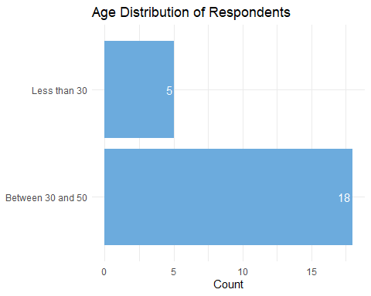

Education
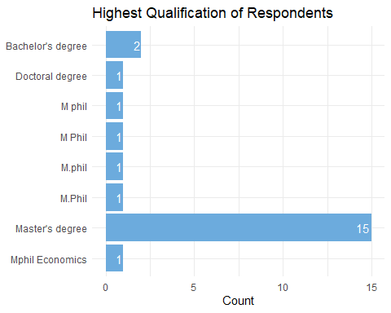

Gender
# A tibble: 2 × 2
Gender Count
<chr> <int>
1 man 17
2 woman 6

Locations
Respondents listed the location of their primary residence. The map below shows their locations.
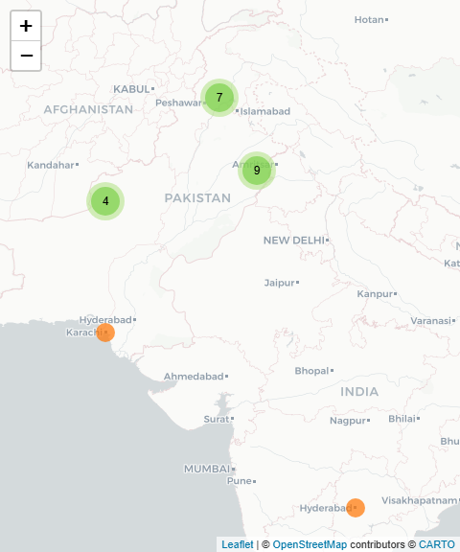

Familiarity with R/Python
Respondents rated their familiarity with R/Python as 2.3 on a 5-point scale.

Familiarity by Education Level
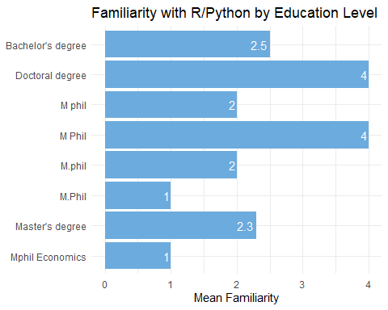

Interest in Learning R/Python
Respondents rated their interest in learning R/Python as 4.6 on a 5-point scale.

Interest by Age and Education Level
Error in `palette()`:
! Insufficient values in manual scale. 8 needed but only 4 provided.

AI Usage and Productivity
