Learn to generate automated reports in minutes R101

V#5

## ggplot2

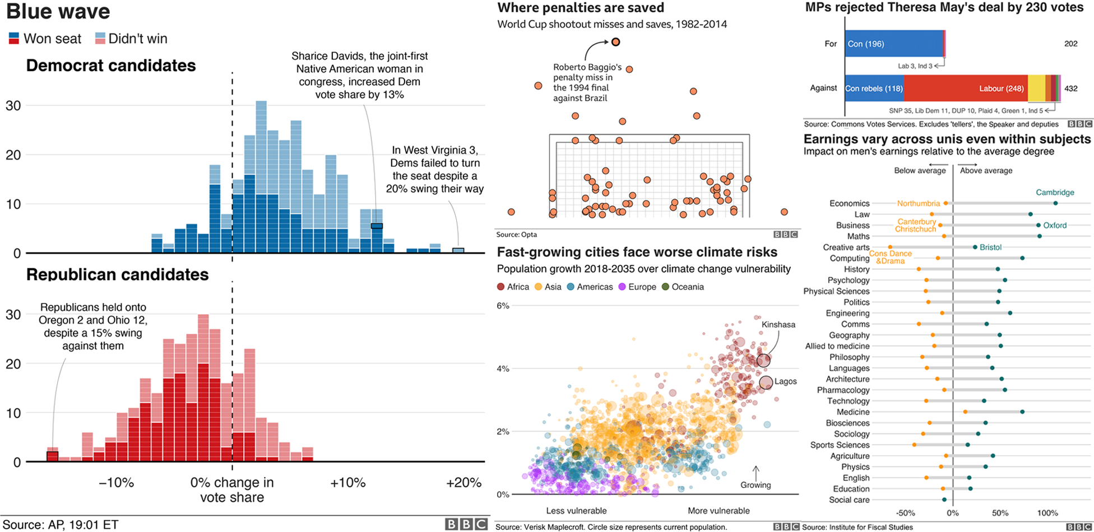

### arrange()

### select()

### mutate()

### filter()

### summarise()

## Read data in R

### csv file, package readr

### excel file readxl

### stata file haven

### spss file haven

## Clean Names (janitor)

### janitor package for data cleaning

1. First

. . .

1. Second
2. Third

. . .

```{r} head(mtcars) . . .

Forth