Animated line graph from WDI using ggplot2

V#6

## ggplot2 Line Graph

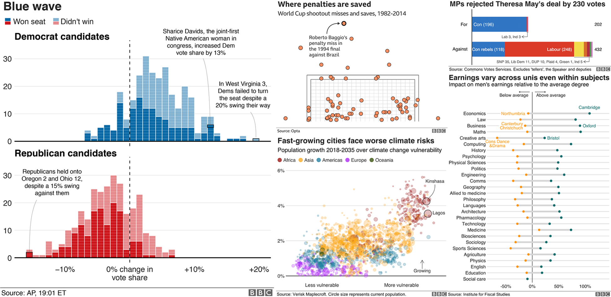

# World Development Indicators in R: simply a fun

# Have a line plot

# Animated Graph

1. First

. . .

1. Second
2. Third

. . .

```{r} head(mtcars) . . .

Forth