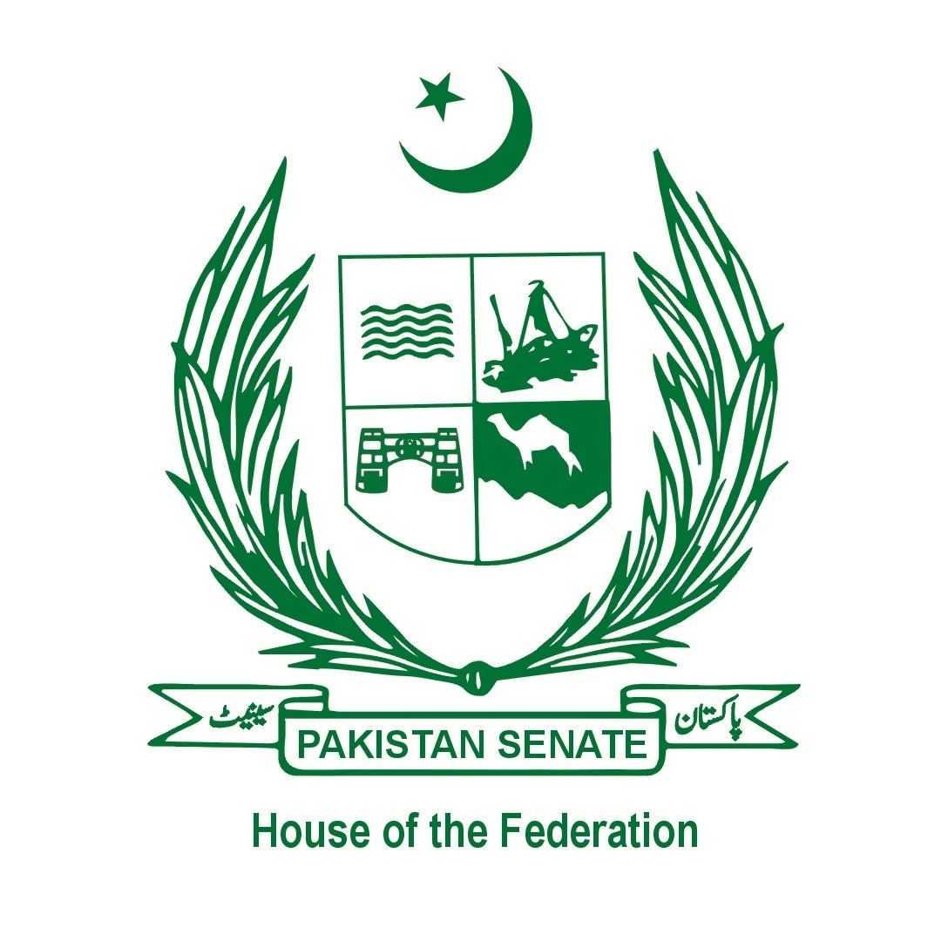

# Senate of Pakistan

## 342nd Session Journal

## Sittings and Hours etc.

|  |  |
| --- | --- |
| Category | Details |
| Session summoned on | 27-08-2024 |
| Session prorogued on | 16-09-2024 |
| Number of working days | 21 |
| Number of actual sittings | 11 |
| Number of Private Members’ days | 03 |
| Maximum attendance | 70 (on 12-09-2024) |
| Minimum attendance | 45 (on 30-08-2024) |
| Average attendance | 59.00% |
| Total hours of sittings | 27 hours and 5 minutes |
| Maximum hours of sitting | 04 hours and 12 minutes (on 12-09-2024) |
| Minimum hours of sitting | 15 minutes (on 16-09-2024) |
| Average hours of sittings | 2 hours and 45 minutes |

## Panel of Presiding Officers for 342nd Session

- Senator Sherry Rehman  
- Senator Irfan-ul-Haque Siddiqui  
- Senator Manzoor Ahmed

## Legislative Business

|  |  |
| --- | --- |
| Type of Business | Details |
| Private Members’ Bills introduced during the Session | 15 |
| Private Members’ Bills received from the National Assembly | Nil |
| Private Members’ Bills withdrawn by the Members-Incharge | Nil |
| Private Members’ Bills passed during the Session | 01 |
| Private Members’ Bills referred to concerned Committees | Nil |
| Government Bills received from the National Assembly | 06 |
| Government Bills introduced during the Session | 02 |
| Government Bills passed by the House | 07 |
| Government Ordinances laid | Nil |
| Presentation of Money Bill/Finance Bill | Nil |

## Calling Attention Notices

|  |  |
| --- | --- |
| Category | Details |
| Total Received | 31 |
| Admitted/Lapsed | 13 |
| Disallowed | 03 |
| Talked out in the House | 06 |
| Lapsed | 05 |
| Referred to Standing Committee for Interior | 04 |

## Prorogation of the Session

On 16th September, 2024, the Deputy Chairman Senate read out the prorogation order of the President and prorogued the Senate Session.