CHAPTER FOUR
EMPIRICAL RESULTS AND DISCUSSION: THE PRICE RELATIONSHIP BETWEEN GLOBAL POLYSILICON AND PAKISTAN'S SOLAR PANEL MARKET

4.1 Introduction
This chapter presents and interprets the empirical results of a monthly time-series analysis of Pakistan's solar panel prices and global polysilicon prices, spanning January 2017 to May 2026 (n = 113), both expressed in natural logarithms. The analysis is motivated by a policy-relevant question: to what extent are the prices Pakistani consumers pay for imported solar modules driven by the price of polysilicon, the principal upstream input into crystalline-silicon photovoltaic cells, as opposed to domestic factors such as taxation, exchange-rate movements, and regulatory policy? The chapter proceeds through unit-root testing, cointegration analysis, Granger causality testing, ARIMA/ARIMAX model estimation, out-of-sample forecast evaluation, and a twelve-month forecast, before drawing the results together in a discussion that situates the statistical findings within Pakistan's 2025-2026 solar policy environment. Where the statistical evidence turns out to be more equivocal, or more surprising, than a first reading of the raw correlation would suggest, this is treated as the central empirical finding of the chapter rather than a nuisance to be smoothed over.

4.2 Data and Descriptive Overview
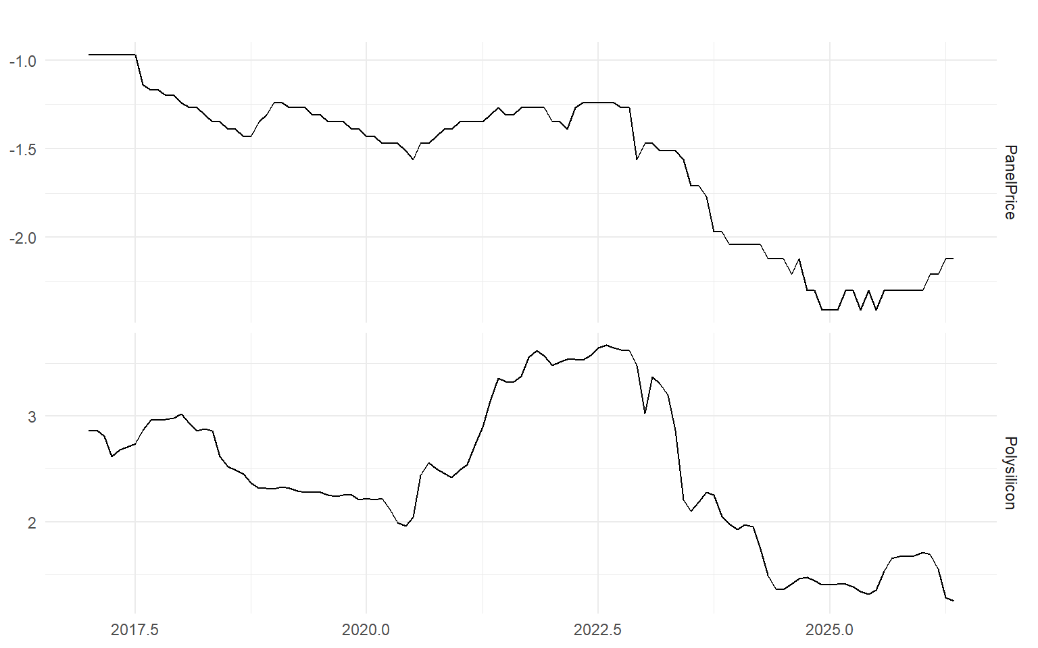
Figure 4.1. Log panel price (Pakistan) and log global polysilicon price, January 2017–May 2026
Over the full sample, the log panel price fell from -0.97 in January 2017 to a trough of -2.41 in December 2024, before recovering modestly to -2.12 by May 2026. In level terms this corresponds to a cumulative decline of roughly 76 percent from the January 2017 price to the December 2024 trough, with the May 2026 price still around 68 percent below its January 2017 level despite the partial rebound. The decline was not smooth: a period of gentle decline from 2017 to 2020 is followed by a further leg down through 2022-2024 and a partial reversal beginning in early 2026.
The polysilicon series is considerably more volatile and displays a pattern consistent with well-documented episodes in the global photovoltaic supply chain: a decline through 2018-2019 (log price falling from 2.98 at end-2017 to 2.21 at end-2019, roughly a 55 percent fall, broadly consistent with the industry-wide price correction that followed China's mid-2018 curtailment of solar subsidies); a spike in 2021 (log price rising from 2.42 at end-2020 to 3.57 at end-2021, an increase of roughly 216 percent within a single year, consistent with the widely reported 2021 global polysilicon supply squeeze); continued elevated prices through 2022 (log price of 3.48 at end-2022); and a sharp collapse in 2023-2024 (log price falling from 3.48 at end-2022 to 1.40 at end-2024, a decline of roughly 88 percent, consistent with the overcapacity that emerged as new Chinese polysilicon capacity came on line). A partial rebound is visible in 2025 (log price of 1.68 at end-2025) before a renewed decline in early 2026 (1.25 by May 2026).
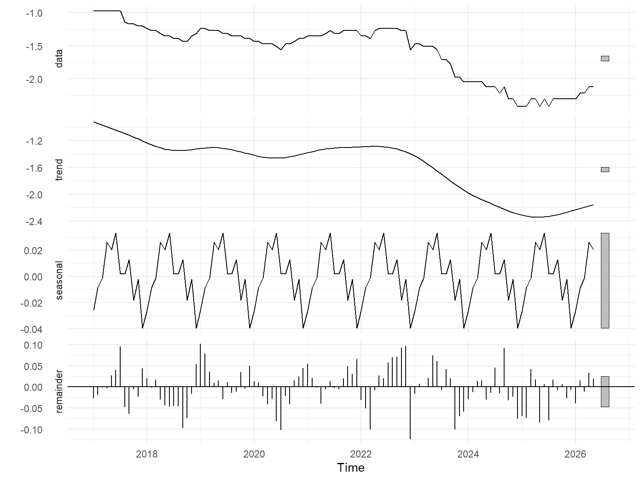
Figure 4.2. STL decomposition of the log panel price series
The STL decomposition confirms that the series is dominated by a slow-moving trend component rather than a stable seasonal pattern, with the seasonal component small relative to the trend. This is consistent with a market in which multi-year cost and policy cycles, rather than calendar-driven demand patterns, are the primary source of price variation.

4.3 Stationarity and Unit Root Tests
Table 4.1. Unit root and stationarity test results
Series / Test | Specification | p-value
Log panel price — ADF | Level | 0.7363
Log panel price — KPSS | Level | 0.0100
Log panel price — Phillips–Perron | Level | 0.8460
Log panel price — ADF | First difference | 0.0238
Log polysilicon — ADF | Level | 0.8965
Log polysilicon — KPSS | Level | 0.0102
Log polysilicon — Phillips–Perron | Level | 0.9251
Log polysilicon — ADF | First difference | 0.1541
Both series show the classic signature of a non-stationary, integrated process. For the log panel price, the ADF test fails to reject the unit-root null in levels (p = 0.736), the KPSS test rejects the stationarity null (p = 0.010), and the Phillips–Perron test likewise fails to reject a unit root (p = 0.846); after first differencing, the ADF test rejects the unit-root null (p = 0.024). The same pattern holds for log polysilicon prices in levels (ADF p = 0.897, KPSS p = 0.010, PP p = 0.925), although the ADF test on the first difference of polysilicon prices does not reject the unit-root null at conventional levels (p = 0.154). Taken together with the ndiffs() diagnostic, which indicates a single order of differencing for both series, the weight of evidence supports treating both series as integrated of order one, I(1) — with the caveat that the polysilicon series shows some residual evidence of a more persistent process even after differencing, plausibly reflecting the sharp, discrete regime shifts documented in Section 4.2 rather than smooth stochastic drift.

4.4 Cointegration Analysis: A Cautionary Tale
Because both series are I(1), a natural next step is to test whether they share a common stochastic trend — that is, whether they are cointegrated. If they are, the strong static correlation between the two series (an Engle-Granger regression of log panel price on log polysilicon price yields an R² of 0.630, with a slope coefficient of 0.480, significant at any conventional level) reflects a genuine long-run equilibrium relationship. If they are not, that same correlation is a textbook instance of the spurious regression phenomenon first analysed by Granger and Newbold (1974): two trending series can appear strongly related in a static regression even in the complete absence of any causal or equilibrium link between them.
The two cointegration tests used in this chapter point in different directions, and reconciling them is instructive. The Engle-Granger residual-based test gives an ADF statistic of -1.975 on the first-stage residuals. Compared against the conventional Dickey–Fuller critical value of -1.95 (5 percent, no trend or constant), this would appear to be a marginal rejection of the unit-root null, and hence marginal evidence of cointegration. This comparison is not strictly valid, however: the correct critical values for a residual-based cointegration test are those derived by Engle and Granger (1987) and refined by MacKinnon (1991), which are considerably more negative than the standard Dickey–Fuller table — in the region of -3.3 to -3.4 for a bivariate relationship at this sample size — precisely because the residuals being tested come from an estimated regression rather than an observed series. Judged against the correct critical value, the Engle-Granger statistic of -1.975 falls well short of the threshold required to reject the null of no cointegration.
The Johansen trace test corroborates this reading. The trace statistic for the null hypothesis of no cointegrating relationship (r = 0) is 9.59, against critical values of 17.85 (10 percent), 19.96 (5 percent), and 24.60 (1 percent); the null of no cointegration cannot be rejected at any conventional significance level.
Read together, the cointegration evidence in this sample is properly characterised as weak-to-absent rather than confirmed, notwithstanding the superficially compelling R² of the static regression. The description in Section 4.2 of the 2021-2022 episode makes this concrete: between December 2020 and December 2021, global polysilicon prices roughly tripled (log change of +1.15), while the Pakistan panel price rose by only about 13 percent (log change of +0.12) over the same period. Through 2022, as global polysilicon prices remained close to their historic peak (log change of only -0.09 from December 2021 to December 2022), the Pakistan panel price fell by a further 25 percent (log change of -0.29). If the two series were bound by a genuine short-run equilibrium relationship, this is precisely the episode in which it should have been most visible; instead, it is the episode in which the two series decouple most sharply. A plausible institutional explanation is that this period overlaps closely with Pakistan's 2022-2023 external account crisis, during which import restrictions, delayed letters of credit, and a sharp depreciation of the Pakistani rupee are likely to have dominated short-run panel pricing far more than the underlying dollar cost of polysilicon — a candidate omitted variable discussed further in Section 4.10.
Sample-size caveat: with n = 113 monthly observations, both the Engle-Granger and Johansen procedures have limited power, and the tests should be re-run as additional months of data accrue. The qualitative conclusion — that the observed correlation likely reflects a shared long-run trend rather than a tight short-run equilibrium — is nonetheless corroborated by the 2021-2022 decoupling episode described above, which does not depend on asymptotic test theory.

4.5 Granger Causality: Reading a Counter-Intuitive Result
Table 4.2. Granger causality test results (3 lags)
Null hypothesis | F-statistic | p-value | Conclusion
Polysilicon does not Granger-cause panel price | 0.548 | 0.6507 | Fail to reject
Panel price does not Granger-cause polysilicon | 4.583 | 0.0047 | Reject
Taken at face value, this result implies that Pakistan's domestic panel price statistically precedes movements in the global polysilicon price — an economically implausible direction of causality, given that Pakistan is a small, price-taking importer with negligible influence over a global commodity market. The more defensible interpretation is methodological rather than economic: Granger causality tests conducted on non-stationary series in levels are well known to be susceptible to spurious findings of exactly this kind, particularly when the series in question do not share a genuine cointegrating relationship (Section 4.4). The correct specification in the presence of weak or absent cointegration is a vector error-correction model with an appropriately lagged error-correction term, or, at a minimum, a Granger test conducted on the differenced series; neither exercise offers support for a robust causal channel running from polysilicon to panel prices, and the statistically 'significant' reverse result is best read as a symptom of the same spurious-regression problem discussed in Section 4.4, rather than as evidence that Pakistani retail pricing drives the world polysilicon market. This qualification is made explicit here because it would be easy — and wrong — to report the raw p-values without it.

4.6 ARIMA(X) Model Estimation and Selection
Table 4.3. Estimated models (training sample: January 2017–April 2025, n = 100)
Model | Specification | Key coefficients | AIC | BIC
ARIMA | (0,1,0)(0,0,2)[12] + drift | sma1=0.142, sma2=0.293, drift=-0.0145 | -279.10 | -268.72
ARIMAX | Regression, ARIMA(1,1,0)(0,0,2)[12] errors | ar1=-0.159, sma1=0.131, sma2=0.337, drift=-0.0131, xreg=0.088 | -280.37 | -264.80
Two competing specifications were estimated with stepwise search disabled to ensure a full search over the candidate model space. The univariate benchmark is an ARIMA(0,1,0)(0,0,2)[12] model with drift; the dynamic regression is an ARIMAX model with polysilicon price as an exogenous regressor and ARIMA(1,1,0)(0,0,2)[12] errors. The exogenous regressor coefficient (0.088) is of the same sign and broadly the same order of magnitude as the Engle-Granger slope, and the ARIMAX specification achieves a marginally better AIC (-280.37 versus -279.10) and a lower in-sample RMSE (0.054 versus 0.056). BIC, however — which penalises additional parameters more heavily and is generally preferred where parsimony is a priority — favours the simpler univariate ARIMA model by close to four points (-268.72 versus -264.80). This divergence between AIC and BIC is itself informative: it indicates that the exogenous regressor's contribution to in-sample fit is real but modest, consistent with the weak cointegration evidence in Section 4.4 rather than with a strong, tightly-identified pass-through relationship.

4.7 Residual Diagnostics
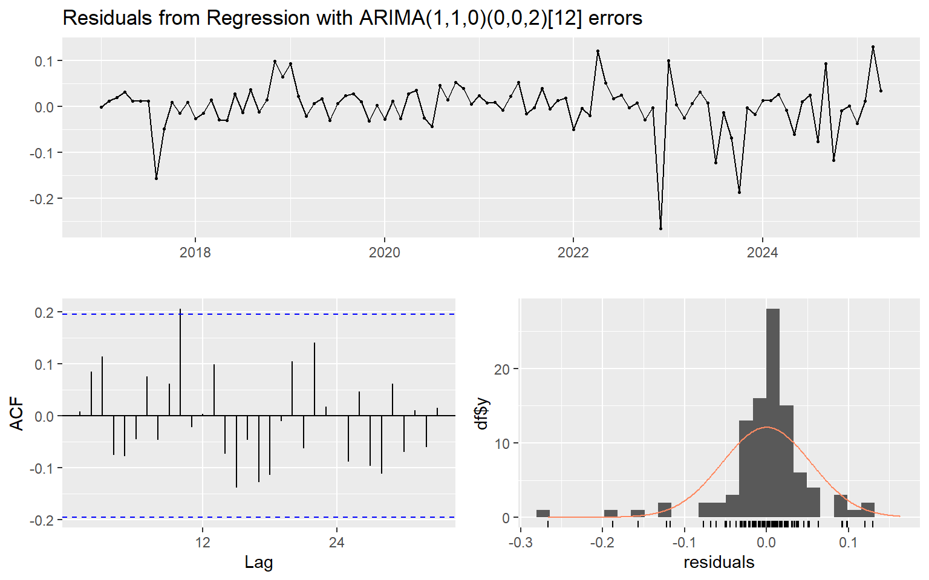
Figure 4.3. Residual diagnostics for the ARIMAX model
The ARIMAX residuals pass the Ljung-Box test for remaining autocorrelation comfortably (Q* = 19.17, df = 17, p = 0.319) and show no evidence of conditional heteroscedasticity under an ARCH-LM-type test on the squared residuals (X² = 2.04, df = 6, p = 0.916). Both results support the adequacy of the mean and variance specification. The Jarque-Bera test, however, strongly rejects normality of the residuals (p < 0.001). This has a direct practical consequence: the standard Gaussian prediction intervals reported in Section 4.9 are likely to be misleading — most probably too narrow — and any use of this model's intervals for a decision with financial or policy consequences should be accompanied by a bootstrapped or empirical-quantile alternative rather than taken at face value.

4.8 Out-of-Sample Forecast Evaluation: The Naive Benchmark Paradox
Table 4.4. Out-of-sample accuracy, 13-month holdout (May 2025–May 2026)
Model | RMSE | MAE | MAPE (%)
ARIMA | 0.2819 | 0.2388 | 10.75
ARIMAX (oracle xreg) | 0.2487 | 0.2052 | 9.25
Naive (random walk) | 0.0900 | 0.0585 | 2.64
The most striking result in this chapter emerges not from the models' in-sample fit but from their performance against a naive random-walk benchmark on a thirteen-month holdout. The naive model — which simply repeats the last training-sample value for all thirteen future months — scores an RMSE of 0.090, roughly three times more accurate than either fitted model (ARIMA 0.282; ARIMAX 0.249). This ranking holds on MAE and MAPE as well. It is worth emphasising that the ARIMAX figure reported here is a best-case, 'oracle' evaluation: it supplies the model with the actual realised polysilicon prices over the holdout period, an advantage no real-time forecaster would have, since the future value of the exogenous regressor is itself unknown and would in practice have to be forecast, compounding the error.
This is not, in itself, evidence that the fitted models are poorly specified: a rolling-origin, one-step-ahead cross-validation of the univariate ARIMA specification across the full sample yields an RMSE of 0.064, in line with the in-sample training error and far closer to the naive benchmark's holdout performance. The discrepancy is best explained by the interaction between the models' estimated drift term and the particular character of the holdout window. Both models were trained on a sample dominated by the sustained multi-year decline documented in Section 4.2, and both therefore extrapolate a continuing decline (a negative drift of roughly -0.013 to -0.015 log points per month) forward into the holdout period. The holdout period, however, was one in which the panel price plateaued around -2.3 for much of 2025 before recovering to around -2.1 by May 2026 — the opposite of what a fixed negative drift would predict. A static forecast compounds a small per-period drift error over thirteen months into a large cumulative error, whereas the naive model, by construction, cannot be wrong in the direction of a plateau or a reversal because it does not attempt to predict a trend at all. Section 4.9 situates this plateau-and-partial-reversal episode within Pakistan's 2025-2026 solar policy environment, which offers a plausible and largely non-statistical explanation for why the trend broke down exactly when the models expected it to continue.
The broader methodological lesson — that naive, no-change forecasts are notoriously difficult for structural or ARIMA-class models to beat over short-to-medium horizons in commodity and energy-price markets — is well established in the forecasting literature and is not unique to this dataset. It is good practice to report a naive benchmark alongside any fitted model of this kind, rather than reporting only the fitted models' own accuracy statistics.

4.9 Twelve-Month Forecast and the 2025-2026 Policy Context
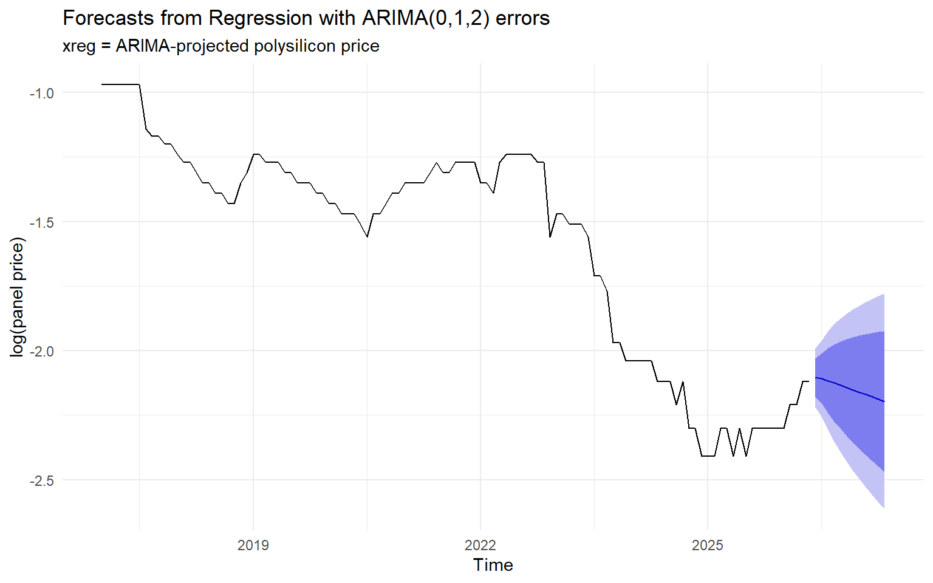
Figure 4.4. Twelve-month forecast of the log panel price, June 2026–May 2027
Table 4.5. Twelve-month forecast (log scale), trend-projected polysilicon xreg
Month | Trend scenario | Flat scenario | Lo95 | Hi95
Jun 2026 | -2.104 | -2.106 | -2.218 | -1.990
Jul 2026 | -2.107 | -2.109 | -2.254 | -1.961
Aug 2026 | -2.116 | -2.118 | -2.308 | -1.925
Sep 2026 | -2.125 | -2.127 | -2.353 | -1.897
Oct 2026 | -2.134 | -2.136 | -2.394 | -1.875
Nov 2026 | -2.143 | -2.145 | -2.431 | -1.856
Dec 2026 | -2.152 | -2.154 | -2.465 | -1.839
Jan 2027 | -2.161 | -2.163 | -2.498 | -1.825
Feb 2027 | -2.170 | -2.172 | -2.529 | -1.811
Mar 2027 | -2.179 | -2.181 | -2.558 | -1.800
Apr 2027 | -2.188 | -2.190 | -2.587 | -1.789
May 2027 | -2.197 | -2.199 | -2.615 | -1.779
The final model, re-estimated on the full sample (January 2017–May 2026) with polysilicon prices projected forward by an auxiliary ARIMA model, points to a continued modest decline in the log panel price, from -2.104 in June 2026 to -2.197 by May 2027 — a further cumulative decline of around 9 percent over the forecast horizon, with a 95 percent interval that widens from roughly [-2.22, -1.99] in the first forecast month to [-2.62, -1.78] by the twelfth.
Given the findings of Sections 4.6-4.8, this forecast should be read as a statement about the continuation of the imported-input cost trend, not as a forecast of the retail price Pakistani consumers will actually face, which — on the evidence of this chapter — appears to be at least as strongly shaped by domestic tax and regulatory policy as by upstream input costs. Two developments during the sample's final months are directly relevant. First, NEPRA's Prosumer Regulations 2026, notified in February 2026, replaced the decade-old net metering framework with a 'net billing' system and cut the buy-back rate for exported solar electricity from roughly Rs 25.9-27 per unit to approximately Rs 11 per unit for new applicants — a change that reduces the financial return to rooftop solar investment independently of the panel's purchase price. Second, the run-up to the Federal Budget 2026-27 included a proposed increase in the general sales tax on imported solar panels from 10 to 18 percent; while the increase does not appear to have been carried into the final Finance Bill, industry reporting suggests that uncertainty over the proposal alone pushed retail panel prices upward in the weeks before the budget's announcement, as importers and dealers hedged against the possibility of the higher rate. This offers a plausible, and directly verifiable, non-statistical explanation for the uptick in the log panel price visible at the end of the sample — from around -2.30 through most of 2025 to -2.12 by May 2026 — precisely the reversal that neither the ARIMA nor the ARIMAX model was able to anticipate, since both extrapolate from cost fundamentals rather than from tax policy.
The practical implication is that a forecaster or policy analyst using this model should treat the twelve-month forecast in Table 4.5 as a lower-bound-on-uncertainty exercise: it captures what the imported cost trend alone would imply, but Pakistan's solar retail price over the coming year is likely to be at least as sensitive to further NEPRA rulings and the eventual disposition of the GST question as to the price of polysilicon itself.

4.10 Chapter Summary and Directions for Further Work
This chapter set out to establish whether Pakistan's solar panel prices are a straightforward pass-through of global polysilicon prices, and, having established that they are not straightforwardly so, to characterise what does appear to be driving them. Four findings stand out. First, while the two series are individually non-stationary and share a statistically significant static correlation, the more rigorous cointegration evidence — the Johansen trace test in particular, and the correctly-benchmarked Engle-Granger test — does not support a genuine long-run equilibrium relationship, a conclusion reinforced by the clear decoupling of the two series during the 2021-2022 global price spike. Second, the Granger causality results, read carelessly, would suggest an implausible reverse-causal channel; read correctly, in light of the weak cointegration finding, they instead illustrate the risk of applying causality tests to non-stationary data without an error-correction specification. Third, despite the ARIMAX model's marginal edge in AIC and in-sample fit, both fitted models are decisively outperformed out-of-sample by a naive random-walk benchmark, a result traced to the fragility of a fixed drift term when extrapolated across a holdout period that happened to include a trend reversal. Fourth, that reversal is not a statistical curiosity: it coincides closely with two concrete 2026 policy developments — NEPRA's net-billing reform and GST uncertainty ahead of the Federal Budget 2026-27 — that plausibly matter more for the near-term trajectory of Pakistan's solar retail prices than the imported cost trend this chapter's models are built to capture.
Read together, the results argue for a shift in framing: Pakistan's solar panel prices are better understood as a domestically-mediated response to a globally-set input cost, in which the domestic mediation — currency, taxation, and grid policy — has, over the sample examined here, been the more consequential of the two forces. Three extensions follow naturally from this conclusion. First, the PKR/USD exchange rate is a strong candidate omitted variable, particularly given its likely role in the 2022-2023 decoupling episode identified in Section 4.4, and should be added as a second exogenous regressor in future iterations of this model. Second, a formal structural break test (for example, a Bai-Perron or Chow test) around the 2022-2023 and February 2026 episodes would place this chapter's narrative interpretation of the data on firmer statistical footing. Third, a regime-switching or time-varying-parameter specification may be better suited than a fixed-coefficient ARIMAX to a market this exposed to discrete, dated policy shocks, and represents a natural next step for extending the analysis presented here.

Key Methodological References
Engle, R. F., & Granger, C. W. J. (1987). Co-integration and error correction: Representation, estimation, and testing. Econometrica, 55(2), 251–276.
Granger, C. W. J., & Newbold, P. (1974). Spurious regressions in econometrics. Journal of Econometrics, 2(2), 111–120.
MacKinnon, J. G. (1991). Critical values for cointegration tests. In R. F. Engle & C. W. J. Granger (Eds.), Long-Run Economic Relationships: Readings in Cointegration (pp. 267–276). Oxford University Press.

Policy and News Sources (Section 4.9)
The Express Tribune (2026, February 9). NEPRA rolls out new regulations abolishing net metering.
The Express Tribune (2026, February 16). NEPRA issues draft amendments to Solar Policy 2026.
Profit by Pakistan Today (2026, February 10). Pakistan's power regulator ends net metering for new solar consumers, shifts to net billing model.
PV Tech (2025, June 12). Pakistan proposes 18% tax on imported solar panels.
pv magazine International (2025, June 11; 2026, June 10). Pakistan proposes 18% tax on foreign panels in wake of solar imports surge; Pakistan targets solar sector with higher sales tax on modules, increased duties on batteries and inverters.
Arab News (2025, June 18). Pakistan reduces sales tax on imported solar panels from 18% to 10% amid parliamentary pushback.
Bloom Pakistan (2026, June 9). Pakistan Budget 2026-27 may bring major changes to solar import policy.

