**ANALYTICAL MODELING OF HgCdTe HOMOJUNCTION PHOTODETECTOR FOR LWIR FREE SPACE OPTICAL COMMUNICATION SYSTEM**

A report submitted in partial fulfilment of the requirements for

Completion of internship

by

**Mohmad Zaheer**

**(ID: B192091)**

Under the Guidance of

**Dr. Vijayakumar Devarakonda,**

**Assistant Professor**

Dept. of Electronics and Communication Engineering,

IIITDM Kurnool.



**DEPARTMENT OF**

**ELECTRONICS AND COMMUNICATION ENGINEERING**

**Rajiv Gandhi University of Knowledge Technologies, Basar**

**Telangana,504107**

**ACKNOWLEGEMENT**

I take immense pleasure to express my deep sense of gratitude to our beloved guide **Dr. Vijayakumar Devarakonda,** Assistant Professor in Electronics and Communication Engineering, **IIITDM Kurnool** for his valuable suggestions and rare insights, for constant source of encouragement and inspiration throughout my internship work. This internship period was a great chance of learning and professional development.

I express my deep sense of gratitude to **B. Neelima**, Assistant Professor, HOD of Electronics and Communication Engineering in Rajiv Gandhi University of Knowledge Technologies for the valuable guidance and for permitting me to carry out this Summer Internship work at IIITDM Kurnool.

With gratitude,

Mohmad Zaheer B192091

**ABSTRACT**

This project report provides a comprehensive overview of the analytical modelling of p+ -Hg0.78Cd0.22Te/ n - Hg0.78 Cd0.22Te/CdZnTe(mercury cadmium telluride) homojunction infrared photodetector. The photodetector has been studied in respect of energy band diagram, electric field profile, doping efficiency, spectral response, responsivity and detectivity by analytical method using closed form equations. Utilizing MATLAB for simulation, the research aims to enhance the understanding of key performance factors in long wavelength infrared (LWIR) and very long wavelength infrared (VLWIR) photodetectors. The report highlights the significant factors affecting the performance of these photodetectors, such as various generation-recombination mechanisms including trap-assisted tunnelling (TAT), Shockley-Read-Hall (SRH), Auger, and radiative processes. Numerical simulations were conducted to investigate the effects of different parameters like absorber layer thickness, material compositions, trap density, and trap energy levels on the photodetector performance.The outcomes of this research provide crucial insights into optimizing detector designs to improve sensitivity and performance.

While the provided information can be used as a guide for optimizing the device processing conditions and detector structure, it also enlights the importance of various intrinsic mechanisms on the detector sensitivity.

July 2024

**INDIAN INSTITUTE OF INFORMATION TECHNOLOGY DESIGN AND MANUFACTURING KURNOOL**

**CERTIFICATE**

This is to certify that **MOHMAD ZAHEER (B192091)** of **Rajiv Gandhi University of Knowledge Technologies, Basar** have successfully completed a Project titled **“ANALYTICAL MODELING OF HgCdTe HOMOJUNCTION PHOTODETECTOR FOR LWIR FREE SPACE OPTICAL COMMUNICATION SYSTEM”**, as part of Summer Internship programme under my guidance at Indian Institute of Information Technology Design and Manufacturing, Kurnool during **15/05/2024** to **30/06/2024**.

**Internship Guide**

**Dr. Vijayakumar Devarakonda**

**Assistant Professor**

**Dept. of ECE**

**IIITDM-Kurnool.**

**TABLE OF CONTENT**

* INTRODUCTION -------------------------------------------- 1
* APPLICATION OF LWIR -------------------------------------------- 4
* STRUCTURE OF HgCdTe -------------------------------------------- 5
* MODELING -------------------------------------------- 7

1. DARK CURRENT
2. DIFFUSION CURRENT
3. G-R CURRENT
4. TAT & BTB CURRENT
5. CARRIER LIFETIME
6. QUANTUM EFFICIENCY
7. SPECIFIC DETECTIVITY

* STIMULATION & RESULT --------------------------------------------- 17
* CONCLUSION --------------------------------------------- 20
* REFERENCES

**INTRODUCTION**

1. **Semiconductors:** Materials with electrical properties that fall between those of insulators and conductors. They are the backbone of modern electronic devices, enabling the development of integrated circuits, transistors, diodes, and many other essential components.
2. **Extrinsic Semiconductors**: Semiconductors that have been doped with impurities to modify their electrical properties. Doping introduces additional charge carriers, which can enhance conductivity. The bandgap is the energy difference between the valence band and the conduction band. It's a crucial property that determines a material's electrical conductivity and its response to light.
3. **Indirect Bandgap**: when the minimum of the conduction band and the maximum of the valence band do not occur at the same momentum (or wave vector) value in the material's Brillouin zone. Electrons in an indirect bandgap material require a change in momentum to transition from the valence band to the conduction band or vice versa.
4. **PN junction:** A PN junction is formed by joining a p-type semiconductor, which has an abundance of holes, with an n-type semiconductor, which has an excess of electrons. This junction is a key component in many semiconductor devices.
5. Formation of the Junction

When the p-type and n-type materials are brought together, diffusion of charge carriers occurs:

* + - **Electrons** from the n-region diffuse into the p-region and recombine with holes. **Holes** from the p-region diffuse into the n-region and recombine with electrons. This diffusion results in the formation of a **depletion region** at the junction where mobile charge carriers are depleted, creating an area with fixed, immobile ions (positive ions on the n-side and negative ions on the p-side).

1. Characteristics of the PN Junction

* **Depletion Region:** The width depends on the doping levels of the p-type and n-type regions. The immobile ions create an electric field that opposes further diffusion of electrons and holes.
* **Forward Bias:** When a positive voltage is applied to the p-side and a negative voltage to the n-side. Reduces the width of the depletion region and lowers the barrier potential, allowing current to flow as electrons and holes recombine at the junction. The majority carriers (electrons in the n-region and holes in the p-region) cross the junction and contribute to the current. The current increases exponentially with the applied voltage due to the reduction in the barrier potential.
* **Reverse Bias:** When a negative voltage is applied to the p-side and a positive voltage to the n-side. Increases the width of the depletion region and raises the barrier potential, preventing current flow. A small current, known as reverse saturation current, flows due to minority carriers. : At a certain reverse voltage, the diode undergoes breakdown, leading to a large increase in current. This can be due to either avalanche breakdown or Zener breakdown depending on the diode design and doping levels.

1. **Homo Junction:** A homo junction is formed between two regions of the same semiconductor material with different doping levels (e.g., p-type and n-type silicon). Both regions are made of the same semiconductor material.
2. **Heterojunction:** A heterojunction is formed between two different semiconductor materials with differing bandgaps and electronic properties, such as gallium arsenide (GaAs) and aluminium gallium arsenide (AlGaAs).

* Different bandgap materials create discontinuities in the conduction and valence bands. Enhanced electron and hole mobility across the junction. Used in devices that require high-performance characteristics.

1. **Optoelectronics**: A device that interacts with light by producing, measuring or manipulating light is said to be an optoelectronic device. The study of such devices and their behaviour contributes to the field of **Optoelectronics**. These devices have various applications in various fields like medicine, sensing, imaging, security and many military applications as well.
2. **Photodetector:** It is a device that detects light and converts it into an electrical signal. The light can be in various parts of the electromagnetic spectrum, including ultraviolet (UV), visible, and infrared (IR).
3. **Infrared Radiation (IR)**: Electromagnetic radiation with wavelengths ranging from about 700 nm to 1 mm, situated between visible light and microwaves on the electromagnetic spectrum.Corresponds to frequencies from approximately 300 GHz to 430 THz.

* **Near-Infrared (NIR)**: 700 nm to 1,400 nm
* **Mid-Infrared (MIR)**: 1,400 nm to 3,000 nm
* **Far-Infrared (FIR)**: 3,000 nm to 1 mm

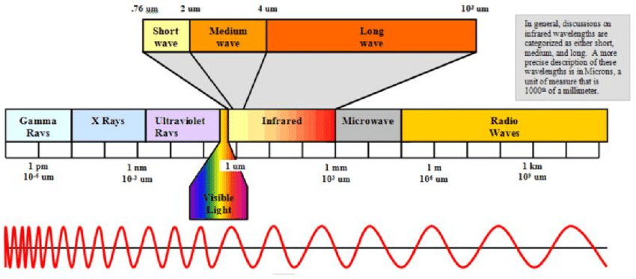

1. **Long-Wave Infrared (LWIR)**: The infrared (IR) spectrum with wavelengths longer than those of mid-wave infrared (MWIR) and shorter than those of far infrared (FIR). The LWIR range generally spans from 8 µm to 14 µm, though some sources may extend it slightly beyond this range.

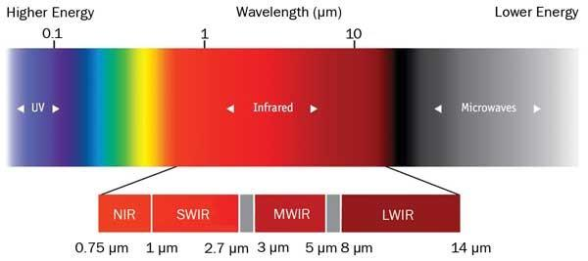

**APPLICATION OF LWIR**

1. **Thermal Imaging:**

* **Surveillance and Security**: LWIR cameras are widely used for night vision and surveillance, as they can detect heat from objects even in complete darkness.
* **Search and Rescue**: Used to locate people and animals based on their body heat in low visibility conditions.
* **Building Inspections**: Identifies heat leaks, insulation issues, and other thermal anomalies in structures.

1. **Environmental Monitoring:**

* **Climate Studies**: LWIR is critical for studying Earth’s thermal radiation and understanding climate patterns.
* **Pollution Detection**: Measures the concentration of gases like CO₂ and water vapour in the atmosphere by detecting their unique absorption signatures in the LWIR range.

1. **Industrial Applications:**

* **Quality Control**: LWIR imaging is used to monitor processes that involve heat, such as welding, casting, and drying, ensuring uniformity and quality.
* **Predictive Maintenance**: Identifies overheating components in machinery and electrical systems before failure occurs.

1. **Medical and Biological Uses:**

* **Thermography**: Non-invasive imaging technique used to detect abnormal heat patterns in the human body, which can indicate conditions like inflammation or vascular issues.
* **Animal Studies**: LWIR imaging is used in wildlife research to monitor body temperature and health without disturbing the animals.

1. **Remote Sensing:**

* **Agriculture**: Monitors plant health by measuring surface temperature and detecting stress indicators in crops.
* **Earth Observation**: Used in satellites to measure land and ocean temperatures, contributing to weather forecasting and climate monitoring.

**STRUCTURE OF HgCdTe**

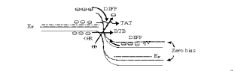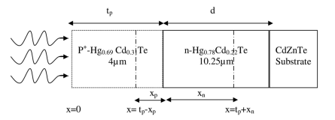

**Hg1-xCdxTe** (Mercury Cadmium Telluride-MCT): It is one of the most important semiconductors for IR detection. HgCdTe is a direct bandgap material. Its absorption coefficient is very high which provides high quantum efficiency. x represents CdTe mole fraction in the HgCdTe alloy. Cut-off wavelength of HgCdTe can be adjusted from 0.7 to 30 μm by changing the CdTe mole fraction.

MCT is the only well-behaved intrinsic semiconductor with an energy band gap of around 0.1 eV (for x ≈ 0.2), which makes this alloy very significant for IR imaging at LWIR band. CdTe and HgTe have zinc-blende structures. Hg1-x Cdx Te has also zinc-blende structure for all x values. At 77 K, CdTe has an energy band gap value of 1.6088 eV and HgTe has an energy band gap value of –0.2608 eV. Hg1-x Cdx Te has a direct energy band gap changing from energy band gap value of CdTe to that of HgTe as x varies from 1 to 0. There exist some equations expressing the energy band gap value of Hg1-x Cd x Te in terms of x and temperature.

E(x, t)= -0.302 + 1.93*x + 5.35 * 10 -4 * t (1 – 2 * x) – 0.810 * x2 + 0.832 * x3

Where E_g is the energy band gap of Hg1-x Cd x Te in eV and x is the mole fraction of CdTe. T is the temperature in Kelvin. Energy band gap of Hg1-x Cd x Te for x between 0 and 0.30.HgCdTe is the rare semiconductor covering the entire IR region of the electromagnetic spectrum with a small change in the lattice constant . The lattice constant (a) of HgCdTe as a function of x is given by

a = 6.4614 + 0.0084 * x + 0.01168 * x2 – 0.0057 * x3

Where “a” is in terms of angstroms (Å). The lattice constant of CdTe (x=1) is only 0.3 % larger than that of HgTe (x=0). This is very important since small variation of lattice constant permits the fabrication of new devices based on lattice matched high quality complex epitaxial layers.

HgCdTe is a direct energy band gap material, and it has a very sharp optical absorption characteristic. Optical absorption coefficient of Hg1-x Cd x Te as a function of x. As a result of the strong optical absorption of HgCdTe, relatively thin layer of HgCdTe about 8–20 μm is sufficient for absorption of high percentage of the IR flux yielding high quantum efficiency. Hougen formula for absorption coefficient is given by

α =100 + 5000x

Where x is the Cd mole fraction. Absorption coefficient is plotted according to Hougen formula in a range of x = 0.1 to 0.3.

The intrinsic carrier concentration of HgCdTe can be calculated using the following expression

Ni = ( 5.24256 – 3.5290 * x – 4.72019 * 10-4 * T + 1.25942 * 10-2  * x * T * -5.77046 * x2 – 4.24123 * 10-6 * T2 ) * 1014 * Eg3/4  * T3/4 * exp (- Eg / 2*K*T)

Where T is in Kelvin and k is Boltzmann’s constant.

The electron effective mass is given by:

Mn* =

The hole mass m­p* is given as 0.55mo. HgCdTe is characterized by very low electron effective mass when compared to the hole effective mass. This in many ways shapes the way the device behaves. Since the electron mass is so low, the electrons also tend to have a very high mobility when compared to the holes. This property can be used to make a high performance detector. Detectors are designed in such a way that the electrons carry the majority of the current. This also results in better transit.

The expression for mobility is:

µe = 9*104 * (7.5 * T -2 *( 0.6

Where x is the mole fraction and T is the temperature. The hole mobility is usually given by:

µh =

HgCdTe has very high electron mobility. There are various scattering mechanisms that would affect the mobility as we increase temperature but that will not be discussed in this thesis. In HgCdTe the theoretically calculated mobility is usually greater than the experimental value at low temperature. It is 66 because sufficient information is not represented for theoretical calculation especially concerning impurity level, compensation, and impurity iconicity.

The expression for permittivity is given by:

εHgCdTe = 20.5 – 15.5 * x + 5.7 * x2

**MODELING**

1. **Dark Current:**

The dark current of the p+ -n photodetector has been modelled here by considering

1. The diffusion of the thermally generated carriers from the neutral regions, IDIFF
2. generation-recombination of carriers in the depletion region, IGR
3. Tunnelling of carriers through the barrier, ITUN. In order to generalize the analysis, we have however considered both trap assisted tunnelling (TAT) as well as band-to-band tunnelling (BTB). The tunnelling component of current thus constitutes two components e.g., ITAT arising from the trap assisted tunnelling and IBTB arising out of band-to-band tunnelling. The net current can be written as:

JTOTAL = JDIF + JGR + JTUN ,

Where JTUN  = JBTB + JTAT

1. **Diffusion Current:**

In the present structure under consideration, the diffusion of minority carriers from both p+ and n regions, contribute diffusion current. The minority carrier diffusion current under application of a bias voltage, V can be obtained by solving 1-D diffusion equation under appropriate boundary conditions. Diffusion current density due to holes injected from p+ region in n-Hg0.78 Cd0.22Te region is modelled as:

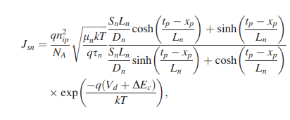

Diffusion current density due to electrons injected from intrinsic n region in p+ -Hg0.78 Cd0.22Te region is modelled as

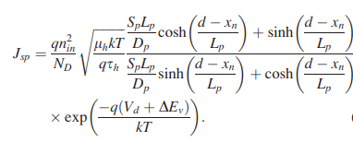

ni is the intrinsic carrier concentration of HgCdTe, NA and ND are the acceptor and donor concentrations in p and n regions respectively, q is the electronic charge, μh and μn are the hole and electron mobility respectively, τ­h and τn are hole and electron life time’s respectively, Sp and Sn are the surface recombination velocities of holes at p-HgCdTe/metal interface and electrons at HgCdTe/CdZnTe hetero-interface and Lp and Ln are respective diffusion lengths of holes and electrons on n-and p-side respectively. Were t and d are the thickness of p+ - HgCdTe and n-HgCdTe regions respectively, xp and xn are respectively the width of the depletion regions in p and n regions and A is the junction area, V is the applied voltage. The total diffusion current can be written as

JDIFF = ( JSN + JSP) * (exp ($\frac{q*V}{K*T})-1)$

1. **Generation – Recombination Current:**

The generation-recombination current component arises due to impurities and defects within the depletion region that acts as intermediate states for the thermal generation and recombination of carriers. These intermediate states are known as Shockley-Read-Hall centers. This current could be important than diffusion current, although depletion region is much less than the minority carriers diffusion length, especially at low temperature. The generation-recombination component of current density and associated resistance area product can be approximated as

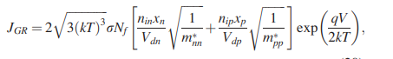

Where m*nn and m*pp are the effective masses of electrons and holes in the n and P regions, respectively.

1. **Trap Assisted Tunnelling Current:**

In this case the minority carriers may tunnel from the occupied trap states on the quasi neutral side to the empty band states on the other side of the junction or through the trap sites present in the depletion region of the junction. In the P+-n junctions, the major contribution of TAT may be due to tunnelling of electrons, via trap levels to the conduction band on the n side. This trap-assisted tunnelling current density can be calculated as

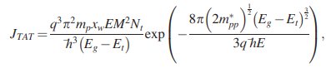

where xw is the total width of the depletion region, m*pp is the effective mass of holes in the valence band, M is the matrix element associated with the trap potential, E is the electric field across the depletion region, and Nt is the trap density responsible for trap assisted tunnelling, which is different from the SRH trap density. Et is the position of the trap levels in the bandgap measured from the top of the valence band.

1. **Band-To-Band Tunnelling Current:**

At relatively higher bias voltage, the electrons from the filled in states in the valence band on the P+ side tunnel to the conduction band on the n side. This band to band current density can be obtained as

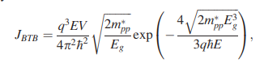

V is the applied voltage, m*pp is the effective mass of holes in the valence band, E is the electric field across the depletion region, and ħ=h/2π, h being Planck’s constant.

1. **Carrier Lifetime:**

In the present lifetime modelling, we have considered bulk recombination processes in HgCdTe to involve radiative recombination and two non-radiative recombination mechanisms. The direct band-to-band photon assisted recombination is radiative recombination and the phonon assisted recombination processes consists of Auger and Shockley-Read-Hall (SRH) recombination mechanisms which are non-radiative recombination processes. The modelling of the radiative recombination process is straightforward. For direct bandgap HgCdTe semiconductors, the lifetime of carriers due to radiative recombination for low level injection can be approximated. The non-radiative Auger recombination is quite complex. It is an important mechanism in determining the performance of light-emitting devices and infrared detectors made from narrow-gap semiconductors. A semiconductor with a single conduction band and heavy-hole and light-hole valence band there can be at least ten different types of Auger transitions occur. Out of these transitions, the two most significant transitions that occur at the minimum threshold energy (ET≈Eg) are the Auger-1 or CHCC (involving two conduction band electrons and a heavy hole) and Auger-7 or CHLH (involving one conduction band electron and one heavy hole and one light hole). The former is generally dominant in n-type material and the later in p-type material. The net Auger recombination lifetime of the carriers can thus be written. The Auger-1 recombination process involves the direct band-to-band recombination of a conduction band electron with a heavy hole and excitation of another electron in conduction band, dominant in n-type HgCdTe material. The lifetime of carriers due to Shockley-Read-Hall recombination can be modelled in terms of trap density and capture cross-section as

τSRH =

Where NT is the SRH trap density, σ is the capture cross-section and vth is the thermal velocity of the minority carriers in the active region, given by

VTH **=**

mn is the effective mass of electrons in the active region. The effective lifetime of the carriers in the active region can be obtained as

$\frac{1}{τeff}= \frac{1}{τrad}+ \frac{1}{τau}+\frac{1}{τsrh}$

Raug = Cn * ( pn2 - nni2 ) + Cp * (p2n – pni2 )

1. **Quantum Efficiency:**

The quantum efficiency (η) of a p-n junction photodetector has generally three major components. These components arise from the contribution of the three regions e.g., neutral n-region (ηn), neutral p-region (ηp) and the depletion region (ηdep). The optical generation rate of electron-hole pairs, as a function of distance x from the surface can be written as



Where α(λ) is the optical absorption coefficient of the material which is a function of wavelength λ, R is the Fresnel reflection coefficient at the entrance, Popt is the incident optical power, ν is the frequency of radiation and A is the device area. The quantum efficiency components can be obtained as

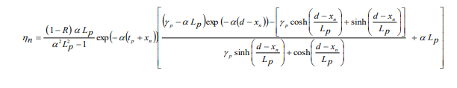

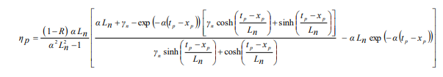

Where Lp and Ln are the hole and electron diffusion lengths in n and p regions respectively. γn = SnLn/Dn and γp = SpLp/Dp are the ratio of surface to bulk recombination velocity in p and n regions respectively. The contribution of the photo-generated carriers in the depletion region to the total quantum efficiency can be obtained as



1. **Specific Detectivity:**

The most important fƍigure of merit of the photodetector for use in optical communication is the specific detectivity D*, which depends on the wavelength of incident light λ, the quantum efficiency η and zero bias resistance area product, R0A. As the dark current of the detector is contributed by three major components e.g., diffusion, generation-recombination and tunnelling (which includes trap assisted tunnelling (TAT) and band to band tunnelling (BTB)), the detectivity of the photodetector under consideration should be estimated from the net value of R0A product arising out of these mechanism. The specific detectivity of the photodetector which is a function of the applied voltage can be written as



* Responsivity-The current responsivity ( R ) of the photodetector is given as



1. **Noise Equivalent Power:**

The variation of noise equivalent power (NEP) with wavelength can be written as



Where A is the area of the detector and B is the bandwidth, here NEP is calculated at unity bandwidth (B=1Hz).

**ANALYTICAL MODELING & RESULTS**

Numerical computations have been carried out on p+ - Hg0.78Cd0.22Te/n- Hg0.78Cd0.22Te/CdZnTe LWIR p+ n homojunction photodetector at 77K for operation at 10.6 µm. The light has been assumed to be incident on the top p+ -Hg0.78Cd0.22Te side of the photodetector. The photons with energy higher than the energy gap create electron-hole pairs in p and n region. The mole fraction of cadmium in the ternary MCT material has been calculated so that the bandgap energy of the material corresponds to the long wavelength cut-off value of 10.6 μm for LWIR free space optical communication. The band gap of Hg1-xCdxTe as a function of temperature, T and alloy composition, x is included in the simulation model using the empirical formula. The intrinsic carrier concentration was calculated using the expression. From Kane band model the hole effective mass is taken as m*h =0.55 m0 and electron effective mass has been computed. The hole mobility has been assumed to be as taken. The absorption coefficient of Hg1- x Cdx Te for optical carrier generation can be calculated within the Kane model, including the Moss-Burstein shift. For photon energy E< E g (tail region), α < αg, the absorption coefficient obeys the rule



And for photon energy E> E g (Kane region), the absorption coefficient obeys the rule

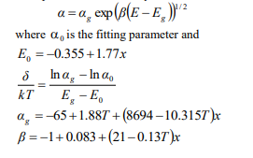

A program was developed separately for calculation of various characteristics of the photodetector using MATLAB platform by choosing appropriate material parameters. The simulated results were obtained for p+-Hg0.78Cd0.22Te/ n0- Hg0.78Cd0.22Te/CdZnTe, homojunction p + -n photodetector at 77K. Instead of the graded doping the numerical model includes a uniform doping profile. A minimum set of material properties data includes, bandgap, dielectric constant, electron affinity, densities of conduction and valance band states, electron and hole mobility, optical recombination coefficient, and an optical file containing the wavelength dependent refractive index, n and extinction coefficient K for the used materials. The wavelength dependent values of extinction coefficient K is computed from the relation, K=αλ/4π.

Normalized current increases with wavelength of operation and attains a maximum value at λ=10.6µm and there is a sharp fall beyond λ=10.6µm which is longer cut off wavelength for the proposed composition of the Hg1-x Cdx Te, which is absorbing layer in the proposed photodetector. Variation of dark current with voltage as obtained from analytical model. It is clear from this figure that there is a good agreement between dark current obtained from analytical model and device exhibits very low dark current of the order of 2×10-11 A. Variation of quantum efficiency of p-i-n photodetector with wavelength of operation obtained from analytical model at a bias voltage of 0.5V . The device exhibits quantum efficiency of the order of 50% at the desired wavelength of operation 10.6 µm and there is a sharp fall beyond the longer cut-off wavelength 10.6 µm and QE also falls at lower wavelength of operation. From this figure it is clear that there is a good agreement between quantum efficiency obtained by analytical model. The device exhibits 50% quantum efficiency at the desired wavelength of operation and at a reverse bias of 0.5V. The variation of responsivity of the photodetector with wavelength of operation. The device exhibits very high values of responsivity ~4.75A/W at wavelength 10.6µm and a bias voltage of 0.5V. Variation of specific detectivity with wavelength of operation, obtained by analytical model which indicates that order of detectivity values obtained by analytical model. The device exhibits very high value of specific detectivity ~5×1010 mHz1/2W-1 at the desired wavelength of operation 10.6µm and a bias voltage of 0.5V. Variation of noise equivalent power of the photodetector with wavelength of operation. We can see that the device exhibits a very low value of noise equivalent power (NEP) of the order of ~10-16 W at the desired wavelength of operation 10.6 µm and NEP increases drastically at smaller wavelengths (<2 µm) and it also increases beyond the upper cut off wavelength 10.6 µm of the detector.

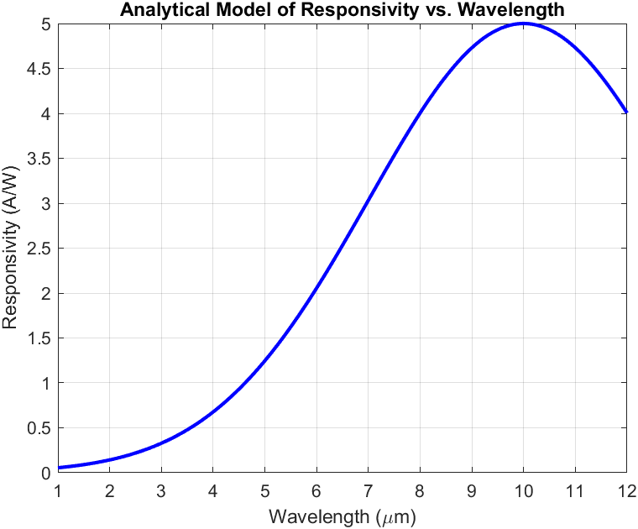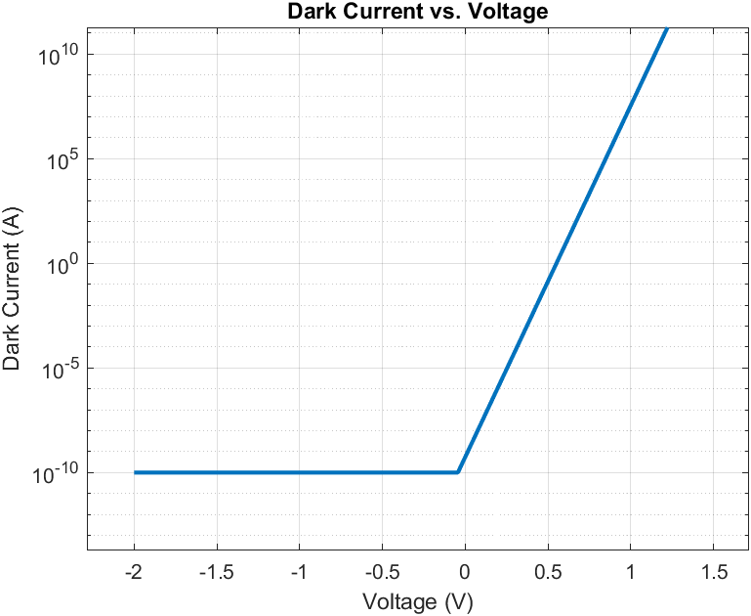

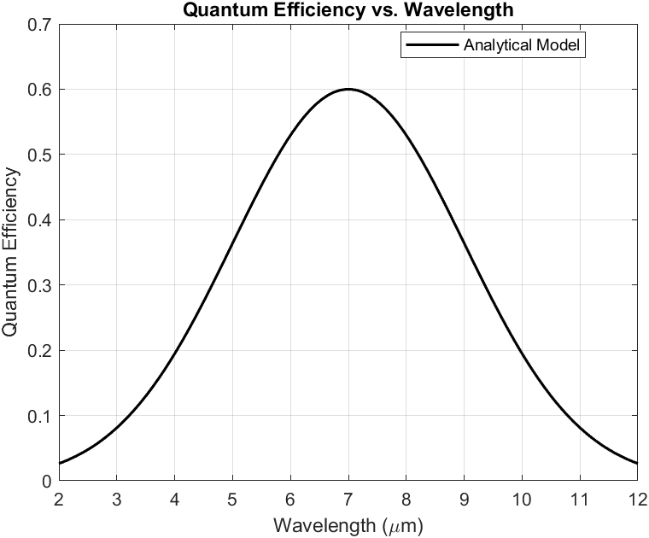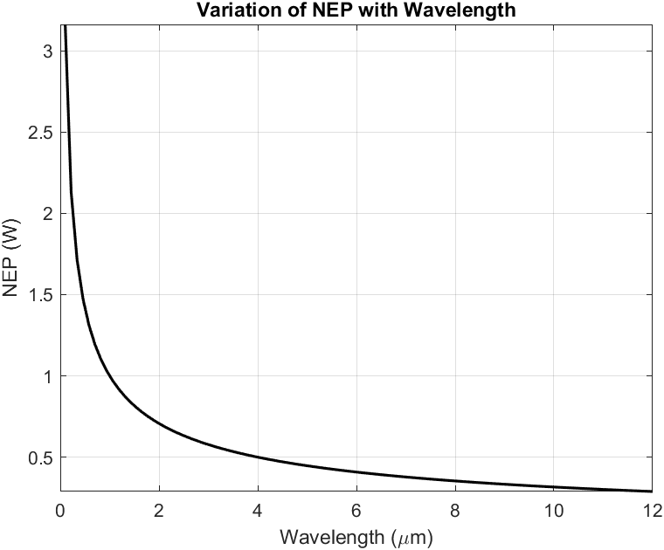

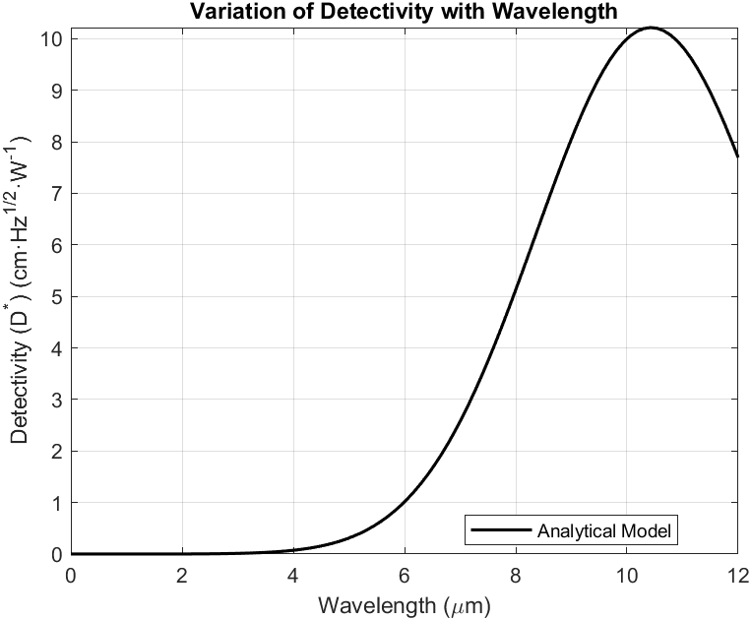

**CONCLUSION**

The performance of the device has been examined by developing an analytical model for the dark current, quantum efficiency, responsivity and detectivity and results obtained from analytical model. The device exhibited a very low dark current of the order of 2×10-11A, quantum efficiency ~50%, responsivity ~4.75A/W, detectivity~5×1010 mHz1/2W-1 and noise equivalent power (NEP) ~ 10-16 W at wavelength of operation 10.6 µm and bias voltage of 0.5V.

**References**

* + 1. Numerical modelling and optimization of HgCdTe infrared photodetectors for thermal imaging.
    2. One-Dimensional modelling of Mercury Cadmium Telluride Photodetectors Operated at Low Temperatures.