**A Mini project Report on**

**Solar Tracking System**

submitted by

**MD.ZAHEER B192091**

under Supervision of

**Mrs.Tejasvey Madam, Assistant Professor**

In partial fulfilment of the requirements for the mini project in department

**ELECTRONICS AND COMMUNICATION ENGINEERING**

of



**RAJIV GANDHI UNIVERSITY OF KNOWLEDGE TECHNOLOGIES**

BASAR, TELANGANA

**ABSTRACT**

This project introduces a solar tracking system designed to optimize the efficiency of solar panels by tracking the movement of the sun thing from solar throughout the day. The system employs an Arduino microcontroller to control the orientation of solar panels, ensuring they consistently face the sun. thereby maximizing energy harvesting from solar radiation. The primary components of the solar tracking system include Arduino-based microcontroller units, light sensors (typically LDR’s or photodiodes), and motors for adjusting the panel’s orientation. The system objective is to continuously monitor sunlight intensity and adjust the panel’s position accordingly to ensure that it remains perpendicular to the incoming solar rays.

The Arduino-based solar tracking system offers an efficient and cost-effective solution for optimizing solar panel performance. By continuously aligning solar panels with the sun’s position, this system improves energy harvesting, making it suitable for both residential and industrial applications. This project abstract provides an overview of the system’s core functionality, emphasizing its potential to enhance solar energy generation and promote sustainability.

**TABLE OF CONTENTS**

S.No. Content Page No.

1. INTRODUCTION

2. SOLAR TRACKING SYSTEM

3. COMPONENTS REQUIRED

4. INTRODUCTION TO COMPONENTS

5. METHODOLOGY

6. STEPS IN MAKING SYSTEM

7. CODE

8. RESULTS

9. CONCLUSION

**INTRODUCTION**

* Fossil fuels are non-renewable energy resources. They are too expensive and causes environmental damages. There are many types of renewable energy resources such as wind and solar energy which are constantly replenished and will never run out. Solar energy is one of the most popular renewable energy. It is the radiant light and heat comes from the sun and got converted into an electricity by lots of technologies such as solar heating, photovoltaic, solar thermal energy, to be used in day-to-day life. This can be achieved by using solar cells, which are electrical devices that convert the solar energy directly into electricity. This conversion is done by photovoltaic effect. Photovoltaic effect is the process of creating a voltage and electric current in a material when a sun light hits it.
* It has many advantages such as:

It is available at every day of the year, if the weather is cloudy it produces some power and don’t stop the process of power generation, it produces clean energy that does not effect on the environment, it’s operation more safety than the conventical electricity resources, it has batteries to store additional energy to be used when it is needed , it could be established anywhere like buildings, hospitals, factories .... etc.

* It has some disadvantages such as:

It is very expensive, needs a wide surface to increase the number of panels and so increase amount of the generated power, it has a low efficiency to be considered as the main resource of electricity, needs batteries to store the electricity to be used at night.

**SOLAR TRACKING SYSTEM**

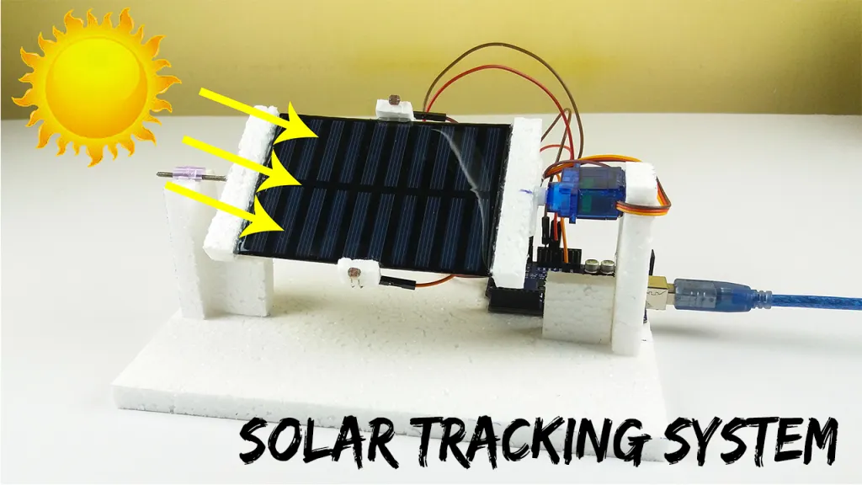

* A tracking system is a system that makes the solar panel follows the movement of the sun from east to west to make the solar system work with its maximum capability. More solar power ids generated because it outs the solar panel directly towards the sun and makes the solar panel moves anywhere the sun goes. This increases the efficiency of the solar panel. There are various types of solar trackers. They are:
* Single- Axis Tracking System

Single- axis trackers have one degree of freedom. That acts as an axis od rotation. This work has brought many benefits like, it is possible to confine the largest amount of sunlight and to help produce more electric energy. Single axis tracker uses one motor and two light sensor in any side of the two sides. This method increases power collection efficiency.

* Dual- Axis Tracking System

To track the sun in two directions, a dual axis tracking prototype s developed to capture the maximum sun rays by tracking the movement of the sun in four different sides. One axis which allows the solar panel to move left and right and the other axis which allows the panel to turn up and down. This new development provides the solar panels with extensive freedom of movement. This implemented system can save more energy and probably offers more reduction in cost.

**COMPONENTS REQUIRED**

S.No. Components Required No.

1. Arduino UNO Board 1
2. Solar Panel 1
3. SG90 Servo Motor 1
4. LDR Sensor 2
5. 10 K Resistor 2
6. Jumper Wires as per requirements
7. Cardboard 1
8. Battery 1

**INTRODUCTION TO COMPONENTS**

1. 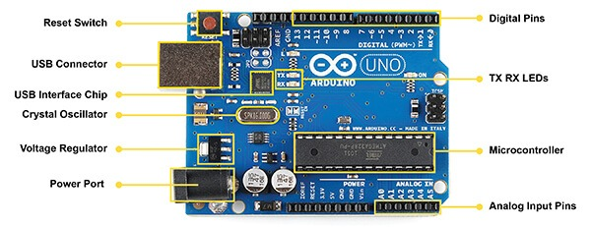ARDUINO UNO BOARD

The Arduino UNO is a standard board of Arduino. It is considered as the powerful board used in various projects. Arduino UNO is based on an ATmega328P microcontroller is easy to use compared to other boards, such as the Arduino Mega board, etc. The board consists of digital and analog I/P pins(I/O), shields, and other circuits. The Arduino UNO includes 6 analog pin inputs, 14 digital pins, a USB connector, a power jack, and an ICSP (in-circuit serial Programming) header. It is programmed based on IDE, which stands for Integrated Development Environment. It can run on both online and offline platforms.

* ATMEGA328 Microcontroller

It is a single chip Microcontroller of the ATmel family. The processor code inside it is of 8- bit. It combines MEMORY (SRAM, EEPROM, and FLASH), Analog to Digital converter, SPI serial ports, I/O lines, register, timer, external and internal interrupts, and oscillator.

* ICSP pin

The in-circuit serial programming pin allows the user to program using the firmware of the Arduino board.

* Power LED Indicator

The ON status of LED shows the power is activated. When the power is OFF, the LED will not light up.

* Digital I/O pins

The digital pins have the value HIGH or LOW. The pins numbered from D0 to D13 are digital pins.

* TX and RX LED’s

The successful flow of data is represented by the lighting of these LED’s.

* AREF

The Analog Reference (AREF) pin used to feed a reference voltage to the Arduino UNO board from the external power supply.

* Reset button

It is used to add a Reset button to the connection.

* USB

It allows the board to connect to the computer. It is essential for the programming of the Arduino UNO board.

* Crystal Oscillator

The Crystal Oscillator has a frequency of 16MHZ, which makes the Arduino UNO a powerful board.

* Voltage Regulator

The voltage regulator converts the input voltage to 5V.

* GND

Ground pins. The ground pin acts as a pin with zero voltage.

* Vin

It is the input voltage.

* Analog Pins

The pins numbered from A0 to A5 are analog pins. The function of Analog pins is to read the analog sensor used in the connection. It can also act as GPIO (General Purpose Input Output) pins.

1. SOLAR PANEL

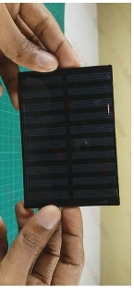

Solar panels, also known as photovoltaic (PV) panels, are devices that convert sunlight into electricity through the photovoltaic effect. The basic working principle of solar panels involves the generation of electric current when photons from sunlight interact with semiconductor materials within the panel.  
  
1. Photovoltaic Cells: Solar panels consist of multiple photovoltaic cells, which are made of semiconductor materials, often silicon. These cells are responsible for converting sunlight into electricity.   
  
2. Photovoltaic Effect: When photons (particles of sunlight) strike the semiconductor material in the solar cells, they excite electrons, causing them to break free from their atomic bonds. This creates an electric current.   
  
3. Electric Field Formation: The semiconductor material in the solar cells is typically treated to create an electric field. This electric field acts as a medium to guide the liberated electrons in a specific direction, creating a flow of electric current.

4.Generation of Direct Current (DC): The movement of electrons through the electric field results in the generation of direct current (DC) electricity. However, most of our appliances and the electricity grid operate on alternating current (AC).

5.Inverter Conversion: To make the electricity compatible with standard household appliances and the grid, the DC electricity generated by the solar panels is passed through an inverter. The inverter converts it into alternating current (AC), which is the standard form of electricity used in homes and businesses.

6.Utilization or Grid Connection: The converted AC electricity can then be used to power electrical devices within the property where the solar panels are installed. Excess electricity can also be fed back into the grid, often earning credits or compensation for the solar panel owner through net metering programs.

1. SG90 SERVO MOTOR

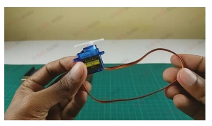

A servo motor is a type of motor that is powered by a DC source, either from an external supply or by a controller. A small and lightweight servo motor with high output power is called a micro servo motor SG90. This means that the sg90 micro servo motor will only work as hard as is required to complete the task at hand. A wide range of applications for servo motors exists, including cameras, telescopes, antennas, industrial automation, and robots. A motor rotates from 0 to 180 degrees at each position of 90 degrees so that names it SG90. Servo motors have a gear that reduces the rotational speed of the motor by reducing its RPM and increasing the torque. SG90 is a popular micro servo motor commonly used in hobbyist and DIY projects. It is a small, low-cost servo motor that can rotate 180 degrees with a maximum torque of 1.8 kg-cm. It operates at 4.8-6V and has a weight of approximately 9 grams, making it ideal for small-scale robotics and model control application.

1. LDR SENSOR

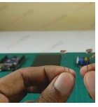

The Light-dependent resistors made with photosensitive semiconductor materials like Cadmium Sulphides (CdS), lead sulphide, lead selenide, indium antimonide, or cadmium selenide and they are placed in a zig-zag shape. It works on the principle of photoconductivity whenever the light falls on its photoconductive material, it absorbs its energy and the electron of that photoconductive material in the valence band get excited and go to the conduction band and thus increasing the conductivity as per the increase in light intensity. Also, the energy in incident light should be greater than the bandgap energy so that the electrons from the valence band got excited and go to the conduction band. The LDR has the highest resistance in dark around 1012 Ohm and this resistance decreases with the increases in light.

**METHODOLOGY**

* Block Diagram

LDR

ARDUINO

SERVO

MOTOR

SOLAR

PANEL

* Circuit Diagram

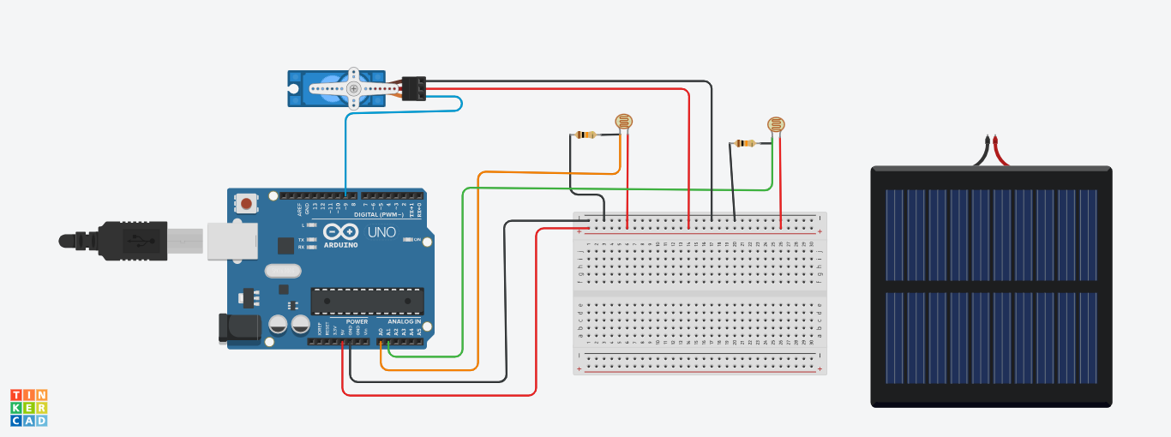

**FORMULAS**

* Angle of Rotation

For a single-axis tracker, the rotation angle typically aligns the solar panels perpendicular to the sun's rays. This angle can be computed based on the solar hour angle (HRA) and the tilt angle of the tracker. The HRA is the measure of time since solar noon, expressed in angular measurement (degrees).

The formula for the hour angle (HRA) in degrees is:

HRA = 15° x (solar time - 12)

Solar time can be approximated from standard time (with adjustments for the equation of time and longitude). Once you have the HRA, the rotation angle (θ) of the tracker can be computed. For horizontal single-axis trackers, the formula is generally:

θ = HRA

* Power Generation

The power output of a solar panel is influenced by several factors, including the angle of incidence of the sunlight, the irradiance, and the efficiency of the panel. The angle of incidence depends on the tilt and orientation of the panel.

The power P generated can be calculated using:

P = A × G × $η$

where:

* A is the area of the solar panel.
* G is the solar irradiance (in W/m²) incident on the panel.
* 𝜂 is the efficiency of the solar panel.

To account for the angle of incidence (θi​), the effective irradiance Geff on the panel can be given by:

Geff = G × cos(θi)

where θi is the angle between the sunlight and the normal (perpendicular) to the solar panel surface. For single-axis trackers, this angle can be minimized throughout the day, enhancing power generation.

Putting it all together, the power output considering the angle of incidence can be written as:

P = A × G × cos(θi) × 𝜂

**CODE**

* #include <Servo.h> //including the library of servo motor
* Servo sg90;
* int initial_position = 90;
* int LDR1 = A0; //connect The LDR1 on Pin A0
* int LDR2 = A1; //Connect the LDR2 on pin A1
* int error = 5;
* int servopin=9; //You can change servo just make sure it’s on Arduino's PWM pin
* void setup() {
* sg90.attach(servopin);
* pinMode(LDR1, INPUT);
* pinMode(LDR2, INPUT);
* sg90.write(initial_position); //Move servo at 90 degree
* delay(2000); }
* void loop() {
* int R1 = analogRead(LDR1); // read LDR 1
* int R2 = analogRead(LDR2); // read LDR 2
* int diff1= abs(R1 - R2);
* int diff2= abs(R2 - R1);
* if((diff1 <= error) || (diff2 <= error)) {
* else {
* if(R1 > R2) {
* initial_position = --initial_position; }
* if(R1 < R2) {
* initial_position = ++initial_position; }\ }
* sg90.write(initial_position);
* delay(100);
* }

**RESULTS**

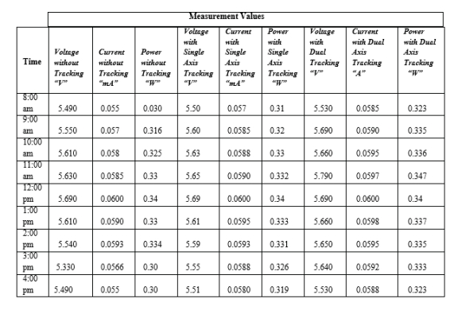

**CONCLUSION**

* The designed system improved the output of the solar cell by using a single axis solar tracking system. And it proved practically the efficiency of the solar tracking systems for increasing the overall output of the panels. A comparison between the single axis solar tracking was benchmarked with the dual axis tracking system and it is found that was performed and results in the dual axis tracking system is the best. The results proved that the design improved the efficiency of the PV panel and the amount of the generated power increased. And we did the simulation, a study for the stability of the motor and it’s works.