

CSE366: Artificial Intelligence (Section-09)
[Summer 2026]

Project Report

Project/Application Title

Project URL/Link

Submitted by:

Student ID | Student Name | Contribution Percentage

- Abstract
Heart disease is one of the leading causes of death worldwide, and early risk prediction can help doctors act before serious complications occur. This project builds a binary classifier that predicts whether a patient is at risk of heart disease using the UCI Cleveland Heart Disease dataset (303 patients, 14 clinical attributes such as age, chest pain type, cholesterol, and maximum heart rate). After cleaning the data, encoding categorical attributes, and standardizing continuous features, two feature selection methods were compared: Recursive Feature Elimination (RFE) and a custom Genetic Algorithm (GA). A Logistic Regression model was then tuned using GridSearchCV and validated with Stratified 5-Fold Cross-Validation and Leave-One-Out Cross-Validation (LOOCV), since the dataset is small. On the held-out test set, the final model reached 85.2% accuracy and a ROC-AUC of 0.927. Statistical tests (Wald test, Likelihood Ratio test, and odds ratios using statsmodels) confirmed that sex, number of major vessels (ca), and chest pain type are the strongest predictors. The trained model was saved and connected to a simple Streamlit web app so the prediction can be demonstrated live.

- Introduction
  - Problem Definition
The task is to predict whether a patient has heart disease or not, using clinical measurements collected from a routine medical check-up (e.g., blood pressure, cholesterol, ECG results, chest pain type). This is a binary classification problem: the model must output either "disease" or "no disease" for a given patient.

This problem is relevant because heart disease is a major global health issue, and many risk factors are correlated with each other in complex ways, which makes manual diagnosis difficult without expert experience. It is also a challenging problem for machine learning because the dataset is small (only 303 patients), some features have missing values, and several features are only mildly correlated with the outcome individually, so the model has to combine multiple weak signals together to make a confident prediction.

  - Project Goal and Scope
Primary objective: The goal of this project is to build an interpretable Logistic Regression model that predicts heart disease risk from the UCI Cleveland dataset, and to compare two different feature selection strategies — a traditional method (Recursive Feature Elimination) and a novelty method (a custom Genetic Algorithm) — to see which one gives a better and more stable subset of features.
Scope and limitations: The project is limited to binary classification (disease vs. no disease) on the 303-patient Cleveland subset only; it does not attempt to predict the 5-level disease severity (0–4) that is present in the raw UCI data. The model is trained only on this one dataset, so it may not generalize perfectly to patients from other hospitals or populations. The Streamlit app is built only for demonstration purposes and is not a certified medical tool.

- Theoretical Background (Algorithm/Model)
  - Core Concept
The main algorithm used in this project is Logistic Regression. Unlike Linear Regression, Logistic Regression is used for classification because it predicts a probability between 0 and 1. It does this by passing a linear combination of the input features through the sigmoid (logistic) function:
p(y = 1 | x) = 1 / (1 + e^-(β₀ + β₁x₁ + β₂x₂ + … + βₙxₙ))
Here, β₀ is the intercept, and each βᵢ is the weight (coefficient) learned for feature xᵢ. If the predicted probability p is above 0.5, the patient is classified as "at risk" (target = 1), otherwise "not at risk" (target = 0). One useful property of Logistic Regression is that e^βᵢ can be interpreted as an odds ratio — it tells us how much the odds of heart disease change when feature xᵢ increases by one unit, which is why this model was chosen instead of a black-box model: it is easy to explain the reasoning to a doctor or a professor.
Two feature selection techniques were used to reduce the input features to the most useful ones: Recursive Feature Elimination (RFE) repeatedly trains the model, removes the least important feature (based on model coefficients), and repeats until the desired number of features remains. As a novelty addition, a Genetic Algorithm (GA) was also implemented: each "chromosome" is a binary string where each bit represents whether a feature is included (1) or excluded (0); a population of such chromosomes evolves over generations using selection, crossover, and mutation, and the "fitness" of each chromosome is measured using 5-fold cross-validated ROC-AUC.

  - Implementation Details
- Data structure: cleaned dataset is stored as a Pandas DataFrame with 14 columns (13 features + target).
- Preprocessing components: scikit-learn's StandardScaler (for continuous features) and pandas.get_dummies (for one-hot encoding of categorical features).
- Feature selection: scikit-learn's RFE class (wrapping a Logistic Regression estimator) and a custom Genetic Algorithm written from scratch using Python lists and the random module (population size = 20, generations = 30, mutation rate = 0.1, crossover rate = 0.7).
- Model: scikit-learn's LogisticRegression, tuned with GridSearchCV over regularization strength (C) and penalty type (L1/L2).
- Statistical validation: statsmodels.api.Logit, used to compute p-values (Wald test), 95% confidence intervals, odds ratios, and a Likelihood Ratio test against a null (intercept-only) model.

- Methodology and Implementation
  - Dataset / Environment Setup
Source: UCI Machine Learning Repository — Cleveland Heart Disease dataset (processed_cleveland.csv).

Size: 303 patient records, 14 columns (13 clinical features + 1 target column).

Features: age, sex, cp (chest pain type), trestbps (resting blood pressure), chol (cholesterol), fbs (fasting blood sugar), restecg (resting ECG results), thalach (maximum heart rate achieved), exang (exercise-induced angina), oldpeak (ST depression), slope, ca (number of major vessels colored by fluoroscopy), and thal.
Data preprocessing steps carried out in the notebook:
- Missing value handling: the raw "?" symbols in the ca and thal columns were treated as missing values (4 and 2 missing values respectively) and filled using the column mode.
- Target binarization: the original target column (0 = no disease, 1–4 = increasing severity) was converted into a binary label — 0 = no disease, 1 = disease present. After binarization the class balance was 164 "no disease" vs. 139 "disease" cases.
- Categorical encoding: cp, restecg, slope, and thal were one-hot encoded using pandas.get_dummies (drop_first = True to avoid the dummy-variable trap).
- Feature scaling: continuous columns (age, trestbps, chol, thalach, oldpeak, ca) were standardized (mean = 0, std = 1) using StandardScaler, fitted only on the training set to avoid data leakage.
- Train/test split: 80% train / 20% test, using stratified sampling to preserve the class ratio — 242 training samples and 61 test samples.

  - Model/Algorithm Design
The overall pipeline used in this project can be summarized as: Data Upload → Cleaning & Target Binarization → One-Hot Encoding & Scaling → Feature Selection (RFE and GA, compared) → Hyperparameter Tuning (GridSearchCV) → Logistic Regression Model → Statistical Validation → Model Export (.pkl) → Streamlit Live Demo.
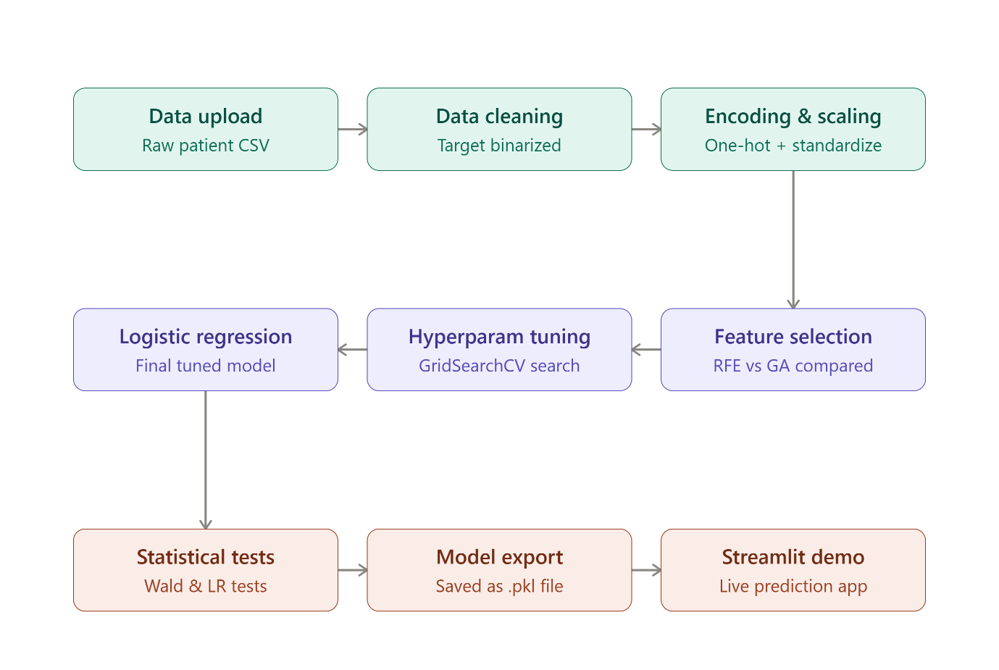
Figure 1: Workflow of the Proposed Methodology
Recursive Feature Elimination (RFE) was configured to select the best 8 features out of all encoded features, using a base Logistic Regression estimator. It selected: sex, exang, ca, cp_2.0, cp_4.0, restecg_2.0, slope_2.0, and thal_7.0.
As a novelty contribution, a Genetic Algorithm was also run to search for a good feature subset. It evolved over 30 generations and converged to a best cross-validated ROC-AUC of about 0.905, finally selecting: sex, chol, exang, ca, cp_4.0, slope_2.0, slope_3.0, and thal_7.0 — a similar but not identical feature set to RFE.
The Logistic Regression model was then tuned using GridSearchCV with 5-fold stratified cross-validation, searching over C ∈ {0.01, 0.05, 0.1, 0.5, 1, 5, 10} and penalty ∈ {L1, L2} (solver = liblinear). The best configuration found was C = 1, penalty = L2, solver = liblinear, and this tuned model (trained on the RFE-selected features) was used as the final model for evaluation.

  - Implementation Language and Tools
- Programming language: Python 3, run on Google Colab.
- Core libraries: NumPy, Pandas (data handling), Matplotlib & Seaborn (visualization).
- Machine learning: scikit-learn (LogisticRegression, RFE, GridSearchCV, StandardScaler, train_test_split, StratifiedKFold, LeaveOneOut, evaluation metrics).
- Statistics: statsmodels (Logit model for Wald test, odds ratios, Likelihood Ratio test), SciPy (chi-square test).
- Model persistence & deployment: joblib (to save the trained model, scaler, and feature list as a .pkl file) and Streamlit (to build the live demo web app).

  - Live Demo — User Interface (Streamlit App)
To make the model usable outside of the notebook, a simple web application was built with Streamlit (app.py) and connected to the saved heart_disease_model.pkl artifact (model, scaler, selected features, and column lists). The interface is designed so that anyone — not just someone who knows Python — can enter a patient's details and instantly see a risk prediction.
- Input form: the 13 clinical attributes are arranged in a clean two-column layout (age, sex, chest pain type, resting blood pressure, cholesterol, fasting blood sugar, resting ECG on the left; max heart rate, exercise-induced angina, ST depression, slope, number of major vessels, and thalassemia on the right). Dropdowns are used for categorical fields (e.g., "Chest Pain Type", "Thalassemia") instead of raw numeric codes, so the user does not need to know the dataset's internal encoding.
- Prediction pipeline: when the "Predict Risk" button is pressed, the app rebuilds the same preprocessing steps used during training — one-hot encoding of categorical fields, aligning columns to match the training set, and scaling the continuous features with the saved StandardScaler — before passing the row to the trained Logistic Regression model.
- Result display: the predicted probability is shown using an interactive Plotly gauge chart (0–100%), color-coded green/yellow/red for low, borderline, and high risk zones, along with a clear "High risk" or "Low risk" message and the exact probability.
- Safety disclaimer: the app includes a visible caption reminding users that it is for academic demonstration only and is not a substitute for professional medical advice.

- Results and Analysis
  - Experimental Setup
The model was evaluated using Accuracy, Precision, Recall, F1-score, ROC-AUC, and the Confusion Matrix. Because the dataset is small, robustness was additionally checked using Stratified 5-Fold Cross-Validation and Leave-One-Out Cross-Validation (LOOCV) on the training set, in addition to a final held-out test set evaluation (61 samples that the model never saw during training or tuning).

  - Results Presentation
Comparison of the two feature-selection approaches (before hyperparameter tuning):
Feature Selection Method | Test Accuracy | Test ROC-AUC
RFE (8 features) | 83.6% | 0.932
Genetic Algorithm (8 features) | 86.9% | 0.927

Final tuned model (RFE-selected features + GridSearchCV, C = 1, L2 penalty) on the held-out test set:
Metric | Value
Stratified 5-Fold CV Accuracy | 83.46% (± 5.69%)
LOOCV Accuracy | 83.47%
Test Accuracy | 85.25%
Test Precision | 82.76%
Test Recall | 85.71%
Test F1-score | 84.21%
Test ROC-AUC | 0.927

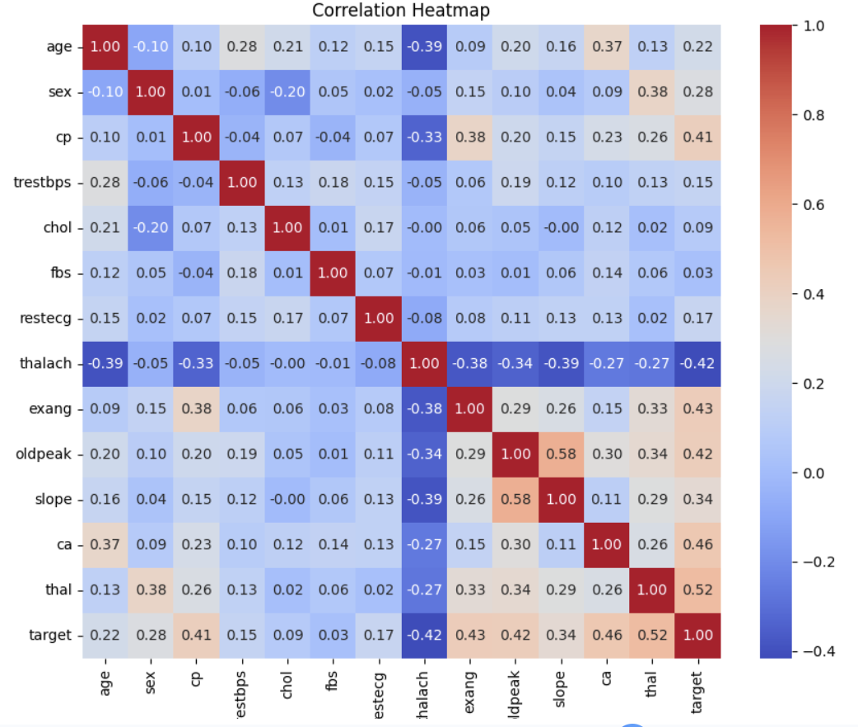
Figure 2: Correlation Heatmap
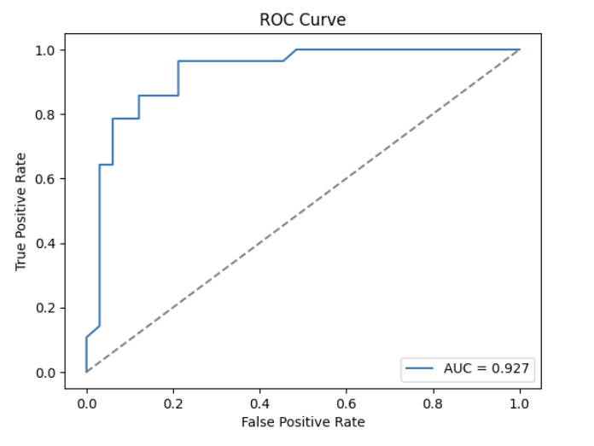

Figure 3: ROC Curve
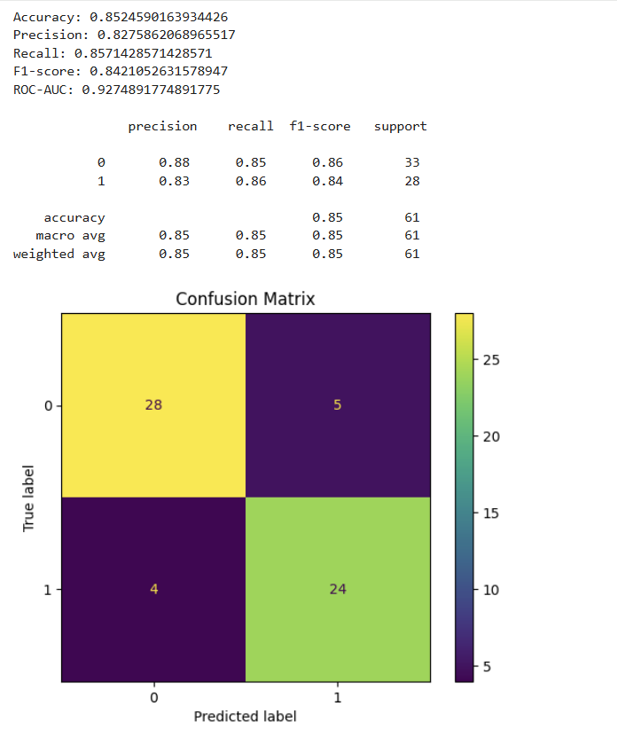

Figure 4: Confusion Matrix

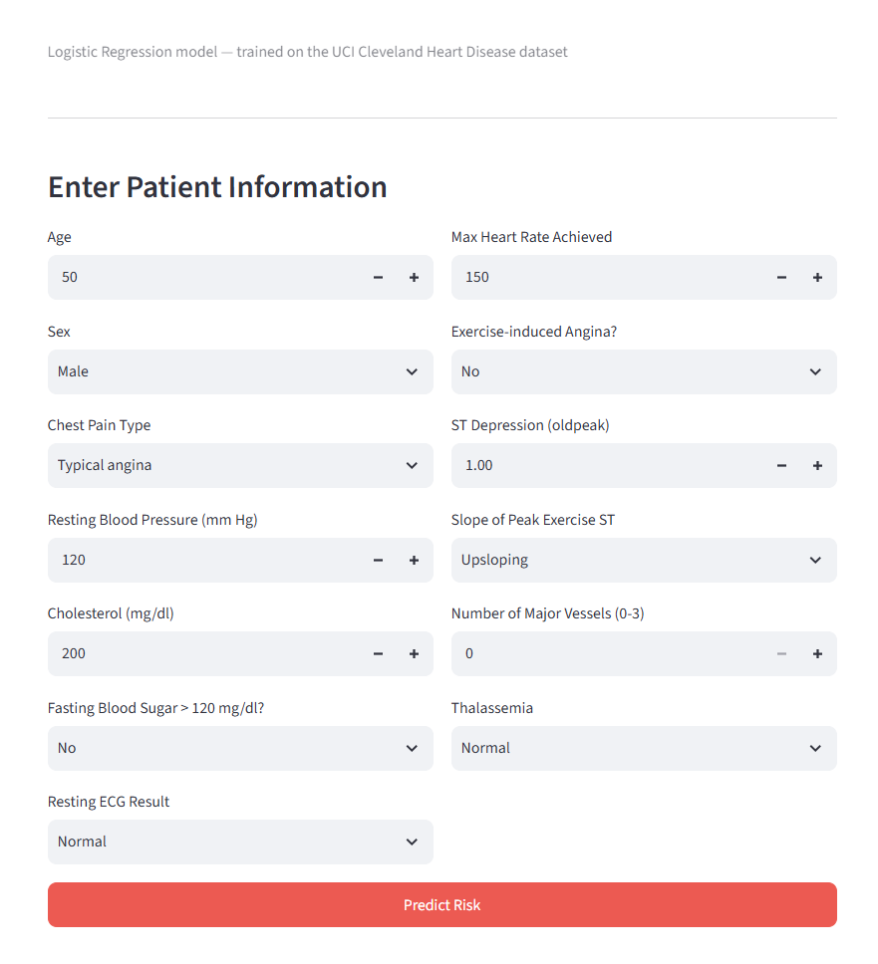

Figure 5(a): Patient Information Input Interface of the Streamlit Application

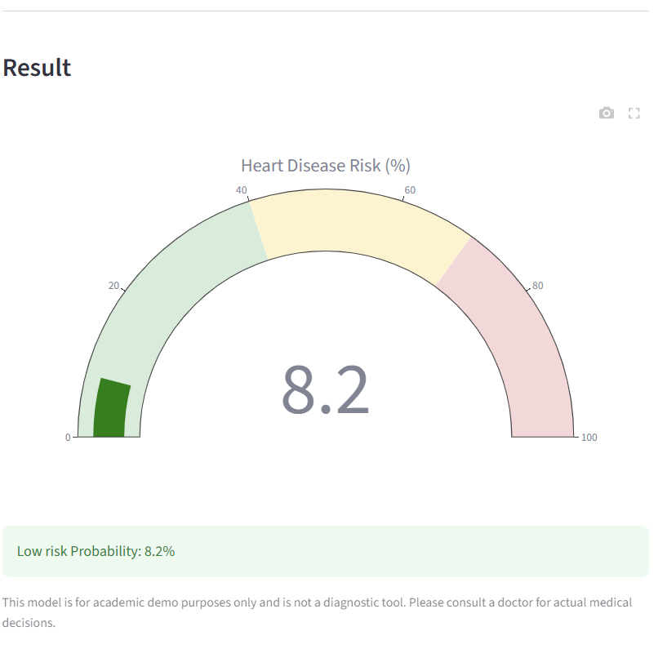

Figure 5(b): Predicted Heart Disease Risk Output with Probability Gauge

  - Discussion and Interpretation
The final model reaches a ROC-AUC of 0.927 on unseen test data, which means it is very good at ranking patients from lowest to highest heart-disease risk. The balance between precision (82.8%) and recall (85.7%) is healthy — the model does not favor one class too strongly, which is important in a medical setting where missing a real disease case (false negative) can be more costly than a false alarm.
The statsmodels Logit model gave extra insight through statistical significance testing. The Likelihood Ratio test comparing the full model against a null (intercept-only) model gave a very large LR-statistic (163.04) with a p-value far below 0.001, confirming that the selected features together explain a statistically significant amount of the variation in heart disease risk. Looking at individual predictors, sex (p = 0.003), ca — number of major vessels (p < 0.001), and cp_4.0 — asymptomatic chest pain (p < 0.001) were all highly statistically significant, meaning we can be confident these are genuine risk indicators and not just noise. On the other hand, restecg_2.0 (p = 0.185) and cp_2.0 (p = 0.210) were not statistically significant on their own, suggesting they add less unique information once the other features are already in the model.
Comparing the two feature-selection strategies: the Genetic Algorithm found a slightly different 8-feature subset than RFE and reached a marginally higher raw test accuracy (86.9% vs. 83.6%) before tuning, while RFE's subset reached a marginally higher ROC-AUC. This shows that both approaches are reasonably close in quality, and the small differences are expected given the small size of the test set (only 61 patients).
Strengths: interpretable model with statistically validated predictors; strong ROC-AUC; robustness confirmed with two independent cross-validation strategies (5-fold and LOOCV giving almost identical accuracy, ~83.5%).
Weaknesses / Error analysis: the dataset is small (303 patients), so results can vary noticeably depending on the exact train/test split; a few engineered dummy features (e.g., restecg_2.0, cp_2.0) were not statistically significant, meaning the model may be carrying some redundant features; the model has not been tested on patients from a different hospital or country, so its generalization outside the Cleveland cohort is unknown.

- Conclusion
This project successfully built and validated a Logistic Regression model to predict heart disease risk from the UCI Cleveland dataset, reaching 85.25% test accuracy and a ROC-AUC of 0.927 after Recursive Feature Elimination and GridSearchCV-based hyperparameter tuning. A Genetic Algorithm was implemented as a novelty alternative to RFE and produced a comparable feature subset and performance, showing that evolutionary search is a viable feature-selection technique even on small clinical datasets.
The original project goal stated in Section 3.2 — building an interpretable classifier and comparing two feature selection strategies — was fully achieved. Statistical validation using the Wald test, odds ratios, and the Likelihood Ratio test confirmed that the model's predictions are backed by statistically significant relationships in the data, not just correlations found by chance.
The single most important takeaway from this project is that a relatively simple, interpretable model like Logistic Regression — when combined with careful feature selection and proper statistical validation — can achieve strong predictive performance while still explaining why it made each decision, which is essential for any model intended to support real medical decisions.

- Future Work
- Compare Logistic Regression against other classifiers such as SVM, Random Forest, and Gradient Boosting on the same feature sets, to see whether a more complex model improves accuracy without losing too much interpretability.
- Collect or combine data from additional heart-disease datasets (e.g., other UCI centers: Hungarian, Switzerland, VA Long Beach) to test generalization beyond the Cleveland cohort.
- Extend the Genetic Algorithm to also tune hyperparameters (C, penalty) alongside feature selection, instead of running GridSearchCV separately.
- Add model explainability tools such as SHAP values to show, for each individual patient, which features pushed the prediction toward "at risk" or "not at risk".
- Improve the Streamlit app with input validation, probability confidence display, and a simple explanation panel for non-technical users.

- References (APA or IEEE Style)
- Detrano, R., Janosi, A., Steinbrunn, W., Pfisterer, M., Schmid, J., Sandhu, S., Guppy, K., Lee, S., & Froelicher, V. (1989). International application of a new probability algorithm for the diagnosis of coronary artery disease. American Journal of Cardiology, 64(5), 304–310.
- UCI Machine Learning Repository. (n.d.). Heart Disease Data Set. University of California, Irvine. https://archive.ics.uci.edu/dataset/45/heart+disease
- Guyon, I., Weston, J., Barnhill, S., & Vapnik, V. (2002). Gene selection for cancer classification using support vector machines. Machine Learning, 46(1–3), 389–422. (Recursive Feature Elimination reference.)
- Holland, J. H. (1975). Adaptation in Natural and Artificial Systems. University of Michigan Press. (Genetic Algorithm reference.)
- Pedregosa, F., et al. (2011). Scikit-learn: Machine Learning in Python. Journal of Machine Learning Research, 12, 2825–2830.Seabold, S., & Perktold, J. (2010). Statsmodels: Econometric and statistical modeling with Python. Proceedings of the 9th Python in Science Conference.
- Streamlit Inc. (n.d.). Streamlit Documentation. https://docs.streamlit.io

- Appendix (Optional)
Key hyperparameter search grid used with GridSearchCV:
param_grid = {"C": [0.01, 0.05, 0.1, 0.5, 1, 5, 10], "penalty": ["l1", "l2"], "solver": ["liblinear"]}
Genetic Algorithm settings used for feature selection: population size = 20, number of generations = 30, mutation rate = 0.1, crossover rate = 0.7, fitness function = mean 5-fold cross-validated ROC-AUC minus a small penalty (0.001 × number of selected features).
Saved model artifact: heart_disease_model.pkl (contains the trained Logistic Regression model, the fitted StandardScaler, the list of selected features, and the list of continuous/categorical columns), used directly by the Streamlit demo app.

