**ASSESSMENT**

1)Case Study- IT/OT convergence.

**DEFINITION**

What is IT/OT convergence?

T/OT convergence is the integration of [information technology](https://www.techtarget.com/searchdatacenter/definition/IT) (IT) systems with [operational technology](https://www.techtarget.com/whatis/definition/operational-technology) (OT) systems. IT systems are used for data-centric computing; OT systems monitor events, processes, and devices, and make adjustments in enterprise and industrial operations.

Modern organizations grapple with two worlds. There is the traditional physical world composed of machines, electromechanical devices, manufacturing systems and other industrial equipment. Then there is the more recent digital world using servers, storage, networking and other devices used to run applications and process data. These two worlds have largely occupied separate domains, shared little (if any) meaningful data or control, and relied on oversight from business staff with distinctly different skill sets.

Today, the worlds of IT and OT are converging. Advances in technologies such as the internet of things (IoT) and big data analytics are systematically allowing the digital information world to see, understand and influence the physical operational world. When implemented properly, IT/OT convergence can merge business processes, insights and controls into a single uniform environment.

### What is OT?

OT focuses on the management and control of physical devices existing and operating in the physical world. The control of real-world devices is as old as industry and manufacturing itself. The introduction of electronics and digital technologies over time also found plentiful uses in operational control systems, such as computerized numerical control machining systems.

[Where IT focused on data and communication, OT focused on behaviours and outcomes](https://internetofthingsagenda.techtarget.com/tip/Operational-technology-vs-information-technology-explained). Most control systems employed across industrial and manufacturing installations weren't networked, resulting in silos of specialized devices -- each electronic at some level, but not able to communicate or share information. This means human operators were tasked with programming or managing the physical operations of each piece of equipment. Even equipment that provided centralized control used closed or proprietary protocols.

Consider a traditional automobile. Although a modern vehicle contains a wide array of electronic devices, it remains an unintegrated and singular system. The vehicle might record data but doesn't share data and doesn't allow any overarching management or control. It functions in all real-world conditions but relies solely on the capabilities and experience of a human operator for successful operation.

### What is the difference between IT and OT?

IT includes any use of computers, storage, networking devices and other physical devices, infrastructure, and processes to create, process, store, secure and exchange all forms of electronic data.

OT, traditionally associated with manufacturing and industrial environments, includes industrial control systems such as supervisory control and data acquisition.

T/OT convergence project success and overall security [can benefit from a range of initiatives](https://www.techtarget.com/searchsecurity/tip/Tips-and-tricks-to-integrate-IT-and-OT-teams-securely) involving project teams, including the following:

* having an IoT sponsor;
* keeping OT and IT in the same loop;
* understanding how to design IoT;
* understanding how to integrate IoT;
* training staff and developing expertise; and
* planning for scale.

### What is IT/OT convergence?

The idea of [technological convergence](https://searchconvergedinfrastructure.techtarget.com/definition/convergence) is not new. By allowing different technologies to integrate and interoperate efficiently as a single cohesive system, businesses can generally improve efficiency, reduce errors, cut costs, enhance workflows and gain competitive advantages.

Enterprise IT has long been a focus of convergence efforts, bringing often-disparate data centre technologies together and supporting seamless interoperation. One example of convergence is the appearance of IT converged infrastructure -- later evolving into hyper-converged infrastructure. These developments merge traditionally separate servers, storage, networking and management tools into a single, cohesive, centrally managed product.

The idea of IT/OT convergence seeks to bring physical (OT) equipment and devices into the digital (IT) realm. This is possible because of advances such as machine-to-machine communication, as well as the introduction of sophisticated IoT sensors and actuators that can be fitted to physical equipment. These devices can employ wireless communication over standardized networking protocols to communicate the relevant data from each physical system back to a central server for monitoring and analysis. The results of that analysis can then be passed back to the physical system to allow more autonomous operation, enhance accuracy, benefit maintenance, and improve uptime.

### Types of IT/OT convergence

Convergence isn't a single initiative or effort. Convergence initiatives can take a variety of directions depending on the needs and goals of the particular organization. There are three main categories of IT/OT convergence:

* Process convergence covers the convergence of workflows. IT and OT departments must reform their processes to accommodate each other and make sure important projects are communicated. This is an organizational convergence, dealing with the structure of the internal business. For example, a business might follow specific processes for storing and protecting IT data, but this process might be adapted or extended for converging OT systems.
* Software and data convergence deals with getting the software and data in the front office to work to address OT needs. This is a technical convergence involving the network architecture of the business. For example, IT might need to implement new tools to gather OT data and combine OT and IT data for analysis.
* Physical convergence includes physical devices being converged or retrofitted with newer hardware to accommodate the addition of IT to traditional OT. This is an operational convergence, where the hardware itself is updated and maintained over time. This might include the purchase of new OT systems or the addition of aftermarket devices to facilitate data communication and control.

Here are some industries that benefit from the convergence OT and IT:

* **Manufacturing.** IT/OT convergence enables organizations to be more cost- and resource-efficient by using sales and inventory data to [drive manufacturing operations](https://internetofthingsagenda.techtarget.com/feature/Reap-the-rewards-of-IT-OT-convergence-in-manufacturing) -- optimizing equipment and power use while minimizing maintenance and unsold inventory.
* **Utility and energy companies.** Modern IT enables OT teams to access operational data remotely, helping [industries such as oil, gas and electricity](https://internetofthingsagenda.techtarget.com/tip/Understand-the-role-of-IT-OT-convergence-in-oil-and-gas) to optimize industrial equipment inspections, make damage assessments and handle inventory monitoring and distribution.
* **Transportation.** Asset management is a priority in transportation. Integrating IT and OT can help rail, bus, delivery and other transportation organizations gain better visibility into the coordination, condition and usage of assets to guide short-term repairs, route optimization and long-term planning for asset replacement and safety.
* **Military and law enforcement.** IT/OT convergence can aid in the coordination and rapid deployment of resources, while providing more insight into the condition and maintenance of critical equipment.
* **Communications and media companies.** Regional and global communication providers can employ IT/OT convergence to oversee the performance and operation of equipment and quality of service, leading to faster troubleshooting and better user satisfaction.
* **Retail.** The use of IoT devices such as start product tags, along with other OT devices such as cameras and POS devices, can deliver more data to IT for analysis, leading to inventory and sales floor optimizations for cost savings and better revenue generation and shopper experience.
* **Medical and pharmaceutical.** IT/OT integration allows more medical devices to exchange and share patient information for real-time visibility, leading to better patient analysis and outcomes; meanwhile, convergence can improve the manufacturing of medicines to enhance and ensure product quality.

There are four principal security threats to IT/OT convergence:

* **Lack of collaboration.** IT and OT teams have rarely worked together, and this can lead to security oversights that can increase complexity, duplicate efforts, increase operating costs and expose security flaws that attackers can exploit.
* **Legacy OT systems.** Where IT systems rarely last more than five years, OT systems can have lifecycles that measure into decades. Such legacy systems typically incorporated few, if any, security features and can't be upgraded because of proprietary designs or protocols.
* **Insufficient insight.** IT routinely relies on asset discovery and configuration to provide a clear and complete picture of the environment being managed. OT systems must be able to share this environment and offer discoverability and remote configuration and management.
* **Mission-critical demands.** OT production systems are often called upon to function 24/7 year-round and can't be paused or turned off for upgrades or updates without a significant loss of revenue or physical risk. Imagine turning off medical life support equipment for updates.

# What is IT/OT convergence? Everything you need to know

IT/OT convergence is the integration of [information technology](https://www.techtarget.com/searchdatacenter/definition/IT) (IT) systems with [operational technology](https://www.techtarget.com/whatis/definition/operational-technology) (OT) systems. IT systems are used for data-centric computing; OT systems monitor events, processes, and devices, and adjust in enterprise and industrial operations.

Modern organizations grapple with two worlds. There is the traditional physical world composed of machines, electromechanical devices, manufacturing systems and other industrial equipment. Then there is the more recent digital world using servers, storage, networking, and other devices used to run applications and process data.

Today, the worlds of IT and OT are converging. Advances in technologies such as the internet of things (IoT) and big data analytics are systematically allowing the digital information world to see, understand and influence the physical operational world. When implemented properly, IT/OT convergence can merge business processes, insights, and controls into a single uniform environment.

### What is OT?

OT focuses on the management and control of physical devices existing and operating in the physical world. The control of real-world devices is as old as industry and manufacturing itself. The introduction of electronics and digital technologies over time also found plentiful uses in operational control systems, such as computerized numerical control machining systems.

[Where IT focused on data and communication, OT focused on behaviours and outcomes](https://internetofthingsagenda.techtarget.com/tip/Operational-technology-vs-information-technology-explained). Most control systems employed across industrial and manufacturing installations were not networked, resulting in silos of specialized devices -- each electronic at some level, but not able to communicate or share information. This means human operators were tasked with programming or managing the physical operations of each piece of equipment. Even equipment that provided centralized control used closed or proprietary protocols.

Consider a traditional automobile. Although a modern vehicle contains a wide array of electronic devices, it remains an unintegrated and singular system. The vehicle might record data but doesn't share data and doesn't allow any overarching management or control. It functions in all real-world conditions but relies solely on the capabilities and experience of a human operator for successful operation.

What is the difference between IT and OT?

IT includes any use of computers, storage, networking devices and other physical devices, infrastructure and processes to create, process, store, secure and exchange all forms of electronic data.

OT, traditionally associated with manufacturing and industrial environments, includes industrial control systems such as supervisory control and data acquisition.

IT/OT convergence project success and overall security [can benefit from a range of initiatives](https://www.techtarget.com/searchsecurity/tip/Tips-and-tricks-to-integrate-IT-and-OT-teams-securely) involving project teams, including the following:

* having an IoT sponsor;
* keeping OT and IT in the same loop;
* understanding how to design IoT;
* understanding how to integrate IoT;
* training staff and developing expertise; and
* planning for scale.

### What is IT/OT convergence?

The idea of [technological convergence](https://searchconvergedinfrastructure.techtarget.com/definition/convergence) is not new. By allowing different technologies to integrate and interoperate efficiently as a single cohesive system, businesses can generally improve efficiency, reduce errors, cut costs, enhance workflows, and gain competitive advantages.

The idea of IT/OT convergence seeks to bring physical (OT) equipment and devices into the digital (IT) realm. This is possible because of advances such as machine-to-machine communication, as well as the introduction of sophisticated IoT sensors and actuators that can be fitted to physical equipment. These devices can employ wireless communication over standardized networking protocols to communicate the relevant data from each physical system back to a central server for monitoring and analysis. The results of that analysis can then be passed back to the physical system to allow more autonomous operation, enhance accuracy, benefit maintenance, and improve uptime.

Consider how this affects everyday technologies, such as vehicles. The addition of sensors, actuators and standardized communication allows a vehicle to pass real-time position, movement and condition data back to a collection point for analysis. At the same time, instructions and real-time data -- such as traffic and weather -- can be passed to the vehicle. This can help a human driver make better driving decisions, such as finding alternate routes or servicing the vehicle before breakdowns occur. But this kind of IT/OT convergence is also the underpinning of autonomous (self-driving) vehicle technology.

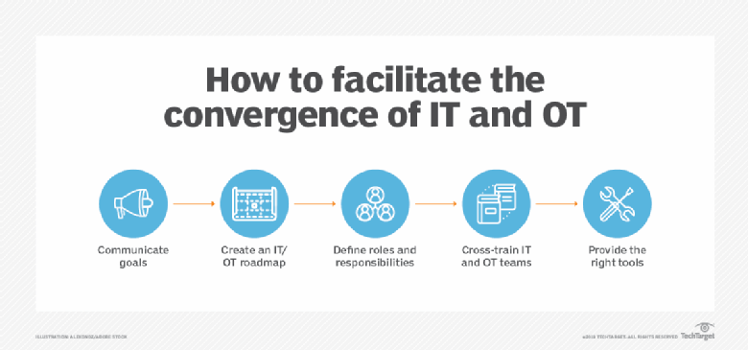

### Types of IT/OT convergence

Convergence is not a single initiative or effort. Convergence initiatives can take a variety of directions depending on the needs and goals of the organization. There are three main categories of IT/OT convergence:

* Process convergence covers the convergence of workflows. IT and OT departments must reform their processes to accommodate each other and make sure important projects are communicated. This is an organizational convergence, dealing with the structure of the internal business. For example, a business might follow specific processes for storing and protecting IT data, but this process might be adapted or extended for converging OT systems.
* Software and data convergence deals with getting the software and data in the front office to work to address OT needs. This is a technical convergence involving the network architecture of the business. For example, IT might need to implement new tools to gather OT data and combine OT and IT data for analysis.
* Physical convergence includes physical devices being converged or retrofitted with newer hardware to accommodate the addition of IT to traditional OT. This is an operational convergence, where the hardware itself is updated and maintained over time. This might include the purchase of new OT systems or the addition of aftermarket devices to facilitate data communication and control.

### IT/OT convergence industry examples and use cases

Increasingly, sensors and connected systems, such as wireless sensor and actuator networks, are being integrated into the management of industrial environments -- such as those for water treatment, electric power, and factories. The integration of automation, communications and networking in industrial environments is an integral part of IoT and is often referred to as [Industry 4.0](https://www.techtarget.com/searcherp/definition/Industry-40).

Here are some industries that benefit from the convergence OT and IT:

* **Manufacturing.** IT/OT convergence enables organizations to be more cost- and resource-efficient by using sales and inventory data to [drive manufacturing operations](https://internetofthingsagenda.techtarget.com/feature/Reap-the-rewards-of-IT-OT-convergence-in-manufacturing) -- optimizing equipment and power use while minimizing maintenance and unsold inventory.
* **Utility and energy companies.** Modern IT enables OT teams to access operational data remotely, helping [industries such as oil, gas and electricity](https://internetofthingsagenda.techtarget.com/tip/Understand-the-role-of-IT-OT-convergence-in-oil-and-gas) to optimize industrial equipment inspections, make damage assessments and handle inventory monitoring and distribution.
* **Transportation.** Asset management is a priority in transportation. Integrating IT and OT can help rail, bus, delivery and other transportation organizations gain better visibility into the coordination, condition and usage of assets to guide short-term repairs, route optimization and long-term planning for asset replacement and safety.
* **Military and law enforcement.** IT/OT convergence can aid in the coordination and rapid deployment of resources, while providing more insight into the condition and maintenance of critical equipment.
* **Communications and media companies.** Regional and global communication providers can employ IT/OT convergence to oversee the performance and operation of equipment and quality of service, leading to faster troubleshooting and better user satisfaction.
* **Retail.** The use of IoT devices such as start product tags, along with other OT devices such as cameras and POS devices, can deliver more data to IT for analysis, leading to inventory and sales floor optimizations for cost savings and better revenue generation and shopper experience.
* **Medical and pharmaceutical.** IT/OT integration allows more medical devices to exchange and share patient information for real-time visibility, leading to better patient analysis and outcomes; meanwhile, convergence can improve the manufacturing of medicines to enhance and ensure product quality.

### IoT and IT/OT convergence

IoT, especially when paired with edge computing, enables the IT portion of IT/OT convergence. As mentioned, OT devices are not traditionally networked technology. IoT devices, by definition, are networked computing devices with the ability to collect, transfer and analyse data. Traditional OT devices -- sensors, for example -- can collect data, but cannot transmit the data over a large network or perform any sort of in-depth analysis on that data.

Newer smart sensors would be able to collect the data from the source, such as a factory floor, and transmit it to an IoT hub or gateway, which would then transfer that information to an analytics application or an enterprise resource planning software platform to be integrated into an organization's unified system of business operations. When networked, an OT device functions as an IoT device. In the factory floor example, a sensor can collect operational data on materials or machines in the factory and send it over a wireless network to the back-end system application to be interpreted and trigger an action -- maintenance on factory equipment, for example.

The addition of edge computing capabilities to industrial internet of things (IoT) devices enables real-time data processing closer to the source. Instead of sending the data over a network to a centralized location for processing, the IoT devices can analyse time-sensitive manufacturing process data and return insights quickly for direct monitoring of industrial conditions before it becomes obsolete. This is important because IoT and OT devices are often part of a distributed network architecture, making transmission to a central processing location difficult or impossible -- IoT is an important technology behind distributed or edge computing. These devices are also often responsible for critical industrial systems that, if shut down or interrupted, would incur severe consequences.

IT/OT convergence can pose challenges in IoT security. Convergence isn't just a blending of technologies, but also teams and processes. The addition of OT brings new stakeholders into the security environment. IT security teams and processes must incorporate the diverse real-time demands of industrial environments. For example, it's just not possible to shut down a smart grid for a few hours to apply patches or change configurations. In other cases, OT systems might be in place decades longer than IT systems, presenting additional security risks to consider and mitigate. But OT systems weren't built for internet connectivity and [must be retrofitted with IoT devices](https://internetofthingsagenda.techtarget.com/tip/IT-OT-convergence-security-must-adapt-for-IoT-connectivity) and [proper security controls](https://internetofthingsagenda.techtarget.com/feature/An-IoT-security-maturity-model-for-IT-OT-convergence).

There are four principal security threats to IT/OT convergence:

* **Lack of collaboration.** IT and OT teams have rarely worked together, and this can lead to security oversights that can increase complexity, duplicate efforts, increase operating costs and expose security flaws that attackers can exploit. To ensure security, disparate teams must prioritize, collaborate, and communicate in ways that might not have been necessary or even possible in years past.
* **Legacy OT systems.** Where IT systems rarely last more than five years, OT systems can have lifecycles that measure into decades. Such legacy systems typically incorporated few, if any, security features and can't be upgraded because of proprietary designs or protocols. Every converged system must be evaluated for security, and systems that cannot support security requirements might demand new or updated OT equipment.
* **Insufficient insight.** IT routinely relies on asset discovery and configuration to provide a clear and complete picture of the environment being managed. OT systems must be able to share this environment and offer discoverability and remote configuration and management. If an administrator cannot see an OT device, they can't secure and manage the device. Such gaps can lead to security vulnerabilities.
* **Mission-critical demands.** OT production systems are often called upon to function 24/7 year-round and cannot be paused or turned off for upgrades or updates without a significant loss of revenue or physical risk. Imagine turning off medical life support equipment for updates. Organizations might ignore potential security vulnerabilities simply because they cannot afford the cost of downtime needed to remediate risks.

### Benefits of IT/OT convergence

IT/OT convergence enables more direct control and more complete monitoring, with easier analysis of data from these complex systems, from anywhere in the world. This enables workers to do their jobs more efficiently and improves decision-making, as organizations, leaders and employees have access to real-time insights that converged data provides. Businesses including manufacturing, transportation, mining and other industrial [organizations are embracing IT/OT convergence](https://internetofthingsagenda.techtarget.com/feature/IT-OT-convergence-is-hard-work-heres-why-its-worth-it)

The following are some of the [benefits of IT/OT convergence](https://internetofthingsagenda.techtarget.com/tip/5-benefits-and-challenges-of-IT-OT-convergence) over separate IT and OT:

* less siloed IT and OT departments, as the departments must share their respective areas of expertise to manage converged technology;
* reduced development, operational and support costs, as well as less unplanned downtime due to predictive maintenance enabled by IoT devices;
* faster time to market for converged technology;
* improved compliance with regulatory standards, as the addition of IT to OT enables better visibility, management, and auditing;
* improved automation and visibility into distributed OT because OT gain the ability to transmit real-time maintenance data;
* more efficient energy and resource usage, as OT systems can be engaged more in line with actual product needs; and
* more efficient asset management because all IT and OT systems are seen and managed through a common methodology.

### Challenges of IT/OT convergence

* **Process convergence.** Organizations might struggle with reorganizing previously siloed IT and OT departments to manage and operate newly converged technology.
* **Secure IoT implementation.** Oftentimes, IoT initiatives aren't owned by any one department, and communication of a new project might not reach all departments -- especially in a more siloed organization. Typically, OT departments have limited knowledge of security, and IT has a limited knowledge of the projects currently underway. This can create a dangerous security gap with IoT deployments.
* **Training.** Only recently have certifications, such as the Cisco Certified Network Associate Industrial IoT, been offered to help OT workers understand how the technology they are accustomed to intersects with networked technology. Before that, there was little in the way of standardized courses for manufacturing process control. This means that older systems and staff might have previously been adhering to standards that vary from organization to organization, causing compatibility and security issues.
* **Integration with existing systems.** The business side of an organization might be tempted to replace technologies instead of modernizing existing OT with IT technology. This defeats one of the benefits of convergence, which is cost efficiency. The point of convergence is to do more with what is available.

### IT/OT convergence strategies and best practices

* **Communicate goals.** Develop a clear picture of the overall objectives, and ensure that both IT and OT groups understand the convergence goals involved.
* **Show the overlap.** Illustrate the ways in which IT and OT will overlap for each team, especially in terms of systems management and security.
* **Define the roles and responsibilities.** Outline the duties, goals, roles and responsibilities for IT and OT teams, and focus on opportunities to collaborate.
* **Provide training.** Cross-training can help IT and OT groups develop a better sense of the other and understand each other's needs. In addition, a [growing number of IT/OT convergence certifications](https://internetofthingsagenda.techtarget.com/tip/How-to-approach-IT-OT-convergence-training-and-certification) are appearing to help organizations manage convergence projects more effectively.
* **Use the right tools.** Teams can work together to identify and deploy tools that can provide the appropriate amount of visibility and control over IT/OT assets. Tools should cover discovery, configuration, management, and security.

2)Identify the cloud service types, and list their characteristics, and advantages.

Cisco Webex, Google app engine, Amazon

**List of features for Webex Meetings:**

**1)Moderated unmute mode**

Moderated unmute mode can be enabled for meeting cases where hosts and cohost can directly unmute participants. (As opposed to the standard privacy mode, where a participant will receive a request to unmute from the host or cohost.) This is useful for cases like the classroom, where students may be too young to read the prompts, and the teacher needs more direct control over the students' unmute.

**2)Keyboard shortcut management (Windows)**

You can now access and manage the keyboard shortcuts directly from the desktop app meeting window, by going to the help menu.

* Here, you can manage the Global Shortcut setting to determine if you would like to be able to use the shortcut even when the Webex Meetings app isn’t in focus.
* You also have the option to customize the shortcut and redefine it to the key combination of your choosing.

**3)Support for whiteboard and doc sharing, in a video centric MP4 cloud**

This update allows video centric format recordings to record documents and Webex whiteboard shared in a meeting, except for video file sharing. This will be applicable to newly generated recordings in both Webex Meetings and Webex Events. Previously, if you shared a document or a whiteboard in a recorded meeting, the recording became a standard format MP4 recording. A standard format MP4 recording isn’t subject to the recording layout preference setting, and therefore, doesn’t support stack or grid layouts.

**4)Unified registration for Webex Meetings, Webex Events, and Webex Training**

Starting with this update, a host can include custom questions in the attendee’s registration form for a meeting. Each of the custom questions can be marked as required or optional. The types of questions include text-based input, check boxes and multiple choices. In addition, custom questions can be saved and reused in a future meeting.

### 5)Pre-meeting experience

**6)Time zone information added to first time Join page**

First time users joining a Webex meeting see the timezone information when they join their meeting immediately on the page, so that they won't get confused about the meeting join time.

**7)Webex meeting registration summary in meeting list**

The Modern View meeting list includes a registration summary (number accepted, number rejected), when hovering over their meetings. Registration must be enabled.

**8)Import CSV files when scheduling breakout sessions**

For easier breakout session scheduling, Modern View users can import CSV files when pre-assigning their breakout sessions.

### In-meeting experience

**9)View and share Webex meeting details**

Webex produces meeting assets—highlights, transcripts, and recordings—related to the Webex Assistant, in the following scenarios:

* Both Recording and Webex Assistant are on.
* Webex Assistant is on, and set to generate highlights.

### Webex Meetings VDI

**10)Support for Dell Thin OS 9.1 available in Citrix Environment**

In this update, the VDI client supports Thin OS 9.1 for Citrix environment.

**11)Improved high frame rate content share**

In the previous update, the sharing content is converted to picture by server first and then delivered to thin client through the Citrix or VMware VDI channel from HVD. The new solution provides thin client the capability to decode the share media stream directly.

**12)Moderated mute mode**

Similar to the Webex Meetings desktop app, mobile hosts will now also be able to mute and unmute attendees without prompting those attendees, if the admin has this capability set up and the meeting is scheduled with this capability turned on.

**13)Introducing Gesture Controls**

In 40.11, we introduced in-meeting reactions—a great way for meeting participants to interact and express themselves non-verbally. In this update, we've made sending reactions even more natural by introducing gesture controls in the desktop app. Simply motion to your camera, and your hand gesture will automatically be recognized, and the reaction will be sent! This includes:

* Giving a thumbs up
* Giving a thumbs down
* Applauding with your hands

### Pre-meeting experience

**14)Meeting invite email template changes**

Going forward, meeting invite email templates will have simpler wording at the beginning of the email,

* To indicate the name of the host sending the invite. Example: "%host name% is inviting you to a scheduled Webex meeting".
* To clearly indicate if the recipient is a host or a cohost. Example: "You're the host for this Webex meeting. When it's time, start your Webex meeting here" or "You're a cohost for this Webex meeting".
* The green **Join** button is updated to say "Join meeting" for all participants and "Start meeting" for host and cohosts. This makes it clear to end user if this is a meeting, they have privilege to start or only join.

**GOOGLE:**

## Advantages of Google

* Google is the largest search engine in the world, and according to Google, 1 trillion websites are indexed on the search engine. This immediately benefits internet users since they can get reliable information on a variety of topics based on their preferences.
* In contrast, websites aren't as well-indexed in search engines besides Google, which means that users have fewer alternatives for finding information. For this reason, Google search is the greatest option for users.
* After integrating Google AdSense code into his website, users may start making money online using Google AdWords. This Google platform allows for online advertising, which helps publishers earn a lot of money as the site's traffic increases. meets.
* Google offers it's Android customers the Google Play Store for free, where users may download different programs from different categories at their discretion. Google periodically introduces new products and services to improve its consumers' surfing experiences and enable them to do activities swiftly, pleasantly, and safely.
* The fastest browser in the world is thought to be Google Chrome**.** This has tens of thousands of plugins and add-ons. This allows user to do their jobs fast and easily.
* The primary benefit of using Google, or the fact that it is a free search engine, is that we may utilize its extensive set of search tools to obtain free answers to our inquiries.
* Despite being such a large search engine, Google's performance consistently remains good, which is why it has gained popularity as the top option. Today, almost all of Google's services are accessible over the Internet in accordance with customer demands. What makes these services unique is that they are provided without charge, which has helped Google establish itself as the preferred option among consumers.
* Consumers may use Google's wide range of paid and unpaid products and services to meet their requirements.

**AMAZON:**

## What is AWS?

[AWS](https://intellipaat.com/blog/what-is-amazon-web-services-aws/) is a Cloud Computing platform, which helps you build your applications over the cloud. It offers various services like a combination of infrastructure and software services, along with computing power, scalability, reliability, and secure database storage. You can use AWS for quality development as it offers around 200 products and services all over the world.

## Top 7 AWS Benefits and Advantages

### **1)User-friendly**

This tops the list of the Amazon Web Services benefits. AWS is easy to use as the platform is specially designed for quick and secure access. Users can modify their data whenever they want, wherever they want. Most companies find starting with AWS as their cloud provider much easier than using other providers, namely, [Azure](https://intellipaat.com/blog/what-is-microsoft-azure/) or [Google Cloud Platform](https://intellipaat.com/blog/what-is-google-cloud/). AWS provides you with all the information, documentation, and video instructions to help you learn how to use all of its services.

### **2)Flexible**

Flexibility is also the reason why many companies prefer AWS. It always lets you use those operating systems, programming languages, and web application platforms that you are comfortable with. With a service like AWS EC2, you can build your virtual computing environment by setting up your preferable operating systems and applications. AWS benefits provide all the best services that your application requires to function seamlessly. It can also ease the migration process, and you can work on new solutions simultaneously.

### **3)Secure**

Security is one of the best benefits of AWS cloud computing. As we know, security is the uppermost priority for any company that is data-driven. AWS provides a highly secure infrastructure to ensure the privacy of your data. Security professionals at AWS follow different layers of data surveillance such as:

### **4)Cost-effective**

If you follow traditional methods, then you should build your own servers for storing your data and applications, which consumes a good amount of both your time and money. So instead of building your own expensive servers, you can use AWS where you need to pay only for the tools and services that you use. AWS offers a pay-as-you-go pricing method, which means that a company will only pay for the services that it needs and has used for a period of time. It is the same as paying your electricity bill; you only pay for the units you have consumed. These [AWS services](https://intellipaat.com/blog/aws-services-list-and-products/) are unique and cheaper than the traditional computing method.

### **5)Reliable**

Amazon offers the highest reliability for its customers. AWS serves over a million active clients in more than 200 nations all over the world. An ultimate team of tech professionals is working on data security. AWS performs its tasks accurately when it is required and offers many services that make it more reliable like the capability to automatically recover from failure. Also, services such as [Amazon DynamoDB](https://intellipaat.com/blog/amazon-aws-dynamodb-tutorial/) and Amazon S3 store the data in three different availability zones so that even if two of them fail to work, the users will still have their data intact. Therefore, AWS benefits are trustworthy in terms of the services and security it provides.

### **6)Scalable and Elastic**

AWS is scalable because the [AWS Auto Scaling service](https://intellipaat.com/blog/what-is-auto-scaling-in-aws/) automatically increases the capacity of constrained resources as per requirements so that the application is always available. Spinning up new servers is easy in AWS. If you want to add more servers, AWS enables you to use them within minutes.

### **7)Highly Performant**

High-performance computing (HPC) is the ability to process a massive amount of data at high speed. Companies find it more crucial for productivity and to compete with other companies. AWS offers a high-performance computing service so that the companies need not worry about the speed.

AWS has become the most popular cloud platform as it always keeps innovating itself with the latest tools and technologies for better productivity. But, every coin has two sides, right? The same is with this popular cloud provider.

3)Step by step creation of Jira.

## **Steps to Follow:**

Click on the Create button in the navigation bar to open the create issue dialogue box.

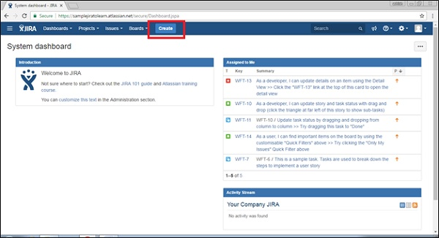

To complete the process of creating an issue, we should follow the pointers given below.

* Select the Project where the issue is.
* Select the type of issue, whether it is a bug/new feature/story, etc.
* Write a one-line summary to provide the overall idea about the issue.
* Write the details of the issue in the **Description** field. Explain the issue, so that stockholders can understand every detail of the issue.
* To create a similar type of issue in the same project and issue type, check the checkbox of “Create another” otherwise keep it as unchecked.
* After entering all the details, click on the Create button.

The following screenshot shows how to create an issue by providing the required and optional details.

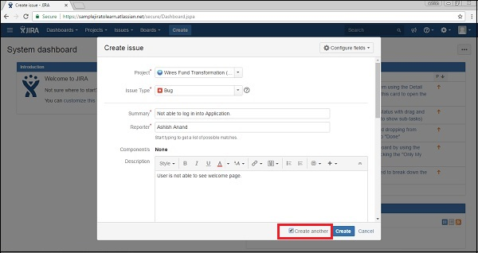

If the “Create another” checkbox is not checked, after clicking on the Create button, the user will have to navigate to the Dashboard and a pop-up will display on the right side with an **issue id** and **summary**.

The following screenshot shows how to know whether the issue is successfully created or not.

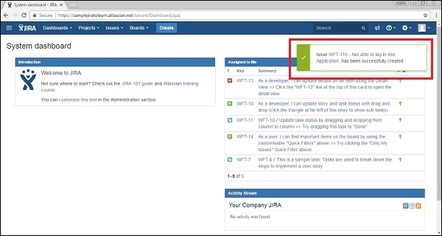

If the “Create another” checkbox is checked while clicking on the Create button, the user will get a new create issue page along with the **issue id**.

The following screenshot shows the page, if the user has checked the “Create another” box.

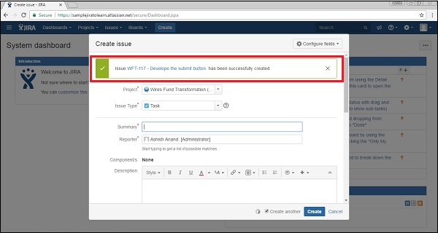

## **Configure Fields**

To add other fields in the Create Issue form, click on “Configure fields” at the top right hand side of the page. The following screenshot shows how to configure the fields in the Create Issue page.

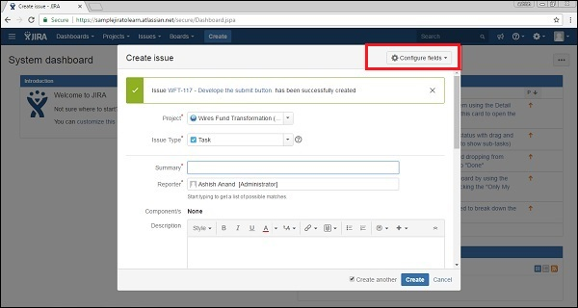

After clicking on the **Configure fields** button, a drop down box will be displayed, click on Custom. The following screenshot shows the available fields under the **Custom** tab.

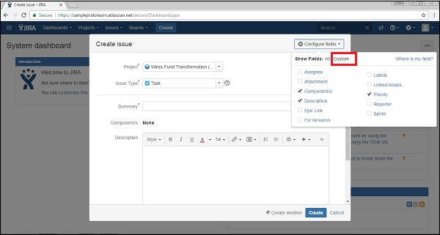

By checking and unchecking the checkboxes to show and hide, fields will be added or cleared from the form. The following screenshot shows the available fields under the **All** tab.

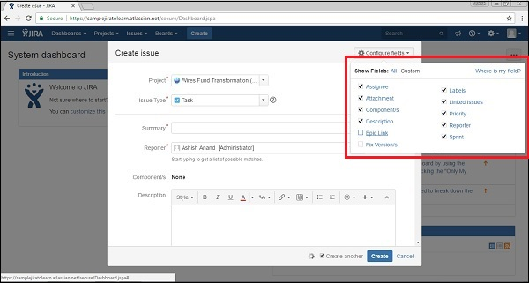

Now navigate to Create Issue, all fields based on choices will be displayed in the form that shows up. The following screenshot shows the configured fields in the Create Issue page.

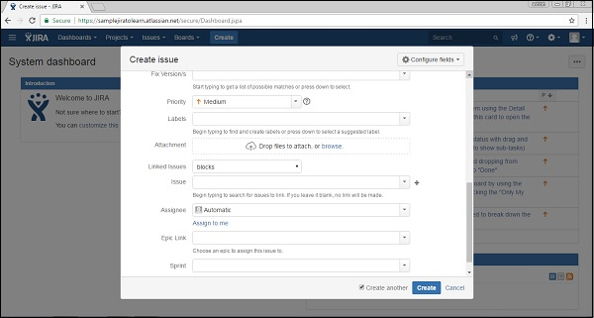

The fields in the Create Issue form are explained below.

* **Priority** − Issue creator can set the priority to resolve the issue as High, Medium, Low, and Lowest.
* **Labels** − It is similar to **Tag;** it helps in filtering out specific types of issues.
* **Linked Issue** − It links other issues that are either dependent on this issue or this issue is dependent on them. Options in dropdowns are – block, is blocked by, duplicate, clone, etc.
* **Issue** − User can link the issue by the **Typing ID** or summary of those that are related to the linked issue field.
* **Assignee** − The person who is responsible to fix this issue. Assignee name can be entered by the issue creator.
* **Epic Link** − An Issue creator can provide an epic link, if the issue belongs to any of those.
* **Sprint** − The user can define in which sprint, this issue belongs to, when this issue should be addressed.