CA2 Capstone Report
Title: Advanced Customer Segmentation and Repeat Purchase Prediction
1. Strategic Overview of the Business Problem
In e-commerce, where acquisition costs are always increasing, customer retention is a strategic concern. Because repeat customers tend to spend more, convert more effectively, and require less maintenance, it is just as important to maximise the value of retaining current customers as it is to acquire new ones (Fader & Hardie, 2009). Businesses need to predict repeat purchase behaviour accurately in order to maximise marketing expenditures and customer engagement strategies.
Accurate customer segmentation is necessary for data-driven engagement, including loyalty programs and reactivation activities. However, traditional demographic-based segmentation frequently fails in dynamic retail environments, making it difficult to leverage large amounts of transactional data. Targeted resource allocation and better decision-making are made possible by the strategic insights that predictive modelling and behavioural segmentation (by clustering) offer.
By analysing transactional data to identify trends and categorise customers according to their probability to return, this project strategically combines data science with business goals. It maintains a balance between model interpretability and prediction performance by using K-Means clustering for unsupervised segmentation and Logistic Regression, Decision Tree, and Random Forest for supervised learning. Finally, by converting transactional data into actionable insight, this strategic technique makes it possible to improve customer retention, predict revenue, and develop data-driven marketing plans (McKinsey & Company, 2021).
2. Project Plan
A popular and standardised framework for structuring data science workflows, CRISP-DM (Cross-Industry Standard Process for Data Mining) is used in this project (Martínez-Plumed et al., 2021). Throughout the project, the methodology makes it possible for technical tasks and business goals to be clearly aligned.
Business Understanding (Stage 1): To support customer retention strategies, the first step is to define the business objective, which is to predict repeat purchases. Understanding of important behavioural elements related to customer segmentation and repeat purchasing behaviour will be guided by a review of the literature (Zhang et al., 2023).
Data Understanding (Stage 2): This project will make use of the Online Retail II dataset from the UCI Machine Learning Repository. In order to comprehend feature distributions and find any missing values or anomalous entries, the dataset will be examined during this phase. Prior to further processing, the objective is to establish a preliminary understanding of the data's quality and structure.
Data Preparation (Stage 3–4): To ensure model compatibility, preprocessing will involve cleaning the data by eliminating inconsistent or incomplete entries, converting raw features into aggregated customer-level metrics (e.g., total spend, average transaction value), and scaling numerical variables for use in clustering algorithms. This phase will adhere to best practices in data preparation (Zhou et al., 2022).
Exploratory Data Analysis (Stage 4): To find patterns and anomalies in the data, this stage will employ descriptive statistics and visualisation tools like correlation heatmaps and distribution charts. Finding patterns that guide feature engineering and model selection is the goal (Tang et al., 2023).
Modelling (Stage 5–6):
Customers will be divided into groups according to behavioural characteristics including frequency of purchases, monetary value, and variety using K-Means clustering. After clustering, three algorithms will be used to perform predictive modelling:
- Logistic regression (to make it easier to understand),
- For rule-based analysis, the Decision Tree Classifier, and
- Random Forest (for performance in groups).
Predictive analytics and explainable AI trends are in line with the model selection process (Lemke et al., 2022).
Evaluation (Stage 6–7): Cross-validation and common performance metrics including precision, recall, F1-score, and ROC-AUC will be used to evaluate each model. In order to facilitate business interpretation and recommendations, customer clusters will be profiled.
Deployment and Reporting (Stage 8): At this point, a thorough report that covers every step, from business understanding to model evaluation, will be put together. At least 10–12 significant commits that cover the development process throughout the data exploration, preparation, modelling, and evaluation stages will be included in the GitHub repository. To make sure the project remains in accordance with goals and schedules, task progress will be monitored through regular checkpoint reviews and organised weekly planning.
3. Business Understanding
Strategically, predicting repeat purchase behaviour facilitates improved demand forecasting, targeted marketing, and loyalty reward optimisation. Being able recognise repeat customers early on has great business value because they account for a larger portion of long-term revenue than do first-time customers. Recent research has shown that customer retention is more cost-effective than customer acquisition, and predictive models can considerably improve the personalisation and relevance of customer outreach strategies (Benedek et al., 2021; Xu et al., 2023). With the use of these models, businesses can also better focus promotions and optimize inventory based on anticipated future demand from loyal customer segments.
Businesses can create effective segmentation strategies by using purchase data to understand customer behaviour. Businesses can offer targeted promotions, increase personalisation, and boost the efficacy of loyalty programs by recognising the essential characteristics of high-value repeat customers (Nguyen et al., 2020). Better inventory planning, resource allocation, and demand forecasting are also made possible by the ability to predict which customers are more likely to repurchase, which lowers overstock and stockouts (Sun et al., 2021).
Businesses that use predictive modelling to foresee future behaviour get a competitive edge in an era where customers have high expectations regarding personalisation. Marketers can use predictive analytics to reach the right customer with the right message at the right time, especially when paired with behavioural segmentation (Benedek et al., 2022). Additionally, businesses that use data-driven customer management typically outperform competitors in terms of financial success and customer satisfaction (McKinsey & Company, 2023).
By utilising unsupervised learning to segment customers based on their purchasing behaviour and supervised models for predicting the likelihood of repeat purchases, this study seeks to support these strategic goals. The resulting insights can be used as the basis for long-term frameworks for customer interaction and practical marketing strategies.

4. Data Understanding
Dataset Overview
Transactional data from a UK-based online store can be found in the Online Retail II dataset, which was obtained via the UCI Machine Learning Repository (UCI, 2020). The dataset contains comprehensive information on customer purchases and covers a number of years. Among the dataset's primary attributes are:
- CustomerID: A unique identifier assigned to every customer.
- InvoiceNo: The unique transaction number for every purchase the customer has made.
- StockCode: A unique number for the item bought.
- Description: The product's description in text form.
- Quantity: the total quantity of items bought during a transaction.
- UnitPrice: The price of every item bought.
- InvoiceDate: The time and date of the transaction.
- Country: The country in which the buyer originated the transaction.

These features are necessary for creating customer segmentation models, predicting repeat purchases, and comprehending customer purchasing behaviour.
Initial Data Inspection
It is essential to make an initial review of the dataset prior to carrying out any advanced data analysis. This include determining the kinds of variables available, looking for missing values or duplicates, and confirming the overall structure of the data. For the initial inspection, the following steps were taken:
1. First Few Rows
To get a basic idea of the data structure, the dataset's first few rows are shown. This helps in recognising any apparent patterns or issues with the data.

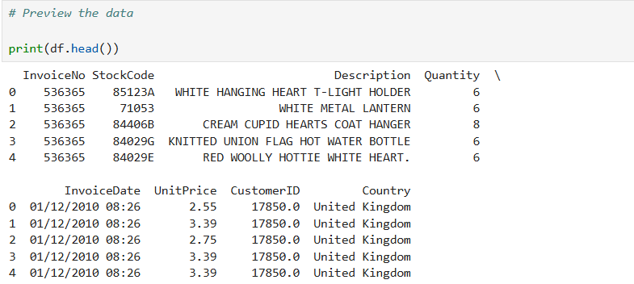

Multiple line items can share the same InvoiceNo, indicating that they are part of the same transaction, as shown in the first five rows. Several different products may be included in a single transaction. For example, all five sample rows are associated with UK customer 17850.0 and invoice 536365, indicating that the dataset is in transactional (line-item) format rather than aggregated at the invoice or customer level.
2. Data Types and Missing Values
Information about the dataset, including the data types of each column and the amount of non-null values in each column, is shown using the df.info() method. This makes it possible to identify columns that might have missing values, which may be addressed during the data preparation process.

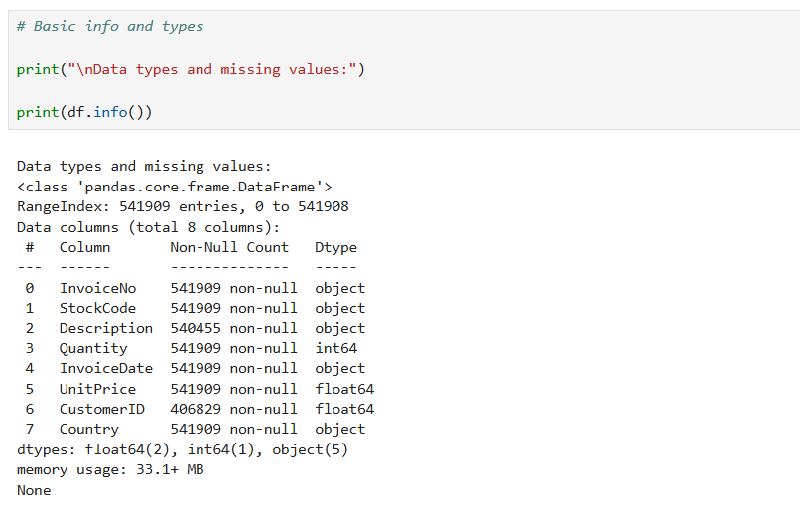

There are eight columns and 541,909 rows in the dataset. Although CustomerID is categorical, it has a float64 type because of missing values. Any time-based analysis should convert the object that is stored as invoicedate to datetime. The other fields are completely filled in, with the exception of Description and CustomerID. For local analysis, the 33.1 MB of memory usage is appropriate.
3. Missing Values Check
The df.isnull().sum() is used to find columns that contain missing data. In order to plan the imputation or removal of these values during the Data Preparation phase, it is necessary to know the total number of missing values per column.
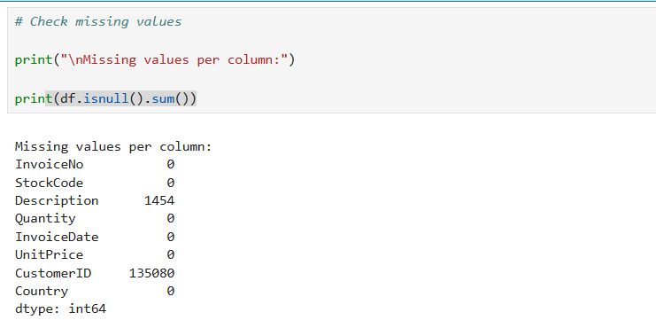

About 25% of the dataset, or 135,080 missing values, in CustomerID suggest that many transactions are anonymous or not linked to a specific customer. 1,454 rows lack a description.
These missing values should be handled during the data preparation phase, particularly when conducting customer-level analysis or clustering, even though they do not render the dataset useless.
4. Duplicate Rows Check
To make sure that the dataset has no duplicate transactions, it is crucial to check for duplicate rows. This may ensure the integrity of any prediction modelling and avoid biased analysis.

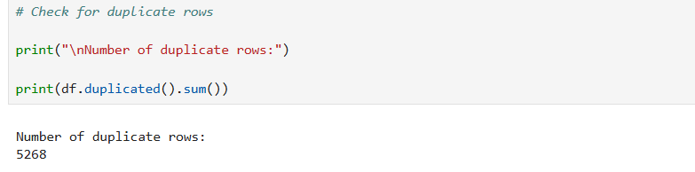

Duplicate rows, or rows that are exactly the same in every column are total 5,268. In retail, it is common to make repeated purchases, but exact duplicates are usually eliminated unless they are shown to be intentional records.

Exploratory Data Analysis (EDA)
Following the completion of the initial inspection, exploratory data analysis (EDA) is performed. Understanding the distribution, relationships, and patterns in the data is the focus of EDA. Later phases of the project, such as feature engineering and model selection, will be informed by the anomalies, trends, and correlations found in this research.
1. Summary Statistics
Summary statistics are calculated to gain a better understanding of the range, central tendency, and distribution of important numerical variables like Quantity and UnitPrice. This shows any extreme values and gives a summary of the data.

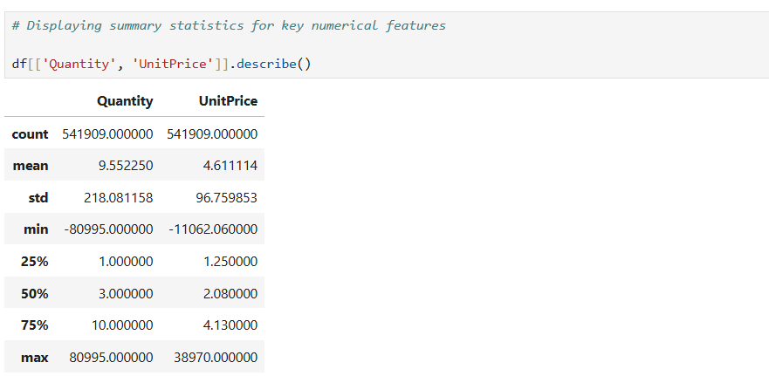

There are 541,909 transaction records in the dataset. With values ranging from -80,995 to 80,995, the Quantity variable has a broad range, according to summary statistics, suggesting the possibility of data entry errors or returns. The large standard deviation (218.08) indicates significant variability and potential outliers, despite the mean quantity being almost 9.55. Likewise, the UnitPrice variable has a range of -11,062.06 to 38,970.00, with the negative and extremely high values possibly indicating problems with the quality of the data. Although the average unit price is £4.61, the wide disparity between the mean and maximum numbers clearly shows how skewed the distribution is. During the data preparation stage, these irregularities require additional analysis.
2. Distribution of Key Features
In order to comprehend their spread and spot any odd patterns, like skewness or outliers, we use histograms and Kernel Density Estimation (KDE) plots to visualise the distribution of Quantity and UnitPrice.
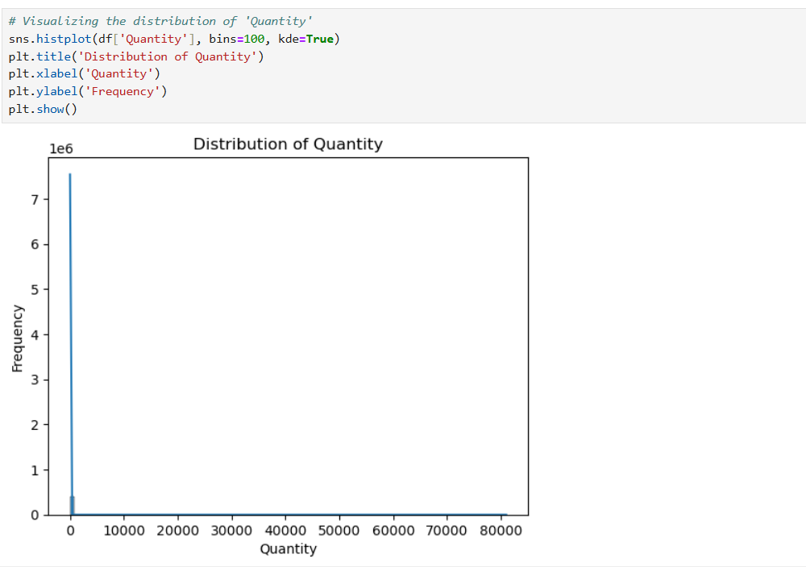

The histogram shows a steep peak close to zero and a highly right-skewed distribution of the Quantity variable. Small quantities are involved in most transactions, but a few extreme values, both positive and negative, greatly skew the scale. These outliers show the presence of anomalous entries, like large bulk orders or returns, and lessen the plot's effectiveness to accurately depict the bulk of the data. This skewed distribution indicates that in order to enhance model performance and the clarity of the analysis, data normalisation or outlier handling may be required during the preprocessing stage.
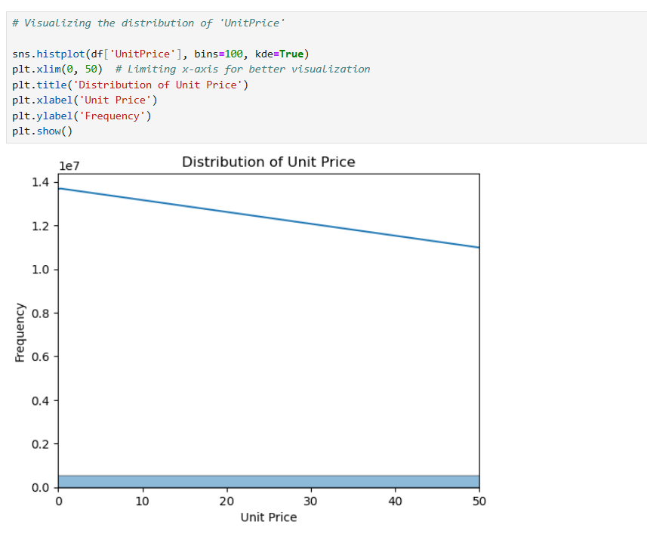

The UnitPrice variable's histogram shows a distribution that is heavily skewed to the right. With a heavy concentration towards the lower end of the spectrum, the majority of products are priced under £5. The x-axis was restricted to a range of 0 to 50 in order to improve interpretability by removing extreme outliers, this helps to more clearly see the underlying distribution. Even after this adjustment, a lengthy tail and a few anomalous values, like very high unit pricing, point to potential data entry errors or unique product situations. This pattern suggests that more preprocessing is required to normalise the feature for further analysis, such as log transformation or outlier handling.
3. Relationship Between Key Features
The relationship between quantity and unit price is analysed using a scatter plot, which might reveal information about the relationship between product pricing and quantity purchased. This could show some interesting trends in purchasing behaviour.
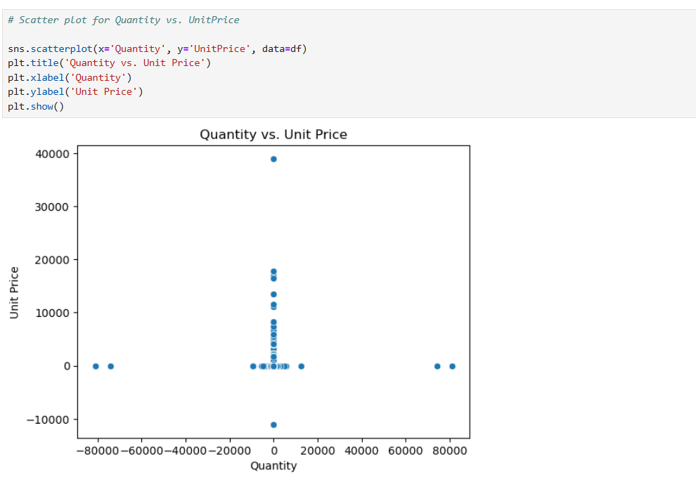

Most transactions include relatively small quantities and low prices, as shown by the scatter plot showing the relationship between quantity and unit price, which shows a significant concentration of data points clustered at the origin. The possibility of major outliers or perhaps inaccurate data entries is suggested by the presence of extreme values on both axes, such as abnormally high or negative quantities and abnormally high or negative unit prices. Interpretability is limited by these outliers, which distort the plot's general scale. This observation emphasises that before moving forward with model development, outlier detection and data cleansing are necessary.
4. Outlier Detection with Boxplots
Potential outliers in the Quantity and UnitPrice columns are found using boxplots. These excessive numbers may indicate data entry errors or unusual transactions that need more analysis.
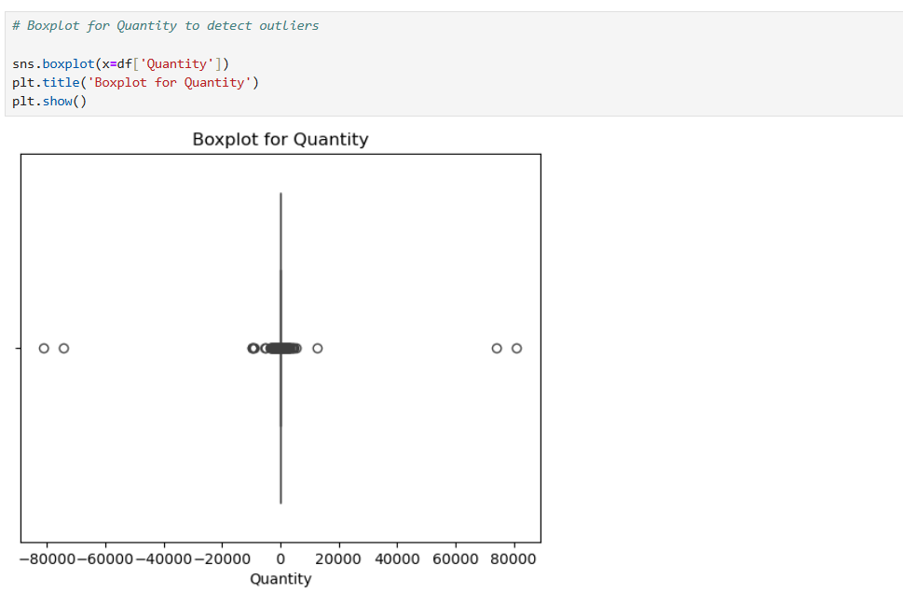
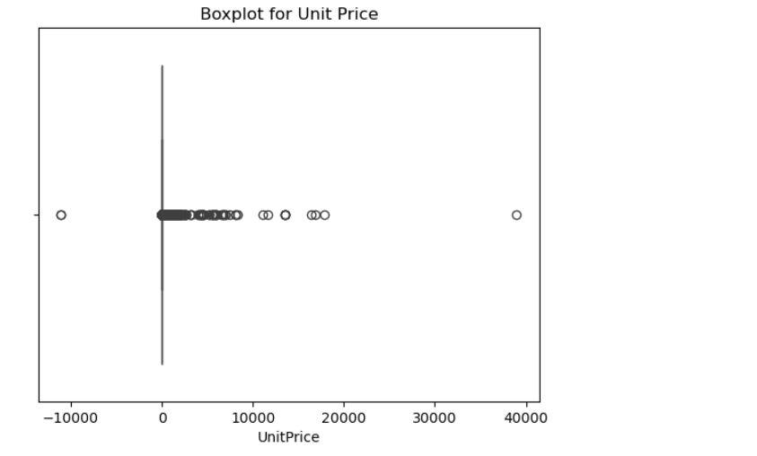

Significant outliers in both quantity and unit price are present in the data set, which causes skewed distributions. Extreme bulk orders and negative values, likely the result of refunds or data errors, are included in quantity. The unit price varies greatly; negative numbers indicate adjustments or inaccurate entries. To improve the reliability of the data for analysis, these anomalies require preprocessing, such as handling outliers and normalising the data.
5. Correlation Matrix
Understanding the relationships between numerical variables is made easier by the correlation matrix. It is especially helpful in identifying linear relationships that could be used in predictive modelling.
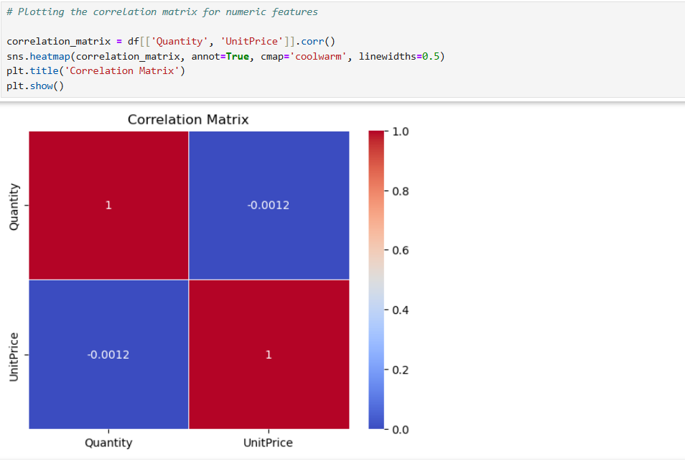

There is no significant linear relationship between the number of items purchased and their pricing, according to the correlation matrix, which shows that quantity and unit price have a weak correlation. This implies that price changes have little effect on the number of purchases, most likely as a result of different product kinds and consumer behaviour. This implies that in order to have a more thorough understanding of purchasing patterns, the assignment analysis needs aggregated variables.
6. Skewness Check
Lastly, determining whether data transformations (such log transformations) might be required to normalise the data for modelling purposes is made easier by analysing the skewness of the numerical features (Quantity and UnitPrice).

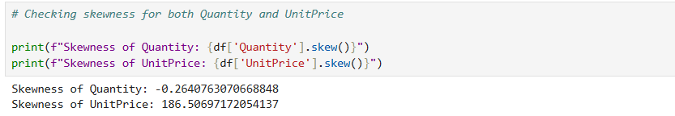

To comprehend the distribution of the data, the skewness of key numerical variables was assessed. With a skewness of -0.26, the quantity variable shows a distribution that is almost symmetric but slightly skewed to the left. UnitPrice, on the other hand, shows excessive positive skewness (186.51), indicating a significant concentration of low-priced items with a few numbers of extremely high-priced outliers. This suggests that further analysis may require data transformation or outlier treatment.

5. Data Preparation
To turn raw retail transactions into a structured customer-level dataset appropriate for modelling and behaviour analysis, a thorough data preparation process was used. The steps performed and the rationale for each are listed below.
5.1 Handling Missing Customer Identifiers
There were several transaction records without a CustomerID. Such entries are useless because the goal of this analysis is to model the customer behaviour. Eliminating them made sure that every row that was kept matched a customer who could be individually identified, which is crucial for segmentation and aggregation.
5.2 Identifying and Removing Cancelled Orders
The letter 'C' in the invoice number was used to identify cancelled orders. Spending and frequency metrics may be distorted by these rows, which frequently represent returns or credit notes and do not accurately reflect real purchases. 8,905 of these transactions in total were not included.
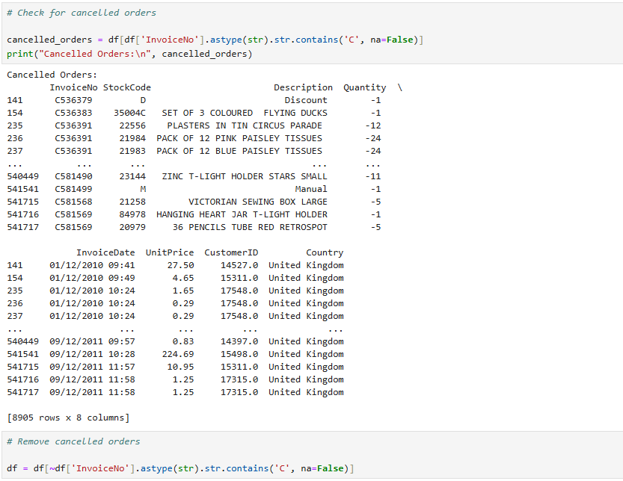

5.3 Removing Invalid Quantities and Prices
Returns, errors, or promotional records could be the cause of transactions with zero or negative Quantity or UnitPrice. The integrity of the behavioural metrics was preserved by eliminating these 40 invalid entries.
5.4 Creating Derived Features
To enable analysis of customer-level revenue, a TotalPrice feature was added to indicate the monetary value of each transaction. InvoiceDate was also changed to datetime format so that time-based computations, including time as a customer, could be performed.

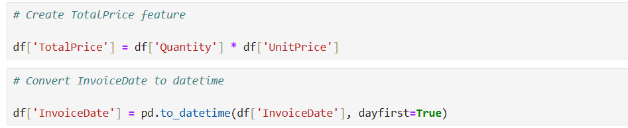

5.5 Aggregation to Customer Level
CustomerID was used to aggregate the data and produce important metrics like:
NumInvoices: Individual invoices for every customer
TotalQuantity: The total amount of items bought
TotalSpent: The sum of all purchases
FirstPurchase and LastPurchase: Date ranges for customer activity
PurchaseDays: The total number of days spent making purchases
This made it possible to model each customer individually.

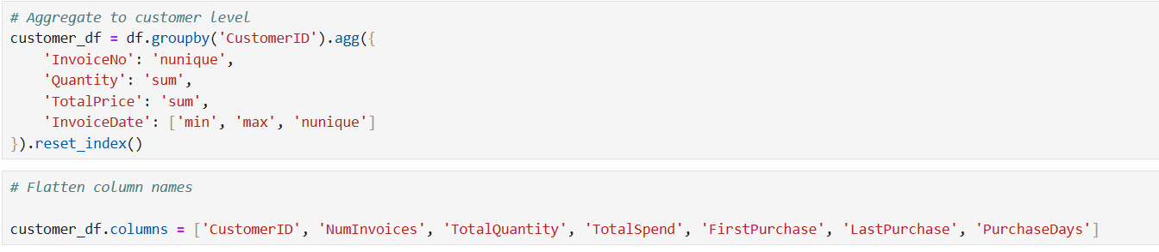
5.6 Additional Feature Engineering
There were three new features added:
PurchaseFrequency: Shows the frequency of purchases, which helps distinguish between frequent and infrequent customers.
CustomerPurchaseDays: Documents time as a customer
RepeatBuyer: A binary indication that serves as the classification target for whether a customer has made multiple purchases.
Through the summarisation of behavioural patterns, these factors improve predictive modelling.
5.7 Feature Scaling
Using StandardScaler, z-score normalisation was used to normalise the numerical features and ensure compatibility with machine learning model. This keeps large-magnitude features from taking over the model.
5.8 Class Distribution and Correlation Analysis
2,845 of the 4,338 customers were repeat consumers, while 1,493 were one-time purchasers, suggesting a target variable that is somewhat unbalanced. It is essential to identify this imbalance in order to choose the right evaluation metrics.
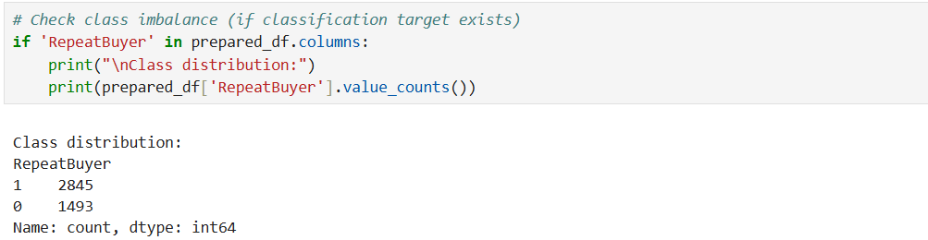

A matrix of correlations showed:
TotalSpend and TotalQuantity have a strong association (r = 0.92).
CustomerPurchaseDays and RepeatBuyer have a moderately favourable connection (r = 0.72).
Purchase frequency has a weak association with other variables.
Later phases of modelling are guided by these insights when choosing and interpreting features.
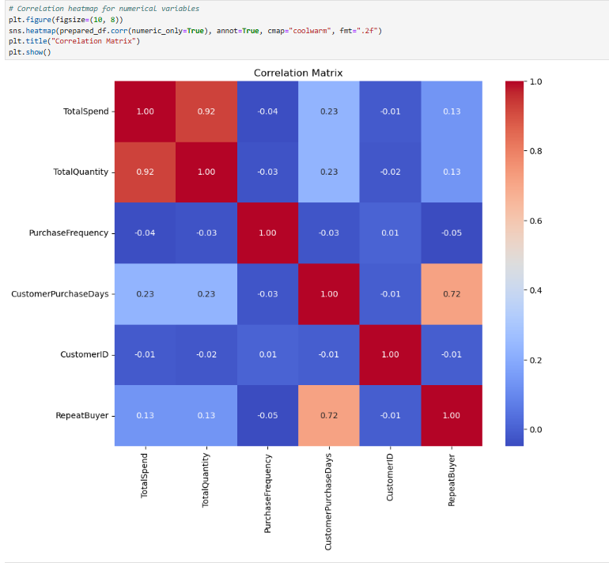

6. Machine Learning Implementation
6.1 Customer Segmentation with K-Means
The standardised customer-level features TotalSpend, TotalQuantity, PurchaseFrequency, and CustomerAgeDays were subjected to K-Means clustering in order to discern discrete behavioural customer groupings. The goal of the clustering was to identify underlying customer characteristics, such as frequent purchases, large spenders, and loyal repeat customers.
Choosing the Optimal Number of Clusters
Two measures for evaluating the model were used:
Silhouette Score: Evaluates cluster dispersion and cohesion, the greater the number, the better.
Calinski-Harabasz Index (CH Score): Assesses the between-cluster to within-cluster dispersion ratio, with a greater value being preferable.
The following code in the figure below analyses both metrics while iterating over values of k between 2 and 10 and providing output.

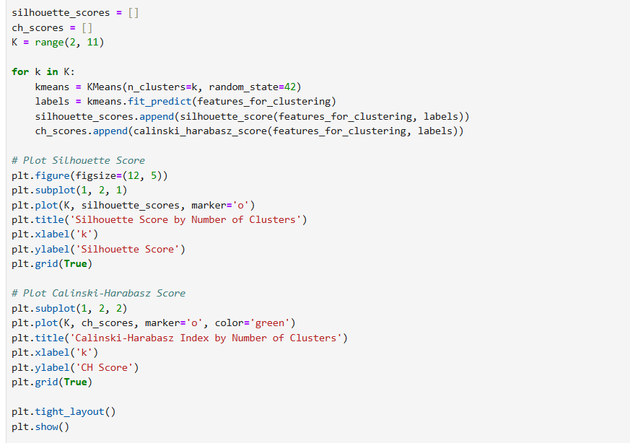
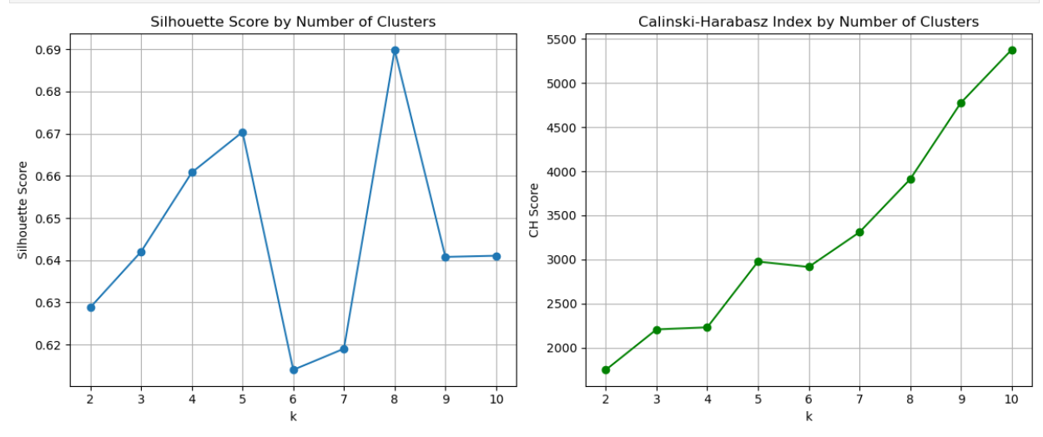

High-quality and well-separated clusters were indicated by the Silhouette Score peaking at k=8 (~0.69).
At k=8, the Calinski-Harabasz Score likewise rose noticeably and kept rising. But after this, Silhouette decreased, indicating overfitting.
Thus, k=8 was chosen as the optimal number of clusters in order to balance separation and compactness.
Final K-Means Model for k=8

Cluster Profiling and Business Insight
In order to comprehend behavioural patterns, cluster-level means were calculated:

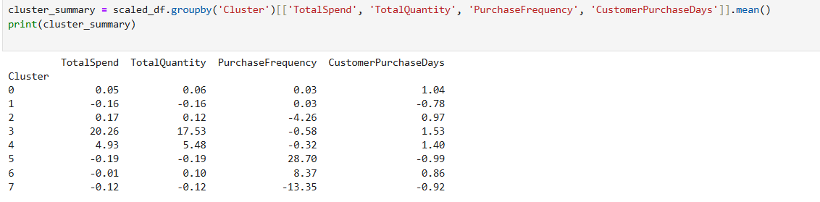

These figures, which are z-scores (standardised units), show how each cluster compares to the average but do not directly reflect real spend, quantity, or frequency.
Cluster 3: These large values in TotalQuantity (20.26) and TotalSpend (17.53), indicate valuable customers.
Cluster 5: Purchase frequency is quite high (28.70 standard deviations above mean) but spend and quantity are slightly below normal; these customers are regular low-spenders.
Clusters 2 and 7: These have extremely low purchase frequencies, with cluster 7 having a particularly low -13.35. probably inactive customers.
Visualizing Clusters Using PCA
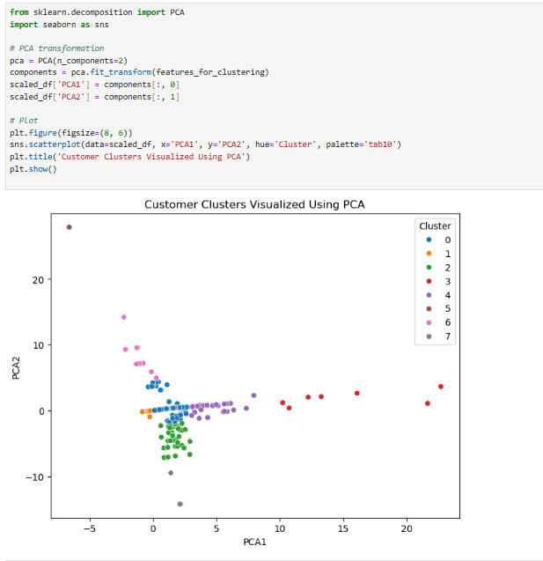

The PCA plot clearly displays:
Cluster separation is a sign of significant segmentation. Given their distance from the others, Clusters 3 and 5 represent distinct behaviour of extremely high-value customers. The comparatively centralised nature of Clusters 0, 1, 2, and 4 may reflect the more "typical" customer.
6.2 Predictive Modeling
A binary classification target variable (RepeatBuyer) was developed in order to recognise repeat buying behaviour. It shows if, throughout the dataset period, a customer made at least one additional purchase following their initial transaction. Four engineered customer-level features were used in the predictive modelling process:
TotalSpend: The sum of the purchases' monetary worth.
TotalQuantity: The total quantity of items bought.
PurchaseFrequency: The number of times a purchase was made.
CustomerPurchaseDays: The total number of different days that a customer made a purchase.
These characteristics serve as helpful predictors of repeat purchasing behaviour since they show customer engagement and purchase behaviour (Fader & Hardie, 2009).
Model Selection
Three models of classification were implemented and assessed:
Logistic Regression: Selected due to its ease of interpretation and ease of use in assessing the impact of features on the probability of an outcome.
Decision Tree Classifier: Chosen due to its clear predictions based on rules.
Random Forest Classifier: Used because of its great accuracy and resilience (Breiman, 2001).
Training (80%) and test (20%) sets of data were separated, and models were assessed using:
- Accuracy
- Precision
- Recall
- F1 Score
- ROC-AUC

Logistic Regression

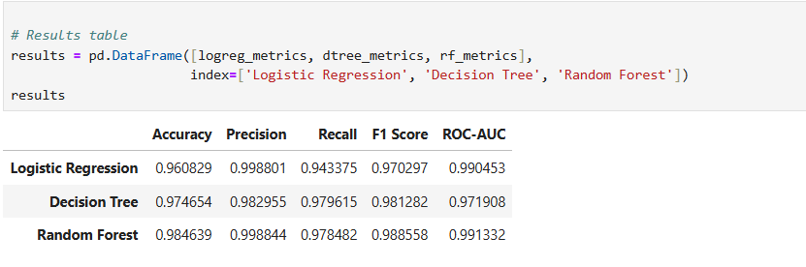

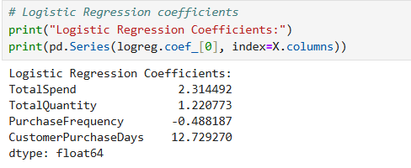

Interpretation: CustomerPurchaseDays was the best positive predictor of repeat behaviour, according to logistic regression. This suggests that customers are more likely to return the more days they spend interacting with the platform. While PurchaseFrequency showed a slight negative impact, maybe as a result of behavioural overlap or multicollinearity, TotalSpend and TotalQuantity were likewise positively correlated.

Decision Tree Classifier
Interpretation: In addition to providing excellent prediction performance, the Decision Tree classifier made it possible to comprehend model splits intuitively. The model used the same four customer-level attributes as inputs. The model is effective in detecting repeat customers with few false positives or false negatives, according to the performance measures, which show a good balance between precision and recall.

Random Forest Classifier
Interpretation: Out of the three models, the Random Forest model had the highest accuracy and ROC-AUC, demonstrating its ability to handle feature interactions and non-linear relationships.

ROC Curve Analysis
Plotting the True Positive Rate (TPR) versus the False Positive Rate (FPR) across various thresholds allows the ROC (Receiver Operating Characteristic) curve to assess model performance. Better class separation ability is shown by a model that is closer to the top-left corner of the plot and has a bigger Area Under the Curve (AUC).
The following AUC values were noted, as shown in Figure below
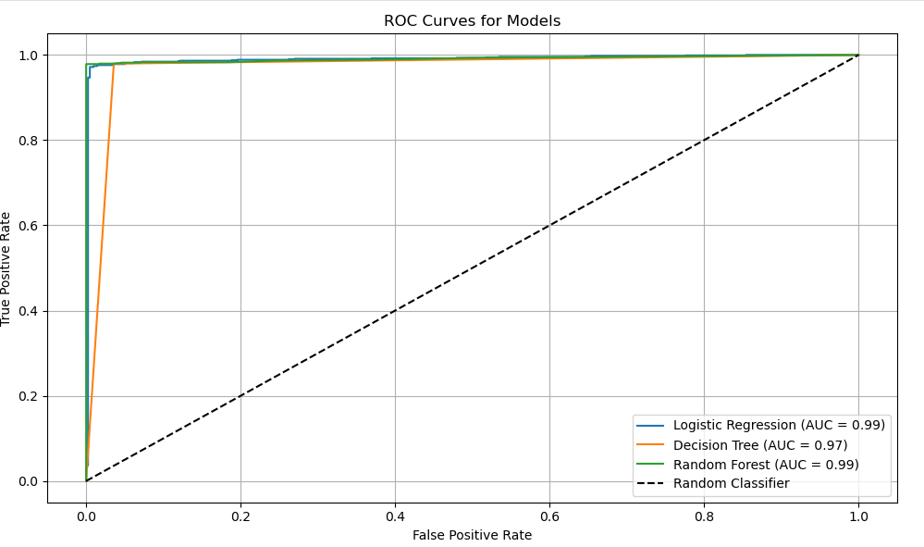

AUC for logistic regression is 0.99.
AUC for the decision tree is 0.97.
AUC for Random Forest: 0.99
Near-perfect classification performance was attained by Random Forest and Logistic Regression, while the Decision Tree also did well, however with a somewhat lower AUC. Strong predictive potential in identifying repeat purchasers was confirmed by the fact that all models performed significantly better than the random baseline (AUC = 0.50).

7. Findings
K-Means clustering and supervised learning were used in the analysis to examine customer buying patterns in the UCI Online Retail dataset. Key findings include:
Cluster Segmentation
Customers were properly divided into distinct behavioural categories using K-Means clustering (K=8).
- With a particularly large TotalSpend, high TotalQuantity, and extended engagement length, Cluster 3 represented high-value customers.
- In contrast, Cluster 5 had a high PurchaseFrequency but very low TotalSpend and Quantity, which may indicate one-time or short-term bulk purchases.
- Cluster 6, which represents possibly loyal mid-tier customers, displayed a reasonably high level of buying activity over several products and days.
PCA Visualisation
Clear cluster separation was shown by the PCA plot, which particularly highlighted Cluster 3's extreme. The notion that there are several kinds of buyers, from one-time buyers to devoted repeat customers, is supported by this.
Top Predictive Features
The following were the most significant predictors of repeat purchase from the supervised learning stage:
- TotalSpend (larger values indicate a greater chance of a repeat purchase)
- CustomerPurchaseDays (repeat behaviour is associated with more spread purchases)
Model Performance
- Overall, the Random Forest classifier produced effective classification scores and the highest AUC (0.99).
- With an AUC of 0.99, logistic regression also demonstrated strong performance and improved interpretability.
- Despite having a slightly lower AUC of 0.97, the Decision Tree model is still useful for rule-based segmentation.

References
Fader, P.S. and Hardie, B.G.S. (2009) ‘Probability models for customer-base analysis’, Journal of Interactive Marketing, 23(1), pp. 61–69.
McKinsey & Company (2021) The importance of customer retention in e-commerce. Available at: https://www.mckinsey.com
Martínez-Plumed, F., Contreras-Ochando, L., Ferri, C. and Hernández-Orallo, J., 2021. CRISP-DM Twenty Years Later: From Data Mining Processes to Data Science Trajectories. IEEE Transactions on Knowledge and Data Engineering, 33(8), pp.3048–3061.

