Mawlana Bhashani Science and Technology University

Lab-Report

Report No: 02

Course code: ICT-3110

Course title: Operating Systems Lab
Date of Performance :

Date of Submission : 15/09/2020

Submitted by Submitted to

Name: Zahid Hasan Chowdhury Nazrul Islam
ID:IT-18017 Assistant Professor
3rd year 1stsemester Dept. of ICT

Session: 2017-2018 MBSTU

Dept. of ICT

Experiment NO : 02

Experiment Name : Basic Command of Linux Operating System. Introduction :
- whoami : This command prints the username associated with the current effective user ID.

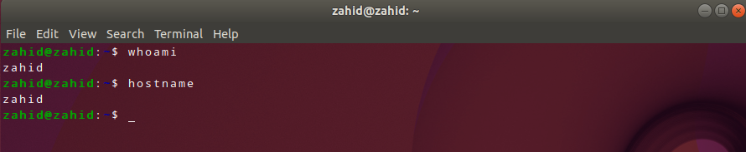

- hostname : The hostname command shows or sets the system hostname.

- pwd: hort for print working directory, pwd is a Linux, Unix, and FTP command to print the directory you're currently working in when at the command line.
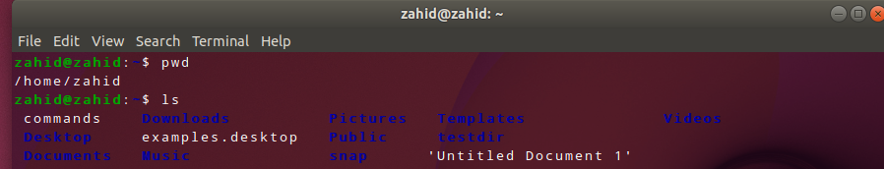

- ls : ls lists the files in the current working folder.

- ls -a: list all files including hidden file starting with '.'
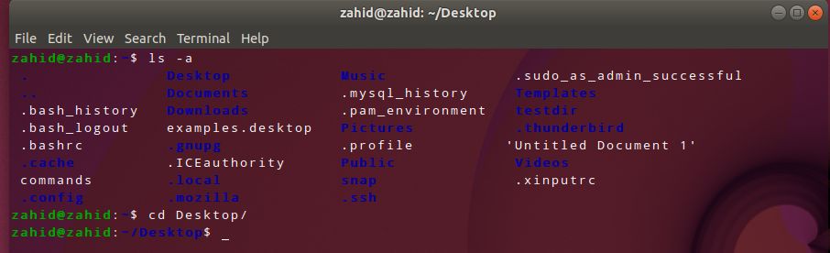

- cd: The cd command, which stands for "change directory", changes the shell’s current working directory .

- mkdir: The mkdir command creates new directories in your file system.
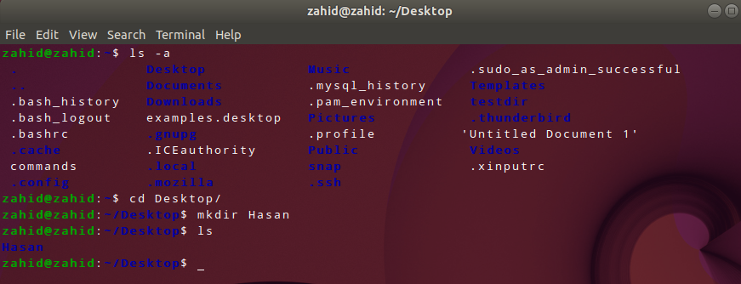

- rmdir: remove a directory.
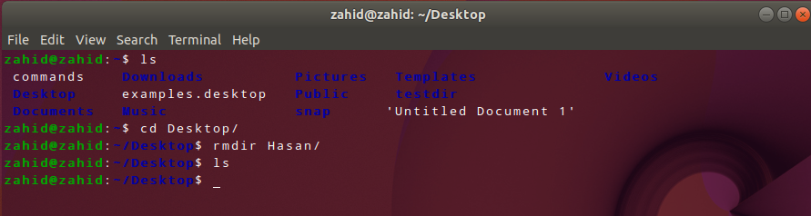

- rm -r: remove directory with its content.

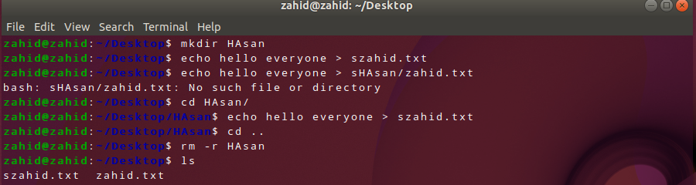

- gedit : Working with text editors: $ gedit ---> its an editor

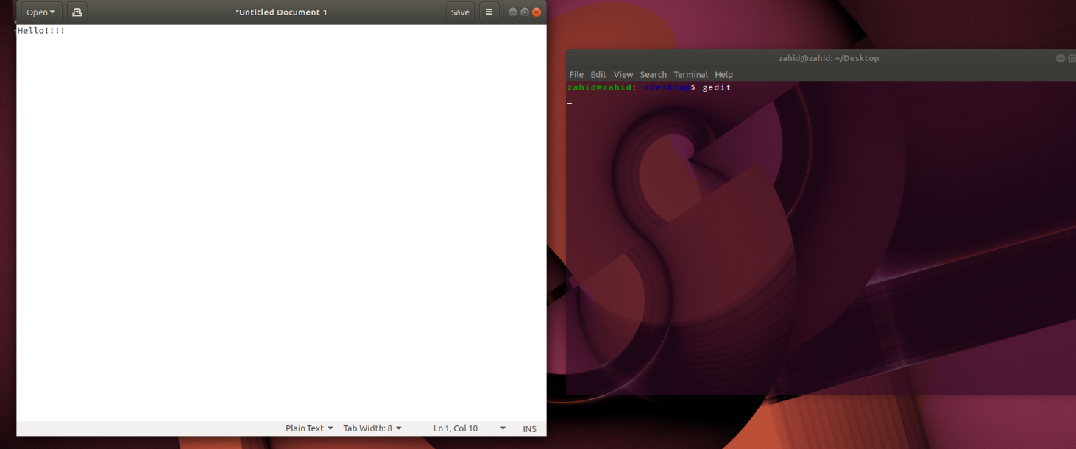
- cat: creates new file.
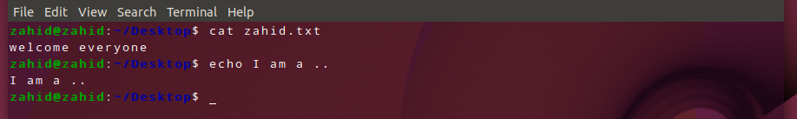

- echo: show something on the terminal.

- sudo: sudo (Super User DO) command in Linux is generally used as a prefix of some command that only superuser are allowed to run.
