

**North South University**

Department of Electrical & Computer Engineering

**Project Report**

Course Code : CSE327

Faculty Name: ABH3

Section: 04

Group Members:

1.Samiha Tasnim-1813211642

2.Zahid Hasan-1812578042

**Table of contents**

1. **Introduction**...........................................................................................**3**
2. **System Analysis**......................................................................................**3**
3. **Requirement Analysis**................................................................**3**
   * 1. **Roles/Users**
     2. **User stories for software requirement**
4. **Requirement Specification**........................................................**4**
   * 1. **Functional and non-functional requirements**
     2. **Requirements with details**...........................................**5**
        1. **Login/ Logout**
        2. **View post**
        3. **Add/Delete Post**
        4. **Edit/View profile**
        5. **Chat**
        6. **Help (Voice Based Artificial Intelligence)**
5. **Hardware and Software Specification**....................................................**.7**
6. **UML Diagram**……………………………………………………………………………..………..**8**
7. **Use case diagram**…………………………………………………………..………..**8**
8. **Class Diagram**………………………………………………………………………....**9**
9. **Sequence Diagram**…………………………………………………………..………**10**
10. **Conclusion**.................................................................................................**11**
11. **Bibliography**..............................................................................................**11**
12. **Appendices**................................................................................................**12**

**1.Introduction**

The era of mobile technology opens the window to the android application. So it’s the time to change form conventional websites to apps, which has become a part of our daily routine. Even we can communicate with the people all over the world by using this kind of applications. “INSBies.apk” is the kind of communicating application by which we can communicate, share posts, comment, get notifications, view others profile, edit our profiles. The application is mainly for the students and faculties of a student branch organization named IEEE NSU Student Branch. So only the students and faculties of this organization can have access on it. The students and also the faculty can use this application for interact with each others, can view profiles and edit their profiles, get updates and latest news about INSB.

**2.System Analysis**

* 1. **Requirement Analysis**

A requirement is a feature that must be included in the actual design and implementation, getting to know the system to be implemented is of prime importance. It is related to the users and focus on their demand.

So, we would have specify the users roles in this application.

**Roles/Users:**

INSB Members

|  |
| --- |
| * Student members * Faculty members |

**User stories for software requirement:**

**Students:**

As a student member of this organization I want the application to be helpful for interact with each other and easily get the updates, latest news and information of INSB.

**Faculties:**

As a faculty advisor of this organization I want the all the helpful information and activities easily.

* 1. **Requirement Specification**

|  |  |
| --- | --- |
| **Functional Requirements** | **Non-Functional Requirements** |
| * Login with gmail * Logout * Reset Password * Add post * View Post * View all users * View users profile * Chat * Edit profile * Voice based help option | * Delete post * View users post * Online status * Time of add post |

* 1. **Requirements with details**

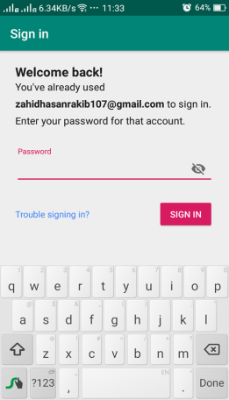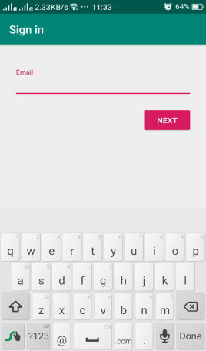**Login/ Logout :**

|  |
| --- |
| Only the IEEE members of the branch can log in or access to the app by their gmail which will be in our application database. The login/logout system is based on firebase authentication. |

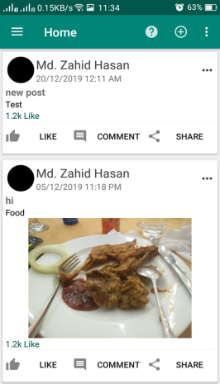**View post:**

|  |
| --- |
| Users can view any post in their Newsfeed. The user can see the post and also can view the person who add the post. |

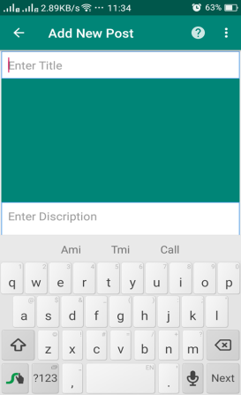

**Add/Delete Post:**

|  |
| --- |
| The user can add any post which maybe relate to image or text. For the delete option only the person who add can delete the post at anytime. |

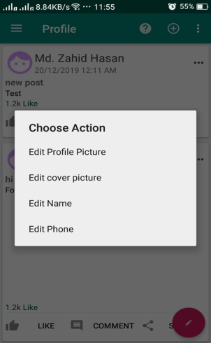**Edit/View profile:**

|  |
| --- |
| Only the user can edit his/her profile by changing profile picture, cover photo, name, email,contact no. ,position, address and major. |

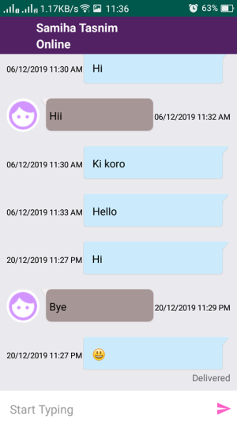

**Chat:**

|  |
| --- |
| There is a chat option by which the users can communicate with each other. One user can text other user and they can text each other. |

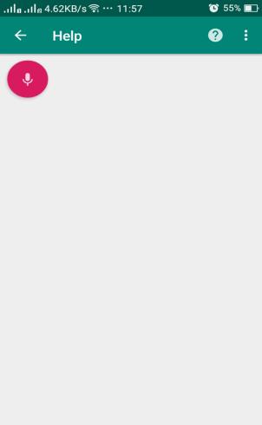

**Help (Voice Based Artificial Intelligence):**

|  |
| --- |
| The application has a help option based on artificial intelligence. The user can ask some specific questions related to IEEE by sending voice message and the help option would answer them properly. |

1. **HARDWARE AND SOFTWARE SPECIFICATION**

**Hardware Specification Processor:**

|  |
| --- |
| **Intel P-IV based system processor speed :** 250MHz to 833MHz  **RAM :** 512MB  **Hard Disk :** 8GB to 30GB |

**Software Processor:**

|  |
| --- |
| **Language :** JAVA  **Technologies :** Android  **Database :** Firebase real time database  **Operating System : Android** |

**4.UML Diagrams:**

**4.1 Use Case Diagram:**

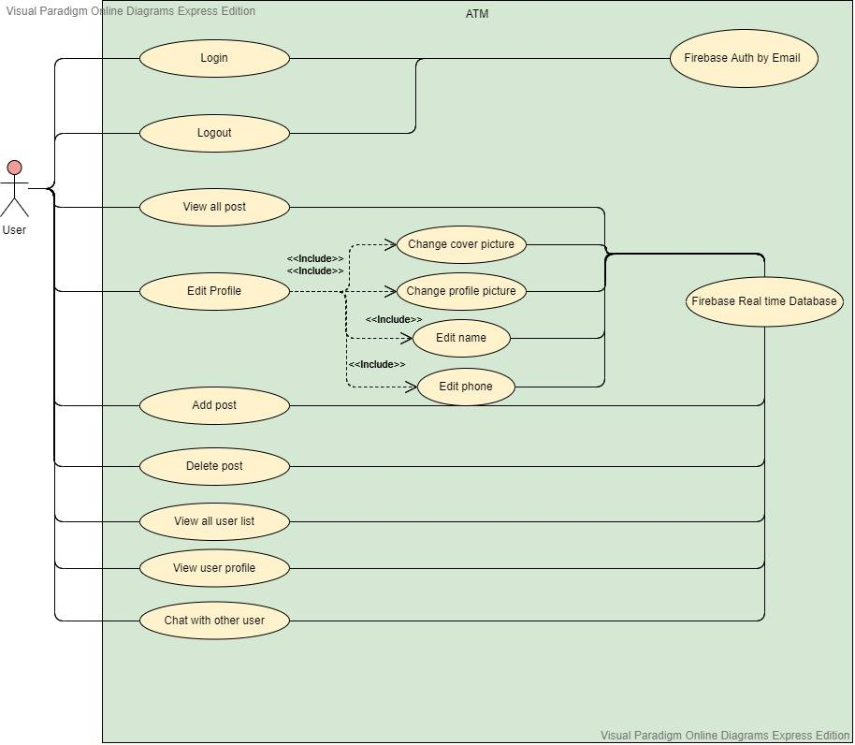

**4.2 Class Diagram**

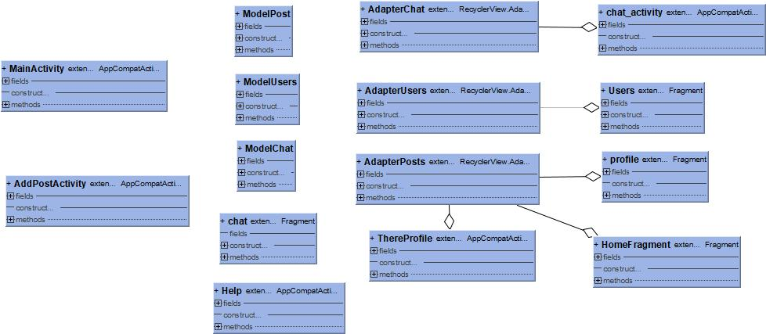

**4.3 Sequence Diagram:**

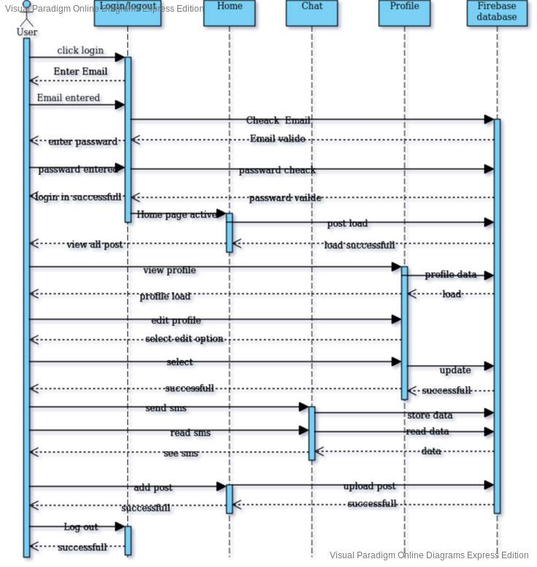

**5.Conclusion:**

This Project was a great opportunity for us to discover new ideas and ways of working in android applications. We started the project with no clear objective, and our main goal at the beginning was to build a communication based android application. Therefore, we were very glad to be able to finally produce a complete and working application. Moreoverthis atmosphere in which we worked clearly motivated us to try new things and gave us the ideas that was needed for such a project.

**6. Bibliography:**

1. <https://firebase.google.com/docs/auth/android/email-link-auth>
2. <https://developer.android.com/>
3. <https://firebase.google.com/docs/auth/android/firebaseui>
4. <https://developer.android.com/studio/releases/gradle-plugin>
5. **Appendices**

What kind of login system do you need?

* Login with Facebook
* Login with Google account
* Login with Gmail

What are the information do you want to show other users in your profile?

* Name
* Contact No.
* Address

What kind of help (AI based) option do you need?

* Text Based
* Voice Based

Do you want the option to permit other users to comment in your post?

* Yes
* No

Do you want the users to text you anytime when you are online?

* Yes
* No

Do you want the delete option for texts in chat?

* Yes
* No

Do you want the option to permit other users share your post?

* Yes
* No