Personal Notes

Model selection
- For production, I’d choose Claude Sonnet 4 models for agentic recommendation solution (…however, I used gpt-4o-mini for coding scenario, since I already had the API subscription for it – but the notes are prepared for actual production case)
- [Might consider using Claude Opus 4 (…probably overkill)]
- Pros:
  - Up to 1M tokens (custom rate or Tier 4 limit)
  - Constitutional AI (Anthropic focuses on ethical AI safety)
  - Opting out of data retention possible using Zero Data Retention (ZDR) Agreement (check point 5)
  - Model can remain focused on multi-step tasks for over 30 hours!
- Cons:
- Bit expensive compared to other models ($3 per million input tokens and $15 per million output tokens)
- Overcautious at times (may be considered a pro for Scenario 1)
- https://privacy.claude.com/en/articles/7996868-is-my-data-used-for-model-training
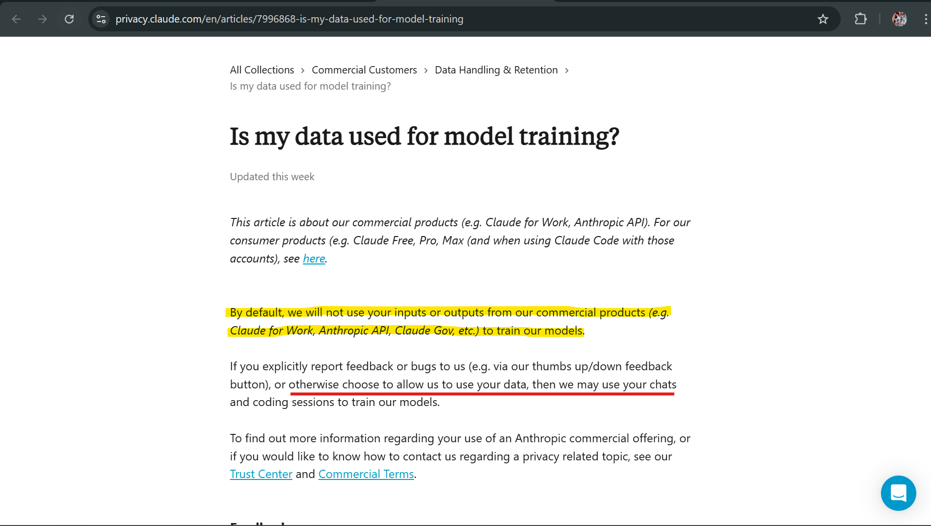

Agentic workflow selection
- Next, I am selecting CrewAI framework for multi-agent orchestration (…could’ve chosen some other framework (…like AutoGen) but due to time constraints going with CrewAI for now)
- Pros:
  - Allows memory for retaining conversation history per invocation i.e. crew.kickoff()
  - Debugging is extremely easy using tool/tracing logs on terminal
  - High throughput (is tested under many real-world operations – “Flows currently run 12M+ executions/day for industries from finance to federal to field ops”)
  - Easy scaling for adding new tasks and requirements
  - Internal delegation possible between different agents
- Cons:
  - Code might get complicated and hard to understand as CrewAI relies upon different agents and those agents have different backstories, tasks, roles, etc.
  - Due to above point, switching frameworks becomes harder later as CrewAI uses it’s own internal tools (like vision_tool)
  - No control over delegation (if set to True) – might make prompting + trial & error bit challenging

Assumptions for simulation
- Using gpt-4o-mini instead of Claude models (mentioned above)
- Data

