Rule Quiz



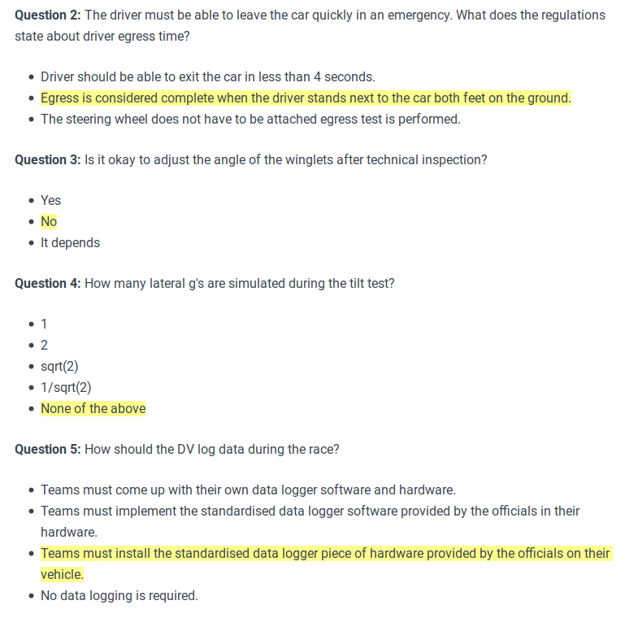

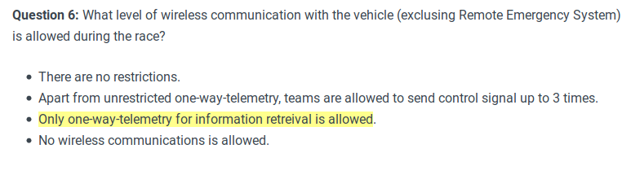
Pseudocode for A* algorithm

// A* (star) Pathfinding// Initialize both open and closed list
let the openList equal empty list of nodes
let the closedList equal empty list of nodes// Add the start node
put the startNode on the openList (leave it's f at zero)// Loop until you find the end
while the openList is not empty // Get the current node
let the currentNode equal the node with the least f value
remove the currentNode from the openList
add the currentNode to the closedList // Found the goal
if currentNode is the goal
Congratz! You've found the end! Backtrack to get path // Generate children
let the children of the currentNode equal the adjacent nodes

for each child in the children // Child is on the closedList
if child is in the closedList
continue to beginning of for loop // Create the f, g, and h values
child.g = currentNode.g + distance between child and current
child.h = distance from child to end
child.f = child.g + child.h // Child is already in openList
if child.position is in the openList's nodes positions
if the child.g is higher than the openList node's g
continue to beginning of for loop // Add the child to the openList
add the child to the openList

Source Code (in Python)

class Node():
"""A node class for A* Pathfinding"""

def __init__(self, parent=None, position=None):
self.parent = parent
self.position = position

self.g = 0
self.h = 0
self.f = 0

def __eq__(self, other):
return self.position == other.position

def astar(maze, start, end):
"""Returns a list of tuples as a path from the given start to the given end in the given maze"""

# Create start and end node
start_node = Node(None, start)
start_node.g = start_node.h = start_node.f = 0
end_node = Node(None, end)
end_node.g = end_node.h = end_node.f = 0

# Initialize both open and closed list
open_list = []
closed_list = []

# Add the start node
open_list.append(start_node)

# Loop until you find the end
while len(open_list) > 0:

# Get the current node
current_node = open_list[0]
current_index = 0
for index, item in enumerate(open_list):
if item.f < current_node.f:
current_node = item
current_index = index

# Pop current off open list, add to closed list
open_list.pop(current_index)
closed_list.append(current_node)

# Found the goal
if current_node == end_node:
path = []
current = current_node
while current is not None:
path.append(current.position)
current = current.parent
return path[::-1] # Return reversed path

# Generate children
children = []
for new_position in [(0, -1), (0, 1), (-1, 0), (1, 0), (-1, -1), (-1, 1), (1, -1), (1, 1)]: # Adjacent squares

# Get node position
node_position = (current_node.position[0] + new_position[0], current_node.position[1] + new_position[1])

# Make sure within range
if node_position[0] > (len(maze) - 1) or node_position[0] < 0 or node_position[1] > (len(maze[len(maze)-1]) -1) or node_position[1] < 0:
continue

# Make sure walkable terrain
if maze[node_position[0]][node_position[1]] != 0:
continue

# Create new node
new_node = Node(current_node, node_position)

# Append
children.append(new_node)

# Loop through children
for child in children:

# Child is on the closed list
for closed_child in closed_list:
if child == closed_child:
continue

# Create the f, g, and h values
child.g = current_node.g + 1
child.h = ((child.position[0] - end_node.position[0]) ** 2) + ((child.position[1] - end_node.position[1]) ** 2)
child.f = child.g + child.h

# Child is already in the open list
for open_node in open_list:
if child == open_node and child.g > open_node.g:
continue

# Add the child to the open list
open_list.append(child)

def main():

maze = [[0, 0, 0, 0, 1, 0, 0, 0, 0, 0],
[0, 0, 0, 0, 1, 0, 0, 0, 0, 0],
[0, 0, 0, 0, 1, 0, 0, 0, 0, 0],
[0, 0, 0, 0, 1, 0, 0, 0, 0, 0],
[0, 0, 0, 0, 1, 0, 0, 0, 0, 0],
[0, 0, 0, 0, 0, 0, 0, 0, 0, 0],
[0, 0, 0, 0, 1, 0, 0, 0, 0, 0],
[0, 0, 0, 0, 1, 0, 0, 0, 0, 0],
[0, 0, 0, 0, 1, 0, 0, 0, 0, 0],
[0, 0, 0, 0, 0, 0, 0, 0, 0, 0]]

start = (0, 0)
end = (7, 6)

path = astar(maze, start, end)
print(path)

if __name__ == '__main__':
main()

Source: https://medium.com/@nicholas.w.swift/easy-a-star-pathfinding-7e6689c7f7b2

