# Assignment 1

**Name: Zahiduzzaman Anik**

**ID: 1632091942**

**Section: 10**

**LECTURE1**

Activity1:

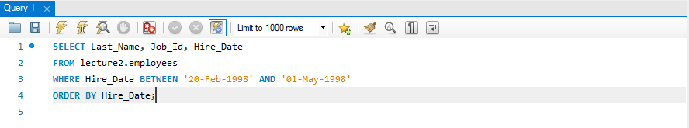

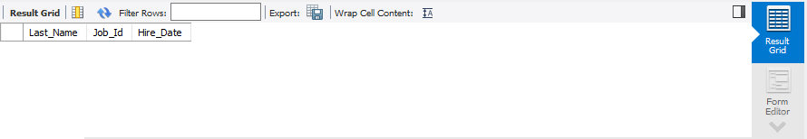

Activity2:

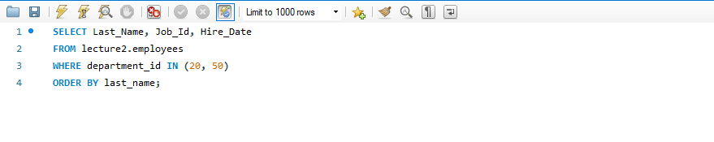

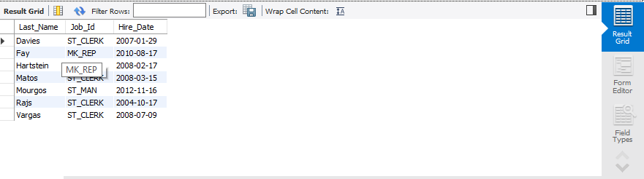

**LECTURE 2**

Activity1:

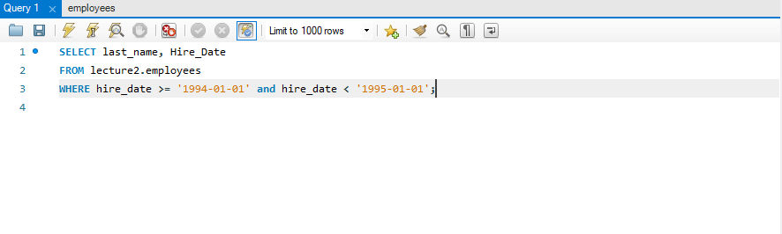

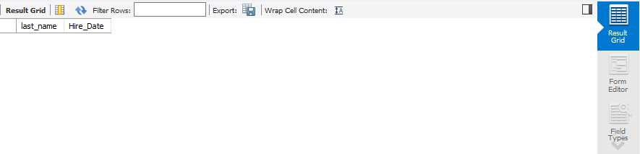

Activity2:

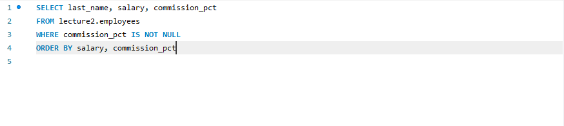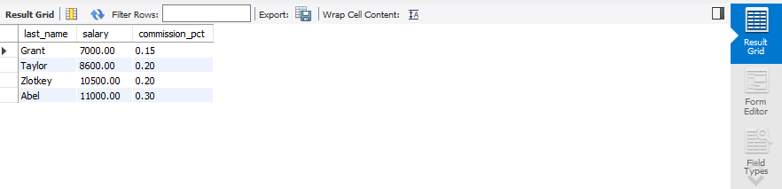

Activity3:

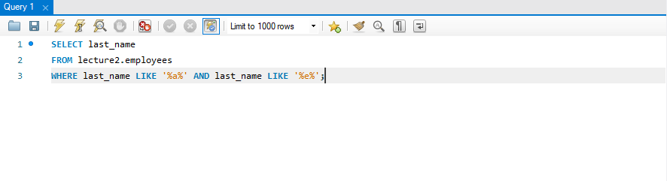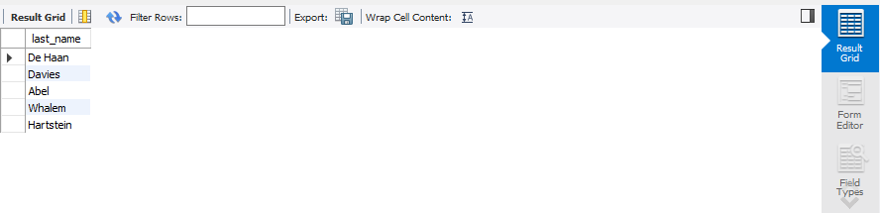

SCHEMA – TABLE :

