**UNIVERSITI MALAYSIA TERENGGANU**

**CSM3103 FRONT-END PROGRAMMING (K1)**

**BACHELOR OF COMPUTER SCIENCE (MOBILE COMPUTING) WITH**

**HONORS**

**LAB 4**

# SEMESTER II 2023/2024

**Prepared for:**

DR. RABIEI B MAMAT

**Prepared by:**

MUHAMMAD ZAHIER BIN RAZMI

(S67943)

Task 1:

Output:

1.

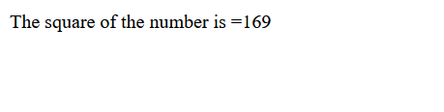

2.

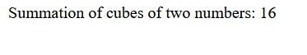

3.

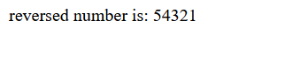

4.

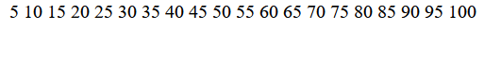

Task 2:

Output:

1.summation of 5 and 10



2. 2 to the power 5

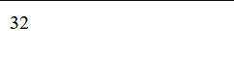

Task 3:

Output:

1.

2.

3.

Task 4:

Output:

1.

*when hovered:



*when clicked:



*when double clicked:

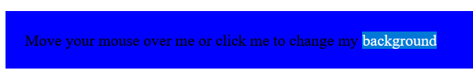

*when mouse is out:

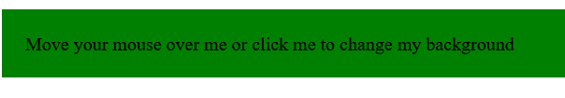

2.

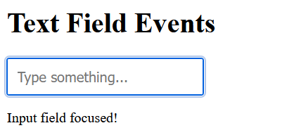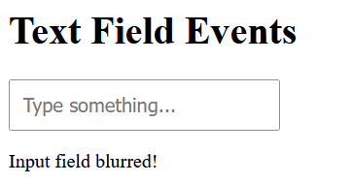

Task 5:

Output:

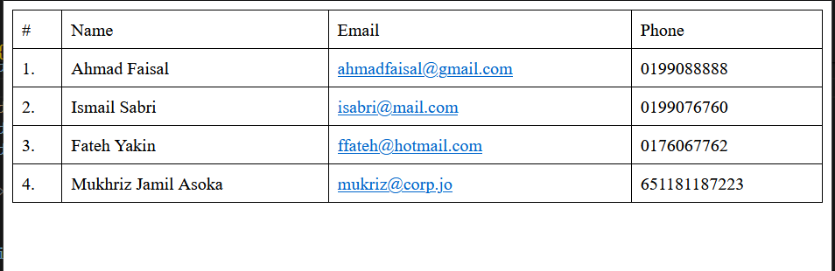

*when row clicked

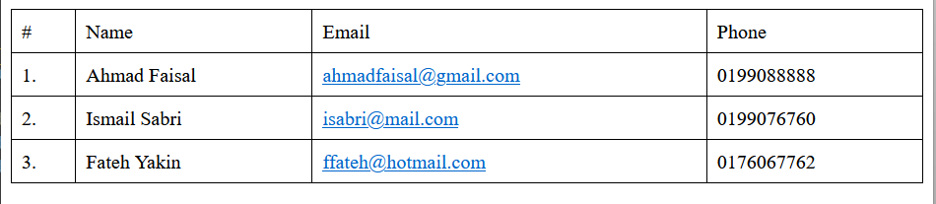

Task 6:

Output:

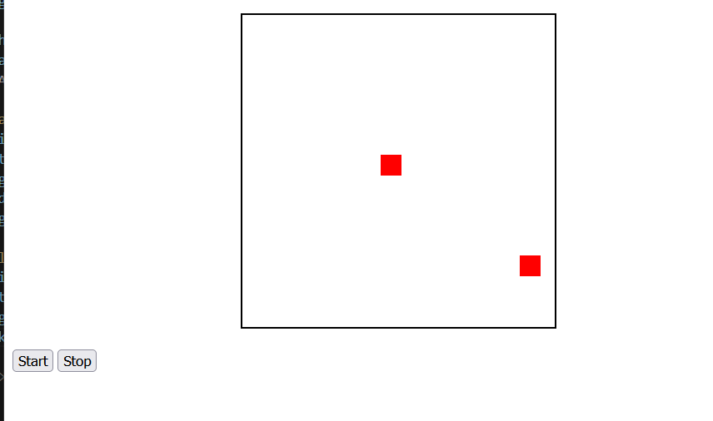

Github link:

<https://github.com/ziqmunk/CSM3103/tree/ffa44906e4c6e995adfe2507c6a9091b4e6e6c88/S67978%20-%20Lab4>