**UNIVERSITI MALAYSIA TERENGGANU**

**CSM3103 FRONT-END PROGRAMMING (K1)**

**BACHELOR OF COMPUTER SCIENCE (MOBILE COMPUTING) WITH** **HONORS**

**LAB 5**

# SEMESTER II 2023/2024

**Prepared for:**

DR. RABIEI B MAMAT

**Prepared by:**

MUHAMMAD ZAHIER BIN RAZMI

(S67943)

Task 1:

1. What is the id of button and input field

Dropdown list id = color_selector

Button id = button_change

1. What happened when you clicked change button and why?

All the related color text change color to color opted from the dropdown list.

Output:

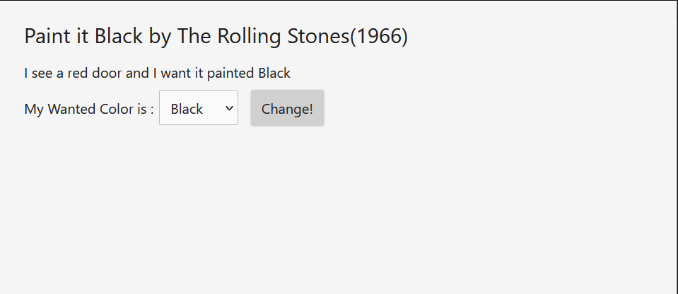 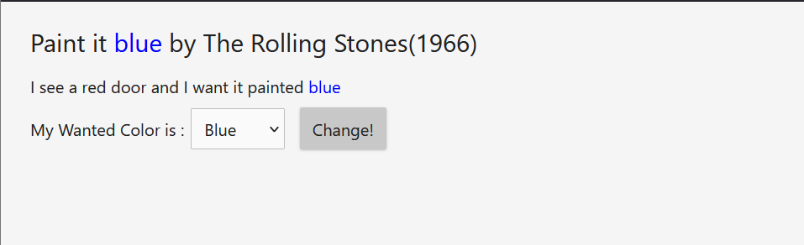

Task 2:

Output:

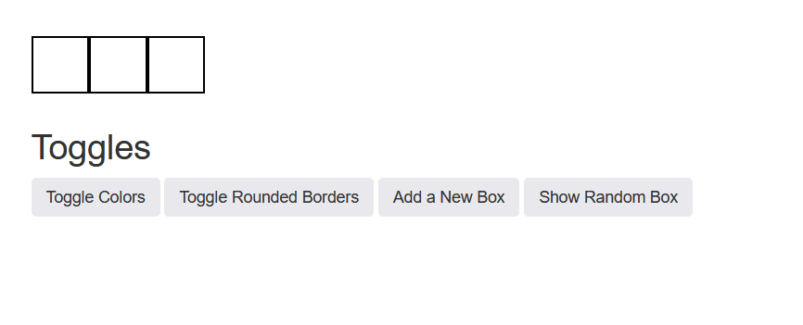

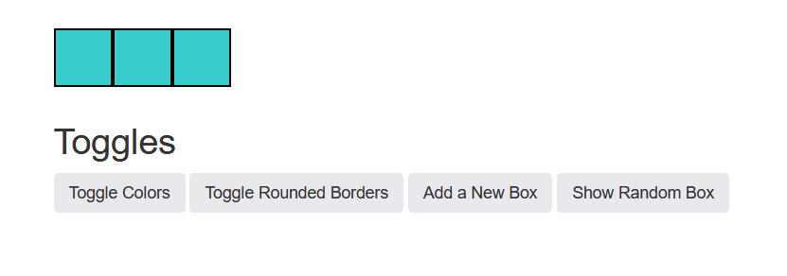

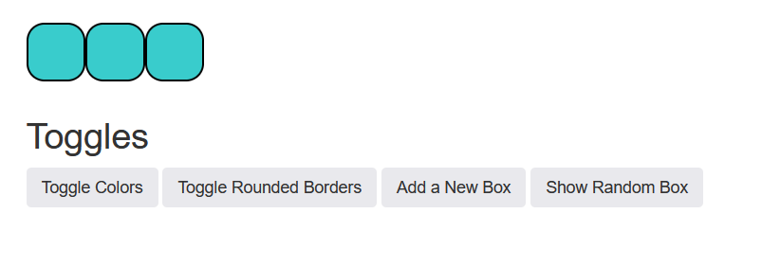

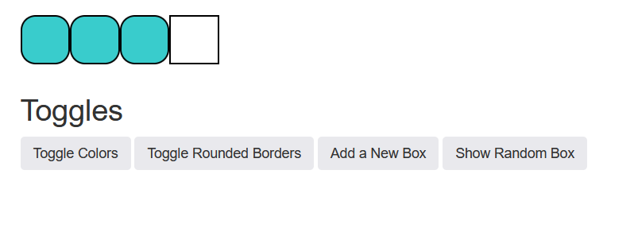

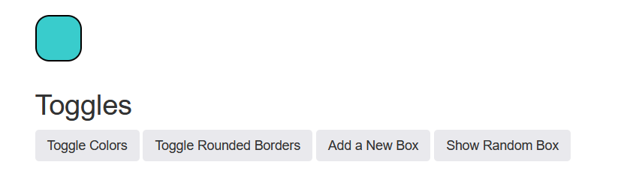

Task 3:

Output:

Task 4:

Output:

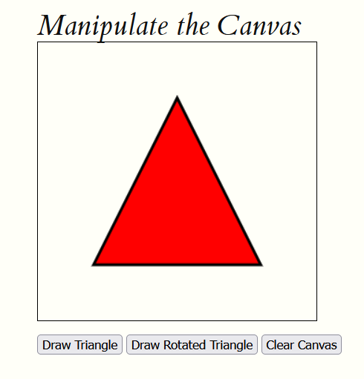

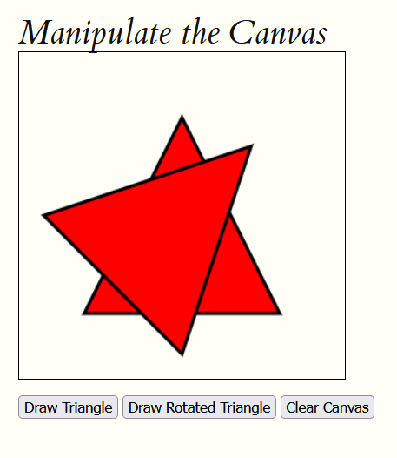

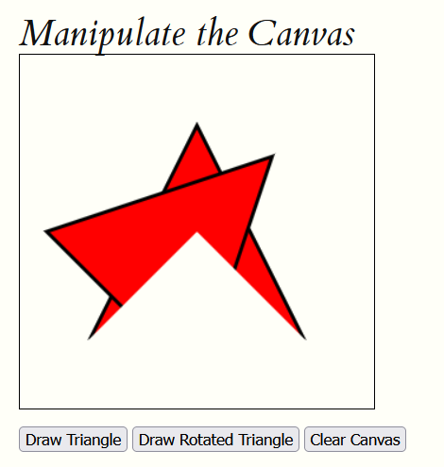

Github repositories:

https://github.com/Zahier98/S67943_CSM3103_Lab5