**UNIVERSITI MALAYSIA TERENGGANU**

**CSM3103 FRONT-END PROGRAMMING (K1)**

**BACHELOR OF COMPUTER SCIENCE (MOBILE COMPUTING) WITH** **HONORS**

**LAB 6**

# SEMESTER II 2023/2024

**Prepared for:**

DR. RABIEI B MAMAT

**Prepared by:**

MUHAMMAD ZAHIER BIN RAZMI

(S67943)

Task 1:

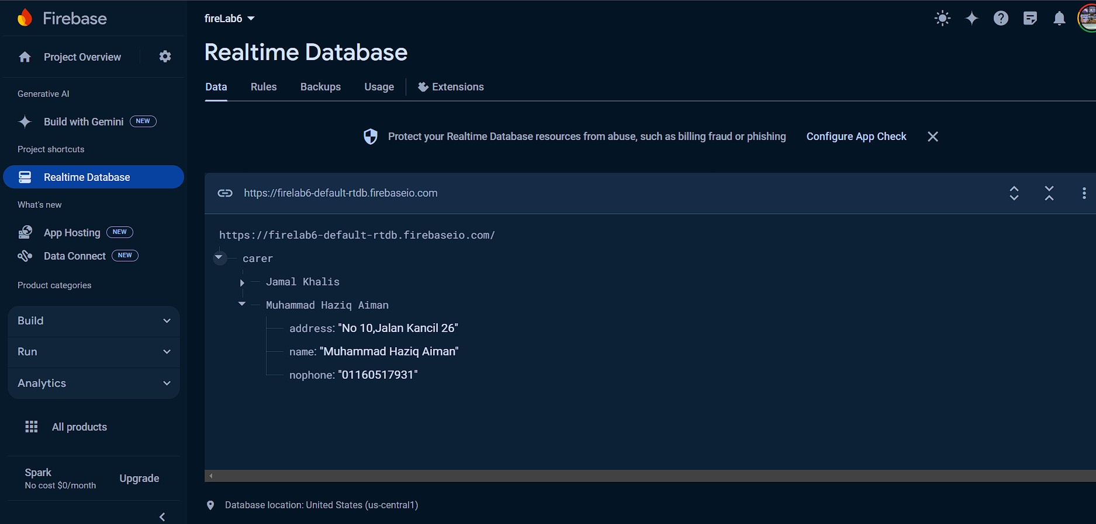

Task 2:

Output:

Input data to database:

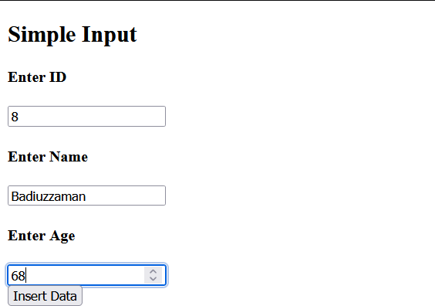

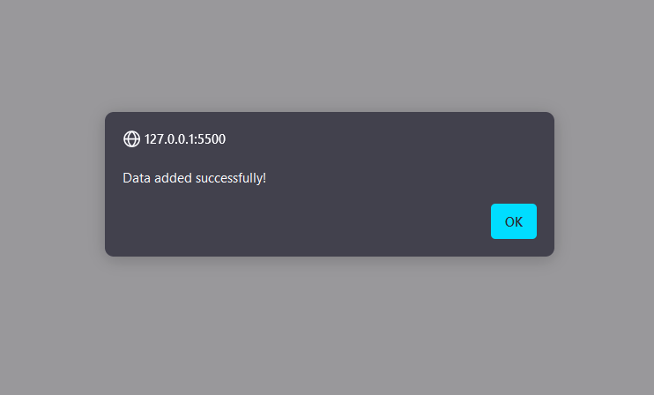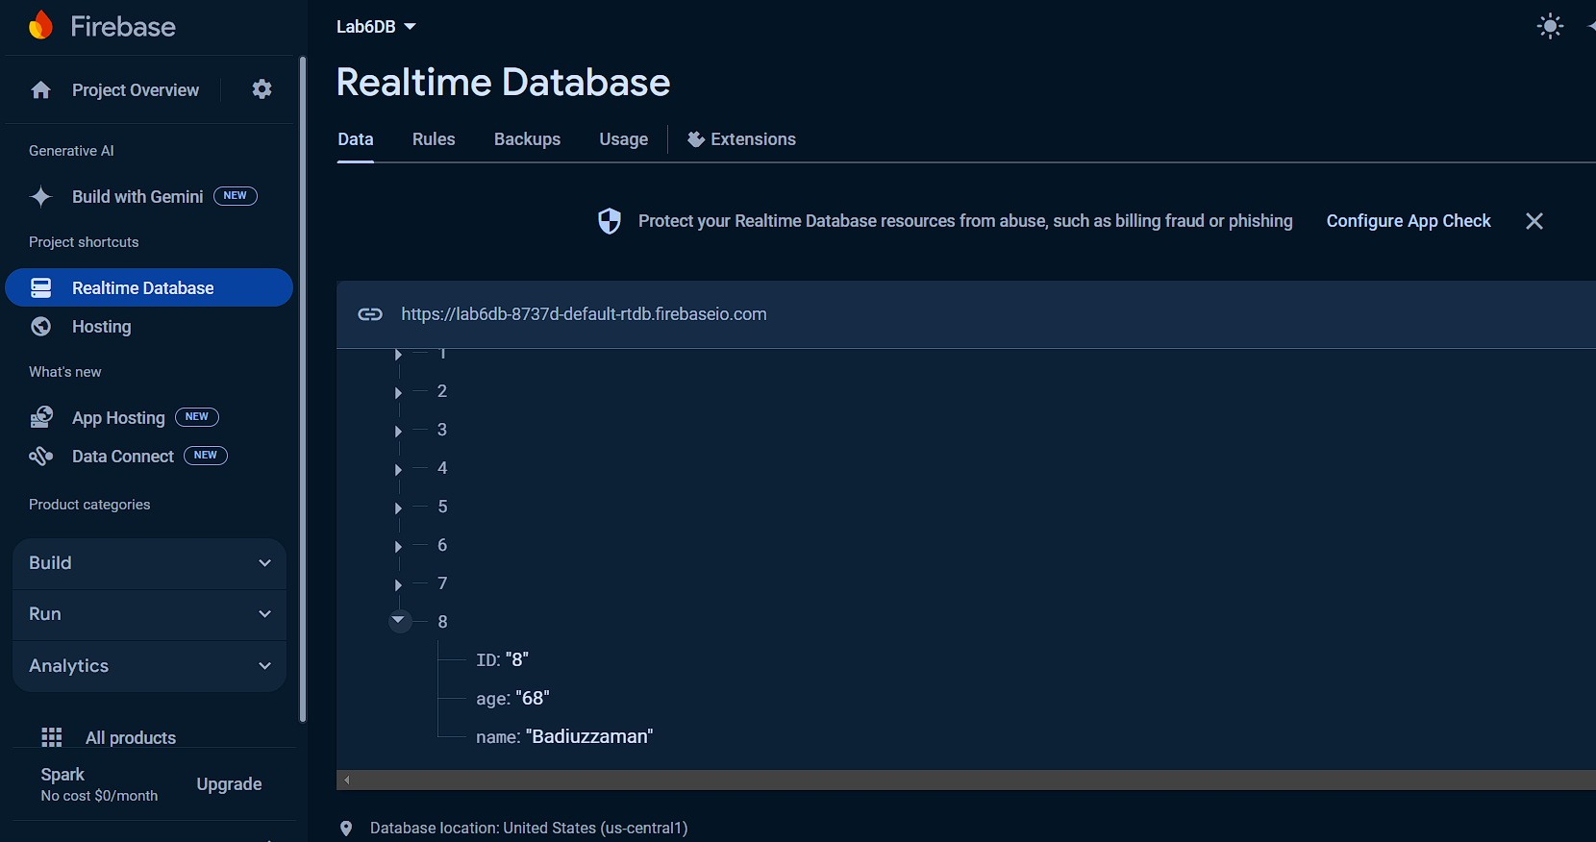

Delete data from database:

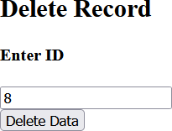

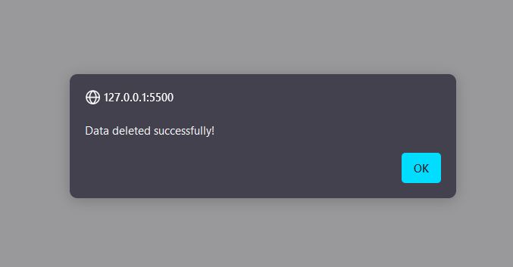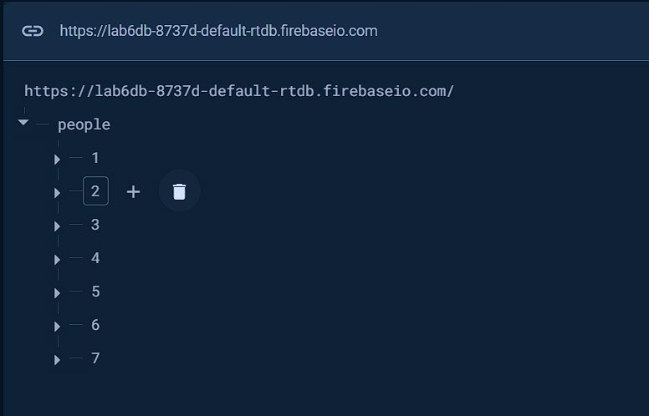

Task 3: Output: Register Page:

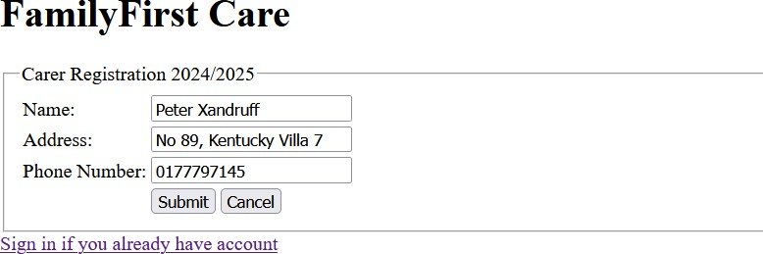

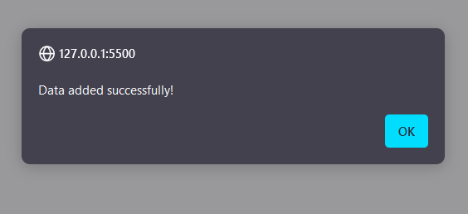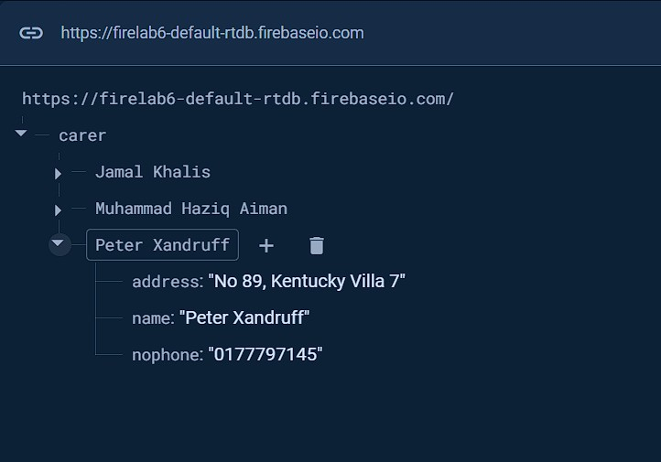

Login Page:

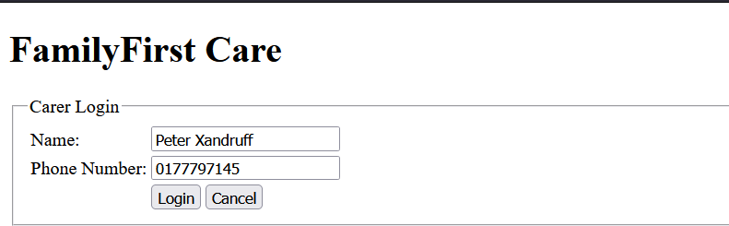

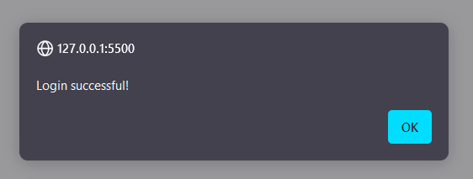

User list page:

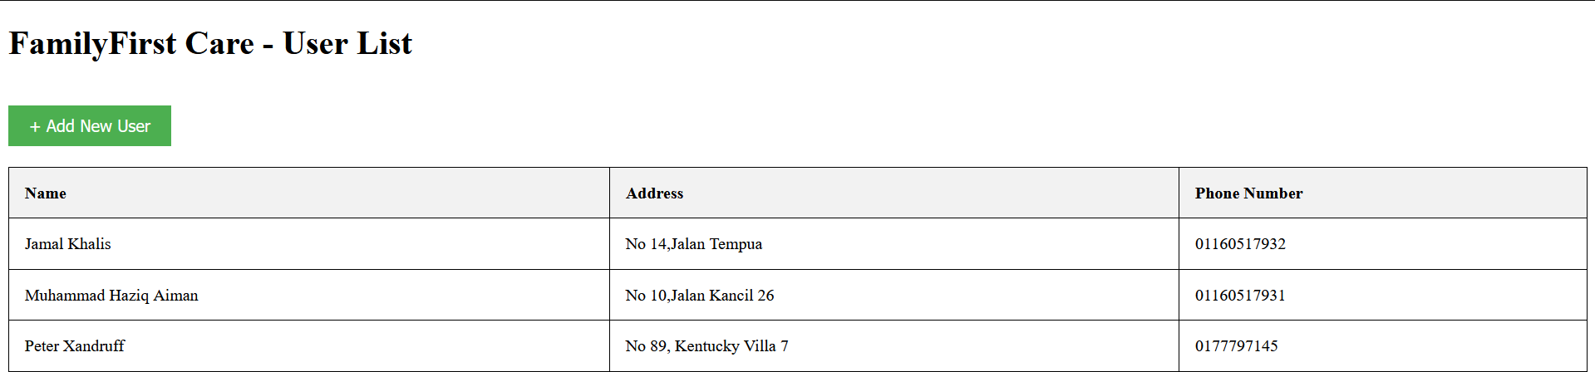

Github repositories:

https://github.com/Zahier98/S67943_CSM3103_Lab6