Given Graph:

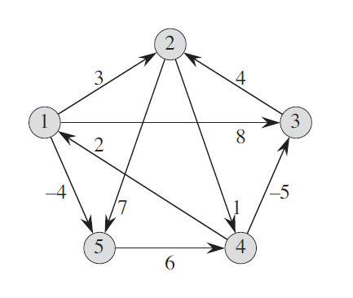
GRAPH INPUT:
 | 1 | 2 | 3 | 4 | 5
1 | 0 | 3 | 8 | INF | -4
2 | INF | 0 | INF | 1 | 7
3 | INF | 4 | 0 | INF | INF
4 | 2 | INF | -5 | 0 | INF
5 | INF | INF | INF | 6 | 0

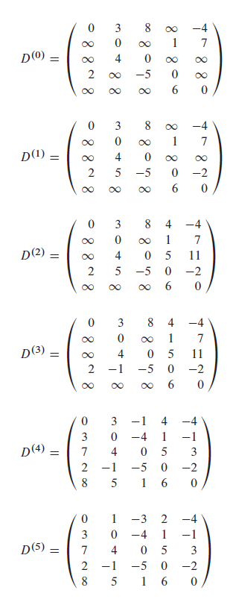
OUTPUT:

