Garment’s Inventory Management System

OVERVIEW: What We’ll Build

Modules in Our System:

1.Authentication (Login + Roles)
2.Product + Variants
3.Raw Materials
4.Suppliers + Purchases
5.Production Orders
6.Stock Management
7.Sales Orders
8.Reports

1,Authentication (Login + Roles)

Purpose:
Control who can access what. This protects your data and ensures the right people can do the right things.

Features:
- User Registration & Login
- Password encryption (e.g., using BCrypt)
- JWT-based authentication (for stateless security)
- Role-based access:
  - ADMIN – Full access
  - STORE_MANAGER – Access to stock & materials
  - PRODUCTION_OFFICER – Access to production orders
  - SALES_OFFICER – Access to customer orders

2.Product + Variants

Purpose:
Manage the finished garments your factory produces.

Features:
- Add/edit/delete products: e.g., "Shirt", "Pant", "Saree"
- Define variants for each product (size, color, fabric)
- Generate or assign SKUs (unique identifiers)
- Track quantity per variant
- Attach product images (optional)

Connected To:
- Production Orders (produces variants)
- Sales Orders (sells variants)
- Stock Management (manages quantity)

Raw Materials

Purpose:
Track the ingredients used in production, like fabric, threads, buttons, etc.

Features:
- Add new raw materials
- Update stock (e.g., when purchases arrive or items are used)
- Define units (e.g., meters, kg, pieces)
- Set minimum stock level and trigger alerts
- Categorize materials (e.g., fabric, accessories, chemicals)
Connected To:
- Suppliers + Purchases (adds stock)
- Production Orders (reduces stock)

. Suppliers + Purchases

Purpose:
Manage the materials you buy from external suppliers.

Features:
- Add/manage supplier profiles
- Create and track Purchase Orders (POs)
- Record material receipts (Goods Received Notes)
- Automatically update raw material stock when received
- View purchase history by supplier or material

Connected To:
- Raw Materials (stock increases after receiving)
- Reports (track spending)

Production Orders

Purpose:
Track the garments being made from raw materials.

Features:
- Create production jobs (e.g., "Make 100 Large Red Cotton Shirts")
- Assign raw materials to each job
- Update job status: CREATED, IN_PROGRESS, COMPLETED
- When job is completed, update finished goods stock
- Track how much material was used per job

Connected To:
- Raw Materials (consumes stock)
- Product Variants (produces stock)

6. Stock Management

Purpose:
Real-time tracking of how much inventory you have — both raw materials and finished products.

Features:
- Monitor current stock levels
- Transfer stock between warehouses (if multi-location)
- Handle stock adjustments (damaged, returned, stolen)
- Show alerts for low stock

Connected To:
- Raw Materials + Product Variants
- Reports (inventory valuation, fast/slow moving items)

7.Sales Orders

Purpose:
Record and manage orders from customers (wholesale or retail).

Features:
- Add customer orders (with items, quantities, price)
- Automatically deduct stock from product variants
- Generate invoice
- Track order status: PENDING, DELIVERED, CANCELLED
- Associate order with customer

Connected To:
- Product Variants (reduces stock)
- Reports (sales summary, revenue, etc.)

8. Reports

Purpose:
Give you insights about your garments business — like a factory manager’s dashboard.

Features:
Stock Summary (raw materials + finished goods)
- Purchase Reports (by supplier, time period)
- Production Reports (pending jobs, completed)
- Sales Reports (top-selling products, customers)
- Alerts (low stock, overdue POs or jobs)

Connected To:
All modules — pulls data from across the system.

How They Work Together (Mini Flow Example):
- You buy raw materials → Materials come in → Raw material stock increases
- You create a production order → Materials used → Finished goods produced → Raw stock decreases, finished stock increases
- You get a customer order → System checks stock → Deducts quantity → Generates invoice
- Reports show your sales, inventory levels, and material usage.

Design

com.garments.inventory
├── domain → Business entities (no Spring)
├── application → Services + Interfaces + DTOs
├── infrastructure → Controllers, JPA Repos, Entity classes
├── config → BeanConfig, SecurityConfig, etc.
└── GarmentsInventoryApp → Main Spring Boot class

Domain

1.Product.java
public class Product {
private UUID id;
private String name;
private String category;
private List<Variant> variants;
}

2,Variant.java

public class Variant {
private UUID id;
private UUID productId;
private String size;
private String color;
private String fabric;
private int quantity;
}

3.RawMaterial.java

public class RawMaterial {
private UUID id;
private String name;
private String unit; // e.g. meters, kg
private int currentStock;
private int reorderLevel;
}

4.ProductionOrder.java

public class ProductionOrder {
private UUID id;
private UUID productVariantId;
private int quantity;
private String status; // CREATED, IN_PROGRESS, COMPLETED
}

6.SalesOrder.java
public class SalesOrder {
private UUID id;
private String customerName;
private List<SalesItem> items;
private double totalAmount;
private String status; // CONFIRMED, DELIVERED
}

Application

- ProductService.java
- RawMaterialService.java
- ProductionService.java
- DTOs: ProductDTO, VariantDTO, SalesOrderDTO

Infrastructure

🧾Controllers
- ProductController.java
- SalesController.java

JPA Entity Classes
- ProductJpaEntity, VariantJpaEntity
- SalesOrderJpaEntity, etc.

Repositories
- Spring JpaRepository interfaces (e.g. ProductJpaRepository)
- Adapters that implement the domain's repository interfaces

CONFIGURATION LAYER

BeanConfig.java

DATABASE (PostgreSQL) TABLES
Table | Description
products | List of garments
variants | Size/color/fabric variations
raw_materials | Fabric, buttons, threads
suppliers | Raw material suppliers
purchases | Purchase orders
purchase_items
production_orders | Tracks ongoing jobs
Sales_items
sales_orders | Final product customer orders
..

1.products
Stores high-level info about a garment type (e.g., T-Shirt)
Field | Type | Description
id | UUID (PK) | Unique product ID
name | TEXT | Product name
category | TEXT | Men/Women/Kids/Unisex
description | TEXT | Optional longer description
created_at | TIMESTAMP | Date of creation

2. variants
Variants of a product — by size, color, fabric, etc.
Field | Type | Description
id | UUID (PK) | Unique variant ID
product_id | UUID (FK) | References products(id)
size | TEXT | Size (S, M, L, XL, etc.)
color | TEXT | Color name (e.g., Red)
fabric | TEXT | Fabric type (e.g., Cotton)
quantity | INTEGER | Current stock level
sku | TEXT | Stock Keeping Unit (e.g., "TS-RED-M")
created_at | TIMESTAMP | Date of creation

3.raw_materials
Inventory of fabric, thread, buttons, zippers, etc.
Field | Type | Description
id | UUID (PK) | Unique ID
name | TEXT | Material name
unit | TEXT | e.g., meter, kg, piece
current_stock | INTEGER | How much is currently in stock
reorder_level | INTEGER | Alert threshold
category | TEXT | e.g., fabric, accessory
created_at | TIMESTAMP | Date of entry

4. suppliers
Stores information about raw material suppliers.
Field | Type | Description
id | UUID (PK) | Unique supplier ID
name | TEXT | Supplier name
email | TEXT | Email address
phone | TEXT | Contact number
address | TEXT | Location/address
created_at | TIMESTAMP | Registration date

5. purchases
Purchase orders made to suppliers.
Field | Type | Description
id | UUID (PK) | Purchase order ID
supplier_id | UUID (FK) | References suppliers(id)
order_date | DATE | When the order was placed
status | TEXT | CREATED, RECEIVED, CANCELLED
total_amount | DECIMAL | Sum of all material costs
created_at | TIMESTAMP | Record creation date

6. purchase_items
Items inside each purchase order (many-to-one with purchases)
Field | Type | Description
id | UUID (PK) | Unique line item ID
purchase_id | UUID (FK) | References purchases(id)
material_id | UUID (FK) | References raw_materials(id)
quantity | INTEGER | Ordered quantity
unit_price | DECIMAL | Price per unit

7. production_orders
Tracks manufacturing jobs and material usage.
Field | Type | Description
id | UUID (PK) | Production job ID
variant_id | UUID (FK) | Which product variant is being produced
quantity | INTEGER | How many pieces to make
status | TEXT | CREATED, IN_PROGRESS, COMPLETED
start_date | DATE | When job started
end_date | DATE | Completion date

8. sales_orders
Stores customer orders for finished products.
Field | Type | Description
id | UUID (PK) | Sales order ID
customer_name | TEXT | Customer's full name
status | TEXT | PENDING, DELIVERED, CANCELLED
order_date | DATE | Order date
total_amount | DECIMAL | Total order value

9. sales_items
Line items in each customer sales order.
Field | Type | Description
id | UUID (PK) | Unique ID
sales_order_id | UUID (FK) | References sales_orders(id)
variant_id | UUID (FK) | References variants(id)
quantity | INTEGER | How many pieces sold
unit_price | DECIMAL | Price per piece

Constraints & Relationships Summary
- variants.product_id → products.id
- purchase_items.purchase_id → purchases.id
- purchase_items.material_id → raw_materials.id
- purchases.supplier_id → suppliers.id
- production_orders.variant_id → variants.id
- sales_items.sales_order_id → sales_orders.id
- sales_items.variant_id → variants.id
ER table…

Table | Included in ER Diagram? | Notes
products | ✅ Yes | Core entity
variants | ✅ Yes | Linked to products (One Product → Many Variants)
raw_materials | ✅ Yes | Linked to purchase_items
suppliers | ✅ Yes | Linked to purchases
purchases | ✅ Yes | Linked to suppliers, referenced by purchase_items
purchase_items | ✅ Yes | Junction table: purchases + raw_materials
production_orders | ✅ Yes | Linked to variants
sales_orders | ✅ Yes | Linked to sales_items
sales_items | ✅ Yes | Junction table: sales_orders + variants

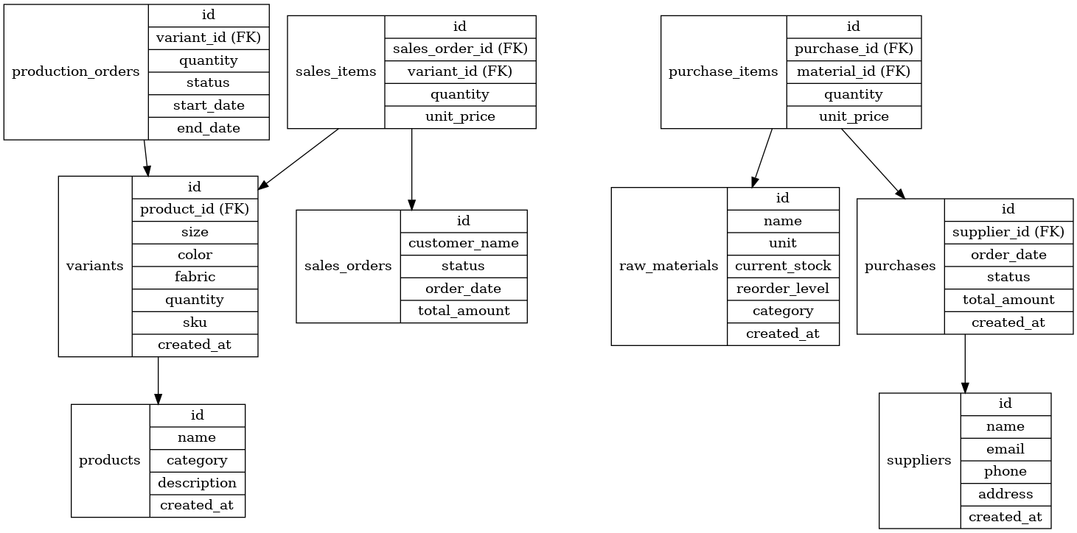
products ──< variants ──< production_orders
raw_materials ──< purchase_items >── purchases ──< suppliers
variants ──< sales_items >── sales_orders

