**SLOVENSKÁ TECHNICKÁ UNIVERZITA V BRATISLAVE  
FAKULTA ELEKTROTECHNIKY A INFORMATIKY**

**Univerzálny IoT Wifi modul s dlhým dosahom**

Semestrálny projekt

NAVEZ – Návrh elektronických zariadení

**Oliver Hollý**

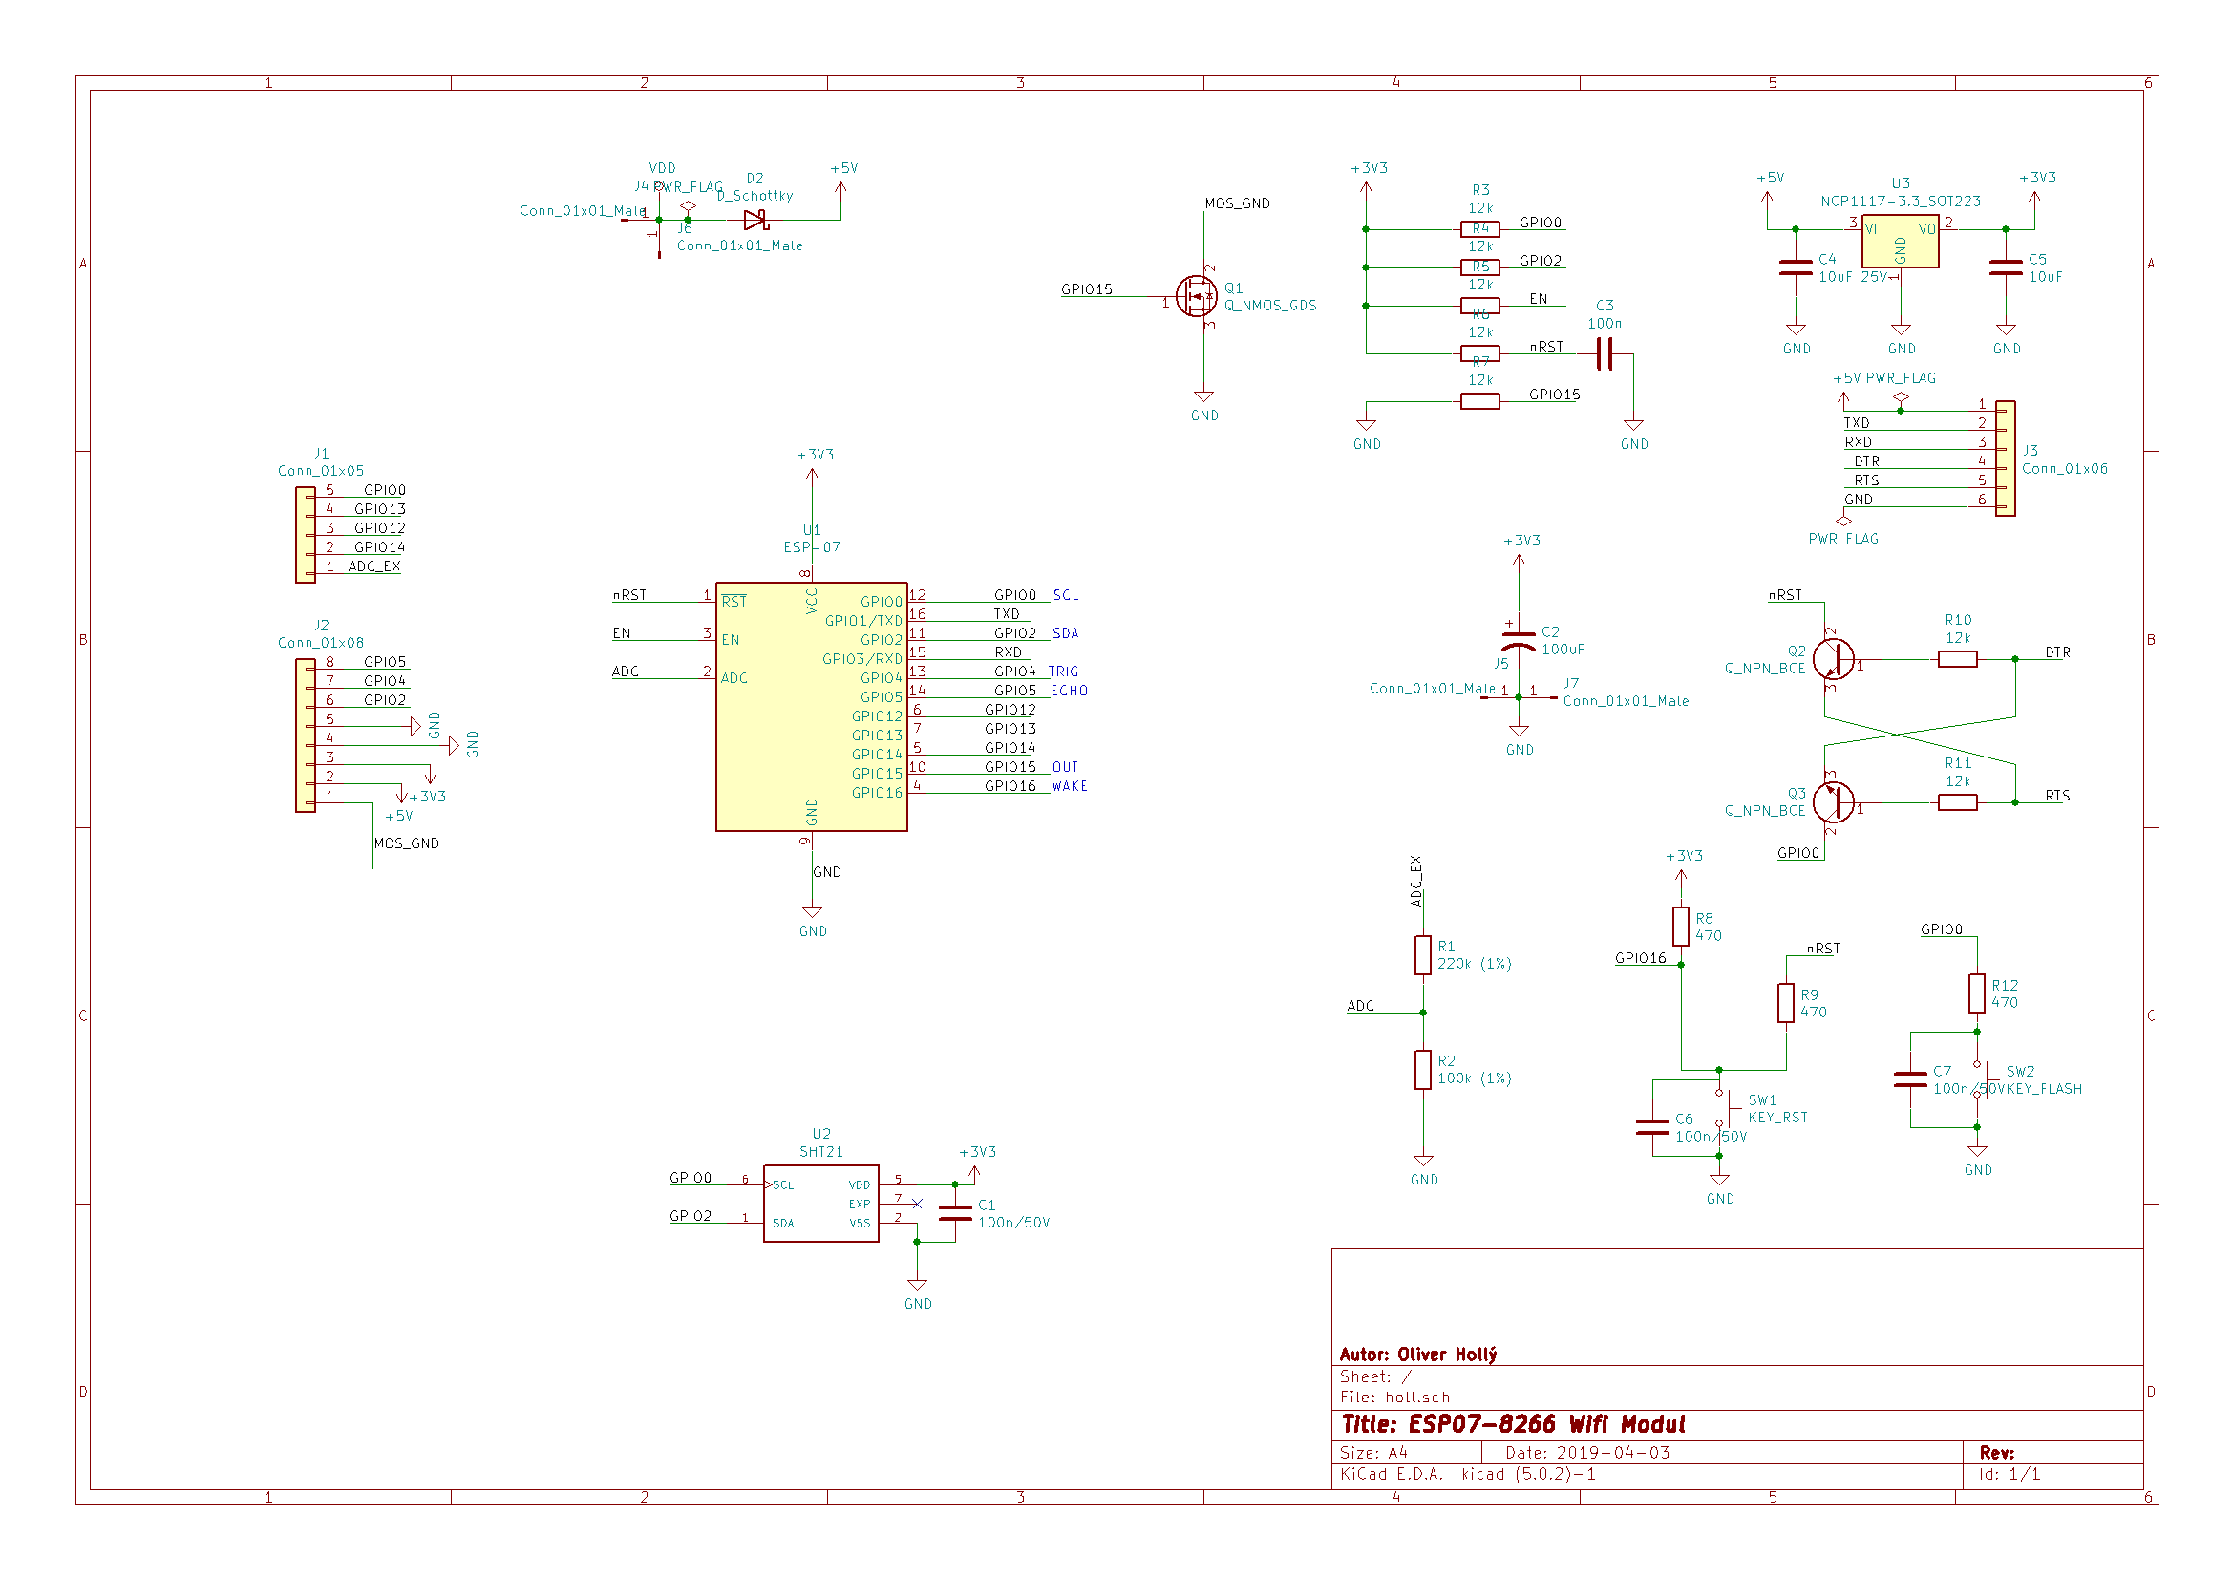

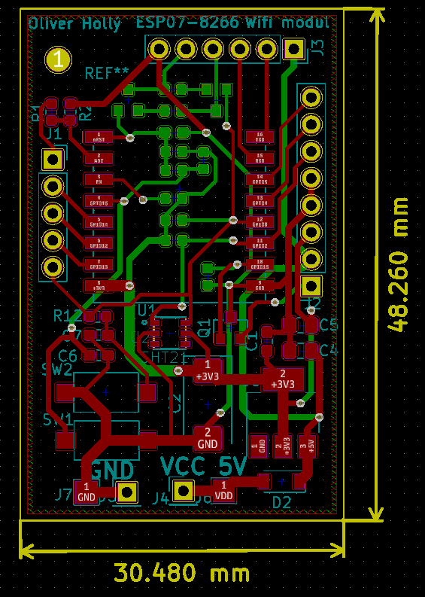

|  |  |  |  |  |  |
| --- | --- | --- | --- | --- | --- |
| **Amount** | **Reference** | **Desciption** | **Type** | **Value** | **Price** |
| 1 | U1 | ESP07 | SMD | 8266 | 5,03 |
| 1 | U3 | LDO | SMD | 3.3 V | 0,37 |
| 2 | SW1-2 | Switch | SMD |  | 0,24 |
| 1 | C2 | Capacitor | SMD | 100uF | 0,83 |
| 2 | Q2-3 | Transistor | SMD | NPN | 0,5 |
| 1 | Q1 | MosFET | SMD |  | 0,09 |
| 1 | D1 | Schottky | SMD |  | 0,09 |
| 20 | R | Resistor | SMD | 12k | 0,02 |
| 4 | C1, C3, C6, C7 | Capacitor | SMD | 100n | 0,08 |
| 2 | C4, C5 | Capacitor | SMD | 10u | 0,07 |

|  |  |  |  |  |  |
| --- | --- | --- | --- | --- | --- |
| **Amount** | **Reference** | **Desciption** | **Type** | **Value** | **Price** |
| 1 | Q1 | SHT21 | SMD |  | 5 |
| 1 | USB-TTL | prevodník | modul |  | 0.5 |
| 1 | Anténa | Externá |  | 2.4 GHz | 1 |

