

TECHNICAL SPECIFICATION

Green BA Application

Oliver Hollý, Ján Macek, Mária Kostická, Lucia Forrová, Filip Kafka,
Simona Demová, Daniel Križan

CLIMATHON BRATISLAVA 2020

Introduction

The goal of the project for Climathon 2020
Increase the awareness about cycleways in Bratislava and make bike planning easier for users of the application by providing a safe and optimal cycleway from point A to point B by bicycle. The algorithm tries to avoid proposing risky areas with a higher frequency of vehicles or with a lack of infrastructure.
The goal was derived and supported by the questionnaire of which results can be found here:
https://docs.google.com/forms/d/1Nkl0KPwjOdSNNmYNJhU_9Ng7GqjiH8TfcvWAVKgMDGw/edit#responses
The answers are still coming up.

Target Group

We focus on people:

- Who don’t know cycleways in Bratislava - we provide them cycle map
- Who are afraid of transport by bicycle - we provide them planner of safe cycleways
- People that use cars for transport in the city but there is a potential to use a bicycle instead

Description of the application GreenBA
Within the project for Climathon Bratislava 2020, we decided to technically describe and visually design the application for planning bike routes in Bratislava for everybody who would like to use a bicycle (electric bicycle) instead of a car. We also want to design other features that help the users during biking in Bratislava, which we want to introduce to you in more detail below.

Backend implementation

User activity monitoring and prediction
We need to actively detect user activity type based on mobile device sensors (GPS, accelerometers, gyroscopes). We are going to use third party solutions for the best accuracy of prediction.
Android sdk: https://developer.android.com/guide/topics/location/transitions
iOS sdk: https://developer.apple.com/documentation/coremotion/cmmotionactivity
These software development kits are able to detect the start, pause or stop of the activity and also the type of the activity: IN_VEHICLE, ON_BICYCLE, RUNNING, STILL, WALKING

Optimal route planner
This feature is the backbone of the whole application. As the most important parameter of our path-searching algorithm is not total time spent, but the combination of time and safety, we need to look for weighted path-searching. As there is no easy way to import weighted data to Google Directions API, we have to go for a more complex solution. As a base map provider, we will use OpenStreetMap and as a tool that finds an optimal route for users, we will use graphHoper. Data set for graphHoper will be constructed from multiple exports from openStreetMap. Each route type export ( roadway, cycleway, sidewalk, … ) will be done separately and then to each point of export is added weight by route type. GraphHoper will then find the best route, even if it is a combination of multiple route types.
Also, when the user finishes his journey, the app asks him to rate the route and by this rating are adjusted all points that route consists of.

GraphHoper Routing API
https://docs.graphhopper.com/#tag/Routing-API

Implementation Structure
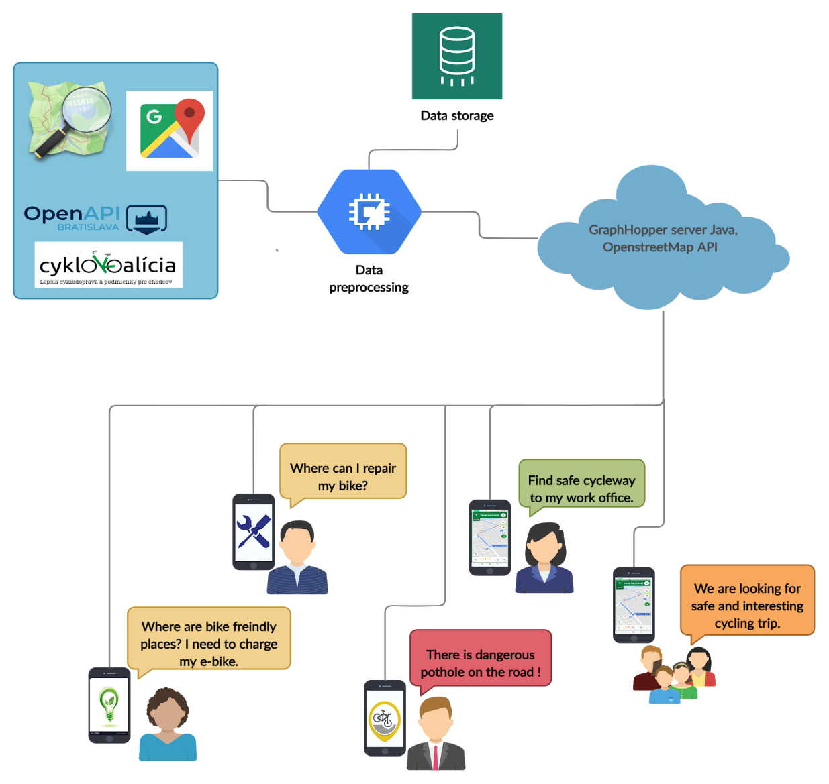

Data sources and specifications

Cycleways - official and recommended
Our app will use the cycleways from the following data sources:
Bratislava cycleways: https://www.openstreetmap.org/#map=12/48.1474/17.0947&layers=C
Additional source: https://www.cyclosm.org/#map=12/48.1270/17.1258/cyclosm
Cyklokoalicia: https://cyklokoalicia.sk/
The data source for export: https://overpass-turbo.eu/, https://www.openstreetmap.org/

The exporting script, which downloaded cycleways data for use in Google map base:
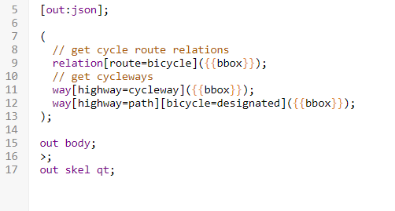

Our final exported cycleways layer that would be added on the Google Maps layer: https://www.google.com/maps/d/edit?mid=1R1JOOl7aNccqrpv0NY2bzHvGahBXNBVu&usp=sharing

Bike relevant points on the map
Most of these data are officially available but from the different sources. We are connecting all relevant bike and green mobility hotspots to the one multilayer map.

Source: Cyklokalicia https://cyklokoalicia.sk/
- Potholes or damaged cycleways, places, where you can safely leave your bicycle for a short period of time

Source: Slovnaft bajk stations - Open Data portal Bratislava ( Slovnaft bajk )
- Renting points ( slovnaft bajk, rekola )

Sources: Slovnaft bajk stations - Open Data portal Bratislava ( Slovnaft bajk )
Cyklokalicia https://cyklokoalicia.sk/
- Bicycle-friendly restaurants and bars
- Repair point places where you can find tools for basic bike repairs
These points will be added continuously as our solution gets a larger impact. The city could be responsible for updating information about new cycleways. (Agreement in progress with Tomas Peciar).

App overview

HomePage
Home page contains the most basic but also most important functionality of the app: map. You can do the following actions here:

- Search for a bike-friendly route from one point on the map to another (you can pick these points on the map or search for an address). Multiple routes are found and they are ordered by total duration and also by how secure the route is. Secure route means that it mostly uses official cycleways, it doesn’t use roadways that are meant for cars and also at night, a secure path is illuminated. User can turn on and off all of these secure path parameters in the settings.
- When searching for a route, user can set in settings to use a rented bike and the app will first look for closest renting places for bikes, such as rekola or slovnaft bajk, and then find the best cycle-route within these renting points.
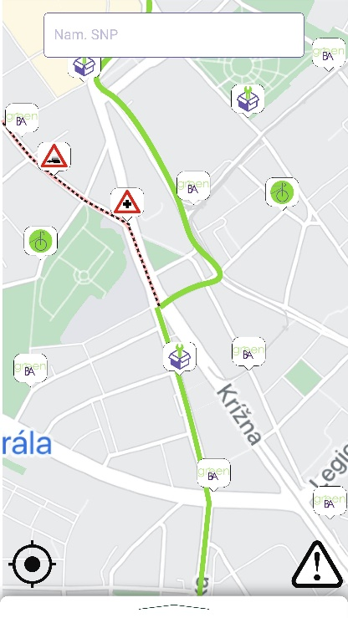
- Users can explore Bratislava and all of the cycleways it has. Those are highlighted by different colours and strokes. Cycle-highways are bold and non-cycleways are dashed. Users can also choose options to show planned cycleways.
- User can also view on the map following cycle-friendly features:
  - Places, where user can safely leave his bicycle for a short period of time
  - Cycling training fields
  - Bicycle-friendly restaurants and bars
  - Renting points ( slovnaft bajk, rekola )
  - Potholes or damaged cycleways
  - Repair point, places where user can find tools for basic bike repairs
  - Report issues on the cycleway (pothole, damages, obstacles,...)
- At the bottom, there is a navigation menu, from which the user can go to his profile and also there is an option in this menu to report damaged roads ( potholes, fallen trees, cars parked on sideways, … ).

Features

Vouchers
This section enables the user to check his actual “GreenCoins” that were obtained depending on the distance travelled by bicycle and have a look at the vouchers that are provided by the sponsors.
The aim is to have sponsors like companies, cafes, restaurants, shops and other organizations that would get a “bike-friendly” sticker from us.

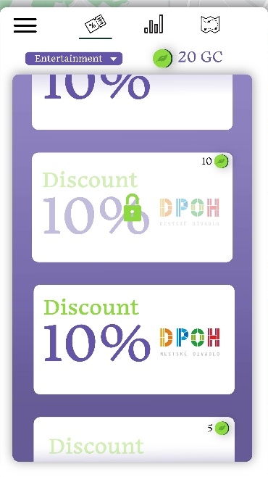
The condition that has to be met to get the sticker is to have at least one of the following requirements met:
- Bicycle storage
- Shower with dressing room
- Possibilities of charging an electric bicycle

For sponsors, it is a PR activity or so-called social enterprise concept. These organisations could have higher attendance as the application will notify the user about the bike-friendly organisation nearby.
Users would be more motivated to use bicycle transport in the town as it would be more convenient for them.

Report a Complaint
This section enables the user to report a complaint with respect to cycleways in the city. The typical complaint can be a pothole on the road.
The user can fill 3 types of information:
- Location - either automatically obtained from the app or type the exact address where the issue was found
- Description - space for the specification of the complaint
- Photo documentation ( optional ) - possibility to upload a photo of the issue.
The complaint is then sent to the admin of the app. We recommend using the same admin that takes care of complaints via “Odkaz pre starostu”.

Profil
The users can find complex statistics (time saved / carbon footprint / earned points) about his rides for the specific time period (day/week/month/year) in their profile processed in simple dashboards. Settings could also be changed in this section.

Final Screen
After the end of each trip, users should be informed about the results. The first reason for that is the users have instant information about how they helped the environment, thanks to the decision to choose a more ecological type of transportation.
Generally, apps that contain reward systems and instantly show your results are popular among users. But it is necessary to keep a balance between spamming users and show them useful information and notifications. For that reason, we decided to include the most relevant data collected during their trip session only to a simple overview screen, which pop-up for users after the end of the trip session. You could find the preliminary design of this user screen in our final presentation. Content of overview screen:

Carbon footprint - Part of the summary trip screen will be the information about the carbon footprint. Users will get this information after each ride, but also their results will be saved into their global stats. For the computing of carbon footprint, we collected information from more relevant sources and concluded that we should use the research result of a study of the European Environment Agency. They determined that the average new car made in 2017 creates a 119 g/km carbon footprint. They used data from 9 manufacturers. Usually, they dealt with cars whose weight was not greater than 1600 kilograms. So it is not necessary to ask the user for information about his vehicle.

Session trip summary - At the top of the screen, you could find fundamental and relevant information about user trip summary like time spent on a bike, distance, and description of the starting point and endpoint.
Our app gathers data about:
- Time spent on the bike
- The distance on the bicycle from google maps through API modules
We plan to offer the user two options to collect data about his trip starting point and endpoint:
- Users can add this information to the app manually through a route planner.
- The second option is through modality differentiation functionality, which automatically observes the user's change of speed and starts to record the trip session. After a decrease in movement speed, it will automatically evaluate the trip. We need to have their approval for location tracking. The collected data are anonymised and do not use any persistent identification.
The results of the session trip summary can be shareable through social networks, which could secure the improvement of the user base and motivate other people to think about their impact on the environment based on information about saved carbon footprint.
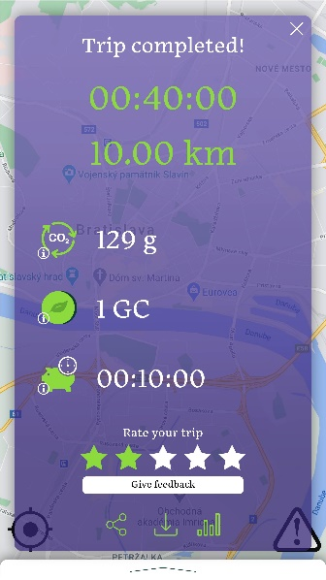
Saved time - In case the user adds start and endpoint in the application, we could automatically gain information through Google maps API about the time estimation of an ordinary car to go through the same trip. So after the end of the session trip, the app compares the difference between time lengths and shows the user result in a summary screen. If users don’t want to use the application option, we could use the monitoring of the beginning point and endpoint thanks to modality movement functionality and find out the total time of the trip. Estimated time of session trip for an ordinary car can be gained by the following method: After the end of the bike trip, we send information about the startpoint, endpoint, and start time and through google API, we receive information about time estimation for a car trip. After synchronization, it is enough to compare results to see the saved time.

Google Distance Matrix API
https://developers.google.com/maps/documentation/distance-matrix/overview

Reward point (Green coins) stats - More information in section vouchers.

Road quality - Evaluation of the bike road. User can express his experience from the bike route. User can enter a range of stars from 1 to 5. If he enters 1 or 2 stars there will pop outbox where he can put a detailed description of the issue. This data can be provided to the city and be the base for improvement.

Data statistics impacts
We looked at the basic statistics of how many cyclists are on the roads with respect to time in a day. The graph says that most cyclists are on road from 3 pm to 7 pm. This encouraged us to think about what else can be done for cyclists in Bratislava. As we had some responses about insufficient street lighting on the roads in our questionnaire, this could be a suggestion for improvement in the street lighting. Graph below indicates that it is necessary to cover cycleways by more light.
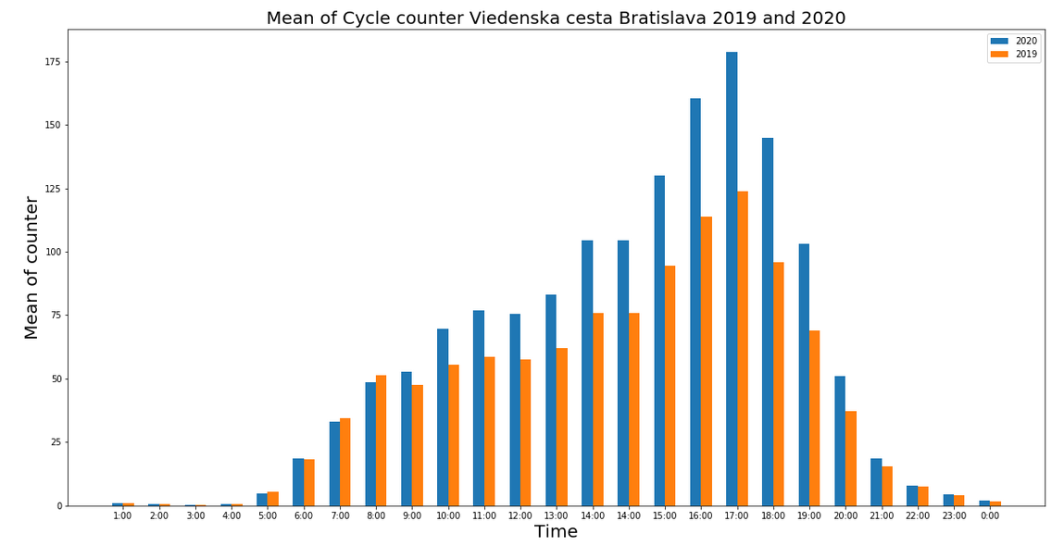

Recommended cycleway
We are going to actively collect feedback on specific routes in Bratislava, later we are going to evaluate routes by experienced cyclists and city coordinators. The official cycleways could be evaluated as the best, then any other road will be evaluated by the sufficient width and traffic volume. Another approach is to use third party data, for example, the most usable cycleways, like these:
https://www.strava.com/heatmap#11.95/17.05674/48.17150/hot/ride
