Covid public restrictions
project by Oliver Hollý (Zahorack)

1 Development documentation
2 Contributing manual
3 User guide

Obsah
1 Develoment documentation 5
1.1 Thermal imaging 5
1.1.1 Problems with human temperature measurement 5
1.1.2 Problems with thermal imaging 5
1.2 Raspberry pi and camera 6
1.3 People counting data science 7
1.3.1 Human pedestrian recognition 7
1.3.2 Motion detection 8
1.3.3 Motion tracking 10
1.3.4 People counting evaulation 10
1.4 Server - linux virtual machine 11
1.4.1 Socket communication 11
1.4.2 Client authentification 11
1.4.3 SQL database 11
1.4.4 Web server 12
1.5 Future improvments 13
2 Contributing manual 14
3 User guide 15

Abstract
Documentation describes concept, implementation and guideline how to use and participating in Covid public restrictions project. Project begun as a reaction on global situation connected with coronavirus pandemic. Main motivation is to use modern technical resources to avoid virus spread. I have decided to use light and thermal camera imaging techniques to check and monitor public restrictions ordered by government. After brainstorming and collecting hardware resources and knowing their limitations I begun assembly first concept. Core of project is people counting practices, which should count people inside a closed public space like shop or office. My way is to implement low cost and real time people tracking and counting system shareable on remote web server. Earned information about number of people inside, should limit people contact and rapid virus spreading.

Develoment documentation

Thermal imaging
Thermal imaging is technique based on environment sensing with thermal or infrared camera. Since we know, higher human temperature is significant symptom of coronavirus infection, the complex information about temperature in camera view space could be used on measuring temperature of human or multiple people at same time.

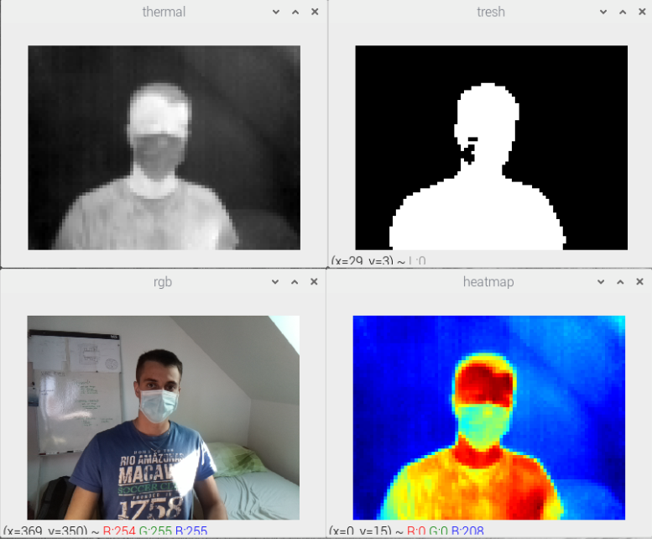

Figure 1. Me with face mask, captured by thermal and RGB camera

Problems with human temperature measurement
Recommended and most accurate measurement of human temperature with thermal imaging should be near to eye canal. That should be problem with low resolution camera. Another issue is human temperature adaptation between various environments and weather conditions.

Problems with thermal imaging
My first attempt in Covid public restrictions project was based on low cost thermal camera Flir Lepton v2. I ran into multiple problems while developing. I quickly recodnized some factors influencing thermal imaging and sensing.

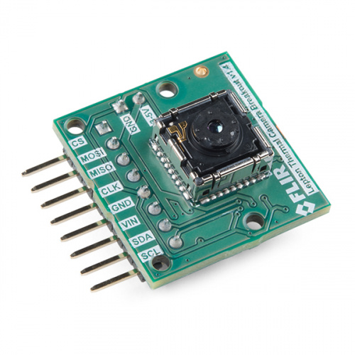

Figure 2. Thermal – infrared camera module Flir Lepton v2

My thermal camera module cost about 250 euros, but it is calssified as a low cost technology. Resolution means a lot in thermal cameras prices. Resolution was not even a far the worst problem. Flir lepton v2 in contrast with newer version v3 has not even has internal radiometric corection, which means measuremnt of absolute temperature for each pixel depends on camera core temperature. That makes my camera an indequate for that purpose.

Of course, there is solution for calibrating absolute temperature with external black body object with known temperature, standalone in camera view. But at this point I met the biggest problem, absolute themperature measurement depends on object distance from camera too. Solution for this is more complex. It is really hard and expensive to measure distance of multiple objects in camera view, i thought about stereo cameras and lasers.

Thats why I don't use thermal imaging in my project.

Raspberry pi and camera
While programing image processing with thermal camera I have realized that only thing I can really do is human recognition by thresholding relative temperature difference. But that I can do with RGB camera too, and cheaper. So I have decided to began with implementation human or pedestrian recognition, tracking and counting.

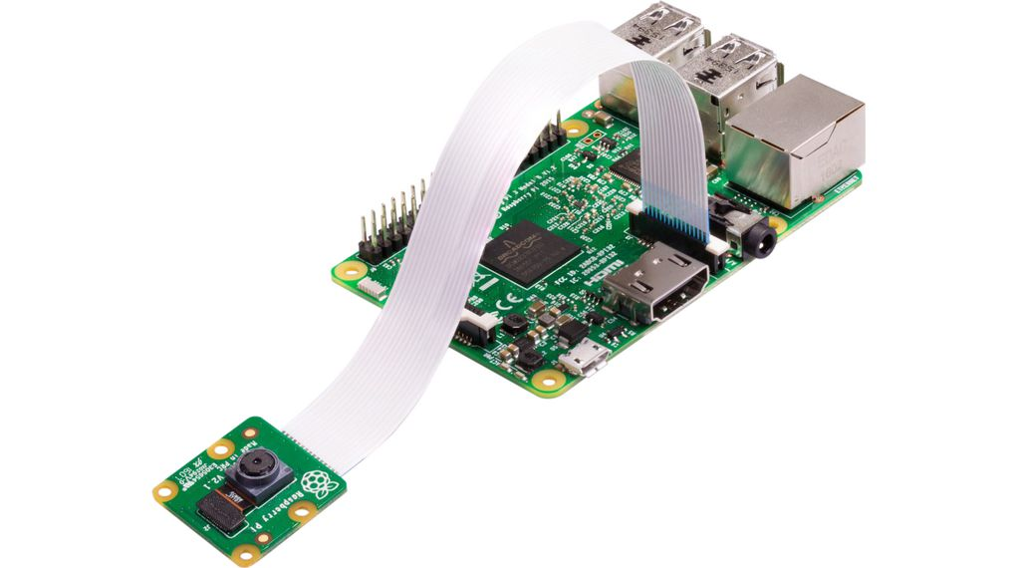

Figure 3. Raspberry pi 3B and camera module

My hardware since then consist from Raspberry pi model 3B and simple RGB camera module, what is pretty cheap setup. Raspberry runs adapted ubuntu linux distribution called raspbian. I was developing with python and OpneCV.

People counting data science
Following development process will deal with software implementation of people counting method. As I mentioned earlier density of population inside closed public space should be limited due to virus spread.

I began researching the state of art solutions and I figure out there is lots of them. Most of them are based on learned neural network models and deep learning techniques. That is why, before we could count humans, we must alreade recognized them in environment. So we have first important keyword – human or pedestrian recognition.

Human pedestrian recognition
OpenCv toolbox offers various trained models based on HAAR cascades, so I did not have to learm my own model, instead of that, and in addition with python language I could rapidly fast develop and test first demo application. As fast as I was developing, as fast I have met another problems. Raspberry with raspbian operating system and python OpenCV definetly can not handle human recognition in real time. This also applies to head, eyes or body top recognition. There is not enough computing power. Low cost solution again began seems like an unreachable.

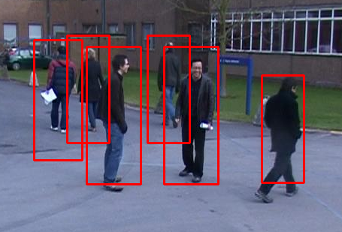

Figure 4. Pedestrian recognition

Motion detection
Then I have decide to try obtain information about pedestrians movement speed and direction by motion detection practise. Motion detection is based on recognizing difference between each frames in camera video stream.

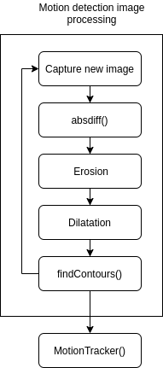

Figure 5. Motion detection flow chart

Figure 5. represent motion detection image processing flowchart, I have implemented algorithm in python with OpenCV. The goal is to extract motion difference between series of frames and create binary (black and white) mask. In Figure 6. is shown example of motion detection and tracking.

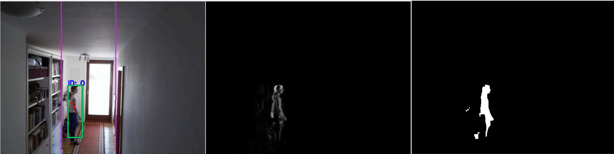
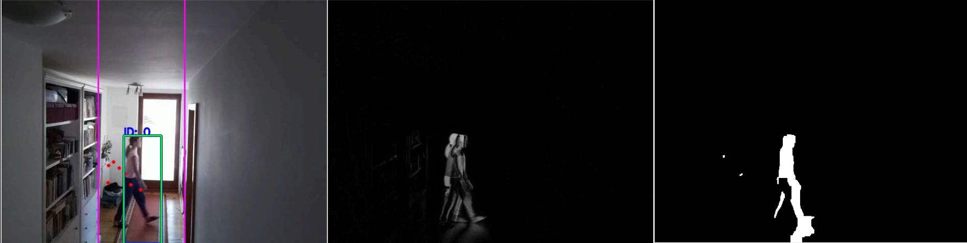
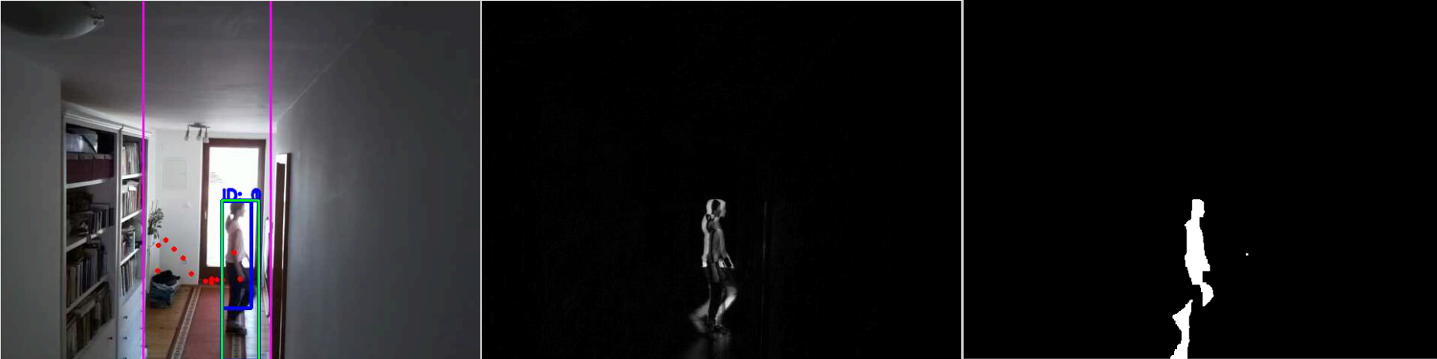
Figure 6. Motion detection and tracking

Figure 6. consist from series of 3 frames captured by RGB camera – first column. Second frames for each RGB image is displaying absolute difference between previous image. Third column is finally binary mask of moving object, obtained from differential image and by appling morphological operations – erosion, dilation, opening and closing. Last step in this section is the object segmentation. For that pupose I have used findContours function from OpenCV toolbox.

Motion tracking
Now we want to track detected moving object, it means we are going to follow each contour from motion detection procedure. This task requires complex data analysis algorithm. Basic idea is unveiled in Figure 7.

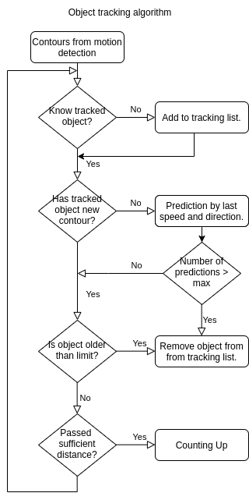

Figure 7. Object tracking algorithm

People counting evaulation
In this moment we can recognize moving object in RGB camera view and follow his trajectory. Last task is to evaluate tracking data by passed distance and direction of moving object. We would be done, if we wanna just monitor our house or neighbourhood. But our goal is to make globally accessible web infrastructure to share number of people inside monitoring place. In the next section we will deal with data sending and visualisation on web server.

I should mention counting measuring reliability and accuracy. Bad news are, that counting error occurs occasionally. Good news are that counting average error converges to zero thanks to statistics.

Server - linux virtual machine
Server is centralised point where clients (raspberry) are connected, here is also running web server which holds web page up. Server must receive data from clients (people counting data), save them to database and render them on web page. For that purpose I have decide to buy remote ubuntu virtual machine from DigitalOcean, also called droplet.

Socket communication
The first necessary functionality is socket communication. I have implemented scalable multi threaded socket communication. Server is listening on one socket file descriptor and for every one new client communication gate is created thread, what enables paralel request handling. Also I have did secure and correct socket port closing. Pretty cool, uhm?

Client authentification
Philosophy of this project is the open source and even more friendly. There is possibilty to contribute and together try limit virus spreading by connect your own client device with active people counting function to my server. All you need to know is described in the Contributing manual section. For now I have to tell how is client authenticated to connect on server and save data to database.

Socket communication message looks like:

{"name": grocery_shop, "key": unique_key, "counter": 5}

message is packed in JSON data format and contains name of monitoring place, unique key and of course counting data. Unique key is paired only with clients place name. Example:

unique_key = "QDR84IGV"

SQL database
When client is successfully authorized, payload data should be saved to database system. I have chosen MySQL database.

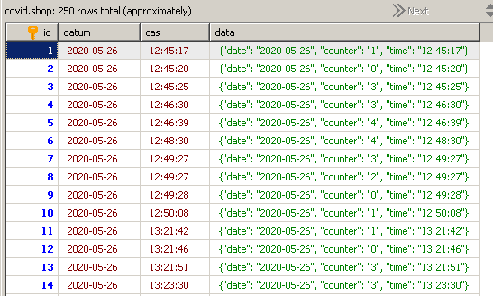

Figure 8. Database system preview

Web server
I have used Flask backend framework and development server. For deployment server I setted up NGINX. Simple one frontend is classics HTML, JS, CSS combo. User interface offers selection of available monitoring places and monitoring dates based on database.
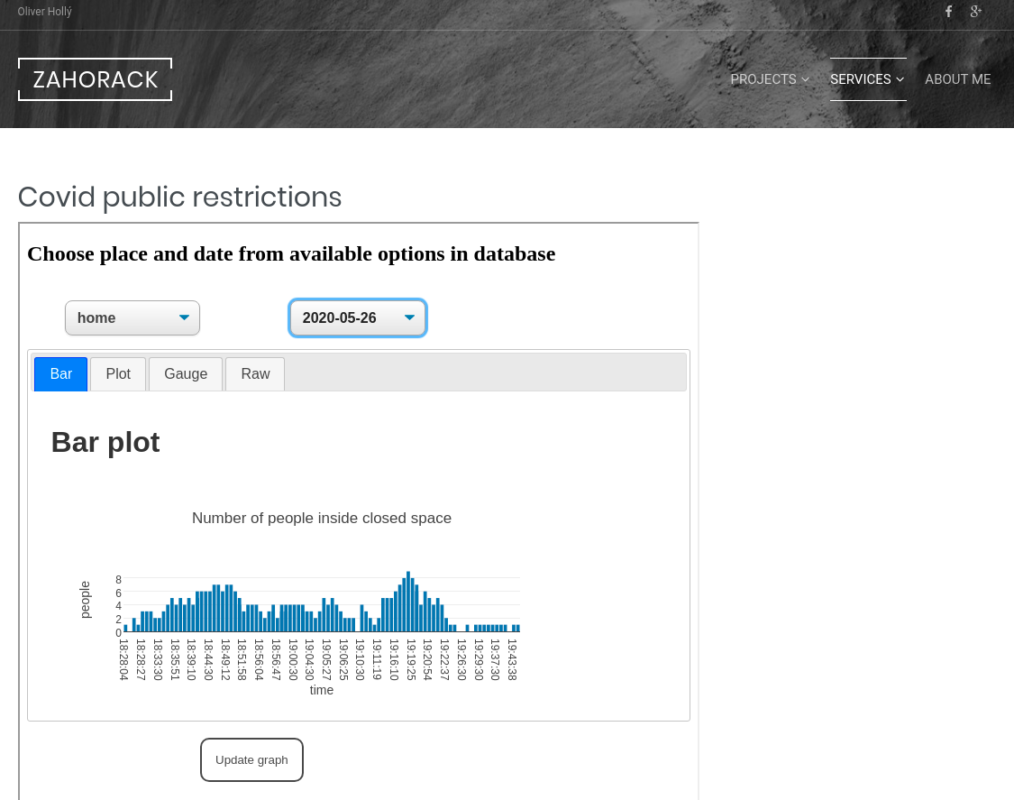

Since I have limited frontend designing skills I have decided to render my page inside my personal Wordpress page.

Future improvments
Since main idea and philosophy of this project is homemade low cost implementation we have to use all available technologies. There is possibility to use video stream from security cameras installed in offices, shopping malls, etc. Raspberry or another device connected on local security network should do image processing and people counting.

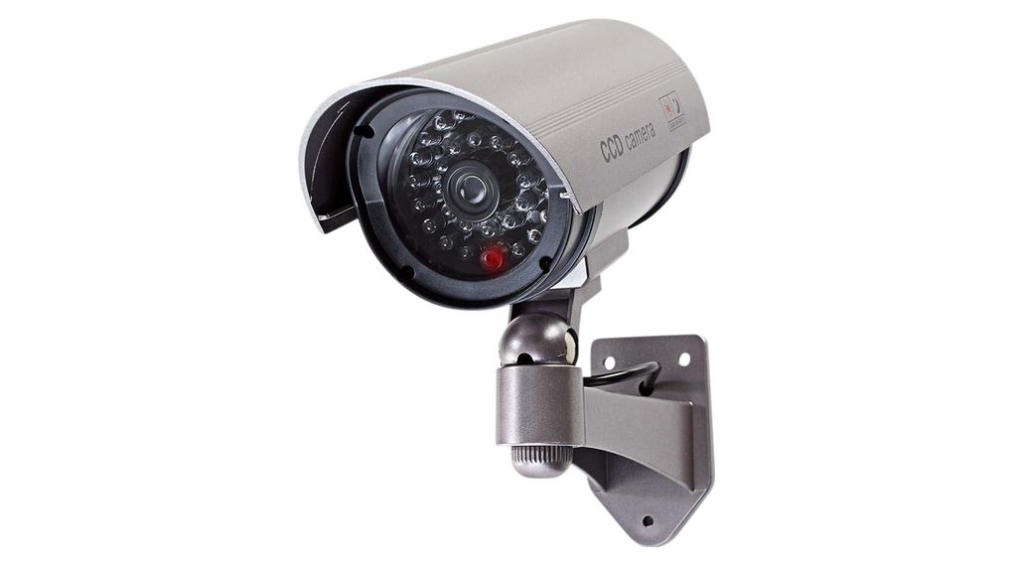

Contributing manual
I am glad if you have decided to contribute and participate in Covid public restrictions project. All you need to do is clone my repository:

https://github.com/Zahorack/covid-public-restrictions

and install covid-linux-client package on your raspberry pi. Then please contact me on oliverholly11@gmail.com and I will generete unique key for your monitoring place.

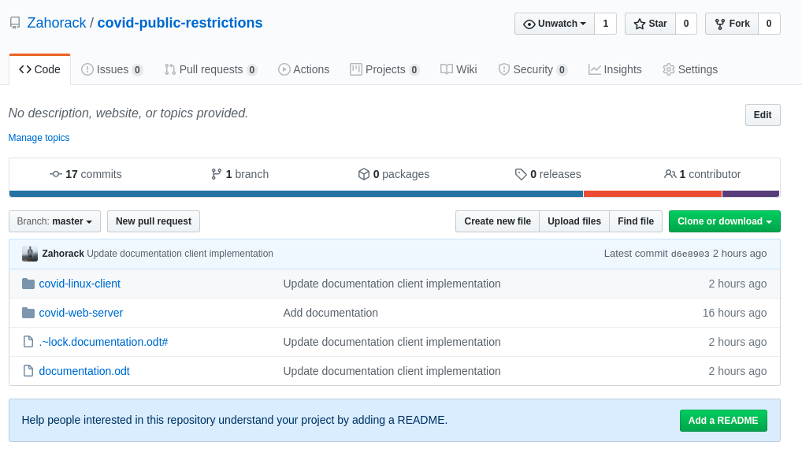

There is also opportunity to contribute by developing and makes this project better, robustness and safer.

User guide
This web application is designed as for management or employee of monitored area as well as for public population, who plans to visit this place.

https://www.zahorack.com/services/covid/
